Unit 2 – Managing People

In Unit 1, we focused on the roles of the manager. One of them was the interpersonal role which involves providing formal authority or serving as a figurehead, managing relationships with and between staff and leading the organisation. This unit addresses this role and serves as preparation for your first assignment.

There are four Study Sessions:

Study Session 1: Managing Yourself and Your Team Study Session 2: Motivation
Study Session 3: Developing and Leading Teams Study Session 4: Managing Conflict
In Session 1, we will work through some management survival skills, including stress management, time management and delegation. In Session 2, we will examine the factors which influence motivation and explore the manager’s role in developing staff to meet their individual goals and those of the organisation. In Session 3 we will look at the way teams develop and at the manager’s role in guiding the process of team building. In Session 4, we will examine symptoms, causes and management of conflict.

Intended Learning Outcomes of Unit 2

By the end of Unit 2 you should be able to:
- Manage yourself in order to manage others better.
- Analyse factors which influence people’s motivation to work.
- Examine leadership practices in relation to management.
- Debate the process of developing and leading a team.
- Apply conflict management concepts and models to your own work situation.
While you work through the study sessions and readings, you should also frequently remind yourself of the requirements of the assignments for this module. Be on the alert for ideas and information which might feed into the assignment.

Enjoy the unit, and concentrate on reflecting on your own experience in relation to these topics: critical reflection is an excellent way of developing your management skills!

Unit 2 - Session 1
Managing Yourself and Your Team

Introduction
We started this module by looking at the meaning of management and the roles managers play in their jobs. We suggested that a manager is someone who gets things done through people. To manage people effectively, you need to make sure that you are managing yourself effectively. In this session, we explore strategies to better manage yourself and your team. We will examine some of the challenges which managers face and suggest some ways of dealing with them.
We include:

- stress management
- time management and
- delegation

Session Contents
- Learning outcomes of this session
- Readings
- Managing stress
- Recognising role strain
- Time management
- Delegating effectively
- Session summary

Timing of this Session

This session contains 25 pages of reading and thirteen tasks. It is likely to take you three hours if done thoroughly. The tasks are short but require engagement and reflection, so try to put aside two study periods to keep the continuity of the session.

LEARNING OUTCOMES OF THIS SESSION

By the end of this session, you should be able to:
Management outcomes:  - Manage yourself in order to manage others effectively. This involves being able to:  → Identify signs and impacts of stress.  → Discuss some of the causes of stress.  → Identify strategies for managing stress.  → Analyse your use of time.  → Implement measures for improving your use of time.  → Analyse some of the advantages and disadvantages of delegation.  → Describe the types of tasks which can be delegated and the steps of the delegation process. | Academic outcomes:  - Learn and apply the concepts of Role Theory.  - Practise time management strategies.  - Analyse and reflect critically on your own practices.

- READINGS

There are readings from two sources: you will be referred to them in the course of the session.

Publication details
Handy, C. (1999). Understanding Organisations. London: Penguin Books: 60-71; 72-74; 92-95; 334-339.
McMahon, R., Barton, E. & Piot, M. (1992). Ch 4 - Managing Time. On Being in Charge.
Geneva: WHO: 195-208; Ch 2 - Implementing Health Activities. On Being in Charge. Geneva: WHO: 323-327.

MANAGING STRESS

The Impact of Stress

As a manager, you will inevitably encounter pressures and stresses in your work. Some people “… find a degree of pressure [to be] positively motivating. They are able to respond to it energetically. Stress, on the other hand, does not produce a positive, energetic response. It is debilitating. It deprives people of their strength, their vitality, and their judgement. Its effects are negative …” (MESOL, 2000: 47). It is important that managers should be able to distinguish between pressure and stress, both in themselves and in their staff, so that they can avoid stress while making the best use of pressure.

The following extract from Handy illustrates the potential effects of stress on a manager:

… Stress heightens the dilemmas:

Stress shortens time-horizons, polarizes issues, exaggerates the importance of the present, makes difficulties into crises and inhibits creativity. Stress in fact is the one thing a person, and especially a senior manager, should be without. And yet, for many a manager, stress is almost a battle honour. To succumb to it is weakness, to be without it is dishonourable. In a way, a heartless way perhaps, it is not the physical and mental outcomes of managerial stress that are the worries. If a [person] has a heart attack, develops an ulcer, has a nervous breakdown, s/he is himself a victim, but s/he is also incapacitated as a manager, prevented from causing hurt to others. It is the less respectable symptoms of stress, the general impairment of judgement and the tendencies listed at the beginning of this paragraph, which can really foul up organizations and the lives of others. Managers, as a social duty, must manage stress, not court it … (Handy,1999: 334).

Another important point to recognise about stress is that:

… Under excessive pressure managers are not the only ones to suffer. Managers experiencing stress may have little time to spend with their families and, when they do find time, they may be irritable and unable to relax … (MESOL, 2000: 47).

We will now look at some signs of stress, then at some of the causes of stress, and finally at ways of managing stress.

Recognising Stress

A simple way of differentiating between pressure and stress is to think of pressure as something that comes from outside of yourself, and stress as the response you have when you are subjected to too much pressure.

… Between these two extremes is a large intermediate area in which pressure merges into stress and this is the danger area. This is where you need constantly to be on the lookout for tell-tale signs.

Some of the more obvious signs of stress are irritability and short temper, panic reactions, heavy reliance on tobacco, alcohol and other drugs such as tranquilizers, over-busyness, insecurity, an unwillingness to delegate. People may become difficult to talk to, morose, confused, unable to relax, insomniac. These can all be signs of other problems, but their presence should make you suspect stress, and should suggest the need to find relief before the stress leads to more damaging effects for the individual and the organization … (MESOL, 2000: 47).
TASK 1 – Looking for signs of stress

Are you displaying any of the signs of stress above? Now think about two of your colleagues who play a management or co-ordinating role: are they showing any signs of stress?

FEEDBACK

Simply by being honest with yourself, recognising the signs of stress and acknowledging stress as a reality, you have taken the first important step in managing it. The next step is to look for the causes of stress

Causes of Work-related Stress

There are many potential causes of stress in the workplace. We will examine this topic by looking first at the different sources of stress and then looking in-depth at role strain. It may or may not be contributing to stress, but as it is a very important problem in the workplace we will examine it separately.

Read the extract titled “The implications of stress” by Charles Handy in which he discusses five of the organisational situations as well as some of the personality variables which can lead to stress for a manager. Then do Task 2 and try to identify the causes of stress in your job situation. Note that role strain (or role stress) may be part of other sources of stress.

READING

Handy, C. (1999). Understanding Organisations. London: Penguin Books: 72-74.

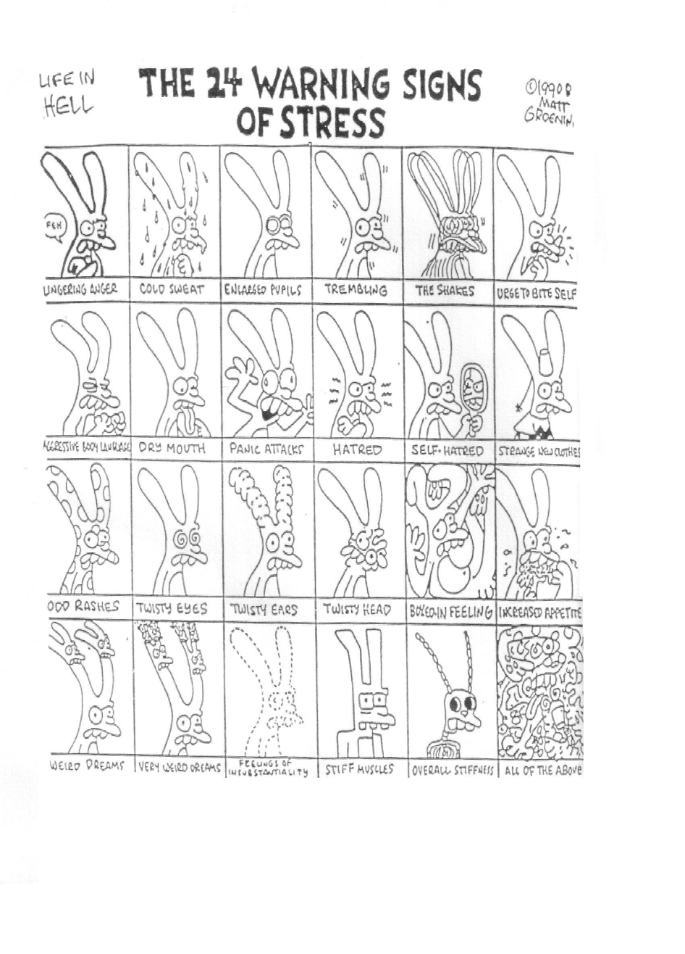

TASK 2 – Identifying the causes of your own stress

Think about any stresses that you are experiencing in your job and jot them down. Now compare them to the table below. Use the empty rows to add any that are not mentioned here.

Use column A to tick the causes of stress in your job. Again think about the stresses faced by two colleagues and use columns B and C to identify their causes of stress. If you know them well enough you could talk this through with them. The categories are explained in the Handy extract which you have just read. The situations marked with an asterisk are explained below.

Some of the situations which lead to stress: | A | B | C
Responsibility for the work of others
Inadequate resources
Lack of control over work
Innovative functions*
Integrative or boundary functions**
Relationship problems
Career uncertainty
Sociability/unsociability
Emotional sensitivity
Flexibility/rigidity
Constant change in the work environment
Role strain***
Fill in any additional causes of stress below:
(Adapted from MESOL, 2000: 48)

* Innovative functions are functions where the manager is responsible for new, experimental programmes or functions, which therefore risk not working.
** Integrative or boundary functions are the functions of a manager which have to do with ensuring that the activities or functions of different groups or departments are integrated.
*** Role strain refers to negative pressure or stress resulting from tensions within or between the role/s we play. We discuss this below.

FEEDBACK

There are many potential causes of stress, but it will be helpful for you to be aware of some of the common causes of stress in the workplace, so that you can help both yourself and your staff to manage stress.

RECOGNISING ROLE STRAIN

We have already seen that a manager’s job involves fulfilling a number of different roles. These roles and the way in which they fit together (or don’t fit!) can be a significant cause of stress. This is called role strain. Some roles, such as being responsible for the work of others, are obvious causes of pressure, but depending on the capability and motivation of your staff, they may or may not cause stress.

Handy has explored a number of important issues around roles and role strain in the work situation. He points out that role strain increases as one rises in the ranks of an organisation. He uses Role Theory to help understand role strain and to find ways of addressing it. In this reading, Handy explains Role Theory. Read these sections and try Task 3 while reading it.

READING

Handy, C. (1999). Ch 3 - On Roles and Interaction. Understanding Organisations. London: Penguin Books: 60-71 & 92-95.

TASK 3 – Understanding concepts in role theory

Before reading Handy’s chapter, study the summary from page 92 onwards and then tick the correct answers.
- Role strain means: positive pressure negative pressure

- Role strain arises from:
  - Unclear role expectations
  - Changes in the health system
  - Your expectations of your role being different from those of the organisation
  - Too many roles being expected of you
  - Poor relationships
  - Too few roles being expected of you
  - Being unable to carry out the various roles expected of you in the your workplace situation.

Now read the chapter and check your answers.

FEEDBACK

1 a) Role strain refers to negative pressure or stress resulting from tensions within or between the role/s we play.
1 b) Role strain arises from:
- Unclear role expectations (role ambiguity).
- Too many roles being expected of you (role overload).
- Too few roles being expected of you (role under-load).
- Being unable to carry out the various roles which are expected of you in your workplace situation (role conflict).
- Your expectations of your role being different from the expectations of the organisation (role incompatibility).

The concepts in brackets are some of the key concepts of Role Theory. Changes in the health system and poor relationships are not role strain - they are situational stresses.

Now that you have clarified the concepts in Role Theory, apply this knowledge to your own situation by doing Task 4.

TASK 4 – Identifying role strain

Think of some of the roles in your job and those of two colleagues. Tick those role tensions which you experience and those which you think they may experience. Write down an example of each. Use the table below.

Role tensions which lead to stress
Role Tensions | Do you experience it? | Does person B experience it? | Does person C experience it?
Role ambiguity
Role incompatibility
Role conflict
Role overload
Role under-load

FEEDBACK

Role strain is a significant cause of stress in managers. Yet as Handy (1999: 93) notes, it “is inherent in organisations” often in areas where innovation is under way, or where different functions must be integrated. If you have identified it in your own situation, see whether you can take any positive steps towards addressing it with key individuals or within the organisation. The next section offers some strategies to do so.

4.4 Dealing with Stress

This section focuses on what can be done to assist in reducing stress levels both in yourself and in those you manage. It also provides opportunities to practise your problem-solving skills. We will first look at Role Theory analysis as a strategy whereby organisations can reduce stress. Then we will examine strategies which individuals can apply to their jobs and lives

Addressing stress in organisations
Handy has explored Role Theory as a way of looking at, and therefore being able to deal with strain (harmful stress) as it arises from role tensions. Role strain management strategies often require the co-operation of a broad range of members of the organisation, in particular the top management. Read the extract titled “The implications of role theory” and summarise Handy’s four strategies for organisations to deal with role tension. Keep your notes for Task 5.
READING

Handy, C. (1999). Ch 3 - On Roles and Interaction. Understanding Organisations. London: Penguin Books: 92 - 95.

Addressing stress in individuals
As an individual, there are some strategies which you can engage to manage personal stress. Read Handy’s discussion on “Dealing with dilemmas” and make sure you understand each of these strategies. Try to relate them to your own experiences of stress as you do the task below.

READING

Handy, C. (1999). Ch 3 - On Roles and Interaction. Understanding Organisations. London: Penguin Books: 334-339.

TASK 5 – Finding ways of dealing with stress
- If you have identified a particular kind of role strain in your job in Task 4, would any of Handy’s suggestions on page 94 be helpful in addressing the problem?

- Study this list of ways of dealing with stress. It should help you to think about how to help both yourself and others in whom you may have observed signs of stress.

Managers or staff under stress need to:
- Try to find a co-operative solution for problems.
- Create a stability zone for themselves.
- Talk to others to get a better perspective on their problem.
- Clarify their role/s.
- Clarify the activities which their roles demand of them.
- Balance the competing demands of their various roles.
- Have a range of responsibilities which matches their competences.
(Adapted from MESOL, 2000: 49).

In order to address your own stresses, write down two strategies that you will use to deal with organizational stress that you are encountering and two to deal with individual stress that you may be experiencing.

FEEDBACK

When we experience pressure that is not excessive, we are left feeling in control; we know that through extra effort we can meet our objectives. When pressure is excessive and we feel under stress, there is a feeling of having lost control: there is too much to deal with, it is too complex and we cannot see our way clear to the goal or we lose sight of the goal.

Addressing the needs listed above can assist a manager to retain control of their situation. It is worth taking the time to consider how to actively address (manage) these issues. If you do not, you may find it extremely difficult to cope with mounting pressures.

As a manager, you can influence the way in which your colleagues and staff deal with stress. Another important strategy for reducing stress is to manage your time more effectively.

5 TIME MANAGEMENT

For many managers, it seems that the work to be done just will not fit into the time available. In the words of Themba, the District Manager, he said:
I’m always being called on to deal with minor issues, so I struggle to find enough time to concentrate properly on the important matters.

Rose noted:
Even when I plan the use of my time, I am unable to keep to the plan because of interruptions.

Margaret, managing the refugee camps added:
I have difficulty in dealing with things that compete for my time and attention.

These experiences can lead to considerable stress and may seem almost impossible to change. The only way to deal with a situation like this is to put some time aside to review your time management practices and to find ways to use the time available more effectively. On the other hand, you may be skilled in managing your time, in which case this section may provide you with a strategy to teach to your staff.
Task 6 - Assessing usage of time

These are some questions you and your staff could ask yourselves to establish whether or not you have a time management problem.
a)
b)
c)
Do you feel you have enough time to complete the tasks required of you? Do you feel that you sometimes waste time?
Do you feel that other people sometimes waste your time?

FEEDBACK

If you have answered “yes” to one or all of these questions then you may have a time management problem. In the case of question (a), take the time to consider your activities with a colleague or line manager to ensure that it is not role overload which is affecting you.

It is important to identify the cause of your time management difficulties. When you cannot see any way of completing what you have to do, you may feel helpless and overwhelmed. You may feel that this signifies a failure on your part which is not necessarily true. Many managers have similar problems. Once again, identifying the problem and analysing its causes are the first steps toward a solution.

The following time management strategy could be used by both yourself and your staff to improve the use of time in the workplace. In addition to the time management strategy, ways of organising the use of time of your staff (duty rosters, leave plans, timetables, meeting schedules, deadlines, etc) should be incorporated.

A Time-management Strategy
There are some very practical ways in which you can help yourself to improve your use of time.
One way is to start monitoring how long it usually takes you to do typical tasks in your job; then plan to include only the tasks that will fit into the time available. In other words, do not set yourself up for failure by planning to do more than is realistic.

Many managers would say that such planning seems almost impossible because there is no such a thing as a normal day. As Rose says, “How ever well you plan, additional things always crop up.” Although this will probably always be a problem for managers, it is possible to improve your control over your time. You just need to find a way of managing your time which fits with your personality and your job. Start by trying out some of the well-used strategies described below.

You can develop your own approach to time management by following these steps:

- Analyse your current use of time at work and then reflect on the difference between your current time-usage and how you feel you should be spending your time.
- Decide what you want to change in your time management and how you will go about changing it.
- Implement your new time-management plan.
- Review your progress at intervals to ensure that your approach is still working

Because time management is such an important issue, spend some time analysing your use of time and consider the choices you have to improve your management of time.

DIAGRAM 1 - A TIME MANAGEMENT STRATEGY
(Drawing adapted from McMahon, Barton, & Piot, 1992).
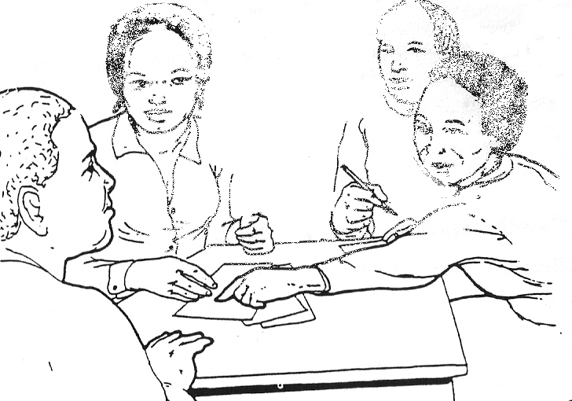
Keep a time log
Analyse the use of time
Implement the time
Review the plan

Keeping a time log

One of the most demanding parts of time-management is clarifying how you presently spend your time. For Task 7, try to keep a time-log or register of your time usage for the current week. This is part of the process of collecting information.

FEEDBACK

TASK 7 - Keeping a time-log

Keep a detailed log or record of how you spend your time in a typical week at work using five copies of the table below. Record your activities for every day of this week.

Then in the columns on the right, categorise the activities by labelling each column with your own categories and ticking the appropriate block for each activity. Here are some examples of possible categories you may want to use: delegating tasks; operational meetings; development planning activities; answering telephone enquiries; having tea and socialising.

This process of clustering activities in your job is very important. By grouping
activities into categories, you are able to see how you spend chunks of time rather than trying to think about a lot of different, short activities. Make five copies of this
Time Log for Task 7.
DAY e.g. day 1 Monday 15 June
Time |  | Activity | Categories of activities
 |  |  | Tel calls
07h30
07h45
08h00
08h15
08h30
08h45
09h00
09h15
09h30
09h45
09h45
10h00
10h15
10h30
10h45
11h00
11h15
11h30
11h45
12h00
12h15
12h30
12h45
13h00
13h15

13h30
13h45
14h00
14h15
14h30
14h45
15h00
15h15
15h30
15h45
16h00
16h15
16h30
16h45
17h00
17h15
17h30
17h45
18h00

FEEDBACK

People are often surprised by what they find when they keep a time-log. Have you learnt anything about your time usage? Have you noted any significant time- wasters in your days?

Analysing the Use of Time

You have already started to reflect on the way in which you use your time by deciding in which category of your work to record each activity. The next step involves reflecting systematically on your use of time at work.

TASK 8 – Analysing your use of time

This task provides guidelines for using your time-log to reflect systematically on your use of time at work. The feedback is integrated into each step of the process, so there is no separate feedback at the end. Take at least 25 minutes on this activity as it could in the end save you time.

… Stage 1:
On your time-log, highlight all the activities which fit into your roles as a manager.

Stage 2:

Now look at all the activities you have not highlighted and ask yourself why you spent time on them. Do you allow too many interruptions or are you perhaps doing work that others could do if you delegated more?

Most managers also find it useful to spend a few minutes at the start of each day trying to visualise how the day will flow and thinking about how they will handle the

events that are expected to happen.

It is important not to think that answering the phone and giving attention to people is poor use of time. It all depends on your job and role/s. If one of your main functions is to make sure that day-to-day services are delivered smoothly, you will have to

(Adapted from MESOL, 2000: 55-56).
Stage 3:
In relation to the main focus of your job, what things should you be doing more of?

To help you to think about this systematically, look back at the areas of work priority that you identified in Unit 1 Session 1.
Compare your time-log with these priorities in your work. If you spend every day carrying out mainly activities like those recorded in your time-log, will you be doing your job adequately, or will important things have been left out?
If some important things have been left out, you need to adjust the balance of your working day to put more emphasis on the work you should be doing. One way to do this is to use your diary as a planning tool, shaping the way you spend the day by committing time to particular categories of activity.

Stage 4:
Are you spending too much time on anything? If you think that you are spending too much time on some activities, think about why this is so.

If it is because you do not do them as well as you should and this causes delays, you may have identified a training need for yourself. If it is because you under-estimate the time needed for the activity, this is something you could learn from and improve your planning in the future.

Stage 5:
How much of your time was spent in responding to demands from others?

If you spend a great deal of your time making decisions on routine matters, consider whether you could delegate some tasks.

Stage 6:
How much of your time was spent dealing with unexpected urgent issues? All managers find that they have to attend to unexpected priorities from time to time, but even in a job in which much of your time is spent responding to demands, you can still plan your time. For example, you might be able to divide your plan for the day into things that must be completed today and things that must be done within the week. The things that do not have to be done today can be the ones that you replace with the unexpected tasks. However, you will have to review the weekly items carefully to make sure that they are not squeezed out completely by unexpected tasks.

Stage 7:
Look at one particular day. Did you complete the things you intended to do on that day?

Many managers … make a list of priorities for each day. This can help you to use your time to achieve your work objectives and is useful for reviewing your own progress. It also helps you not to forget anything important. Towards the end of the day, you can review the list and decide whether you will complete everything or whether you need to reschedule some of the work for another day.

Many managers find it useful to spend a few minutes at the start of each day trying to visualise how the day will flow and thinking about how they will handle the events that are expected to happen.

It is important not to think that answering the phone and giving attention to people is poor use of time. It all depends on your job and role/s. If one of your main functions is to make sure that day-to-day services are delivered smoothly, you will have to devote time to the people running or using the services. However, as a manager, you also need to be able to stand back from the front line and take an overview of the work …

(Adapted from MESOL, 2000: 55-56)

Implementing the time management plan

Time management often requires changes in work habits which may have become second nature to you. After reviewing your time management habits and style, think about the changes you need to implement.

Now that you have mapped out how you use your time, consider whether any of these strategies listed below could improve your management of time.

- Delegate work that others can do.
- Adjust the balance of your working day between immediate and long-term tasks.
- Develop your skills in some aspect of the job to make yourself more efficient.
- Plan and schedule your use of time more carefully.
- Use your diary as a planning tool to help you fit everything in.
- Plan your work in terms of tasks for the week and tasks for the day.
- Make a daily list and review it at the end of each day to check your progress.
- Start the day by visualising and mentally preparing for the main events.
(Adapted from MESOL, 2000: 57)

These strategies may be helpful, but what you really need to do is to plan your time differently, using these strategies to make your plan more effective.

Implement the Time Management Plan

This is the taking action or implementing phase of the time management strategy. Start by reading a broad overview of managing time in a community-based workplace. It includes a set of planning tools used for different purposes and includes a daily time diary, a monthly time schedule for a whole health unit, a week by week schedule for a health team, duty rosters and a timed programme plan. All these tools can be helpful, but for the moment, we are going to concentrate on your individual management of time, by doing Task 9.

READING

McMahon, R., Barton, E. & Piot, M. (1992). Ch 4 - Managing Time. On Being in Charge. Geneva: WHO: 195-208; Ch 2 - Implementing Health Activities. On Being in Charge. Geneva: WHO: 323-327.

TASK 9 – Developing and implementing a time management plan

Review your one week time log from Task 7, and then develop a Weekly Schedule for the week ahead on the template below, taking account of the time management strategies listed above. Implement it in the coming week, and make notes daily on your successes and challenges.

Prioritised Weekly Task List | Completed | WEEKLY SCHEDULE | Monday
 |  | Tuesday | Wednesday
 |  | Thursday | Friday
 |  | Saturday | Sunday

Review the Plan
Task 10 – Reviewing your plan

After two weeks of taking action to improve your use of time, ask yourself:
- What went well according to my plan?
- What could have gone better?
- What went badly wrong and why?
- How effective was the plan?

FEEDBACK

By comparing what actually happened with what you planned to do, and reflecting on it, you can learn more about your ways of managing time. If one approach did not work well, try something else. It is important to find an approach that works in your setting.

The process of reviewing your progress at intervals is called monitoring. After six months or a year, you may want to evaluate to what extent your time management has improved since you first implemented your plan. We will return to these concepts in later units.

In Task 9, we noted that one way of improving your time management is through appropriate delegation of tasks to other staff members. This is the third survival strategy for managers.

DELEGATING EFFECTIVELY

Delegation is a key skill for managers. In reflecting on your use of time, you may have realised that you could delegate more. Delegation is the art of giving work to your staff in such a way that they are accountable to you for it. Although you have overall responsibility for the work, effective delegation makes it possible to reach objectives as a team in less time and with less stress.

Perhaps you think that delegation is not appropriate in your situation or that it causes so much trouble that it is not worth trying. There are challenges associated with delegation, but there are also distinct advantages.

Advantages of delegation | Disadvantages of delegation
- Delegating some decision-making saves time for other duties.  - When work is spread over a large area, as in rural health work, the health workers on the spot must be able to | - A leader who does not delegate properly may end up very stressed because they cannot complete all the work; a leader may also pass all the

make decisions according to circumstances.  - Delegation of responsibility saves long delays that occur when awaiting decisions from a central office or other distant authorities.  - Health workers who are allowed to make decisions enjoy their work more and become more knowledgeable and skilful, i.e. It facilitates staff development. | work on to the team members, leaving very little for her or himself to do.  - A leader may delegate decisions to people with insufficient experience or without sufficient explanation.  - Some staff may make it difficult to delegate by resisting delegation and this can cause interpersonal stresses.
(Adapted from McMahon et al, 1992: 63)
TASK 11 – Reflecting critically on your own delegation experience

- Think of a situation where you successfully delegated a task to a staff member.
- Think of a situation where delegation led to problems.
- Write down possible reasons for the success and difficulty in each case.

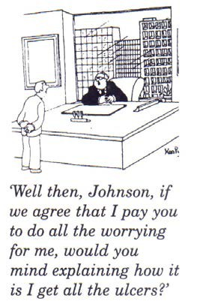
FEEDBACK

Some managers feel they must do everything themselves because they are ultimately responsible for the results. This is a misunderstanding of the nature of a manager’s job. Effective management must involve delegation of certain work and decisions. This means giving someone else the authority (and the necessary resources, including time) to do something on your behalf. You retain the overall responsibility for it, but develop methods for monitoring and getting feedback to satisfy yourself that the results are being achieved. It is the way in which delegation is done which determines its success.

There are a number of factors which make delegation successful:

- Deciding which tasks can be delegated.
- Deciding to whom a task can be delegated.
- Appropriate support.
- Appropriate monitoring.
- Delegating tasks at the right time.

We will now explore these key factors in delegation in more detail.

Deciding which Tasks can be Delegated

Here is Rose’s experience to which you might relate:
Eighteen months ago, I was appointed district programme manager of the HIV and TB programme for District X. For the first year I experienced severe stress because there were so many new activities that had to be initiated since the position had been vacant for several months. I received very little induction into my new role and little support was available. I felt I didn’t even have time to delegate, and I hardly knew my staff, so I didn’t feel particularly confident of their capacity … more especially as I did not know the tasks I was supposed to delegate very well myself.
Partly as a result of my stress level, I became very ill for three weeks. During that time members of my team were forced to take on the day-to-day management of the programme, to run scheduled workshops and weekly planning meetings, and to answer most queries that came to the office. This helped me to recognise their capacity and the potential of delegation. When I came back, I was able to discuss the issue with my staff and together we worked out a delegation plan. They were very understanding, but it took a crisis for me to realise that I had to let go of some things!

Robert Maddux (1990) has suggested that there are certain types of work that can often be delegated. His suggestions are summarised below.

TASK 12 - Reviewing opportunities for delegation in your own context

Study Maddux’s list and think about whether there are any delegation opportunities in your work situation.

TASKS WHICH COULD BE DELEGATED
Decisions you make most frequently | Minor decisions and repetitive routines often consume a major part of a manager’s day. Many of these can be delegated by teaching your staff the policies and procedures that apply. They may already know the details better than you do!
Functions that you are expert in | These are usually operational tasks rather than managerial functions. Your challenge as a manager is to guide and motivate others to produce better results than you ever did as an individual performer.
Tasks and projects for which you are least qualified | It is almost certain that some of your staff are better qualified and can do parts of the job better than you can. Let them!
Functions you dislike | Performing tasks we dislike means we often put them off or do them poorly. Examine the likes and dislike and the talents of your staff. Often you will find someone who likes the job and can do it well. If they need training, provide it.
Work that will provide experience for staff | A manager should be committed to building the capacity of others to perform new tasks and to take more responsibility. This makes growth in the job a reality and keeps staff challenged and motivated.
Assignments that will add | A change of pace is usually welcomed by staff and is often

variety to routine work | a good way to motivate those whose job is growing boring to them
Tasks that will increase the number of people who can perform critical assignments | Maximise the strength of your team by giving people the necessary experience to back one another up during emergencies or periods of unusually heavy work.
Tasks that provide opportunities to use and reinforce creative talents | Give staff some freedom and the opportunity to show initiative. Stimulate them with difficult problems and projects, and reward creative solutions.
(Adapted from MESOL, 2000: 59-60)
Often the process of delegation may seem too time-consuming to take on. However, if done appropriately, it can make you a much more effective manager of a more contented team.

Deciding to Whom a Task should be Delegated

… It is important to identify the most appropriate person for each delegated task, although sometimes it could be appropriate simply to identify someone who has the time and interest to take on something new. You might consider how the task links with a staff member’s other areas of work. There might be someone with the necessary skills who is interested in the area of work and who would welcome a chance to demonstrate his or her ability. Or there might be an opportunity to offer a challenge to someone who has become bored with routine work … (Adapted from MESOL, 2000: 61).

Delegation implies a level of trust in the person to whom you are delegating. Some people respond positively to the increased responsibility and the fact that you trust them to do it. It can be very motivating for them. However, others may feel that you are over-burdening them or may simply lack the confidence to accept additional responsibility. There is also the risk of delegating to the person who is least resistant, and who simply accepts more and more work: this can become a problem for that person. Here it is important for the manager to understand each staff member and their needs.

The Process of Delegation

Once you have identified the person to whom you will delegate the task, you need to do the following:

- Agree with the staff member on exactly what you expect and how you will measure how well the job is being done.
- Explain to other staff members that you have delegated certain tasks and to whom.
- Provide the staff member with the necessary resources for the job, including the relevant authority, training and time.
- Have regular follow-up sessions and provide support where necessary.

- Do not interfere unless asked to and be prepared to support the staff member if she or he makes some mistakes.

TASK 13 – Planning the delegation process

- Think about a task you would like to delegate in the future.
- Identify the person to whom you will delegate.
- Identify who else needs to be informed.
- Write down exactly what you expect from the person to whom you will delegate.
- Write down how you will monitor the job.
- List the resources they will need to perform the task.

Effective delegation is an essential part of effective management. Thinking through the process of delegation in a systematic way will help you to delegate the right tasks to the right people and to provide the right kind of support.

FEEDBACK

It is important to remember that you, the manager, remain responsible for the delegated task. However, your role becomes one of support and systematic monitoring, rather than that of a policeman or a strict school teacher! Remember that one of your responsibilities as a manager is to develop your staff so that they are able to perform delegated tasks effectively and without constant supervision.

SESSION SUMMARY

This session has highlighted a few issues that you will face as a manager. You will inevitably encounter stress in your job, but it is possible to find ways of reducing stress, both for yourself and for others.

Managing time effectively is one of the most important skills a manager should develop. Poor time management all too commonly leads to stress. Analysing the way you are using your time now and planning how you will use your time in the future are both important aspects of developing time management skills.

Delegation is also an essential element of management. It is a strategy for managing your time: it gives you more time for other activities. It is also an important means through which you can develop the capacity of your staff. However, when you delegate, you need to select the right person for the job, make your expectations absolutely clear and anticipate how you will support and follow up with the staff member. Remember that the final responsibility still remains with you. Having explored some aspects of managing yourself, we will move on to look at further skills and issues relevant to managing people.

REFERENCES

- Maddux, R.B. (1990). Delegating for Results. London: Kogan Page.
- MESOL. (Management Education Scheme for Open Learning): The Open University. (2000). Keeping a time-log. Managing in Health and Social Care, Module 1 Resource File. Milton Keynes: Walton Hall.

Unit 2 - Study Session 2 Motivation

Introduction

It has been said that engendering motivation in others is the key to management, an idea which is articulated by the CEO of a successful Australian company, Garry Ridge:

…Too many people go into management without seeing the difference a motivated team or individual can make in closing the gap between where they are and where they could be. People need … a progressive opportunity to make a difference.
When they become passionate about making a difference, they get caught up in creating a desired future …
(Ridge, 2001: 222).

This session looks at motivation, and why people are willing to work harder in some circumstances than in others. We examine what we know about the factors that motivate people and those that demotivate them, recognising that these factors may differ from person to person.

As a manager, you have considerable influence over some of the circumstances that affect people’s motivation, such as developing their jobs so that they are more satisfying. During this session, we will explore how you, as a manager, can help people both to satisfy their own needs and to meet the needs of the organisation.

Session Contents

- Learning outcomes of this session
- Readings and references
- What is motivation?
- The needs of an individual
- Job dissatisfaction and motivation
- Session summary

Timing of this Session
There are three tasks and two readings in this session. It should take you about an hour and a half. A logical point for a break would be at the end of section 4.

LEARNING OUTCOMES OF THIS SESSION

By the end of this session, you should be able to:
Management outcomes:  - Define motivation.  - Apply Maslow’s model to an individual in the workplace.  - Critically analyse main motivating factors at work.  - Identify common causes of dissatisfaction at work. | Academic outcomes:  - Apply concepts to familiar contexts.  - Reflect on your own experiences and analyse them.  - Propose solutions to problems using a set of guidelines.

  - READINGS

There are two sources of readings in this session. You will be referred to them in the session as they are needed.

Publication details
WHO. (World Health Organisation). (1993). Training Manual on Management of Human Resources for Health, Section 1, Part A, Annex 3 - Motivation. Geneva: 1-8.
McMahon, R., Barton, E., Piot, M. (1992). Ch 2 - Leading a Health Team. On Being in Charge. Geneva: WHO: 58-63.

WHAT IS MOTIVATION?
Consider for a moment – are you motivated in your job? And if you are, what motivates you? If you’re not, can you identify what you find demotivating? Use the spider diagram below to work out your ideas.

What motivates me?
Motivation in the workplace
What demotivates me?

Motivation is a commonly used word in everyday speech, but what does it mean in the workplace?

Motivation is:
- An inner impulse that induces a person to act in a certain way; a series of internal drives within a person at different levels (McMahon et al, 1992: 58).
- The psychological drives or forces that cause people to behave in a particular way: to work well and hard, to persist and overcome obstacles, to be enthusiastic about their work (MESOL, 2000: 21).

Part of your job as manager is to get others to work well but also to be a model for them, by working well yourself. To be able to do this, you need to understand the factors that motivate and demotivate people in the workplace.

THE NEEDS OF AN INDIVIDUAL

The first reading in this session explores the forces that motivate individuals; it relates a model, or theory - Maslow’s hierarchy of needs - to working life.
Furthermore, the reading explores how needs and motivation change across the lifespan and in relation to gender and life circumstances.

READING

WHO. (World Health Organisation). (1993). Training Manual on Management of Human Resources for Health, Section 1, Part A, Annex 3 - Motivation. Geneva: 1-8.

Before you start reading, remember that it is always helpful to read texts with questions in mind, in order that you are actively searching for answers while you read. This increases your alertness and concentration and promotes integration of new ideas with existing knowledge. Explore this reading with the following questions in mind and then do Task 1.

- According to the authors, what individual needs affect our motivation in the workplace?
- Do the authors see the differences in women’s and men’s needs (in the workplace) as mainly physiological or social? What do you think and why?
- Which of our individual needs do they say are best met in the workplace?
- According to the authors, in what ways can employers give recognition to employees?
- Why do the authors believe that motivation in a job is important?

TASK 1 – Analyse whether your job meets your individual needs

The reading presents a framework or model of needs experienced in the workplace. Use it to analyse your own job.
- Study Figure 1, Individual Needs on page 2 of the reading. Which of the needs listed here do you feel are met by your job? Write brief notes describing how each need has been met.
- Now list your unmet needs. What do you think your employer or supervisor could do to help with some of your unmet needs at work?
- Are there any needs which your job cannot realistically fulfil? Why not?

FEEDBACK

For guidance, here is an answer from Daniel, a recently-graduated junior pharmacy technician, working as a storekeeper in Tayo’s hospital dispensary warehouse.

- Physiological needs:

My salary is low, but it allows me to rent a place to stay, to buy enough food and clothing for myself and also to send some money back home to help my parents and younger siblings.

Safety needs:

I think it is usually very difficult to fire a government employee, so at least I feel my job is quite secure!

Social needs:

My co-worker Karriem, who is in charge of the warehouse for medical supplies and equipment, is a good friend to me. We help each other and laugh together.

- Self-esteem needs:

In the workplace my status is low. I don’t feel that junior staff like Karriem and me are respected. Sometimes field staff from the clinics and hospitals will come at any time and demand that we supply them immediately, even if we had planned other work. This disrupts our job: if we don’t get time to keep the store well organised and maintain our stock cards, we will lose track of what we have and the drug management system will become chaotic. Our supervisor is harsh. He doesn’t understand the pressures we must face with all the different people making demands. He doesn’t stand up for us. Even if we are trying our best, we receive no praise, only criticism.

Self realisation:

I don’t think there is much opportunity for self-realisation in this job. Because I don’t have a degree qualification, there is not much hope of advancement and storekeepers never seem to get sent on any training courses. It seems that only the senior people get such opportunities. I want to learn computer skills but I have

no access to a computer at work, so now I am studying in the evenings. As soon as I have completed the course, I am going to look for a different job.

- In terms of the needs which the job cannot fulfil, Daniel said:

I wish my supervisor would make a proper schedule for field staff to come and collect drugs and then insist that they follow it. Then we could organise our work and keep the store in good order. If someone would only occasionally recognise some of the things we do well, it would make us want to work even harder.

My salary is very low, but I know that this is a government job and I can’t expect to earn as much as someone working in the private sector.

JOB DISSATISFACTION AND MOTIVATION

You are no doubt aware that loss of personnel from the health services is a major area of concern in the health sector. The reasons for staff attrition include job dissatisfaction over a wide range of issues, amongst them low salaries, limited opportunities for advancement and stress arising from increased workload in the era of HIV/AIDS.

The role of the manager is importantly to address dissatisfaction and turn it into motivation. To do so, you need to analyse and understand potential sources of demotivation. In the last reading (WHO, 1993), the implications for an organisation meeting an individual’s needs were listed on page 7.

Some ways of countering job-dissatisfaction may be beyond your immediate control as a manager such as “… providing the best financial rewards …” (WHO, 1993: 7). On the other hand, research shows that financial and nonfinancial incentives have a significant impact on motivation (MSH, 2010). A list of possible incentives reaching beyond financial gains is presented below, and comes from MSH’s (Management Sciences for Health) recently published handbook (2010) Health Systems in Action.

Another tool which they have included in their manual is a survey of Employee Satisfaction. Here the questions are based on their understanding of what factors are key to motivation – fairness of salaries, clarity of role, feedback and respect from one’s supervisor, affirmation, support and opportunities for growth. The survey is also included below.

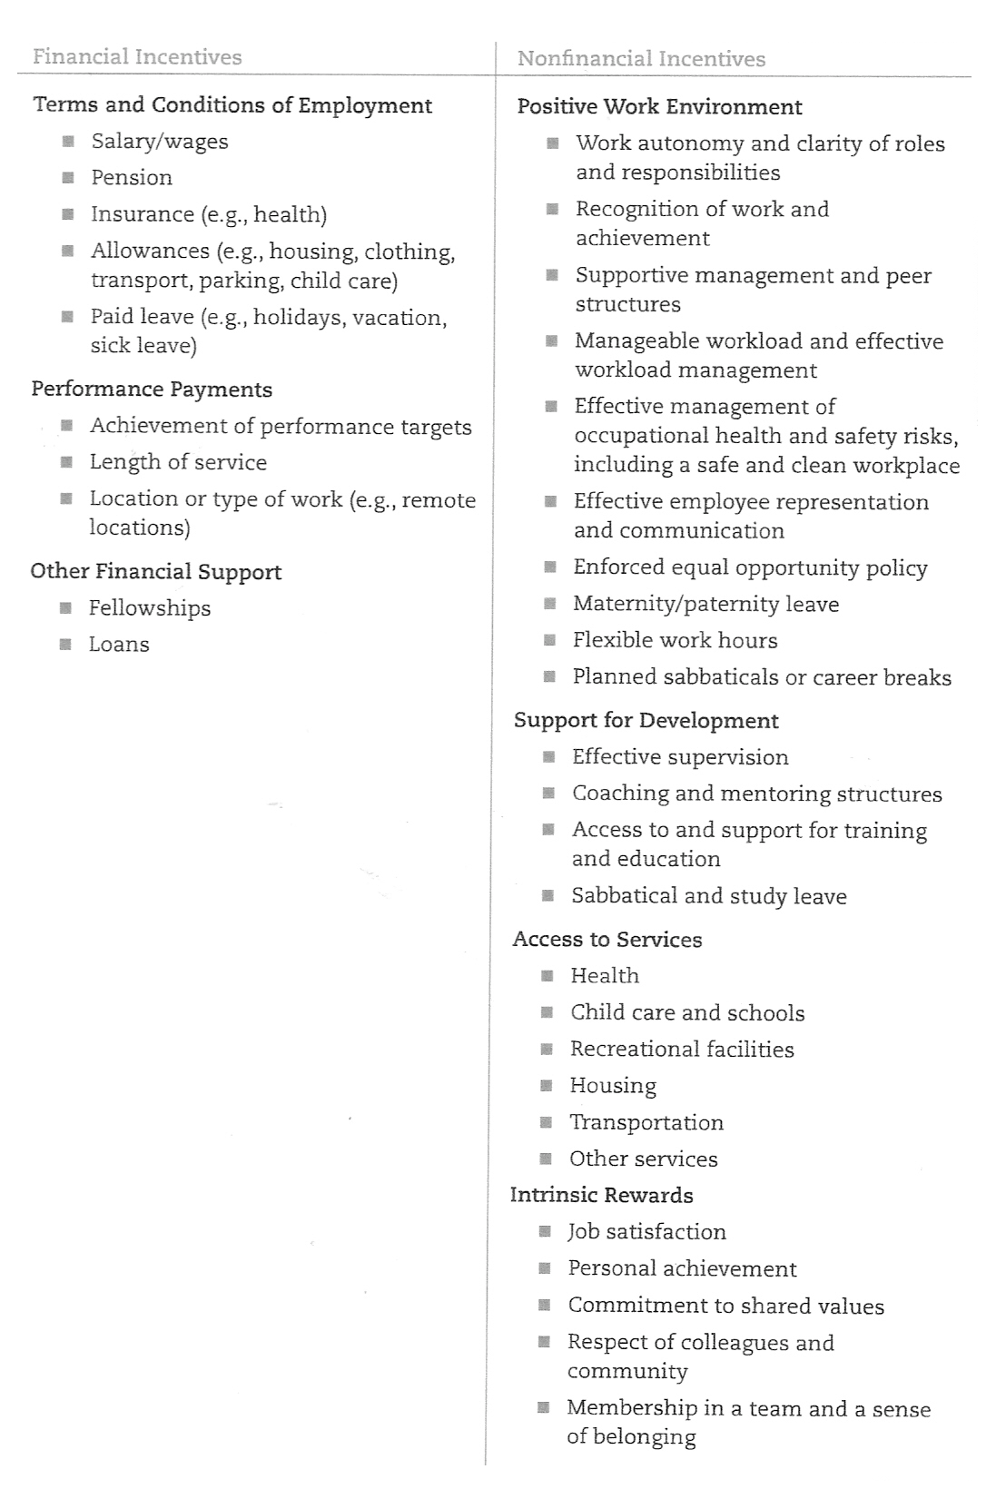TYPES OF INCENTIVES

Source: Global Health Work Alliance/WHO, 2008: 12 published in MSH, 2010: 5.14)

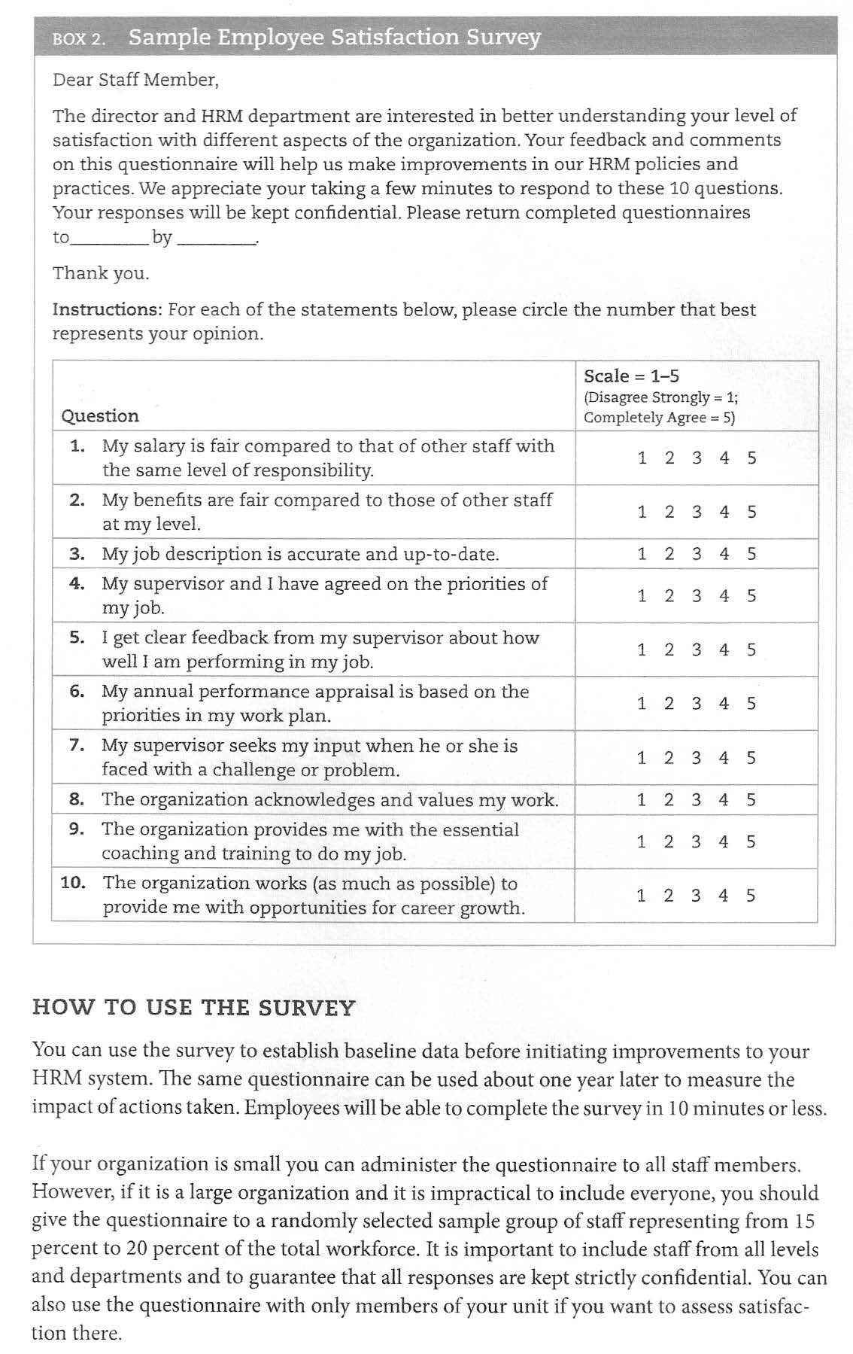

(MSH, 2010: 5:16)

In the next reading, McMahon et al (1992) highlight a number of sources of dissatisfaction which are within a manager’s control. Read pages 61-63 and note the six causes of job dissatisfaction which the writers identify. Then do Task 2.
READING

McMahon, R., Barton, E., Piot, M. (1992). Ch 2 - Leading a Health Team. On Being in Charge. Geneva: WHO: 58-63.
TASK 2 – Identifying causes of job dissatisfaction

- Study the six common causes of dissatisfaction described in McMahon (1992). Are you experiencing any of these frustrations in your job at present?
- Are you aware of any of the staff you manage being dissatisfied? If so, can you speculate on what the causes could be?

FEEDBACK

Although you may have identified other causes of dissatisfaction in your own workplace, we have provided a summary of Daniel’s frustrations as an example for clarification, using the causes of dissatisfaction discussed in the McMahon et al (1992) reading:

- Inefficient administration: There is a lack of schedule for collecting drugs and medical supplies.
- Poor personal relations: There is tension with field staff and harsh criticism from the supervisor.
- Poor leadership qualities: There is unfair treatment by the supervisor and no support in dealing with unreasonable demands from field staff.
- Bad working conditions: The lack of a proper schedule means that it is very difficult to work in an organised and satisfying way.

In situations of dissatisfaction, there is a high likelihood of staff looking for another job, becoming less effective or conflict developing in the workplace. Conversely, there are also substantial gains to be made, not just by removing the causes of dissatisfaction, but by developing a motivated team.

It is therefore extremely important for the manager to do what she can to address those sources of dissatisfaction which are within her capabilities. However, even when staff appear satisfied, managers waste opportunities if they do not seek ways to motivate staff to become passionate about their work. This is your challenge in the next task.

TASK 3 – Finding ways of motivating your staff

Using McMahon et al’s suggestions in the previous reading for “Motivating team members” (pp58-61), the list of possible incentives above and your own ideas, what could you do to improve your own staff’s situation?

FEEDBACK

Daniel’s supervisor could do the following:

- Help him to achieve his objectives by setting up a time-table for collecting drugs.
- Praise him for good work and also let field staff know that he is a competent and valued employee whose work schedule should be respected.
- Emphasise to him that although the work is sometimes difficult and people are trying to push him around, his job is very important. Through managing the drug warehouse well, he is making an important contribution to health service provision in the district.
- Lobby for training opportunities for junior staff.
- Encourage Daniel’s interest in computers by arranging for him to sometimes practise on one of the office computers.

SESSION SUMMARY

The factors influencing motivation are complex. People have different needs, because they have different perceptions of reality, different values and different goals. There is no single formula that can be used to stimulate motivation.
However, all staff have important needs in common which employers or managers can help to satisfy. As a manager, you may not be in a position to address all the needs of your staff. However, it is important that you make the effort to understand the needs of your staff and to address those issues over which you do have influence.

During this session we looked at factors influencing motivation in the workplace. We noted that poor leadership contributed to job dissatisfaction. In the next session, we will explore the process of developing teams.

REFERENCES

- Management Education Scheme by Open Learning (MESOL), The Open University. (2000). Managing in Health and Social Care. Module 2 Book 1. Milton Keynes: Walton Hall.
- MSH (Management Sciences for Health). (2010). Health Systems in Action: An eHandbook for Leaders and Managers. Cambridge, MA: Management Sciences for Health, 2010. [Available] Online at http://www.msh.org/resource-center/health- systems-in-action.cfm [Downloaded 25 May 2010].
- McMahon, R., Barton, E., Piot, M. (1992). Chapter 2 - Leading a Health Team. On Being in Charge. Geneva: WHO.
- Ridge, G. (2001). In Cook, C. & Hunsaker, P. Management and Organizational Behavior. Boston: McGraw-Hill/Irwin.
- World Health Organisation. (1993). Training Manual on Management of Human Resources for Health, Part A, Annex 3 - Motivation. Geneva: WHO.

Unit 2 - Study Session 3
Developing and Leading Teams

Introduction
Session 3 falls within the broad theme of Unit 2, “managing people” and the interpersonal role of the manager. In this session, however, we expand the definition of management to include leadership; we ask you to think of how these concepts relate to each other and how these roles can be integrated to strengthen health systems development. We then link the concept of leadership to team development and explore the role of the leader/manager in this process.

To get you thinking, consider this statement and decide whether you agree with it and why:
Leading and managing are behaviors which can be changed rather than personality characteristics which generally cannot be changed (MSH, 2010: 2.9).

Your opinion is valid as long as you can justify it, but we hope that by the end of the session, you will agree that leadership characteristics can be developed and strengthened just like management capacity!

Session Contents
- Learning outcomes of this session
- Readings
- Defining leadership
- Integrating leadership practices into managing
- How teams develop
- Matching leadership style to a team’s development
- Session summary
- References

Timing of this Session
This study session involves two readings and four tasks. The book is written in dialogue, so it is light to read, but very informative on issues of effective management. Allow about two hours for the session.

LEARNING OUTCOMES OF THIS SESSION

By the end of this session, you should be able to:
Management outcomes:  - Examine the integration of leadership into your own management practices.  - Discuss the value of teamwork in the health services.  - Compare models of team development.  - Discuss management styles appropriate to the stages of team development. | Academic outcomes:  - Develop and critique definitions.  - Compare models.  - Summarise information.

In this session we have looked at the practices of leadership and how they can and should be integrated with management practices. We have also considered the benefits and challenges of working in teams; we have compared two models of the development stages that teams go through on the road to effective performance. We also examined the ways in which a leader can help the team to progress by using different leadership styles and behaviours related to the development stage of the team.

READINGS

There are two readings for this session.

Publication details
Vriesendorp, S. MSH (Management Sciences for Health). (2010). Ch 2 - Leading and Managing: Critical Competencies for Health System Strengthening. Health Systems in Action: An eHandbook for Leaders and Managers. Cambridge, MA: Management Sciences for Health, 2010. [Available] Online at http://www.msh.org/resource- center/health-systems-in-action.cfm [Downloaded 25 May 2010]: 2.2 – 2.13.
Blanchard, K. (1994). The One Minute Manager Builds High Performing Teams.
London: Harper Collins.

DEFINING LEADERSHIP

We have already explored the meaning of management and defined it as “getting things done through people”. So what do you understand by “leadership”?

- Some people say that management and leadership are the same thing.
- Some say management is part of leadership.
- Some say leadership is part of management.
- Some say leadership and management are two completely separate things.

Task 1 – Distinguishing management and leadership
Before reading on, define for yourself how management differs from leadership, and what they have in common.
Management | What they have in common | Leadership

FEEDBACK
The World Health Organisation brings the two concepts into relationship when they give the following definition of leadership in the managerial context:
“Leadership is the capacity to secure the willing support of people in the achievement of the organisation’s worthwhile goals” (WHO,1993: 3)

Defining leadership
The MSH (2010: 2.2)
manual defines managing “… as planning and using resources efficiently to produce intended results … [whereas they] … define ‘leading’ as mobilizing others to envision and realize a better future.
Handy offers an interesting alternative view by saying:
“A manager is someone who does things right; a leader is someone who does the right thing” (Handy, 1993:115 )

On the other hand, MSH sees these two capacities as complementary “…each working toward a common goal but contributing in ways that the other does not” (MSH, 2010: 2.6). However you have defined leadership, keep an open mind and see what you think by the end of the session.

INTEGRATING LEADERSHIP PRACTICES INTO MANAGING

The MSH manual Health Systems in Action (2010) which we have already introduced in Unit 1 views management and leadership as integrated skills and challenges one to become “a manager who leads” (MSH, 2010: 2.2). They place the emphasis on the capacity of managers who lead to strengthen health systems. In your Reader you have an extract of Chapter 2 from this manual.
Remember that you can download the whole manual. Using this extract do Task 2.

5 HOW TEAMS DEVELOP

READING

Vriesendorp, S. MSH (Management Sciences for Health) (2010). Ch 2 – Leading and Managing: Critical Competencies for Health Systems Strengthening. Health Systems in Action: An eHandbook for Leaders and Managers. Cambridge, MA: Management Sciences for Health: 2.1-2.13. [Online], Available:http://www.msh.org/resource-center/health-systems-in-action.cfm [Downloaded: 10/5/10].

TASK 2 – Evaluating your own leadership practices

- Review the comparison of practices of managers and leaders and try to relate them to your own role. Identify which of the leadership roles you are comfortable with playing, and which you will need to work at.
- What does the author suggest as the consequences of managing without leading? Are you at risk?
- Think of someone whose leadership/management qualities you really admire in the workplace (past or present): which of the practices in the MSH manual are clearly evident in this person?
- Identify a management activity in which you are presently engaged. How have you, or could you integrate leadership practices into the process?

FEEDBACK

- What I found interesting about the MSH characterization of leadership practices is that they are quite abstract, e.g. scanning, but at the same time essential to the progress of the organization. They serve to integrate the organisation with its vision, and the staff with the organisation. The resultant outcomes are a state of forward-looking and well-being, rather than concrete outputs, e.g. Managers have up-to-date, valid knowledge of their clients, and the organization and its context; they know how their behavior affects others (MSH, 2010: 2.8).
- They liken the manager who does not lead to a mouse on a treadmill – Concentrating only on managing, you lose track of the vision, the changing environment, and the need to prepare for the future. If you lead well, you will increase the energy and commitment of your team and gain the support of the stakeholders who are so critical to success (MSH, 2010: 2.7).

- Strangely enough I noted that the qualities I admire most in managers I have known are their leadership qualities: the management attributes are necessary, but do not really inspire admiration.
- Here is the example from the MSH manual: how does yours compare? “You articulate a particular challenge, such as reaching more couples with family planning services, by engaging in scanning, focusing, and planning. You produce results by aligning, mobilizing, organizing, and implementing” (MSH, 2010: 2.7).

This has been a brief introduction to the practices of leadership: we are now going to focus in on one aspect of leadership – team development, as this is particularly important in the health and district health setting.

HOW TEAMS DEVELOP

In many work situations, people work individualistically, often in competition with one another. Essentially people are motivated by achieving benefits for themselves and hopefully also those they serve. However, in order to develop effective health systems, teamwork is essential.

… So much of human activity is co-operative. Co-operation is at the heart of all economic systems: members of the same company [or organization] have to work together to achieve their mutual goals (Brombacher & Gibbon, c1997: 1).

Leading teams is thus a key aspect of a manager’s job, where the job is to guide the group through the process of developing into a productive team. A team is more than a group … It is a group with a sense of common purpose which can only be achieved though collaboration, co-operation, and co-ordination of their activities.

Have you ever been part of a team and noticed it changing over time? This is the process of development which is common to any team. In this section, we look at two models of this development process. You are referred to Blanchard’s The One Minute Manager (1994) and asked to read page 6-77 bearing the questions in Task 3 in mind; don’t be alarmed by the number of pages, it’s is a small book and it is written in a conversational tone.

READING

Blanchard, K. (1994). The One Minute Manager Builds High Performing Teams. London: Harper Collins: 6-77.
TASK 3 – Stages in the development of teams
a)
b)
List the four stages of team development in Blanchard’s model.
Review pages 41 - 45. Are elements of this situation of tension in the team and Dan’s feelings familiar to you?

FEEDBACK

- The One Minute Manager describes the stages of group development as follows:
  - Orientation (stage 1)
  - Dissatisfaction (stage 2)
  - Resolution (stage 3)
  - Production (stage 4)

- The team that Dan observes has reached what is called Stage 2 in their development. The One Minute Manager describes the characteristics of this stage on page 46 and regards it as a productive stage although the team members may seem frustrated.

5.1 A Model of Team Development

Critically reviewing a theory of how teams are formed is helpful to the team leader because this enables one to support and nurture positive developments, and to understand what is potentially going on when tensions arise. The leader can also modify his or her behaviour to suit the stage of the team’s development. This is elaborated on page 107 of Blanchard (1994) and discussed towards the end of this session. Cook and Hunsaker (2001: 344) attribute different names to these four stages of team development which are illustrated below.

FORMING
Awareness:
Commitment
Acceptance
STORMING
Conflict:
Clarification
Belonging
NORMING
Cooperation:
Involvement
Support
PERFORMING
Productivity:
Achievement
Pride
ADJOURNING
Separation:
Recognition
Satisfaction

Fig 1: Group Formation (Cook and Hunsaker, 2001: 344)

Here is further explanation of this model.

… Forming

In a newly formed team a lot of uncertainties exist about the team’s purpose, structure and leadership. Teams are concerned about exploring friendship and task potentials. They don’t have a strategy for addressing the team’s task. They don’t know yet what behaviors are acceptable as they try to determine how to satisfy needs for acceptance and personal goal satisfaction. As awareness increases, this stage of team development is completed when members accept themselves as a team and commit to team goals.

Storming

The next stage involves intragroup conflict about the clarification of roles and behavioral expectations. Disagreement is inevitable as members attempt to decide on task procedures, role assignments, ways of relating, and power allocations. One objective at this stage is to resolve the conflicts about power and task structure. Another is to work through the accompanying hostility and replace it with a sense of acceptance and belonging that is necessary to progress to the next stage.

Norming

Co-operation is the theme of the norming stage, which involves the objectives of promoting open communication and increasing cohesion as members establish a common set of behavioral expectations. Members agree on a structure that divides work tasks, provides leadership, and allocates other roles. Desired outcomes for this stage of team development are increased member involvement and mutual support as team harmony emerges. If teams become too contented however, they can get stalled at this stage because they do not want to create conflict or challenge established ways of doing things.

Performing

In this stage of development, team members are no longer conflicted about acceptance and how to relate to each other. Now members work interdependently to solve problems and are committed to the team’s mission. Productivity is at its peak. Desired outcomes are achievement and pride, and major concerns include preventing loss of enthusiasm and sustaining momentum. For permanent work teams, this is hopefully the final and ongoing stage of development.

Adjourning

The adjournment or separation phase occurs when temporary teams like task forces and committees disband after they have accomplished their goals. Feelings about disbanding range from sadness and depression at the loss of friendship to happiness and fulfillment due to what has been achieved. The leader can facilitate positive closure at this stage by recognizing and rewarding team performance …

Team building is not without its challenges however, and below is a
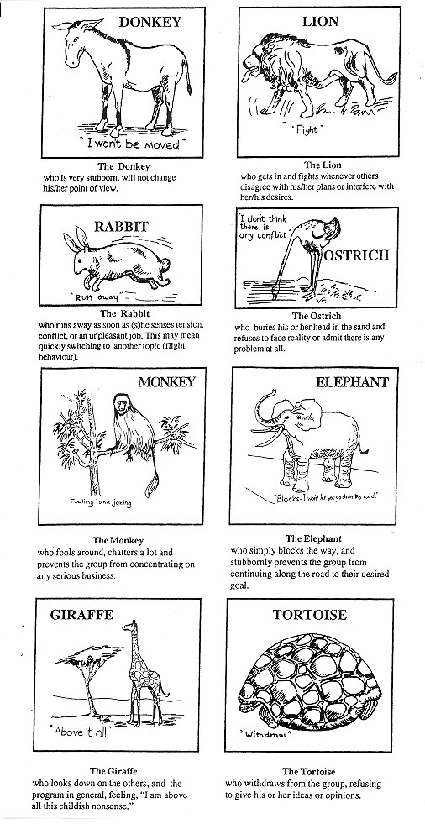playful illustration of common behaviours experienced in groups some of which can be quite disruptive to the process of team-building. It is the team leader’s responsibility to manage disruptive team members and to work towards their “norming” or owning the team’s common purpose to the point where they will also co-operate.

Fig 2: Some Common Behaviours of Group Members (Hope & Timmel, 2001: 73-74).

MATCHING LEADERSHIP STYLE TO A TEAM’S DEVELOPMENT

We have seen that according to the models described above, teams go through a series of stages during their time together. Whichever model you choose to apply in your workplace, there are likely to be distinct stages in the life cycle of team development. The key question here is how should a team leader respond to these stages? It is helpful to recognize how you should be behaving towards the team during these stages – for example – how directive should you be when they are “storming”?
TASK 4 – Match leadership style to stage of development of a team
- The table below has Blanchard’s stages of development recorded in the left column; write the matching stages of team development from Hunsaker and Cook (2001) in the middle column.
- Now fill in the appropriate leadership styles discussed by Blanchard for each stage of development. See page 86 of The One Minute Manager. Make sure you are clear on the rationale for each of these leadership styles at each of the stages.
- Finally add in Blanchard’s suggested appropriate leadership behaviours for each stage of team development.
Blanchard (1994) notes that the role of the team leader or manager is to educate and develop the team to the point when team members are able to take responsibility and perform tasks without constant supervision by the manager.

Four leadership styles used in the four different stages of team development

Team Development Stage – Blanchard (1994) | Team Development Stage - Cook & Hunsaker (2001) | Appropriate Style of Leadership | Leadership behaviour
Orientation
Dissatisfaction
Resolution
Production

FEEDBACK
Four leadership styles used in the four different stages of team development

Team Development Stage – Blanchard (1994) | Team Development Stage - Cook & Hunsaker (2001) | Appropriate Style of Leadership | Leadership behaviour
Orientation | Forming | Directing | Highly directive; low support
Dissatisfaction | Storming | Coaching | Highly directive; highly supportive
Resolution | Norming | Supporting | Highly supportive; low directive behaviour
Production | Performing | Delegating | Low support and low directive behavior
 | Adjourning

In other words, leadership style is dependent on the stage of development of the team. For example, when the team is storming (or dissatisfied), the leader needs to be both strongly directive and supportive to sustain the group.

SESSION SUMMARY

… Maria found that becoming an effective team leader was exciting, challenging, but not simple. It took time, persistence and commitment on her part. Being a good team leader was much harder than being an autocratic leader. She learned that when you want to empower people, it is exhausting to get them ready to share responsibility … It’s not for the faint-hearted, but the results are worth it … (Blanchard, 1994: 108)

In this session we have looked at the practices of leadership and how they can and should be integrated with management practices. We have also considered the benefits and challenges of working in teams; we have compared two models of the development stages that teams go through on the road to effective performance. We also examined the ways in which a leader can help the team to progress by using different leadership styles and behaviours related to the development stage of the team.

Although working with a team may sometimes be difficult and tiring, it is worth remembering that “… none of us is as smart as all of us …” says Blanchard (1994: 25).

7 REFERENCES

- Brombacher, A. & Gibbon, J. (c1997). Co-operative Learning: Potential and Implications. Undated paper distributed at a trainers workshop in Cape Town.
- Cook, C. & Hunsaker, P. (2001). Management and Organizational Behavior. Boston: Mcgraw-Hill/Irwin.
- Handy, C. (1999). Understanding Organisations. London: Penguin Books.
- Hope, A. & Timmel, S. (2001). Training for Transformation, Book 2. London: ITDG Publishing.
- MSH (Management Sciences for Health). (2010). Ch 2 - Leading and Managing: Critical Competencies for Health System Strengthening. Health Systems in Action: An eHandbook for Leaders and Managers. Cambridge, MA: Management Sciences for Health, 2010. [Available] Online at http://www.msh.org/resource-center/health- systems-in-action.cfm [Downloaded 25 May 2010].
- World Health Organisation. (1993). Training Manual on Management of Human Resources for Health, Part A, Annex 3 - “Motivation”. Geneva: WHO.

Unit 2 - Study Session 4 Managing Conflict

Introduction
Conflict may occur if the expectations that one person brings to a situation are not matched by those of the others involved … (MESOL, 2000: 47).

Conflict is neither bad nor unusual in organisations. On the contrary: one should not assume that co-operation is always normal, healthy and proper and that conflict and opposition are pathological, deviant or aberrant. It is also a mistake to assume that conflict arises because those in opposition are wrong, misled, confused or psychologically disturbed. Furthermore, those who disagree may have views which are as reasonable and rational as ours. Conflict and co- operation are both present in teams and organisations, like other social institutions such as families and leisure groups, and often at the same time.

Conflict is normal and can be healthy; it can be useful for improving understanding and generating new ideas. However, conflict can also be painful and destructive and result in waste of time and resources. The challenge for a manager is to be able to recognise the symptoms of conflict and respond to them appropriately. A manager needs to acknowledge the differences between people and channel them in ways that result in positive outcomes for the parties involved as well as for the organisation.

In this session we look at symptoms and sources of conflict in the work situation and at some strategies for managing conflict. We have included several academic activities to help you improve your strategic readings skills. You may wish to start by studying the reading by Jones, Pierce and Hunter which introduces you to an advanced kind of mind-mapping: it is helpful both in reading actively and in recalling important information later for an assignment or exam. This session is relevant to your first assignment, so make yourself aware of the requirements and note relevant parts of it while you study.

Session Contents
- Learning outcomes of this session
- Readings
- What is conflict?
- Sources of conflict
- Managing conflict
- Managing disciplinary and grievances procedures
- Session summary
- References

Timing of this session
This session contains one main reading which is divided into four parts and an academic skills text which can be read at any stage of the session. There are three other short readings. There are nine activities in this session. It is likely to take you at least three hours.

LEARNING OUTCOMES OF THIS SESSION

By the end of this session, you should be able to:
Management outcomes:  - Define conflict.  - Demonstrate familiarity with a range of sources and symptoms of conflict.  - Evaluate your own conflict management skills.  - Apply the collaborative approach to handling conflict.  - Develop a presentation on the disciplinary and grievance procedures in your organisation. | Academic outcomes:  - Develop a range of concepts and categories and apply them.  - Use previewing strategies to read more strategically.  - Select information from a text.  - Develop graphic representations of the contents of a text.

- READINGS

Publication details
Whetten, D. A. & Cameron, K.S. (2005). Ch 7 – Managing Conflict. Developing Management Skills. New Jersey: Pearson/Prentice Hall: 345-352; 352-360; 360-370;
371-373.
Jones, B., Pierce, J. & Hunter, B. (Dec 1988/Jan 1989). “Teaching Students to Construct Graphic Representations”. Educational Leadership: 20-25.
Health Manpower Development Staff. (1982). Health Center Operations. The Medex Primary Health Care Series. Hawaii: John Burns School of Medicine, University of Hawaii: 106-110.
WHO. (1993). Problem-solving. Training Manual on Management of Human Resources for Health, Section 1 Part B. Geneva: WHO: 5-7.
Pillay, Y., Mzimba, M. & Barron, P. (Eds). (1998). Handbook for District Managers.
Pretoria: Dept of Health: 93-95.

- WHAT IS CONFLICT?

Defining Conflict

What do you understand by the word conflict and how do you feel about it as a manager?

Conflict can be defined as:
“… a struggle between opposing interests, principles, values, or feelings …” (MESOL, 2000: 48).

This definition is very generalised. To clarify your understanding, apply the definition to your workplace by identifying some opposing interests that could lead to conflict: think of a principle over which people might disagree, e.g. whether staff should get time off for their studies. Alternatively identify some diverse values which could cause conflict, e.g. women’s right to choice in relation to abortion, or some feelings which could cause conflict e.g. support for a new manager who is a woman. These situations could result in very different kinds of conflict.

… People’s feelings and values may coincide over a wide range of issues, and yet they may find themselves in conflict over whether one department or another should have access to certain resources. This would be a conflict of interest.
Alternately, two people may have no actual conflict of interest, but they may nevertheless clash because one happens to say something, knowingly or not, which offends the other’s feelings.

There is also the possibility that a conflict may arise ‘by mistake’, through misunderstanding of each other. One person may think that a colleague has certain values or feelings e.g. that they are racist, or that they are being obstructive.
However, they could be mistaken in their assessment. They could be making assumptions on the basis of a stereotype, for example, ‘The finance people can never understand the nursing staff’s difficulties’ or ‘All white people think they are superior’. Alternately, an incorrect assessment of a normally very polite person could be made if they behave in an uncharacteristically rude way during a time of severe stress … (Adapted from MESOL, 2000: 48).

The possibility of a true misunderstanding is always worth bearing in mind in situations of conflict.

Symptoms of Conflict

… Conflict does not always manifest itself in overt strife, battles round the meeting table or ‘blood on the carpet’. The bitterest conflicts are sometimes conducted with perfect manners, perhaps without the underlying cause ever being mentioned … (Adapted from MESOL, 2000: 49) This can be quite confusing for the people involved and those around them.

How can you as a manager tell when conflict has arisen or whether it is likely to surface in the future?

TASK 1 – Identifying the symptoms of conflict
From your own experience, what kinds of behaviour among your staff would alert you to the possibility of conflict among them?

FEEDBACK
… A useful way of thinking about the symptoms of conflict is to categorise them as either ‘hot’ or ‘cold’. ‘Cold’ conflict often creates an atmosphere of false cheerfulness … In other words, the person who is angry or upset tries to hide their tension by behaving in socially acceptable ways which are not really appropriate to the situation. [For example, even if someone is very upset with you, on the surface they may behave as though nothing is wrong. You need to be aware of this sort of behaviour in order to pick it up.] The person who is upset is often too unsure or too angry to risk expressing their feelings for fear of the consequences. ‘Hot’ conflict, on the other hand, may be [much more] apparent. It reveals itself in outbursts of feeling and actions which leave little … doubt that … there is a problem. ‘Hot’ conflict is often easier to handle than ‘cold’ … (Adapted from MESOL, 2000: 51).

In addition to symptoms of interpersonal conflict, symptoms of organisational conflict may be manifested in a more generalised way. Handy (1999) categorises the symptoms of organisational conflict as follows:

Most of this frustration under conditions of conflict is directed at the higher levels in the organisation. These symptoms will be found at some time in almost every organisation … To treat the symptoms will be ineffective if the underlying disease is left untouched. A plaster on a boil will cover it up but if the boil is the result of a deeper ailment, another boil will pop up somewhere else …The strategy for resolving conflict must be related to the disease, not the symptom. Diagnosis, therefore, differentiating between symptoms and cause, is the key to the proper management of conflict … (Adapted from Handy, 1993: 299).

Symptoms of organisational conflict (Handy, 1993: 299)
Poor communications laterally and vertically | Decisions are taken on the wrong information, e.g.Group A is unaware that Group B is working on another part of the same problem. Two levels in the same division are moving in different directions on the same problem.
Inter-group hostility and jealousy | This usually comes out in statements beginning:  - Department A is only concerned with keeping their lines straight …  - Division B is totally unaware that …  - If it wasn’t for those people in X department …  - They never tell us anything …  - They expect us to know by intuition.  - They seem to have the MD’s ear …

Inter-personal friction | Relations between individuals, usually in different groups, deteriorate to icy formality or argument. Problems seem to get polarized around people and personalities.
Increase in need for arbitration | More and more inter-group conflicts are passed [upwards] for arbitration. The cross-over point [for arbitration] becomes ever higher in the hierarchy as successive levels of superiors take up the defence of their interested parties. For example, what started as a disagreement between a driver and a clinic midwife becomes a problem between the MCH co-ordinator and the logistics co- ordinator, which ends up having to be resolved by the district manager.
Proliferation of rules and regulations, norms and myths | It becomes more and more difficult to do anything without over-stepping somebody’s regulations, somebody’s established way of doing things, somebody’s essential permission.
Low morale of the type expressed in frustration at inefficiency | - We don’t seem to be able to get anything moving …  - It’s no use trying to be imaginative around here …  - You would think they didn’t want anything to happen

In addition to the symptoms described here, a further clue to conflict may be identified in the fact that staff members are displaying signs of stress as was described in Session 1 of this Unit.

SOURCES OF CONFLICT

Handy (1999) refers to two important causes of conflict in the extract above: inter- group jealousy and poor communication. There are many other possible causes. In the next task, you are asked to identify some of them.

TASK 2 – Identifying some of the causes of conflict

- Think of two episodes of work-related conflict in which you have been involved. Analyse what you think were the causes.
- Think of two episodes of conflict among your staff which you had to help resolve. What do you think were the reasons for this conflict? How were they resolved? These episodes will form the basis of several tasks from here on, so save your notes.

Besides the obvious issues, try to use the concepts discussed so far (e.g. differences in values, realities or goals) as part of your analysis; try to think of some underlying factors which may not necessarily have been mentioned, but which could have contributed to the problems.

FEEDBACK

You will have come up with examples from your own context, but here is an example which illustrates some of the issues discussed:

Probably, the causes included a combination of poor information- sharing on the part of the co- ordinator, and a sort of inter-group jealousy on the part of the fieldwork team. There are underlying values at stake as well – a sense that unfairness has taken place, that the position should have been more openly advertised or at least communicated to the staff.

A group of non-governmental health fieldworkers are surprised to find a new staff member working in the office as assistant to the co-ordinator. They have heard nothing about this appointment and feel that the resources would be better spent employing an extra fieldworker.
They are asked to “make him feel welcome”, and then to help to induct him into his new role. They resist helping and make him feel very unwelcome. What are the causes of the conflict?

The co-ordinator has not taken the present stresses and expectations of
the health worker team into account and has taken decisions without any discussion. She has overlooked the team’s expectations of due process in what they thought was a democratic organisation. The team members feel resentful that she does not regard their views as important.

One could also say that the co-ordinator and the team have different perspectives on how the pressures in the organisation would best be alleviated. The team feels that a staff increase is needed for the field; the co-ordinator may feel that if the central office was more effective, she could support the team better. One way or another, the team does not see the co-ordinator’s viewpoint, and nor does she see theirs, because of poor communication. She did not discuss the issue with them.

The above example illustrates an important source of conflict: differences in expectations. The co-ordinator expected the team to accept the new staff member without question. The team expected to be involved in the decision.

… Conflict often has its origins in a breakdown of the psychological contract – the set of unwritten, often unspoken, but nevertheless implicit, expectations which exist in the minds of parties to [or participants in] enduring relationships (George, 1990: 47).

We will now examine the sources of conflict in further detail as well as strategies to manage it.

MANAGING CONFLICT

So far in this session, we have identified symptoms of conflict and have started to think about the causes of conflict. In this section, we will categorise the causes of interpersonal conflict and examine some strategies for managing such conflicts. At the same time, we will revise the strategy of reading effectively by previewing. The reading for this session is situated in the business context rather than the health sector, but the issues are relevant to both. While you read it, try to identify the parallels in your own work context.
READING

Whetten, D. A. & Cameron, K.S. (2005). Ch 7 – Managing Conflict. Developing Management Skills. New Jersey: Pearson/Prentice Hall: 345-352.

Strengthen Your Strategic Reading Skills

Before you start reading, revise the strategy of previewing. It can save you a lot of time when reading to understand.

TASK 3 – Reading about conflict management
Previewing is a process that leads to what could be called intelligent or strategic reading. Prepare to read the chapter by Whetten and Cameron (2005) by following these steps taking not more than 5 minutes:
- Explore the text for any clues which the publication features provide – look for the author, clues to the purpose of the chapter, the date of publication, the place where it was published. What do these features suggest to you? Remember that you should be critically aware that not everything you read is going to be helpful: it may be biased or confined to a specific perspective, or out of date.
- Scan through the text looking closely at the advance organisers. These are the text features which structure the text. These include headings, diagrams, sub-headings, summaries, photos, captions. Even skim-read the first and last paragraphs of the whole text, or of the different sections. By doing this, try to get an overview of the contents of the text. This means that there are no surprises ahead. Although this may seem like a loss of time to you, it creates a mental picture of what lies ahead. Experts on reading tell us that this gives you confidence as a reader, enables you to speed up, and allows you to skip over difficult phrases or parts that seem less important for your purpose. Now think of a few things that you already know about this topic. (This is important – it creates hooks for you to hang new information on, and it prepares your mind to be receptive to this topic.)
- Finally jot down two questions that you are going to bear in mind while you read the text e.g. What does this writer say are the causes of interpersonal conflict? and What strategies does the author suggest for managing conflict? The questions are suggested by the text, but should serve the reader’s needs too. This means that you are likely to read actively, searching for specific information, and maybe jotting down notes on these two topics too. You could also bear questions in mind which relate to your assignment.

Try out this strategy for reading now, and time yourself on the previewing process (not more than 5 minutes).

FEEDBACK

Did you take the time to try this process or have you already developed your own reading strategies? It is worth working on your strategy as it speeds up reading and enables you to concentrate and read actively. Try to monitor your own reading processes while you read – how long does it take, does your mind drift while you read? If it does, try to be more active while you read by answering a question or taking notes on a mind-map.

Categorising the Causes of Interpersonal Conflict

Teasing out categories of information is useful because it helps one to organise the information in one’s mind and to understand concepts at a deeper level.

As you already know, the reading you have just previewed explores the causes of interpersonal conflict. The writers argue that managers often wrongly attribute conflict to a worker’s personality defect. As an alternative, they propose four categories of causes of interpersonal conflict. Read Task 4 before reading the Whetten and Cameron text in detail.
READING

Whetten, D. A. & Cameron, K.S. (2005). Ch 7 – Managing Conflict. Developing Management Skills. New Jersey: Pearson/Prentice Hall: 345-352.
Task 4 – Reading for specific information from the text
a)

b)
c)
List the four broad categories of causes of interpersonal conflict described in the reading.
Try to identify an example of each category of conflict in your own experience. Go back to the causes of conflict you identified in the Task 2. Group them according to the four categories introduced in the reading.

FEEDBACK

- The four categories of conflict which Whetten and Cameron (2005) identify are:
  - Personal differences
  - Information deficiency
  - Role incompatibility
  - Environmental stress

The feedback for questions (b) and (c) is combined:

The conflict between the co-ordinator and the fieldworkers of the NGO in Task 2 was probably a combination of three causes.

- Firstly, it is an example of information deficiency: the co-ordinator did not tell the team that she was going to employ someone to assist her, did not consult them and also did not disclose why she thought she should employ an assistant. If they had understood her rationale, they may have been less resentful.

- Secondly, the pressures on the fieldwork team added to their anger which is an example of environmental stress.

- But at another level, the roles of the manager and the fieldwork team are to some extent incompatible: management and fieldworkers are in competition to obtain more capacity and inevitably resources are limited. It seems that a number of these categories could overlap, but this in itself is helpful in understanding the cause of conflict more fully.

Different Ways of Responding to Conflict

Now that you have developed a framework for understanding the causes of interpersonal conflict, how do you as a manager respond to conflict? The next section of the reading on “Conflict response alternatives” explores several kinds of responses according to their impact. (The section on negotiation is interesting but more relevant to the business sector so we will not study it further here). Preview the next part of this reading using the instructions for the task below as part of your previewing strategy.

READING

Whetten, D. A. & Cameron, K.S. (2005). Ch 7 – Managing Conflict. Developing Management Skills. New Jersey: Pearson/Prentice Hall: 371-373.

TASK 5 – Responding to conflict
- While reading the section on “Conflict response alternatives” (pp400-403), list the five categories of response to conflict which are discussed. Take brief notes on each (using a graphic representation or mind map) while you read and then write a definition of each type of response. Compare your definitions with those in the feedback before doing question (b).
- In each of the examples of conflict in your own workplace which you listed in Task 2, decide which kind of response was used to resolve it. Do you feel that this was the most appropriate response in each case?

FEEDBACK
    - Here are the five responses to interpersonal conflict mentioned in the reading:

Collaborating:
This response is an attempt to fully address the concerns of both parties. It is also sometimes called the Win/Win method i.e. “Let’s find the solution together”

5 responses to interpersonal
Avoiding:
This is a response which neglects the interests of both parties by side- stepping the conflict or postponing a solution i.e. “I’d rather not deal with this right now”

Accommodating:

Compromising:
This is an attempt to obtain partial satisfaction for both parties. Both parties are asked to make sacrifices to obtain a common gain i.e. “I’ll meet you half way”

conflict

Forcing:
This is an attempt to satisfy one’s own needs at the expense of the other individual’s
i.e. “Do it my way”
This response satisfies the other party’s concern while neglecting one’s own i.e. “Ok, we can do it your way”

    - In our NGO example used in the feedback to Task 2, the conflict situation was resolved as follows: the co-ordinator was fairly quick to pick up the tension, both through her assistant’s reports and through her own observations. She called a meeting with the fieldworker to whom she felt closest and asked what the problem was. The fieldworker was direct in explaining what had offended the staff.
The NGO Conflict situation
A group of non-governmental health fieldworkers are surprised to find a new staff member working in the office as assistant to the co-ordinator. They have heard nothing about this appointment and feel that the resources would be better spent employing an extra fieldworker. They are asked to “make him feel welcome”, and then to help to induct him into his new role. They resist helping and make him feel very unwelcome.

The co-ordinator then called a meeting with the fieldwork team, but without the new assistant. She listened to their
grievances and explained her perspective. She then agreed to meet with them for a planning session about their own sense of pressure. She apologised for not sharing her plans with them, and together they discussed a future procedure for new appointments. They agreed to discuss it as part of organisational policy at the next General Staff Meeting.

Her response was collaborative so far, but would only continue to be collaborative if she followed through on the team’s needs and found a way to resolve their problems. The consequences of not following through would be that she would lose credibility and would be seen as simply talking her way out of the problem in the short-term, without any follow up.

Choosing Your Conflict Management Approach

One of the points made by Whetten and Cameron (2005) is that ineffective conflict managers fall into one of two traps: they either rely on the same strategies whatever the conflict situation, or they struggle to implement the collaborative approach. They argue that effective managers tailor their response to conflict according to the situation. We’ll deal with the issue of matching the conflict management approach with the situation first, using the next section of the reading. Preview the text and then refer to Table 4 reproduced here from page 358.

READING

Whetten, D. A. & Cameron, K.S. (2005). Ch 7 – Managing Conflict. Developing Management Skills. New Jersey: Pearson/Prentice Hall: 352-360.

SITUATIONAL CONSIDERATIONS | CONFLICT MANAGEMENT APPROACH
 | FORCING | ACCOMMODATING | COMPROMISING | COLLABORATING | AVOIDING
ISSUE IMPORTANCE | High | Low | Med | High | Low
RELATIONSHIP IMPORTANCE | Low | High | Med | High | Low
RELATIVE POWER | High | Low | Equal-High | Low-High | Equal-High
TIME CONSTRAINTS | Med-High | Med-High | Low | Low | Med-high
(Adaptation of Table 4 - Whetten and Cameron, 2005: 358)

What the table sets out to do is to show which of the five conflict management approaches would be more suitable in certain situations. Each column represents a conflict management approach. On the left are the situational considerations which you may face. So, for example, if relationships are of high importance, try “accommodating” or ”collaborating”. If time is the problem, try “forcing”, “accommodating” or “avoiding”, as “collaborating” and “compromising” will take too long. Having identified the situational characteristics of a conflict situation, one can see which approach is most appropriate.

Here’s an example: if there is an issue at stake which is of high importance, e.g. an important visitor refuses to comply with safety procedures, forcing or collaborating would be the most appropriate approaches. However, if it is important to maintain a good relationship with the person concerned, it may be better to use collaborating instead of forcing. However, if the visitor has more power than the manager, s/he may be led to think that accommodating might be the best approach. Where the issue is really important, and time is a constraint, then the manager should probably choose the forcing approach for time and safety reasons. The table offers guidance, but choices still have to be made.
TASK 6 – Evaluating your own examples of conflict
a) Analyse both of your conflict situations identified in Task 2 in relation to the model presented in Table 4 and suggest which approach to take.

FEEDBACK
If we analyse the NGO example from Task 2, the situational considerations were, in my view, as follows:

Analysis of situational considerations | Suitable conflict management approaches
The conflict was over the use of resources  (staff allocations) and communication; both  were important issues. | Forcing, collaborating
Maintaining good relationships was of high importance. | Accommodating, collaborating
The manager seemed to have relatively equal power with the fieldwork team, although she exercised much more power in this instance. | Accommodating, compromising, collaborating
Time was not a major issue. | Compromising or collaborating

If one considers the consequences of forcing, compromising or avoiding, all would be negative in this instance. Collaborating therefore seemed to be the most appropriate. In the next section, we will look at the collaborative approach in more detail.

Resolving Interpersonal Conflict Using the Collaborative Approach

The collaborative approach is not an easy approach. It works best when time is not an issue, when the focus of the conflict is important and when the need for maintaining or rebuilding a relationship is significant. The manager involved has to be willing to give away some power in the process.

The collaborative approach is described in the next reading. It is structured as a problem solving cycle, according to the perspectives of those involved in the conflict. A confrontation between two individuals involves an initiator and a responder. In the NGO example, the co-ordinator is the initiator; the fieldwork team are the responders. If the two parties are unable to resolve their differences by themselves, a mediator may be called upon to assist them in reaching a constructive solution. The reading suggests guidelines for each of the three roles, to assist with the problem-solving process.

READING

Whetten, D. A. & Cameron, K.S. (2005). Ch 7 – Managing Conflict. Developing Management Skills. New Jersey: Pearson/Prentice Hall: 460-470.

This is a long reading and contains some useful information in it. Try to develop a diagram which summarises the collaborative approach, and bear it in mind next time you encounter conflict. To help you to get to grips with the reading and to make more sense of it afterwards, read it with a sheet of paper at hand. Try to make a mind-map or graphic representation of it as you read, writing down only the main points. Divide the page horizontally into three columns: one for the initiator, one for the responder and one for the mediator. In each column, note down the stages of the process in sequence. If there is particular advice about what to do and what not to do, highlight these points as DO’s and DON’Ts. While you read, try to apply the process to a real situation that is familiar to you. A graphic like this does not have to look perfect at the end of the process, but it can be a useful way of reminding yourself of the contents of a reading. Compare your notes with the list of “Behavioral guidelines” on page 372.
TASK 7 – Evaluating your conflict management skills

- Think about conflicts in which you have played a role. Were you the initiator, the responder or the mediator?
- To what extent did you behave according to the suggestions in the guidelines? What could you have done differently?

FEEDBACK

In this instance, your responses will be individual. Try to reflect critically on your conflict management skills, as this is a good way to strengthen your own skills. Remember also that the collaborative approach is best used when the issue is critical and when maintaining staff relations is important.

Take a look at the reading by Jones, Pierce and Hunter (1989): it provides further detail on the study skill of making graphic representations while you read. This is a very helpful academic skill to develop: it can make you more alert while reading and saves you time when doing an assignment or revising before an exam.

READING

Jones, B., Pierce, J. & Hunter, B. (Dec 1988/Jan 1989). “Teaching Students to Construct Graphic Representations”. Educational Leadership: 20-25.

Now that you have thought about managing conflict in broad terms, we are going to focus on one very specific skill area of organisational conflict, and that is managing disciplinary and grievance procedures.

MANAGING DISCIPLINARY AND GRIEVANCE PROCEDURES

We cannot present disciplinary and grievance procedures meaningfully in any detail, as these will differ from one organization to the next, but since this is a very important aspect of health management, we plan to engage you in familiarizing yourself with those of your own organization.

Each district or organisation should have their own disciplinary and grievance procedures and codes based on the broad institutional or organisational policies. Read this short extract from the Handbook for District Managers and then do Task 8.

FEEDBACK
READING

Pillay, Y., Mzimba, M. & Barron, P. (Eds). (1998). Handbook for District Managers. Pretoria: Dept of Health: 93-95.
TASK 8 – Review the disciplinary and grievance procedures of your workplace
- Do you have a copy of the disciplinary procedures of your workplace in your office?
- Have your staff been thoroughly inducted into them, or consulted on them?
- Are new staff provided with a copy of them?
- Is the grievance procedure clearly detailed within the disciplinary code?
- Does the grievance procedure comply with the seven bullet points under 8.7 “Grievance procedures” on page 94 of the reading?

If you have answered “no” to any of these questions, you need to take action and set the procedures in place. If there is no disciplinary code or policy, you need to engage in this as soon as possible using expertise from your line manager or human resources personnel. It will also be worth your while to ensure that disciplinary procedures are carefully checked, possibly by a labour lawyer, in relation to current legislation in your country. Procedures should be updated if there are any changes in legislation.

It is very important that you, the manager, and the staff have a good understanding of the disciplinary procedure before any situation arises. Making mistakes here can lead to a lot of problems for a manager.

These two readings provide further information about these procedures.

READING

Health Manpower Development Staff. (1982). Health Center Operations. The Medex Primary Health Care Series. Hawaii: John Burns School of Medicine, University of Hawaii: 106-110.

WHO. (1993). Problem-solving. Training Manual on Management of Human Resources for Health, Section 1 Part B. Geneva: WHO: 5-7.

TASK 9 – Make a presentation on the disciplinary and grievance procedures in your organization

Make a powerpoint presentation of the process of disciplinary action and grievance procedures for your staff using these two readings to guide you. You are welcome to submit this to the convenor for feedback with your assignment, and to include it in your portfolio.

FEEDBACK

We cannot give you feedback now, but hopefully this will be a very practical addition to your resources for management!

SESSION SUMMARY

In this session we looked at symptoms and causes of conflict. We examined different ways in which people respond to conflict and then looked in detail at the collaborative approach to managing conflict.

Conflict management is an unavoidable part of a manager’s job. It requires perceptiveness, sensitivity and skill. As a manager you need to be able to stand back so that you do not become drawn into the conflict yourself, while at the same time having a clear understanding of the issues involved. Having some knowledge of different approaches to handling conflict can help you, whether you are in the role of initiator, responder or mediator.

You have reached the end of Unit 2. In this Unit we looked at some of the skills which are important in managing people. In Unit 3, we look at planning, a key area of the manager’s role. At this stage, you should be ready to complete a draft of your assignment. We hope that Units 1-2 have been interesting and encouraged you to reflect on your own practices as a manager.

REFERENCES

- George, J. (1990). “Why stress is a management issue”. Health Manpower Management, 16(3): 17-19.
- Handy, C. (1993). Understanding Organisations. London: Penguin Books.
- Management Education Scheme for Open Learning (MESOL), The Open University. (2000). Managing in Health and Social Care, Module 2 Book 3. Milton Keynes: Walton Hall.
- Management Education Scheme for Open Learning (MESOL), The Open University. (2000). Managing in Health and Social Care, Module 2 Book 3. Milton Keynes: Walton Hall.

