Foreword – Starting points for this module
F

“… medical knowledge exists to reduce illness and death caused by preventable diseases. Applying knowledge and scaling up evidence-based practices requires strong health systems with skilled and motivated leader-managers who can support and motivate the health workforce” (MSH, 2010: 1: 2).

The quote above is a reminder of the crucial role played by good management, leadership and systems in health provision. Health sector managers have to deal with very particular challenges. Amongst them are the following:
- The health sector is labour intensive, with typically 70-80% of expenditure on personnel; managing people is thus one of the most significant aspects of a health manager’s job.
- The health system consists of a diverse range of geographically scattered units and providers, involved in an infinite number of daily interactions and activities; this makes the health system complex to supervise and control.
- Health services routinely have to confront life and death issues, and the associated vulnerabilities and anxieties; they are therefore also often the subject of public complaint.
- In all settings, health care needs outstrip the availability of resources, and managers are usually under pressure to use existing resources in the most cost effective and efficient manner.
- Managers are involved in a complex set of relationships – with communities, with higher levels of the organization, with other providers, and with staff who report to them (Adapted from WHO, 1993:7).
In developing this module on Management Strategies for Public Health Services II we have worked with a number of assumptions about the module’s audience, the nature of management and leadership in the context of health system, and how best to develop managerial and leadership skills.
Here are some of our starting points for this module:
“A health system consists of all the organizations, people, actions whose primary intent is to promote, restore or maintain health” (WHO, 2007:2). Health systems encompass a wide array of structures and processes – clinics, hospitals, districts, ministries, training institutions and drug suppliers – to name a few. While there are generic principles that apply to all health sector management, each component of the system also has its own managerial needs and challenges. In this module we have chosen to focus specifically on the district and primary health care managers (which we refer to later as “Level One” and “Level Two” managers). The reason for this is that firstly, our course selection process specifically seeks to identify leaders/managers working at these levels; and secondly, because primary health care and district health systems are the first and most important interface between people or populations and the health system. Management and leadership at this level have the most direct influence on the effectiveness and citizen experience of the health system. This primary task of managers at this level is to manage the process of service delivery, and motivate frontline providers. This is as important as knowing about strategic planning and evaluation processes or how to prepare health legislation, which managers at provincial or national levels would be required to do. The focus on this module is thus on management strategies at the frontline.

Another important starting point is that management and leadership are regarded as inseparable ideas. We take the position (like many others) that for health systems to operate effectively, we need “managers who lead”. Henry Mintzberg, author of your prescribed text, in fact notes that:
“It has become fashionable to distinguish leaders from managers … One does the right thing, copes with change; the other does things right, copes with complexity … Frankly, I don’t understand what this distinction means in the everyday life of organisations. Sure, we can separate them, conceptually. But can we separate them in practice? Or, more to the point, should we even try?” (Mintzberg, 2009: 8).

Another reason for merging the concepts of leadership and management is that we regard the task of leadership (and management) to be distributed throughout health systems as is asserted by Gilson and Daire (2011: 71).
“Leadership is often thought to be provided only by those located at the apex of the health system. However, the notion of distributed leadership emphasizes that leadership must be seen as a collective capacity in any organisation or system. Managers at every level of the system and in both the public and private sectors must thus become managers who lead.”

For example, do you, in your present position, recognize the extent to which you lead? This will be further explored in Unit 1.

There is also an important debate surrounding whether the management role should be regarded as an art or a science. Donald Schön (1993: 236-7) notes:
“The field of management has long been marked by a conflict between two competing views of professional knowledge. On the first view, the manager is a technician whose practice consists in applying to the everyday problems of his organization the principles and methods derived from management science. On the second, the manager is a craftsman, a practitioner of the art of managing that cannot be reduced to explicit rules and theories.”

In this module we spend some time discussing Mintzberg’s view of management as a combination of art, science and craft.

We also take the position that management is a practice, learnt in context, and not a profession learnt prior to entering practice. The best way to learn about management is often by listening to other managers or observing how they go about intuitively doing the right thing; this process is significantly enhanced by learning to reflect on and discuss your own practice and that of others. This view guides our approach to assessing this module – and so we ask you to build up your own e-portfolio (see Module Introduction), think about your own practice, share your experience and views with others through e-learning opportunities, and to observe others in action, using tools to analyze what they do. Given that much management takes place under unique contextual circumstances, our desired outcome for this management learning is that you develop a way of thinking, rather than turning to a recipe book or an algorithm.

Finally, this module asserts that management and leadership skills are learnt rather than innate characteristics. We can all learn to be better managers. We hope that the module advances your understanding and stimulates you to think about what being a manager means to you!

References and Further Readings

Gilson, L. & Daire, J. (2011). Leadership and Governance within the South African Health
System. In A. Padarath & R. English (eds). South African Health Review 2011. Durban: Health
Systems Trust: 69–80. [Online], Available: http://www.hst.org.za/publications/south-
african-health-review-2011 [Downloaded: 6.11.12].

MSH (Management Sciences for Health). (2005). Managers Who Lead: A Handbook for
Improving Health Services 3rd ed., Cambridge, MA: Management Sciences for Health.

Mintzberg, H. (2009). Managing. San Francisco, CA: Berrett-Koehler Publishers, Inc.

Schön, D. (1993). The Reflective Practitioner. New York: Basic Books.

WHO (World Health Organisation). (1993). Leadership. Training Manual on Management of
Human Resources for Health. Section 1 Part A., Geneva, Switzerland: World Health
Organization. [Online], Available at: http://www.
whqlibdoc.who.int/hq/1993/WHO_EDUC_93.201_SectionII.pdf [Downloaded: 23.10.12].
World Health Organization. (2007). Everybody’s Business: Strengthening Health Systems to
Improve Health Outcomes: WHO's Framework for Action. Geneva, Switzerland:
World Health Organization.

Management as part

1

of health systems

Welcome to the first unit of this Module. In the preface we have emphasized the importance of leadership and management to improving the health system, and noted that wherever you are in the health system, you are likely to be engaged in aspects of leadership and management. Unit 1 provides a basis for understanding the particular challenges of health sector management. Session 1 situates management and leadership functions within the health system, and provides frameworks for understanding the components of health systems. Session 2 engages you in a process of personal role identification by inviting you to situate yourself on the so-called “leadership ladder”. For this and the next session, you will need your copy of your prescribed book by Mintzberg - Managing (2009). Through the third and last session, you are invited to explore the daily life of a manager, and to reflect on how tightly management is bound to context.

Note that in the course of this module, each session has its own specific intended outcomes which you should be able to achieve by reading the input and prescribed readings, doing the activities, and considering the feedback we provide. These three study sessions lay the foundations for the content presented in more depth in the rest of the Module:
Session 1: Management as part of health systems
Session 2: Moving up the Leadership Ladder
Session 3: The everyday life of the manager

Be aware that you will require a number of complementary resources to work on Unit 1: firstly on your USB flash drive is folder called the ‘Module Guide’ which contains the module introduction and module unit 1 to 5; this which serves as your lecturer, tutor or guide. The ‘Readings’ folder has all the prescribed readings, other then those from the prescribed textbook, and a few additional readings which you may find interesting as extension. The ‘Multimedia’ folder has video clips for the set activities. Secondly you should have your prescribed book by Henry Mintzberg at hand to read when referred to; and thirdly you need a notebook dedicated to this module in which to do the activities and take notes in readiness for including them in your portfolio. When there is a resource on your USB (and it may be a reading, a manual, a video, a powerpoint presentation), you will see this symbol or a box with reference details.

 | USB flash drive resource  [Reference details will be provided]
We advise you to work consistently through the Study Sessions (paying attention to the readings listed at the start) and use the portfolio development process to drive your learning. To succeed in this module and for it to be of value to you, you really need to get involved. We hope that this process will be of value to you, and we look forward to your feedback and reflections on it.

To get started, it may be useful at this point to briefly consider what you understand by the term health system. Draw a mind map (See SOPH Academic Handbook) in your notebook to capture all the elements that, in your understanding, make up the health system. Pinpoint your own workplace or facility-type on the mind map. Remember that the concept of a health system was introduced to you as part of your first module, Population Health and Development II. You will return to this mind map in Session 1.

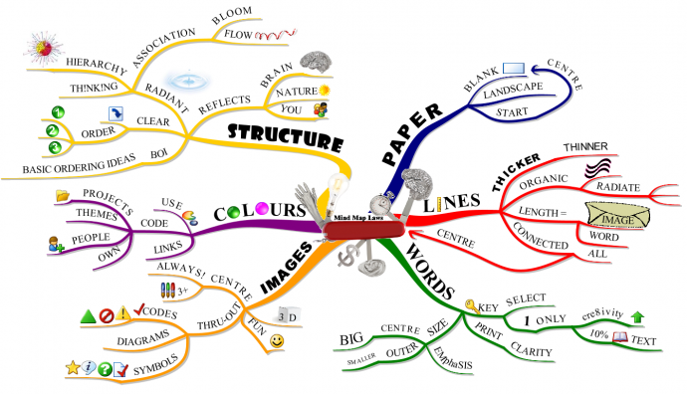

Goddard, J. A Mind Map of the Laws of Mind Mapping.Buzan Centre,
Australia. [Online], Available: http://www.fuzz2buzz.com/en/node/66 [Downloaded: 26 Nov 2011]

Unit 1 - Session 1: The role of management in health system strengthening

1 Introduction

In this session we outline why good management and leadership are so vital to the functioning of a people-centred health system and how they play a role in strengthening that system. Health systems are introduced through WHO’s well-known Health Systems Building Blocks framework and two other renditions of health systems models. To conclude the session, we outline what leading and managing entails in the context of health systems. You should by now have a notebook devoted to this module so that you can capture your work as you proceed for the purpose of your portfolio.

2 Contents

- Learning outcomes
- Readings
3 Frameworks for describing health systems
4 Managing systems “hardware” and “software”
5 Leadership, management and managers who lead
6 Who me … a leader?
7 Summary of session
8 References and further readings

3 Timing
This session involves some introductory reading and four activities. We have allocated 8 hours to this session. It is important that you work through this material thoroughly as it will provide you with important concepts to use in subsequent sessions.

4 Learning outcomes
In the course of this session, you will be addressing the session outcomes in the first column; they relate to the Module Outcome/s listed in your Module Introduction (shown in the second column):

Session Outcomes | Module Outcomes
- Discuss the components of health systems and their interrelationships.  - Appreciate the distinction between the hardware and the software of health systems.  - Describe the leading and managing roles of managers in health systems. | - Understand approaches to the concepts of leadership and management  - Be able to define your and others’ roles as leaders/managers in the context of the public health system

5 Readings and Multimedia

On your USB flash drive you will find a folder called ‘Readings’ which has your prescribed readings, ebooks and a small set of additional readings which are optional, but helpful in extending your understanding. There is a separate folder called ‘Multimedia’ which has video clips. These are marked with this symbol :

Management Sciences for Health. (2010). Chapter 1 – Achieving Results by Strengthening Health Systems; Chapter 2 – Leading and Managing: Critical Competencies for Health Systems Strengthening. Health Systems in Action: An eHandbook for Leaders and Managers. Cambridge, MA: Management Sciences for Health: 1.1-1.11 and 2.1-2.30.
van Olmen, J., Criel, B., Van Damme, W., Marchal, B., Van Belle, S., Van Dormael, M. et al. (2010).
Executive Summary. Analysing Health Systems To Make Them Stronger. ITG Press: 5-12 and 70-73.
World Health Organization. (2007). Everybody’s Business: Strengthening Health Systems to
Improve Health Outcomes: WHO's Framework for Action. Geneva, Switzerland:
World Health Organization: 1-5, 23, 24, 46.

Video - Everyday Leadership : Go2itech – P506NdwapiNdwapi684

6 Frameworks for describing health systems
To start off, view the short video on in the ‘Multimedia’ folder on your USB flash drive called This is Maya. You should remember this video, as you have come across it in your Introduction to Public Health module. While you watch, ask yourself the question, “What comprises the health system in my country?”
USB flash drive in the ‘Multimedia’ folder
Worldbank. This is Maya. From Health Systems Create Healthy Futures: Meet Maya.
[Online], Available: http://worldbank.org/health/maya [Downloaded: 16.1.13].

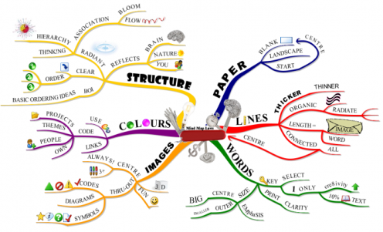
Now review the mind map you drew of the components of the health system of your country and identify where your workplace is located within the health system. (Drawing a mind map was suggested in the introductory section of Unit 1). Keep it alongside you as you try Activity 1 and as you read further. If you have not drawn one, you will have a chance to do so now.

In thinking about this, can you recall how the WHO defines a health system? It was: “… all the organizations, people, actions whose primary intent is to promote, restore or maintain health” (WHO, 2007). This sounds amorphous and complex, and pretty hard to manage. This is why it is useful to develop a diagram or model of the health system, which captures and clusters this complexity in a way that is manageable.
One of the resources on your USB flash drive in the ‘Readings’ folder, De Savigny and Adams’ Systems Thinking for Health Systems Strengthening has a helpful rationale for the emphasis on systems thinking which may not be something you’ve thought about before. They argue that “… systems thinking has huge and untapped potential, first in deciphering the complexity of an entire health system, and then in applying this understanding to design and evaluate interventions that improve health and health equity” (2009: 19). They note the benefits of systems thinking for working in complex environments, helping to clarify relationships between sub-systems, and in so-doing, helping managers to address challenges. You have no doubt noticed the dynamic and interrelated nature of your facility to other parts of the health system? This is where systems thinking may be helpful. The extract on the right from the WHO (2007) makes the critical point that health systems are the weak link in making proven health interventions available to all.
“Much of the burden of disease can be prevented or cured with known, affordable technologies. The problem is getting drugs, vaccines, information and other forms of prevention, care or treatment – on time, reliably, in sufficient quantity and at reasonable cost – to those who need them. In too many countries the systems needed to do this are on the point of collapse, or are accessible only to particular groups
in the population. Failing or inadequate health systems are one of the main obstacles to scaling-up interventions to make achievement of internationally agreed goals such as the MDGs a realistic prospect” (WHO, 2007: 1).

So, having a mental map of the health system and its sub-systems and the complex interrelationships within it would seem an imperative for any manager. We now move on to considering three conceptualisations of the health system.

Activity 1 below requires you to engage with the three readings in order to complete the activity fully.

Activity 1 – How I see the health system
Readings
WHO. (2007). Everybody’s Business: Strengthening Health Systems to
Improve Health Outcomes: WHO's Framework for Action. Geneva, Switzerland: WHO: 1-5.
van Olmen, J., Criel, B., Van Damme, W., Marchal, B., Van Belle,S., Van Dormael, M.,, et al. (2010). Executive Summary. Analysing Health Systems To Make Them Stronger. ITG Press: 5-12 and 70-73.

Management Sciences for Health. (2010). Chapter 1 – Achieving Results by Strengthening Health Systems.Systems in Action: An eHandbook for Leaders and Managers. Cambridge, MA: Management Sciences for Health: 1.1-1.11.

If you haven’t already done so, develop a diagram or mind map of the health system that you are part of, before you start reading. Remember to:
- incorporate as many elements as you think fit within it, i.e. “… all the organizations, people, actions whose primary intent is to promote, restore or maintain health” (WHO, 2007);
- cluster them logically;
- draw arrows where you see linkages;
- note your own position within the health system.

When you are happy with your diagram, skim read the three readings on health systems, and adjust your own health systems diagram where it seems necessary.

As you skim through the readings, look out for similarities and differences between the three health system models, as this is the focus of Activity 2. The three diagrams are included below for easier comparison.

Activity 2 - Comparing and contrasting three health system frameworks

Now read the three extracts carefully, studying the three diagrams and answer the following questions. You may wish to capture your responses in a table.
- How are these health system diagrams (or the way the different bodies conceptualize the health system) similar to or different from yours? What do they add, and what do they not include or emphasize?
- How are the van Olmen and MSH frameworks similar to or different from the WHO building blocks framework?
- How do the various frameworks define leadership and governance?
- How is management presented in these diagrams?

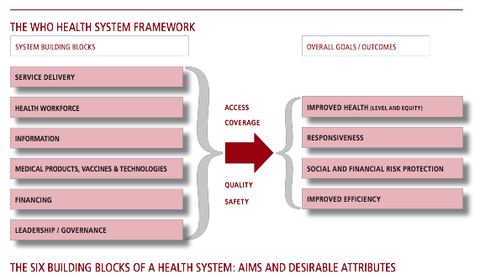
Source: WHO, 2007
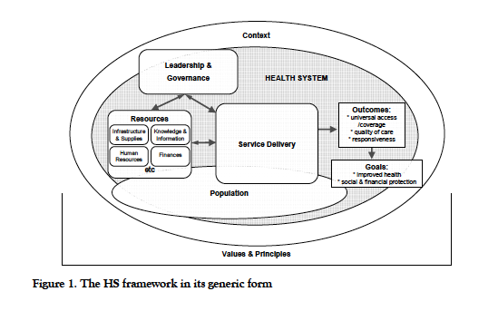
Source: van Olmen et al., 2010

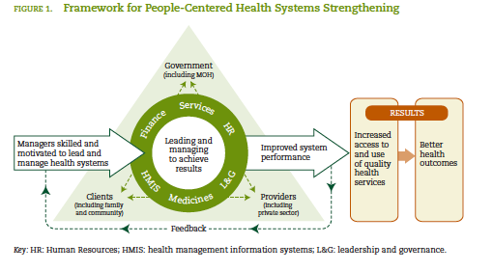
Source: Management Sciences for Health, 2010
Feedback
You may have extracted more than the points below, but treat this feedback as examples against which to check your responses regarding different health systems frameworks and the role of leadership, management and governance within them.

Table 1: Similarities and differences in three health system frameworks
 | WHO, 2007 | Van Olmen et al, 2010 | MSH, 2010
Similarities | All incorporate the building blocks - information, human resources, financing, leadership and governance (although the latter in different relationship). WHO and MSH see improved efficiency and performance as goals.
Differences | No reference to context, population, people-centredness or target groups. | Elements are organized and grouped differently.  Leadership and governance are set at the apex of the system.  Additional elements include: context, values, population. | People-centred framework.  Management and leadership is emphasized.
Definition leadership and governance | Oversight  Accountability  Regulations | Co-ordination of interaction and negotiation between health system role players; creation of means of priority-setting; balancing different  interests; steering participants. | Includes commitment and accountability
What it says about the role and place of management | Not specifically mentioned, implicit in the concept of leadership | Management is mentioned as a key part of facility and local leadership and governance. | Management is at the centre of people and building blocks, and plays a role in motivating people.

The WHO model makes no reference to health system actors, and both WHO and MSH locate leadership and governance in a building block parallel to other sub-systems such as “medical products, vaccines … etc”. These three diagrams or models thus differ in the extent to which they emphasize the central or overarching role of leadership and governance. This is in fact acknowledged by WHO which placed leadership and governance at the centre of another version of the diagram (2007: 5) included below.

Although the different organisations conceptualize leadership and governance in varying ways, they concur that the leadership role in health systems resides primarily with the managers of the system. As has already been suggested, and will be expanded on later, all health system managers, whatever their level, have a leadership role. Furthermore, the management role is explicitly part of two of the frameworks although MSH also has a separate leadership and governance (“L&G”) component.

Pre-eminent thinker in the field, Julio Frenk argues that it is leadership that holds the health system together:

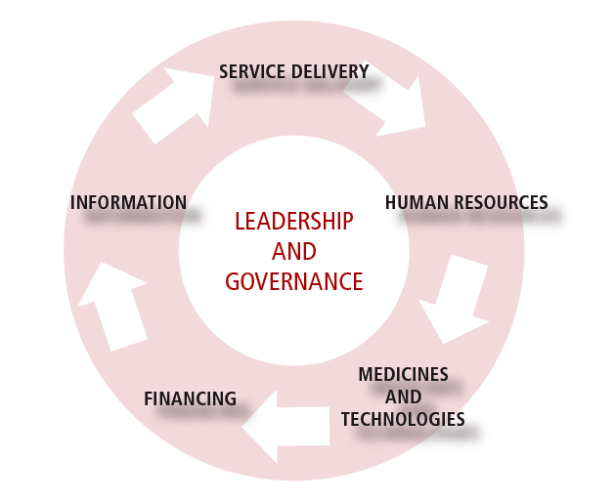
“Probably the most complex challenge in health systems is to nurture persons who can develop the strategic vision, technical knowledge, political skills, and ethical orientation to lead the complex processes of policy formulation and implementation. Without leaders, even the best-designed systems will fail” (Frenk, 2010).

This is echoed in the MSH (2010) manual and is posed as a key workforce development goal in achieving population health improvement:

“Improving the management and leadership skills of those who ‘make the health system happen’ is one of the most important ways to achieve the ambitious Millennium Development Goals. Even in the face of poverty, illiteracy, discrimination, and conflict, stronger management systems and leadership practices can make vital contributions to health services and health outcomes” (MSH, 2010: 1:2).

In the next section, we explore two further ways in which health system functions can be characterized – as “software” or “hardware”.

7 Managing systems “hardware” and “software”

As noted above, the three frameworks differ in the extent to which they emphasize the dimensions of people, relationships and values. For example, MSH’s Framework for People-Centered Health Systems Strengthening emphasizes the need for a holistic approach to thinking about management:

“It is so obvious that people run a health system, whether in the public, nonprofit, or for-profit sectors, we sometimes overlook this critical fact. Much attention is devoted to the process aspect of systems. Often ignored are those who develop or improve processes and procedures to foster the smooth flow of information, money, medicines, and people within the overall health system. The Framework for People-Centered Health Systems Strengthening attempts to remedy this imbalance. It provides a way to think about this critical component of system performance and, ultimately, of improved health outcomes” (MSH, 2010: 1.6).

Management requires paying attention to both people (such as creating positive work climates) and organisational systems. In other words, it is as important for a manager to be able to inspire and motivate teams, as it is to analyse and interpret data from a health information system. This differentiation and its implications have been summarised by Sheikh et al (2012: 2) as the ‘software’ of health and ‘hardware’ of health systems:
“Definitions of health systems, meanwhile, have been based mainly on their utility in the achievement of health outcomes. The World Health Organization (WHO) building blocks approach is one such popular classification, which conceptualizes health systems in the functional or instrumental terms of its constituent ‘hardware’- finance, medical products, information systems, levels and types of human resources, forms of service delivery, and governance understood as organizational structures and legislation … However, in addition to these concrete and tangible expressions of health systems, the ‘software’ - by which we mean the ideas and interests, values and norms, and affinities and power that guide actions and underpin the relationships among system actors and elements - are also critical to overall health systems performance.”
Source: Sheikh et al, 2011

Van Olmen et al’s framework is the only one which makes explicit reference to a foundation in values; WHO’s framework also recognizes the relational goals of health systems (“responsiveness”).

By now, you are hopefully getting the feeling that health system managers operate in highly complex systems and that if they are to be effective, they need to have the ability to address both the hardware and software of health systems. Building your knowledge and skills in managing the hardware and software dimensions of health systems is one of the implicit organising principles of this module.

8 Leadership, management and managers who lead
It is common to make a distinction between leaders and managers, based on the assumption that leadership functions increase as you move up in the organisational hierarchy. In the foreword to this module, we argued that while conceptually, leadership and management may be distinguishable, in practice they occur together, as two sides of the same coin. MSH (2010: 2.6) offers a useful analogy:

“If you lead without managing, although you might be able to create a surge of energy about a future vision, you are unlikely to be able to organize and implement to make things happen. This is similar to being in charge of a space program and looking wistfully at the moon without making coherent plans, organizing the needed training and equipment for the astronauts, and tracking progress toward the moon shot.”
On the other hand they argue that:

“Managing without leading … is like being a mouse on a treadmill - you may engage in a lot of activity and expend a great deal of energy, but it will get you nowhere. Concentrating only on managing, you lose track of the vision, the changing environment, and the need to prepare for the future. If you lead well, you will increase the energy and commitment of your team and gain the support of the stakeholders who are so critical to success” (Management Sciences for Health, 2010: 2:6).

In explaining the particular attributes of managing, they note that it entails making sure of the effective and efficient use of staff, resources and procedures. Management needs consistent and reliable performance which is only enabled through trustworthy operations which allow the health workforce to reach their goals (MSH, 2010). By contrast, leadership, they imply, is characterized by a more forward or future focus:

“When you lead well, you enable others to face challenges to creating the future that you all envision. You help them [staff] to overcome obstacles that stand in the way of desired results and encourage them to adapt to changing conditions. Leading is particularly important in times of crises, since it empowers and aligns people to move forward despite setbacks” (MSH, 2005: 6).

The implication of this is that leadership occurs at all levels of the health system, and may be particularly important at the most peripheral levels, where providers meet patients and communities. This implies that managers at every level of the health system must therefore be “managers who lead”.

This is how the WHO saw leadership in 1993, in arguing for the necessity of leadership in their Health for All by the Year 2000 Campaign:

“[L]eadership in the managerial context may be defined briefly as: the capacity to secure the willing support of people in the achievement of the organization’s worthwhile goals … It is clear that all managers at all levels of the organization, who depend on other people for efficient and effective work performance, require leadership ability …” (WHO, 1993: 3).

Below we have included the MSH’s Leading and Managing Framework, which spells out four Leading roles (scanning, focusing, aligning, mobilizing) and four Managing roles (planning, organizing, implementing and evaluating) played by health managers. Have a careful look at this table as it will be referred to again in the next session and in the Assignment 1.

Activity 3 – Differentiating and classifying leading and managing roles
Once you have looked at the MSH’s framework of leading and managing (on the next page), watch the video of Dr Ndwapi Ndwapi on your USB flash drive in the ‘Multimedia’ folder. Classify the roles he played, according to the MSH framework, by filling in the roles in the table below where applicable (you might not find a role for some of the categories in the table; there might be more than one role for other categories).

LEADING | MANAGING
SCANNING | PLANNING
FOCUSING | ORGANIZING
ALIGNING/ MOBILIZING | IMPLEMENTING
INSPIRING | EVALUATING

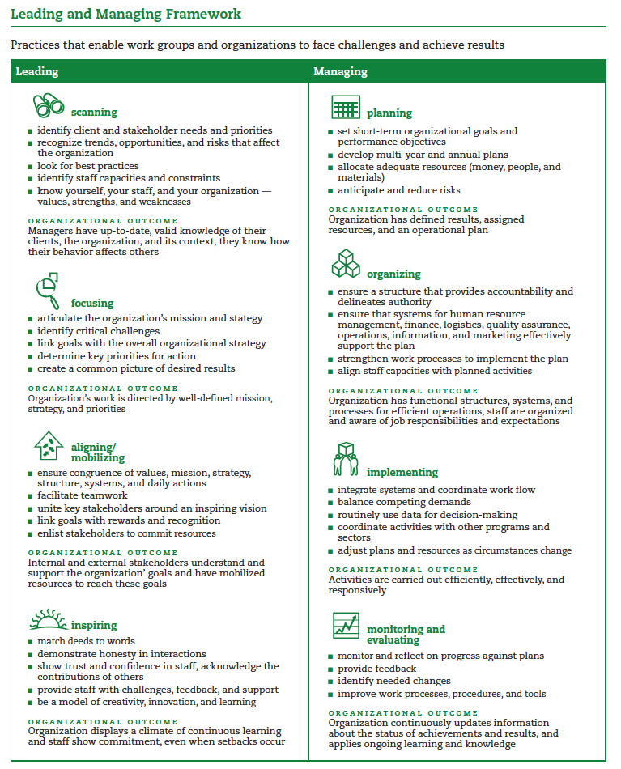Source: Management Sciences for Health, 2010: 2:8

Feedback
Remember that MSH (2010) suggests that management needs the development of reliable operations which allow staff to reach their goals, while leadership enables others to face challenges by helping them over obstacles.

Leading:
We found that Scanning practices were well covered by Dr Ndwapi’s roles as evidenced in the video; he could be seen as practicing all the points bulleted in the framework. We could identify focusing in his practice of identifying critical challenges and key priorities. Mobilising activities included facilitating teamwork and uniting key stakeholders around the vision of effective ARV facilities. Finally, Dr Ndwapi showed inspiring leadership by matching his deeds and words, demonstrating honesty, integrity, innovation, and learning.

Managing:
We found that Dr Ndwapi implemented planning practices by setting short term goals and objectives, and anticipating and reducing risks. He showed evidence of organizing practices in trying to align his staff capabilities with the planned activities. Implementing practices were seen in the way he adjusted plans and resources as circumstances changed. Finally, he practiced monitoring and evaluation by identifying needed changes, and by monitoring and reflecting on progress against the plans.

Were there any roles played by Dr Ndwapi that you think were not taken into account in this activity, but should have been? How useful is the framework above in helping you to understand the roles one might be expected to play as a manager who leads within the health system?

9 Who me … a leader?

“I didn’t set out to be a leader; I set out to be a good worker. I set out to learn and be led by people who knew better than me so that I could learn from them” (Dr Peter Mugyenyi, Executive Director, Joint Clinical Research Centre, Uganda, in Management Sciences for Health, 2005: 84)

“I never wanted to manage or lead. I just wanted to be a cog in a well-oiled machine” (Susan A., Manager of a municipal facility, South Africa)

How many of you have felt the same as Dr Mugyenyi or Susan A. during your careers? Many of us find it difficult to acknowledge that we actually play a leadership role, that we have the potential to contribute to “oiling or guiding the machine”, or that what you are doing in your everyday life at different levels is actually managing and leading. Leadership may not necessarily be your primary role; in other words, you may not be leading at every moment of your working day, but at particular moments in every person’s organizational life they probably do just this.

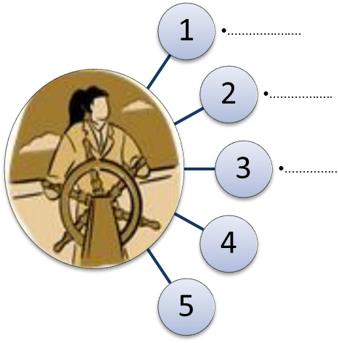
We have suggested in the previous session that leadership is a necessary quality in managers and that they are aspects of the same function which are brought to the fore in response to different contextual imperatives. However, focus for a moment on the leadership aspect, and analyse your own leadership ability and your experience of it.

Activity 4 – At the helm

Regardless of your current role, jot down five instances of
your leading in the workplace.
Use this spider diagram.

Feedback
It is pretty unlikely that you could
not think of anything in response
to this question; see if you can
discern different levels of leadership
within your own diagram – some which have
micro-level consequences for your close colleagues,
and others which have implications for the wider organization.

Examples of micro-level leading might include suggesting at a monthly meeting that your department invites guest speakers to present monthly workshops which would improve staff capacity or morale; a wider impact leadership example might be proposing that your division compose a memorandum to management suggesting the need to budget for improving the poor state of the clinic waiting room.

10 Summary of Session
In this session we have portrayed management and leadership as the glue that holds together the health system, ultimately ensuring its performance. Contemporary health system frameworks enable us to better appreciate the different elements of the management and leadership role in health systems, and the essentially people-centered, dynamic and distributed nature of these roles. Management requires paying attention to both the “software” and “hardware” dimensions of health systems. The point has also been made that managers have to lead (meaning “to do the right thing”, motivate, mobilize) and manage (“to do things right” and use resources efficiently).

To end this session, look at this quote, which is a reminder of the importance of your role as a manager: “A leader… is someone who is able to develop and communicate a vision which gives meaning to the work of others. It is a task too important to be left to those at the top of organizations. Leaders are needed at all levels and in all situations.” (Handy 1999:117).

In the next session, we ask you to review your own management role.

11 References and Further Reading

D. de Savigny & T. Adams. (eds). (2009). Systems Thinking for Health Systems Strengthening.
Geneva, Switzerland: Alliance for Health Policy and Systems Research, WHO.

Gilson, L., & Daire, J. (2011). Leadership and Governance within the South African Health
System. In A. Padarath & R. English (Eds.), South African Health Review 2011.
Durban: Health Systems Trust: 69–80.

MSH (Management Sciences for Health). (2005). Managers Who Lead: A Handbook for
Improving Health Services. Cambridge, MA: Management Sciences for Health.

Sheikh, K., Gilson, L., Agyepong, I. A., Hanson, K., Ssengooba, F., & Bennett, S. (2011).
Building the field of health policy and systems research: framing the questions. PLoS Med,
8(8), 1–6. [doi:10.1371/jour-nal.pmed.1001073].

WHO (World Health Organization). (1993). Leadership. Training Manual on Management of
Human Resources for Health, Section 1 Part A., Geneva, Switzerland: WHO.

Unit 1- Session 2: Moving Up the Leadership Ladder

1 Introduction
In this and the next session, we ask you to explore your role, practice and potential as a manager who leads, using the conceptualization of the leadership ladder by Management Sciences for Health (2005) to guide you.
This requires you to think about transitions – from being a health care provider working directly with patients or communities, to a manager of other providers. Further transitions occur when managers are required to identify, support and nurture other managers. Each of these transitions involves a mind-shift, new challenges and the potential for “derailment”.

2 Contents

- Learning outcomes
- Readings
- The leadership ladder
- Leadership, values and mindset
- A note on leadership styles
- Summary of session
- References and further readings

3 Timing

This session includes four readings and seven activities. The second activity will feed into the first Discussion Group and the fifth activity forms the first part of Assignment 1. We suggest you spend about 8 hours on this session. As with the other sessions, it provides important concepts and frameworks that underpin the subsequent elements of the module.
4 Learning outcomes
In the course of this session, you will be addressing the session outcomes in the first column; they relate to the overall Module Outcome/s in the second column:

Session Outcomes | Module Outcomes
- Define your position on the Leadership Ladder, assess your own tasks, skills and practices and envision your potential trajectory .  - Reflect systematically on prior transitions and the adjustments this required .  - Systematically analyse the skills, practices, strengths and weaknesses of managers in your own organisational environment .  - Identify your own mindsets and values in relation to management and public health )  - Develop an overview of the literature on management styles, and an understanding of your own style, based on this overview. | - Understand approaches to the concepts of leadership and management  - Be able to define your and others’ roles as leaders/managers in the context of the public health system  - Reflect on your own and others’ management practices and how to improve these.

5 Readings
MESOL adapted by SAIDE. (2002). 3.1 Managing Transitions. The Manager’s Job. (Based on the Open University). Johannesburg: National Department of Health of South Africa: 39-46.

Mintzberg, H. (2009). Chapter 1: Managing Ahead, and Chapter 4: The Untold Varieties of Managing.
Managing. San Francisco, CA: Berrett-Koehler Publishers, Inc: 1-16 and 97-154. [Prescribed reading].

MSH (Management Sciences for Health). (2005). Chapter 4: Moving Up the Leadership Ladder.
Managers Who Lead: A Handbook for Improving Health Services. Cambridge, MA: Management
Sciences for Health: 81-113.

6 The leadership ladder
In the previous session you considered five instances when you practised leadership in your workplace. That was a warm up! Now we want you to consider your position in relation to what Management Sciences for Health (MSH) (2005: 81) describe as the “leadership ladder”.
Begin this session by reading Chapter 4: Moving up the Leadership Ladder - MSH Handbook (2005). This is a different and earlier MSH Handbook which is also on your USB flash drive in the ‘Readings’ folder.

Reading
MSH (Management Sciences for Health). (2005). Chapter 4: Moving Up the Leadership Ladder.
Managers Who Lead: A Handbook for Improving Health Services. Cambridge, MA: Management
Sciences for Health: 81-113.

This chapter considers leadership transitions from being a first time manager – a so-called “Level One” manager, to leading and managing right at the top – referred to as a “Level Four” manager. It analyses the shifts – in time horizons, priorities and relationships – required with each transition; drawing on the Leading and Managing Framework presented in Session 1, and it further outlines the competencies, which they refer to as “tasks, skills and practices”, required at each level (MSH, 2005).
The authors of the chapter use the analogy of a theatre – with its stage and seating at different levels - to explain leadership transitions. A Level One manager is on the stage – close to the action, while a Level four manager is high up on the “balcony”, viewing the overall pattern of the performance rather than that of individual performers. Each level therefore has a different perspective of the stage performance.
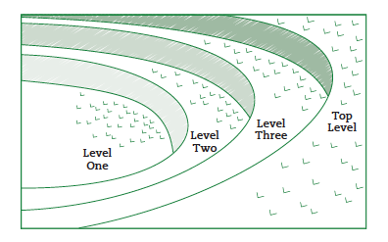
Source: MSH, 2005: 83

Activity 1 – Summarising a text
According to MSH (in the reading), what are the key features of each leadership level? Use the table below for your summary:

Key features of each level of leadership
 | Time horizons | Priorities | New relationships | Tasks & skills | Signs of derailment
Level 1
Level 2
Level 3
Level 4

Activity 2 - Identifying your position on the leadership ladder
Note: This activity will be discussed in your first Discussion Group (see the Module Introduction for a reminder about the Discussion Groups).

- Where are you on the leadership ladder and where do you see yourself going in the future? If you’re not in a leadership position, can you think of a professional situation where you were in charge of others?
- What have been your experiences of transition into leadership roles? What were the most challenging aspects of moving into a leadership role?
- Given the competencies required at the various levels of leadership, where do you think managers in your own environment succeed or fall short?

Feedback
Often one of the most difficult transitions involves the shift from being a clinician to being a first time Level One manager. Consider the situations of Maria de Souza and Sonny Gonzales described on page 84-85 of the chapter, and of Dr Ndwapi Ndwapi whose interview you watched for the last session. The main challenge they faced was that, in addition to being competent clinicians themselves, they were expected to enable others to perform competently. Coming straight from medical school, Sonny Gonzalez found that the knowledge needed to serve as a Level One manager is different to the knowledge required for professional practice as a clinician. The process of medical diagnosis and treatment, for example, can be structured into algorithms and guidelines, learnt through professional training prior to entering the field of practice.
Mintzberg (2009: 120) considers whether medical doctors are “intrinsically less suited to management” and suggests three reasons: firstly he suggests that because their training orientation is “interventionist” and focused on curing more than “continuous and pre-emptive caring”, the transition may be difficult; in addition, individual decision making is key to the practice of clinicians, whereas collective or team deliberation is essential to management; and thirdly he suggests that present day medicine is “about parts not the whole” while “organizations need to be treated holistically”.
However, this is contradicted by the profile of Dr Mehari Desalegn Tesfay, who you will watch in a short video interview (provided in the ‘Multimedia’ folder on the USB flash drive). He is an Ethiopian doctor who discusses the challenge of leading and managing an important change in Wukro hospital environment, thereby contributing to the quality of the health services and indeed to the health system. Although his experience exemplifies some of the transitional tensions faced by a Level One manager when he started at Wukro Hospital, he succeeded in facilitating change through his staff.

Watch the interview with Dr Mehari and identify any transitional tensions he was faced with, but more importantly, assess the practices and actions he undertook to succeed as a Level One manager. Dr Mehari suggests a few key “ingredients” which enabled this change and they are worth noting; we will explore many of these elements, e.g. ownership, in the course of the module.

USB flash drive in the ‘Multimedia’ folder
Video: Go2itech. (2011). P508 The New Doctor as Leader [featuring Dr Mehari Desalegn Tesfay]. Everyday Leadership. [Online] Available: http://www.everydayleadership.org [Downloaded: 28.11.11].

Activity 3 – Level One practices engaged in by Dr Mehari

Using the MSH Handbook (2005:89), identify which practices and actions listed in Table 8 (an elaboration of the Leading and Managing Framework) were critical to Dr Mehari’s success in “getting things done through other people”.

Feedback
You will have noticed that Dr Mehari was able to exercise many of the leading and, managing practices listed in Table 8 in Chapter 4 of Managers Who Lead – amongst them “paying attention to what was going on inside and outside the team”, “modeling a trusting attitude, respect and integrity” (MSH, 2005: 89). Somehow, either as an individual or through guidance, he was aware that he needed to pay attention to the goings on in the work environment in a new kind of way, identifying and analyzing problems, helping others to see their role as part of a team, and showing respect and integrity, as a model for his staff. Although as Mintzberg (2009) points out, managerial practice involves the use of science, it also requires considerable craft – learning from experience, and art – vision and creative insight (see figure below).
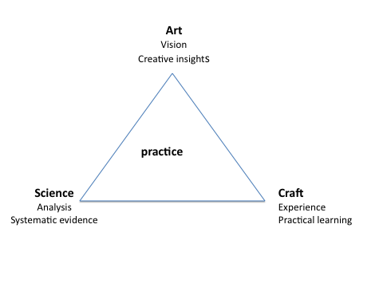
These dimensions are akin to the “hardware” and “software” ideas raised in the previous session; furthermore Mintzberg argues that management skills are mostly learned “on the job, through apprenticeship, mentorship, and direct experience” (Mintzberg, 2009: 12).
He suggests that if a shift in mindset and attitude is not achieved, the Level One manager will not be able to make a successful transition – which may be manifested in either over involvement and micro-management of direct service delivery, or in excessive distancing and detachment from the functioning of those who report to him or her. Because Level One managers are “at the coal-face of service delivery”, failures at this level have serious implications for the quality and responsiveness of health care.
Adapted from Mintzberg, 2009: 148
Dr Mehari’s experience could in fact have been very different had he not made such a successful transition into Level One management.
Leadership Transitions
The issue of transitions is an important one, and given less attention than it deserves. Study the extract in your Reader from a MESOL management course, and do the activity below.

Reading
MESOL adapted by SAIDE. (2002). 3.1 Managing Transitions. The Manager’s Job. (Based on the Open University). Johannesburg: National Department of Health of South Africa: 39-46.

Activity 4 – Make notes to guide your own leadership transition

Depending on where you are on the leadership ladder, you may either be in a state of leadership transition or you may in the future move to another leadership level. Do the following:
- Work through the activities in the reading as a way of engaging with the ideas presented.
- Make notes on the three “player-manager” tension issues that seem most relevant to you, and the strategies to address them when you are in a transitional stage.

Feedback
Have you experienced “player-manager” tension? Hopefully you have realized that this is a common experience and that there are many strategies to address it; but being aware of it is an important starting point.

You may have found the discussion of the phases of transition helpful: if you are not in transition, just remember to look back at this reference if it becomes relevant.

In contrast to Dr Mehari, as a Level One manager, view the short profile of a Level Four manager - Ms Girija Vaidyanathan – who has been employed by the India Administrative Services for 30 years. She discusses some of her experiences as a manager and her strategies for ensuring that she can manage effectively using other people in the organization. As you watch the video, make notes in your notebook about what seem to be her most effective strategies.

USB flash drive in the ‘Multimedia’ folder

Go2itech. (2011). Rocking the Boat Gently [featuring Girija Vaidyanathan]. Everyday Leadership. [Online] Available: http://www.everyday leadership.org [Downloaded: 28.11.11].

Activity 5 - Analysing a leader/manager in your own environment
Note: This forms the first part of Assignment 1 (Refer to the Module Introduction section 3.5).

Think of a manager in your own environment who you consider to be a good leader (but remember - no manager is perfect!). Locate them on the leadership ladder, and consider both their “hardware” and “software” skills, with respect to:
- Scanning, focusing, planning
- Aligning/mobilizing, organising, implementing
- Inspiring, monitoring, evaluating
Write a few paragraphs on what you consider to be their key strengths and weaknesses.

7 Leadership mindset and values

“If you look to lead, invest at least 40 percent of your time managing your ethics, character, principles, purpose, motivation and conduct.” –Dee Hock, in MSH, 2005:2.

This statement might sound extreme, but many theorists of management remind us of the central role mindset and values play in leadership. If you think about a leader who has inspired you, you will probably see that the statement above is valid – a good leader is one we respect, and whose values we admire and trust; someone we feel has a sound mindset, and is a role model of beliefs and behaviour we admire.

Personal values which create positive leadership include:
“Values” are the ideas or beliefs we consider important – or value.
“Mindset” refers to one’s habitual way of thinking, which is underpinned by a set of values.
- Integrity and commitment
- Respect and trust
- Courage to take calculated risks
- Openness to learning

You can read more about these values in the MSH text, Managers Who Lead, page 5.

These values are similar to the leadership strategies or competencies identified by Bennis and Nanus (in Handy 1999: 115) in their study of 90 leaders in different fields:
- Vision, or positive purpose
- Communication – the ability to articulate the vision to others
- Trust – developed through showing consistency, integrity and reliability
- Self-knowledge of their own worth and weaknesses, and the ‘emotional wisdom’ to help others feel good about themselves

Gosling and Mintzberg (2003) describe five mindsets which they consider to be necessary for management in an organization. Managers favour one or more of these mindsets, and can weave them together to produce a balanced management approach:
  - Reflective – looks at behaviours to work out how to do things differently to make positive change
  - Analytical – employs purposeful analysis of situations in order to understand underlying values and meaning
  - Worldly – is interested in context; where the organization intersects with its environment
  - Collaborative – focuses on relationships and structures to get things done in a participatory way
  - Action – balances continuity and change, taking into account the organizational terrain

You will probably recognize the mindset/s to which you are closest; in fact you will probably find there are a number that you can relate to.

Leaders’ mindsets and values underpin their daily actions, as well as the goals they are working towards. For a manager/leader in public health, these goals should relate to the public or common good – what is held as important by society in general. This would include a public health system providing a safety net for the most vulnerable members of society, and the provision of equitable and respectful, as well as effective, treatment for all.
As a leader, then, you will need to pay attention to your mindset and values, as they are the basis of your leading and managing, and relate to your management style. If, for example, you value the contributions and skills of others, this will probably mean your leadership approach is inclusive, invites participation and is open to shared learning. MSH, on page 3 in Managers Who Lead, presents a table indicating shifts leaders should make in their perspectives, if they are to provide positive leadership.

Leader shifts
Shift perspective from……… | ………. to ………
Individual heroics | Collaborative actions
Despair and cynicism | Hope and possibility
Blaming others for problems | Taking responsibility for challenges
Scattered, disconnected activities | Purposeful, interconnected actions
Self-absorption | Generosity and concern for common good

Activity 6 – My leadership mindset and values

Think about the values that have been mentioned so far in this section.
- Which do you consider to be in line with your own?
- Are there any of the values mentioned that you think you would like to develop?
- Are there any other values which you think are important for a public health manager to have?

8 Leadership styles

A key question in thinking about leadership styles is, “Are leaders born or made: are their defining characteristics innate, or can they be learned?” The significance of the question relates to the education/ training of managers. If leadership cannot be learnt, but is intrinsic in a person, there is less need to focus on training managers. This is the view of MSH:
“… [M]any people believe that leadership is an extraordinary quality, a natural gift bestowed upon only a few individuals. We have found, instead, that when people are committed to achieving results and encouraged to take responsibility, they can develop values and learn practices that empower diverse groups to reach their objectives. While not everybody will become a world leader, all people can improve their leadership abilities …” (MSH, 2001: 2)

Many studies have been done in search of ways of addressing the issue, and although some truths and useful guidelines have emerged, none seem to have offered a definitive explanation of the differences between a leadership style or trait that is effective and that which is less so, and whether effective styles can be taught.

Charles Handy, in his book “Understanding Organisations”, outlines some of the approaches that have been taken over the years, and offers a synthesizing model for working with the concept of leadership styles.

Some of the earliest studies have been labelled Trait Theories. These theories assume that the traits or characteristics of a leader can be identified, and that good leaders can therefore be selected on the basis of these characteristics. The problem was that it proved difficult to establish a definitive list of common traits which all good leaders have.

Style theories, on the other hand, claim it is not innate traits, but styles of leadership which are important to identify. They tried to identify and classify styles which are most effective. Studies showed that democratic, or supportive styles of leadership tend to lead to greater staff contentment and involvement, though not necessarily to greater productivity. Autocratic or structuring leadership styles, on the other end of the spectrum, were found to be less effective. Nevertheless, the studies were considered to be inconclusive overall, on the link between leadership styles and productivity.

The third trend was contingency theories, which focused on the relationship between the three variables in a leadership situation – the task itself, the work group members and the position of the leader. They concluded that leadership is most successful when all three variables are favourable, i.e. when the task is clearly defined, the work group has respect for the leader, and the power of the leader is high. In other words, successful leadership does not depend only on the leader.

Handy proposed a more complex model for understanding leadership, which he called the “best fit approach”, in which he described four elements that need to be taken into account in trying to determine a leader’s effectiveness:
- Leader’s style and traits;
- Subordinates’ needs and preferred style;
- Task - objectives and technology involved;
- Environment – the organizational setting and the importance of the task.

Handy says that there is no ‘right’ style of leadership, but it is most effective when all four factors fit each other. He proposed a scale or continuum of tight – flexible, on which each element could be positioned. If the fit is not good – i.e. the elements are not similar in terms of ‘tightness’ or ‘flexibility’, the task will not be achieved and the leadership will not be effective. For example, a leader’s style might be autocratic and tightly prescriptive, in an organization with tight constraints, while the needs of the task require more openness and flexibility and the subordinates would like to work in a more creative, participatory way. In this case, the leader would have to adjust the elements towards a better fit in order to move forward.

Mintzberg’s empirical studies of managers (Mintzberg 2009a and 2009b) led him to conclude that management style as a concept is perhaps over-theorised, and that it is not a valuable concept in itself, but only if seen in relation to the context in which the manager operates. He claims that, “Style and context matter together, in symbiotic relationship.” (Mintzberg 2009a: 130).

He goes on to outline the many dimensions of management style that have been posited, the two most common being the ‘Task versus people’ orientation or ‘command and control versus facilitate and empower’ (found in the academic literature), and the ‘Change and innovation versus status quo’ orientation (found mainly in the practitioner literature). Like Handy, Mintzberg sees the need for balance between orientations. For example, a change and innovation oriented manager still needs to maintain some stability or status quo in order to effect change, or there would be chaos.

Assessing personal style of management

Mintzberg designed the following instrument for assessing personal management style, based on his Art-Craft-Science triangle of management (look again at the figure on page 25 above). He contends that if a manager’s style tends too much to the analytical, science dimension, it can become calculating and dry; if it tends too much to the experiential or craft dimension, it can become tedious and conservative; if it tends too much to the visionary or art dimension, it can become narcissistic and self-absorbed. The best style would be a balance between the three – somewhere in the middle of the triangle. What is important is that the manager is aware of her style in relation to her context, and to know what her main orientation is as a manager, so she can make changes if necessary in a particular situation. Read Mintzberg (below), then complete Activity 7, which follows.

Reading
Mintzberg, H. (2009). Chapter 4: The Untold Varieties of Managing.
Managing. San Francisco, CA: Berrett-Koehler Publishers, Inc: 97-154. [Prescribed text].

Activity 7 – Assess your own management style
Note: Be prepared to discuss this activity will be discussed in the first Discussion Group.

Use Mintzberg’s assessment instrument below, to find out what your own management style is. Your style will tend towards the dimension (column) with the highest score, but you should also have some points in the other columns if your style is a balanced one.

Circle one of the words from each row that best describes you.  When you are finished, add up how many you have circled in each column (the scores for the three columns should add up to 10). | Art | Craft | Science
 | ideas | experiences | facts
 | intuitive | practical | analytical
 | heart | hands | head
 | strategies | Processes | outcomes
 | inspiring | engaging | Informing
 | passionate | helpful | reliable
 | novel | realistic | determined
 | imagining | learning | organising
 | seeing it | doing it | thinking it
 | ‘The possibilities are endless!’ | ‘Consider it done!’ | ‘That’s perfect!’
Total scores
Source: Mintzberg, 2009:128

9 Session summary

This session began by looking at levels of leadership and the leadership ladder, as illustrated in the MSH handbook. You watched two videos, comparing practices of a level one manager and an experienced level three manager. The next section considered leadership mindsets and values as the basis for ethical good leadership practice, while the last section addressed leadership styles. The latter has been widely theorized, and both Mintzberg and Handy suggest a balanced approach to the topic, with emphasis on the context and the manager-in-the job, rather than trying to provide a definitive, generic list of ideal management styles or traits. You were asked to reflect on you practice at various points, and hopefully you will have developed a better understanding of your own management approach and that of people in your organization.

10 References and further reading

Handy, C. (1993). Understanding Organizations. 4th ed. London: Penguin Books.

Gosling, J. & Mintzberg, H. (Nov 2003). The Five Minds of a Manager. Harvard Business
Review: 54–63.

Mintzberg, H. (2009). Managing, San Francisco, CA: Berrett-Koehler Publishers, Inc.

Unit 1- Session 3: The everyday life of the manager

1 Introduction
In the first two sessions of Unit 1, we introduced you to the importance and role of management and leadership in the health system, provided a framework for viewing these roles in more detail and the mind shifts required to transition into management roles and up the leadership ladder.
In some ways these frameworks, styles and roles can seem idealistic and quite distant from the everyday reality of managers: overwhelming constraints on time, unexpected demands, endless crisis management, and a feeling of doing nothing more than “muddling through”. Does any of this sound familiar? Managing is an inherently open-ended and unpredictable process in which you are required to be endlessly responsive to people and events. Mintzberg describes these features in more detail in Chapter 2 (The Dynamics of Managing) of his book “Managing” in which he seeks to dispel myths about what managers do in practice. We invite you to read this chapter and reflect on what strikes a chord with you in your own working life.
In Chapter 3 (A Model of Managing), Mintzberg goes on to systematize what he sees as the real everyday job of a manager into a model consisting of three “planes” – information, people, and action. You will notice that this framework has some similarities with, but is also different from the MSH “Managing and Leading” Framework. The two frameworks should be seen as complementary – while the MSH framework looks at what health sector “managers who lead” should be aiming to achieve (their management functions), the Mintzberg model speaks to how this translates into a manager’s day-to-day practice – what managers typically do (their management roles). The model is also a generic one that includes, but is not limited to, the work of health managers.
The nature of the manager’s job is also explored in the MESOL reading, which helps to unpack what managers actually do in their daily work, and the challenges they encounter.
We also introduce you to the first of the “Waitola Clinic” case studies – a typical day in the life of its manager, and ask you to analyse her daily activities using the Mintzberg framework. This will form part of Assignment 1.

2 Learning Outcomes

In the course of this session, you will be addressing the session outcomes in the first column of the box on the next page; they relate to the overall Module Outcome/s in the second column:

Session Outcomes | Module Outcomes
- Apply the Mintzberg model to analyse the everyday job of a manager.  - Understand the nature of the manager’s job.  - Understand and analyse demands and constraints of a manager’s job, and how these impact on choices.  - Reflect critically on the balance of roles in your own work as a manager, and what new insights you gained from considering this model. | - Understand approaches to the concepts of leadership and management  - Be able to define your and others’ roles as leaders/managers in the context of the public health system  - Reflect on your own or other’s management practices and how to improve these.

3 Readings

Mintzberg, H. (2009). Managing. San Francisco, CA: Berrett-Koehler Publishers, Inc. Chapters 1, 2 & 3

MESOL adapted by SAIDE. (2002). Unit 1: Your Job as a Manager. The Manager’s Job. (Based on the Open University). Johannesburg: National Department of Health of South Africa: 6 -20.

Waitola case study Part 1 – A day in the life of Ms Thandeka Mayekiso, Waitola CHC Manager.

Elloker, S., Olckers, P., Gilson, L. and Lehmann, U. (2013). Crises, Routines and Innovations: The complexities and possibilities of sub-district management. In: A. Padarath & E. English (eds.) South African Health Review 2012/3. Health Systems Trust, Durban. ISBN 978-1-919839-73-8

4 Timing
We have allocated about 10 hours for this session. If you are a fast reader it might take you less time, but make sure you do the readings thoroughly, even though some sections are summarized for you in the session.

5 The dynamic nature of the manager’s job
“Managing is a job with perpetual pre-occupation: the manager can never be free to forget the work, never has the pleasure of knowing, even temporarily, that there is nothing left to do” (Mintzberg, 2009:20)
In session 1 we studied the MSH Leading and Managing Framework, which outlined some key roles or practices of leading and of managing in order to compare and contrast them. We will now focus in more detail on management roles, as identified by Mintzberg in his study of managers managing. In fact Mintzberg is critical of making distinctions between leading and managing; in his studies of 29 managers at work he found it difficult to categorise them in these terms, and asks, “How would you like to be managed by someone who doesn’t lead? That can be awfully dispiriting. Well then, why would you want to be led by someone who doesn’t manage?” (Mintzberg, 2009: 8) He sees leadership as embedded in management, rather than a separate practice.
As you know from the previous session, Mintzberg also claims that management is, “not a science or a profession, but a practice, learned through experience and rooted in context.” You will remember that he created a model in which he showed management practice as a synthesis of science, art and craft, involving seemingly contradictory approaches.

The everyday life of a manager is intrinsically dynamic. In his observations of managers at work Mintzberg, (2009:18) summarised it as follows:
- The unrelenting pace of managing
- The brevity and variety of its activities
- The fragmentation and discontinuity of the job
- The orientation in action
- The favouring of informal and oral forms of communication
- The lateral nature of the job (with colleagues and associates)
- Control as more covert than overt
Chapter 2 of Managing discusses each of these dimensions, separating out the “folklore” of what people commonly (but wrongly) believe about managers’ jobs, from the “fact” of what they actually do. The table below summarises this discussion.
Folklore | Fact
A manager is a reflective, systematic planner | Managers work fast and relentlessly; their activities are varied, fragmented and superficial; they favour concrete tasks and are action- oriented; they are reactive
A manager depends on information supplied by formal systems | Managers favour richer, informal, immediate communicative media, e.g oral and email; from people more than from data systems
Management is about hierarchical relationships | Managers work as much in lateral relationships and networks as they do in hierarchical relationships
Managers keep tight control of their time, activities and units | Managers are constrained by deadlines and expectations, but still exercise control within the freedom they have.
6 Demands, constraints and choices
“no matter what they are doing, managers are plagued by what they might do and what they must do.” (Mintzerg, 2009: 23)
Reading
MESOL adapted by SAIDE. (2002). Unit 1: Your Job as a Manager. The Manager’s Job. (Based on the Open University). Johannesburg: National Department of Health of South Africa: 6 -20.

Because of the nature of managers’ work, as described in the MESOL reading there tend to be many demands and constraints on their ability to perform as they would like. Demands are seen as what they must do; constraints are what they must not do in the job. Rosemary Stewart (1982) drew attention to the nature of these demands and constraints, and suggested that, by being aware of and identifying them in their workplaces, managers could reduce them, thus widening their own freedom to make choices about what to do and how to do it. Choices that managers typically have relate to what, how and when work is done, and with respect to the development of new initiatives. The more demands and constraints on them, the less freedom they have to perform creatively and proactively.

Activity 1 – Identify demands and constraints on you in your managing role

Below are Stewart’s lists of the main sources of demands and constraints on managers. Read these, then do the following:
1. Rate the impact of each on you in your job, from 0 – 10 (where 0 = no impact; 10 = huge impact).
2. Choose two of your highest rated demands and constraints, and think about how you could address these to make changes and give yourself greater freedom to make choices.

Demands imposed by: |  | Constraints imposed by:
Boss |  | Resource limitations
Peers |  | Legal regulations
External sources |  | Trade union agreements
System (e.g. budgets required) |  | Technological limitations
Staff (e.g. supervision needs) |  | Physical location
Self (Personal standards/ habits) |  | Organisational policies and procedures
 |  | Other people’s expectations and attitudes

Feedback
Look at pages 17 -20 of the MESOL reading to find some ideas for possible ways of making such changes. Remember that sometimes apparent lack of choice is actually more about managers not managing the demands and constraints on them. It is useful to try and distinguish what must be done, from what you would like to do, or what other people think you should do.

7 A day in the life of a facility manager
This section includes part of your first assignment for the module. You will work with the case study of the facility manager at the Waitola CHC, Ms Thandeka Mayekiso, using Mintzberg’s model of managing, illustrated below, to analyse her practice. You will have to read the Introduction and Part 1 of the Waitola case study, which includes the timeline and narrative of Thandeka’s day, as well as Chapter 3 of your setbook, Managing (Mintzberg, 2009), and the other reading for this session: Elloker et al (2013).

A model of managing
Management literature has tended to focus on a particular role or aspect of management, for example leading or controlling, whereas Mintzberg sees management as a blend of many roles. His model of managing below was developed over many years of working with the concepts, and shows the key roles that Mintzberg identified in observing managers, and how they relate to each other. Chapter 3: A Model of Managing, in Mintzberg’s Managing, provides a detailed explanation of the complex model.

Activity 2- Analysing a day in the Life of a health facility manager
a. Read Chapter 3 - A Model of Managing from “Managing”. Write 3-5 paragraphs (or 1 page) summarizing Mintzberg’s model in your own words. Below this box is the model, taken from page 48 of the book.
You may also want to look at the website where Mintzberg shows the evolution of his model:
http://www.mintzberg.org/sites/default/files/managingmodel.pdf
b. Now Read the case study Introduction (especially the section entitled “Description of Waitola CHC”) and Part 1: A day in the life of Ms Thandeka Mayekiso, Waitola CHC manager and in tabular form, using the template (Table 3.1 Roles of Managing on page 90 of Mintzberg 2009), categorise the activities in her day. (300 words, approximately 1 page)
c. How well do you think Mintzberg’s model captures Ms Mayekiso’s everyday life? (approx 200 words or ½ page)

d. Now Read Elloker et al (2013): Crises, routines and innovations: The complexities and possibilities of sub-district management, which considers the everyday life of a manager, one level above that of the facility. This chapter draws on the work of Mintzberg. Discuss:
(i) the dynamic nature of sub-district management using Mintzberg’s managerial “facts” outlined in Chapter 2 of “Managing” (your prescribed text), and also summarised on page 35 of the module (approx 300 words or 1 page).
(ii) the extent to which Mintzberg’s model of explains the everyday life of sub-district management (approx 200 words or ½ page).

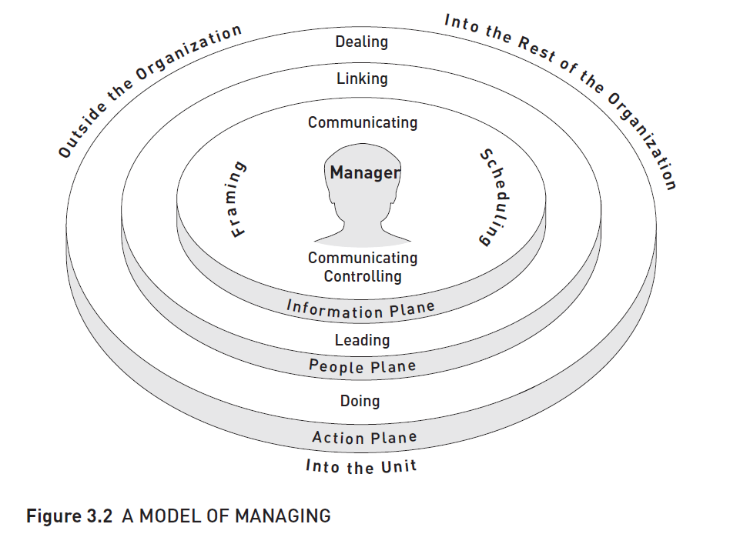

8 How balanced are my roles as a manager?
“The question that continues to nag is how to persistently achieve balance in the face of so many roles.” (Lewis, R. Cited in Mintzberg, 2009: 48)
As we have seen from the information in this unit, managing is a complex, multi-faceted and challenging practice, requiring a manager to play many roles. It is unlikely that any one person can master all the aspects and competencies involved, since managers, like all human beings, are flawed. What we can aim for is balance: being able to use a range of skills, strategies and styles to bring out the best in the people we manage, in order to best effect the tasks required.

Mintzberg categorises the competencies needed by a manager as four types: Personal, Interpersonal, Informational and Actional. Refer to Table 3.2 on page 91 in your setbook, to check which you perform in the course of your daily work as a manager. You will probably find that you cover a wide range of competencies across the four categories. This assessment, together with the tool you used to analyse your management style (Activity 7 in Session 2), should give you a fairly good sense of how balanced you are as a manager.

9 Session summary
This session exposed the nature of the manager’s role as different from what is generally expected. This emerged mainly from Mintzberg’s observations of managers in action. We looked at the dynamic, varied, sometimes chaotic activities managers are involved in, and how their work is constrained by many demands and expectations, despite which they still maintain a degree of freedom to decide what and how to proceed. We ended with a reflection on our own practice, in the light of the information in the session.

