Managing People

3

and Teams

“Management is the art of getting things done through other people” (Mary Parker Follett)
In Unit 1 session 1, you were introduced to the concept of health systems ‘hardware’ (human resources, finances, medicines, infrastructure, systems, etc) and ‘software’ (ideas, values, relationships etc.) (Sheikh et al, 2011). ‘Getting things done through people’, which Follett refers to above, has both hardware and software elements. It involves a combination of:
- inspiring people and formal training plans
- building an external reputation that will attract talent and efficient procedures for recruitment
- enabling organisational climates that foster intrinsic motivation and paying attention to incentive packages
- building a culture of accountability and managing disciplinary procedures
- facilitating teams and setting individual performance objectives

To effectively manage people, you need sound Human Resource Management (HRM) systems and appropriate human resource policies (hardware), but also good management and leadership practices which address relationships and the work climate (software). If these are not in place, the effectiveness and productivity of the organisation can be negatively impacted. The first three sessions in this unit deal principally with the leadership and management roles associated with managing people. The fourth session is devoted to the scope and design of systems for adequately managing human resources.
Managing people and teams is not just about managing “downwards” (the people who report to you), but also upwards (managing your manager), and across (managing other stakeholders both in and outside the organization). The unit therefore begins with a general consideration of the “people” environment surrounding managers and asks you to map your own stakeholder environment. It then goes on to consider in greater detail the tasks associated with leading individuals and teams.

Study Sessions
There are four study sessions in Unit 3:
- Session 1: looks at the range of “people” relationships – down, up and across – in a manager’s life, and the different approaches required to manage these;
- Session 2: examines the concept of “positive work climates” and ways of shaping these, with reference to Waitola; analyzing the factors behind a team that is resistant to change (picking up on Unit 2);
- Session 3: Deals specifically with the management of conflict, and provides a framework for analysing case studies of managers involved in situations of conflict or difficulty with others;
- Session 4: Looks specifically at human resource management systems, focusing on two specific systems: performance management and supportive supervision.

Unit 3 - Session 1: Managing down, up and across
1 Introduction
Health sector managers are involved in diverse sets of relationships. Mintzberg emphasizes this in your setbook, Managing (Mintzberg, 2009a) and the monograph linked to it, 29 Days of Managing (Mintzberg, 2009b). You will be referred to these texts again in this session.
The readings in this session form the core for the unit as a whole and will be picked up again in later sessions.

2 Learning Outcomes

In the course of this session, you will be addressing the session outcomes in the first column; they are part of the overall Module Outcome/s in the second column:

Session Outcomes | Module Outcomes
- Be familiar with the concepts of managing up, down and across;  - Have mapped the range of relationships in your own workplace environment;  - Have considered the challenge of “managing up” in your own work;  - Be able to describe the manager/leader roles involved in managing “down”. | - Understand the scope of human resource management and the systems and skills required for managing relationships with people - below, up and out – in your organisational environment;  - Have reflected on your own management practices and how to improve these.

- Readings

Management Sciences for Health. (2005). Ch 3 – Improving Work Climate to Strengthen Performance. In Managers Who Lead: A Handbook for Improving Health Services. 3rd ed. Cambridge, MA: Management Sciences for Health: 51-79.
Management Sciences for Health. (2010). Ch 5 – Managing Human Resources. In Health Systems in Action: an ehandbook for Leaders and Managers: 5. Cambridge, MA: Management Sciences for Health.
Mintzberg, H. (2009a). Managing: 62-80. San Francisco, CA: Berrett-Koehler Publishers, Inc.
Mintzberg, H. (2009b). 29 Days of Managing : 72-91.

4 Timing
In this session you are expected to read three fairly substantial texts and use them to help you complete four activities. There are also two blogs to read, and a short video to watch. You should allocate about 12 hours to this session.

5 Mapping your key workplace relationships: up, down and across

Amongst the 29 manager case studies which informed Mintzberg’s book “Managing”, seven were of health system managers – three were at the “bottom” of the system (with direct involvement in health care), two at the “middle” (district and nursing managers) and two at the top of system (CEOs). Mintzberg summarised their work collectively as a complex array of “Managing Up and Down, In and Out”, organised along two axes – up and down referring to relationships in the hierarchy, from the CEO/top manager to the front-line clinicians at the base of the system; “in” to managing within the organisation and “out” to managing relationships outwards with patients and the “community”. He positioned the seven managers he observed in the four quadrants formed by the two fold axis depending on their primary function in the system.

Reading
Mintzberg, H. (2009b). 29 Days of Managing : 72-91.

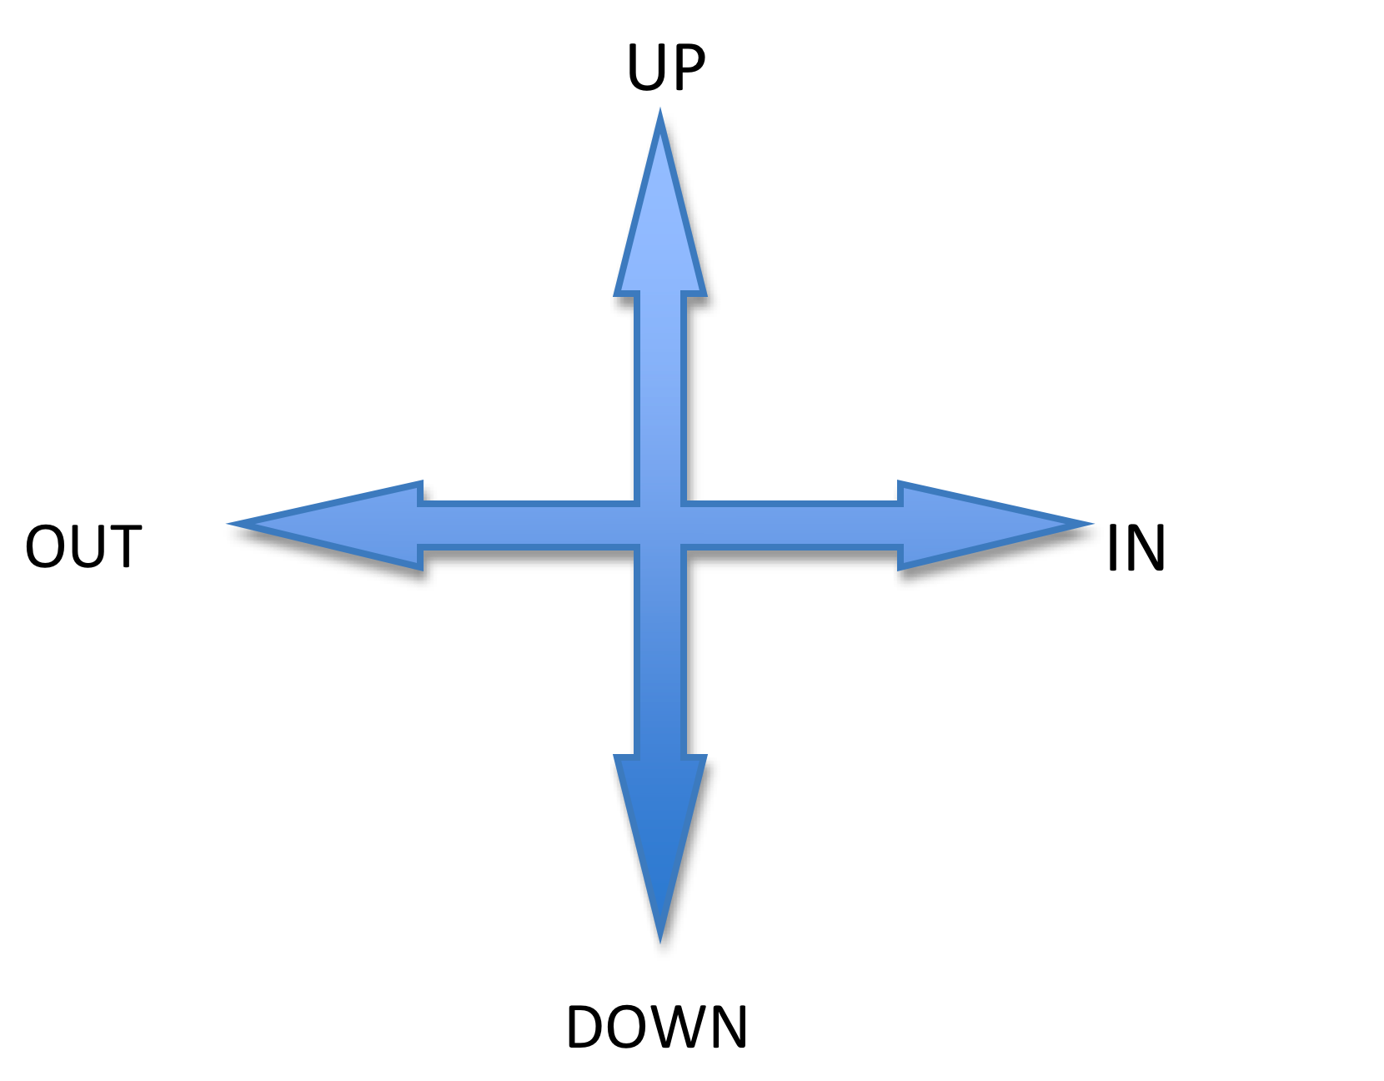

This is similar to the positioning of managers on the Leadership Ladder (Unit 1). Think about your own workplace. In which of the four quadrants would you place yourself?
These relationships have also been referred to by others as up, down and across, where “across” refers to non-hierarchical relationships both within and outside the organization.
In another approach to defining relationships, Blaauw et al (2003), identified four key relationships specific to the health sector:

- “Service relationships: frontline interactions between providers (health care workers) and users (patients);
- Organisational relationships: relationships within the health service − interactions between managers and workers, between colleagues, or between different categories of health workers;
- Inter-organisational relationships: relationships with external organizations such as suppliers, private sector providers and non-governmental organisations (NGOs);
- Political relationships: broader relationships between the government and citizens.”
(Blaauw et al: 35)

They went further to characterise these relationships as one of three kinds: “hierarchy” (relying on authority), “network” (relying on trust) and “market” (relying on contracts) (Blaauw, Gilson, Penn-Kekana, & Schneider, 2003).

Activity 1 – Mapping relationships

a. In unit 1 session 3 activity 2, you were asked to describe the key players whom the Waitola CHC Manager interacted with in her day of managing. Go back to this description, and map the players diagrammatically along the above axes in the diagram above. Next to each, label the type of relationship the manager has with this player as either hierarchical, network or contract. Which domains form the bulk of her relationships?

b. Now map the key players in your own work and the types/domains of relationships with them in the same way. Which of these relationships do you find easy and which challenging, and why? Write one page in response to this question.

6 Managing up, down and across

Different relationships require different approaches. Read the blog below from a website entitled “Rethinking information work”, where the tasks of managing different relationships are summarized as “managing up, coaching down and collaborating across.”

Coach Down, Collaborate Across and Manage up
Last week I had an opportunity to chat with a young colleague who is exceptionally bright, but inexperienced in interacting effectively with people in a workplace setting. He asked for advice about supervising people, which he had recently been asked to do, in a way that met the company's expectations for their work.
He is exceptionally bright, but like so many others of our young "best and brightest," has been put into a role that requires him to supervise others, work at a high level of success with colleagues, and meet executives' expectations – all with little or no training in how organizations work.
My advice to him? Coach down, collaborate across, manage up. Coach down. Supervising others is about helping them deliver their best stuff to the organization, whether a library, a non-profit, or a company. You need to hold people accountable for doing their work successfully, but that's a lot easier to do consistently when you understand and support their motivations, goals, and concerns.
An example of this type of coaching is how you approach annual reviews. Instead of simply evaluating each of you direct reports and letting them know where and how they have or haven't met expectations, consider also asking them to prepare their own assessment of their job, their career goals, and the ways they would like to grow in their jobs. Are there other projects they'd like to take on, teams they'd like to volunteer for, additional skills they'd like to develop?
Obviously you may not be able to accommodate all of their goals, but making the effort to create an environment where people can learn and grow will keep them much more engaged than one where employees are simply told what to do. Although most of us, when first thrust into a supervisory or management role, feel most comfortable micromanaging, in fact this is pretty much guaranteed to bring out the worst in the people reporting to us. So instead, consider working with your people to help them succeed in their jobs.
Collaborate across. An awful lot of organizational culture is about competition – between departments, managers/executives, and budget priorities. You can see it in meetings where people vie for attention and credit rather than supporting anyone else's ideas or solutions. But life – and work – is not a zero sum game, where your win is my loss.
How much better instead to build bridges to others, to find ways to support good ideas whether yours or your colleagues'. You can demonstrate support in many ways, but one of the most basic is simply publicly acknowledging someone's contribution; it's as simple as saying something like "I think Bill's idea is a good starting point for us." Making the effort to value others' participation is not only the smart thing to do personally, it's also how teams become creative and innovative, instead of being mired in infighting and disarray.
It's also how you begin building your impact within (and eventually, outside of) your organization. When you have been willing to acknowledge and support others' good ideas, it's much likelier that they will be willing to do the same for you. And when your colleagues move on to other jobs, they will take with them the knowledge that you're a great team player, and someone with whom they can collaborate – rather than compete.
Manage up. "Managing up" means different things to different people (for one take, see "What it Means to 'Manage Up,'" a recent post by columnist Elizabeth Garone to the Wall Street Journal's Career Journal.) But from my perspective, it means doing those things that enable your boss to have confidence in your performance.
That means finding out what level of communication your boss needs from you, what issues/concerns are important to him or her, and quite frankly, how you can help your boss succeed in his or her job.
Quoting from Ms.Garone's post,
When someone tells you that you need to "manage up," what he or she is really saying is that you need to stretch yourself. You need to go above and beyond the tasks assigned to you so that you can enhance your manager's work...
Additionally, Ms. Garone quotes executive coach Mariette Edwards, who says:
... there are numerous strategies her clients often overlook when it comes to managing up. For example, getting to know one's manager – and his or her style. "If you and your manager seem to be speaking two different languages, then the problem may be that you are not leaning into that person's style," says Ms. Edwards. "An analytical [type boss] will take exception to someone who presents an idea without data to support it. A people person will be offended in the absence of regular communication." Knowing your manager's style -- and adjusting your own to meet it -- will help you manage up, she says.
Other pointers? Pay attention; jump in when needed; maintain a good attitude no matter what; do quality work; keep your boss informed; build relationships, trust and an information network; stay out of politics; learn the art of selling and negotiation as well as the company's rules; and be a good follower when the situation dictates it.
Coach down, collaborate across, manage up. It builds trust, support, and long-term career growth – not to mention a much more effective organizational team effort.

http://www.rethinkinginformationwork.com/column-archives/managing-up-down-and-across/ [Downloaded 12/03/12]

Here is another blog, this time from a Canadian management consulting firm. This gives a slightly different take on the need to manage up, down and across.

Managing Up, Down and Across
There are three skills that are essential to career success in almost any organization: managing up, managing down and managing across. Up, down and across. Think of these skills as balls a manager must constantly juggle during their daily interactions.
Managing Up
One of the first management skills we learn is “managing up”. We all start out with a boss, and those of us who survive get good at keeping that person happy. Early in my career I had a lion of a manager who once roared some wise advice in my direction: “When your manager needs something, it moves straight to the top of your priority list!” The lesson I learned is that what interests my boss ought to fascinate me. It’s the only way to tame that lion.
Managing Down
Eventually, you become a boss yourself. Managing staff (“managing down”) is a career milestone. Young employees look forward to the time when they can crack the whip and others will hop to satisfy them. Soon however they discover it’s actually hard work to keep staff members motivated and productive. The dirty secret of management is that the power bestowed by your title is actually quite limited. The people who work for you are volunteers. They choose how hard to work and they can choose to ignore you, or leave, at any time if they’re not satisfied with your leadership.
Managing Across
Managing across the organization, tests your ability to build trust and to influence others since you wield little or no organizational power with your colleagues. Everyone’s had a taste of managing across while working in groups but this skill becomes essential when you’re part of a permanent management team. The success of an organization depends on how well the management team works together. If even one of its key members acts with self-interest rather than concern for the organization, the management team can easily become dysfunctional as it tilts from cooperation to competition between members. Conversely, a high-performance management team is a daring trapeze act with members taking risks for the sake of the organization, secure in the knowledge that their colleagues will be there to catch them.
To be a good manager you need to be able to rotate easily between managing up, down and across depending on the situation. It’s quite a juggling act but top performers become the stars of the show in the center ring of their organization.
http://www.stratfordmanagers.com/blog/1261/three-management-skills
[Downloaded 12/03/12]

Now read from your prescribed text by Mintzberg.

Reading
Mintzberg, H. (2009a). Managing: 62-80. San Francisco, CA: Berrett-Koehler Publishers, Inc.

In the reading, Mintzberg offers a comprehensive discussion on two aspects of “Managing with people”:
a. Leading people inside the unit. This includes:
- Energizing individuals
- Developing individuals
- Building and maintaining teams
- Establishing and strengthening the culture and values of the organisation

b. Linking to people outside the unit. This includes:
- Networking
- Representing the unit or organization officially to the outside world
- Conveying information and influence, and convincing or encouraging people
- Transmitting information into and out of the organization or unit
- Buffering, or gate-keeping, between the unit/ organization and the outside world

 Activity 2 – Consider your experience of “managing up”
(Note: This will be part of the discussion in your second Discussion Group)

Watch the video of Dr Mehari, which you will find in the ‘Multimedia’ folder on the USB flash drive, talking about “Knowing what the boss needs”.
Drawing on the video, the above blogs and Mintzberg’s descriptions of the job of the manager (especially the roles such as representing, conveying, convincing and buffering), write short notes on each of the following:
- your experience of managing up,
- strategies you have learnt for managing up,
- how you could improve on these strategies.

7 Managing individuals and teams

The remainder of the session focuses on your role as a manager of individuals and teams who report to you. Look at the next reading, Management Sciences for Health (2010), Chapter 5. Take particular note of pages 5:4-5:15 which give an overview of the tasks involved in managing people. The handbook makes clear that to effectively manage people, you need:
- Good management and leadership practices
- Sound human resource management systems
- Appropriate human resource policies

The handbook further outlines how most employees ask five crucial questions about their work environment. Being sensitive to these questions allows a manager to provide appropriate and individually-targeted support.
- Am I being treated fairly?
- What am I supposed to do?
- How well am I doing it?
- Does my work matter to the organisation?
- How can I develop myself in the organisation?

Reading
Management Sciences for Health. (2010). Ch 5 – Managing Human Resources. In Health Systems in Action: an ehandbook for Leaders and Managers: 5. Cambridge, MA: Management Sciences for Health.

Activity 3 – Capture main points about managing individuals
Summarise in your own words what the chapter says about how best to provide answers to each of these questions:

Am I being treated fairly?
What am I supposed to do?
How well am I doing it?
Does my work matter to the organisation?
How can I develop myself in the organization?

Sound management of individuals feeds into the generation of “positive work climates”. This is discussed in MSH (Management Sciences for Health) (2005) - the handbook entitled Managers Who Lead.

Reading
Management Sciences for Health. (2005). Ch 3 – Improving Work Climate to Strengthen Performance. In Managers Who Lead: A Handbook for Improving Health Services. 3rd ed. Cambridge, MA: Management Sciences for Health: 51-79.

You will have noted in the reading that the work climate “is the prevailing atmosphere as experienced by employees. It is what it feels like to work in a group.” (MSH, 2005:52). Work climates are the products of many factors, including an organisation’s history, culture, systems and rules (see Figure 8 reproduced on the following page) – (MSH, 2005: 54). Another significant point made in the reading, is that, “The unit manager (not pay, benefits, or the organizational leader) is the most critical player in building a strong workplace” (ibid, 2005: 55). This highlights the importance of human resources and relationships in effective working environments, and of the role of managers in creating these.

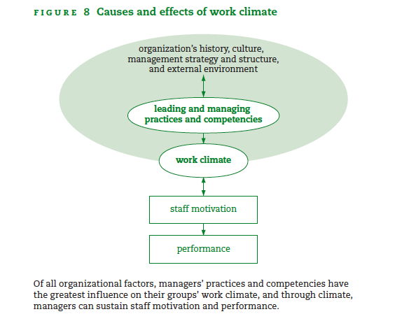
Source: MSH 2005:56

Leadership and management practices which build positive work climates, as outlined in the reading, include:

- Knowing yourself;
- Knowing your staff – their dreams, motivations, life situation, work styles and team roles (see Table 5 reproduced below);
- Providing challenge, clarity and support ;
- Strengthening communication: listening, responding constructively, avoiding inference , coaching, promoting team exchanges amongst others.
Note: We will look at ways of dealing with conflict, another aspect of strengthening communication, later in this unit.
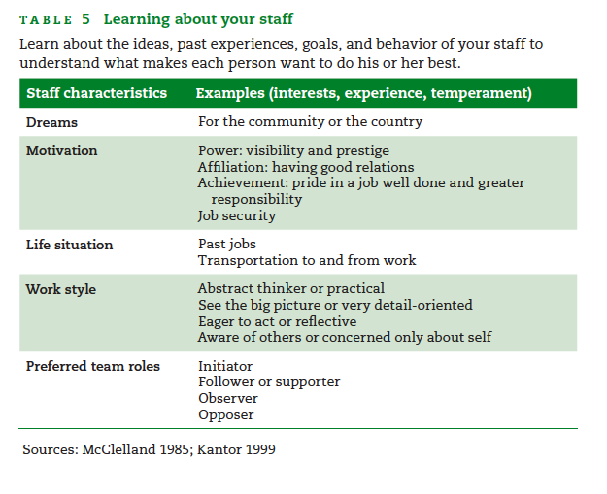

Activity 4: Compare readings about leading

Indicate points of similarity and difference in the three readings you have engaged with in this session by filling in the table below:

 | Mintzberg, (Managing) | Managers who lead | MSH ehandbook
Key points about managing people and teams

Other key words or phrases in the texts

8 Summary of Session
In this session we have considered different workplace relationships and how they affect management and leadership in organizations. We hope the significance of managing up, down and across relationships became clear from the readings and activities. We also looked at various aspects of management and leadership roles, both inward (within the organization) and outward (moving outside the organization). Finally, we explored further the manager’s role in creating a positive working environment, which we can assume is a key goal of good management practices.
In the next session we refer back to these leading/managing practices by analysing an interaction at Waitola Clinic, with which you are by now familiar.

9 References and Further Reading

Blaauw, D. et al., 2003. Organisational Relationships and the “software” of Health Sector Reform: Background paper for the Disease Control Priorities Project (DCPP), Johannesburg: Centre for Health Policy, University of Witwatersrand.

Unit 3 - Session 2: Creating positive work
climates

1 Introduction

In the previous session we outlined the diverse range of people and relationships involved in a manager’s world, and the need, therefore, for different approaches to managing different people. We asked you to consider in particular the challenges of “managing up” – dealing with people at higher levels of authority, and then introduced you to the practices involved in “managing and leading” people who report to you. In this session we explore in more depth the theme of creating positive work climates.

We begin with an activity to apply some of the principles introduced in the first session (e.g. ‘Know your staff’) to consider how to work towards change. We then go on to discuss the theoretical perspectives underlying some of the principles of managing individuals and teams outlined in Session 1. We conclude on a practical note, by discussing how to run an effective meeting, one of the core skills required to manage teams.

2 Learning Outcomes
In the course of this session, you will be addressing the session outcomes in the first column; they are part of the overall Module Outcome/s in the second column:

Session Outcomes | Module Outcomes
- Have applied the principles of creating positive work climates to a real life scenario;  - Be able to describe various theoretical underpinnings of these principles, including different perspectives (machine, economic, socio-cultural) on human beings in organizations, and theories of motivation and job satisfaction ;  - Have reflected on how to improve the way meetings are run in your organisation. | - Have conceptual tools for thinking about organisational change;  - Understand the scope of human resource management and the systems and skills required for managing relationships with people - below, up and out – in your organisational environment;  - Have reflected on their own management practices and how to improve these.

3 Readings

Blaauw, D. et al. (2003). Organisational Relationships and the “Software” of Health Sector Reform: Background Paper for the Disease Control Priorities Project (DCPP). Centre for Health Policy: Johannesburg. 9-33.

Management Education Scheme by Open Learning (MESOL). (2002). Meetings: Making them work. 69-76. In: Skills Pack for Module 1: The Manager. Adapted from The Open University Managing in Health and Social Care Series for South Africa by the South African Institute for Distance Education. Pretoria: Department of Health.

Management Sciences for Health. (2005). Managers Who Lead: A Handbook for Improving Health Services 3rd ed., Cambridge, MA: Management Sciences for Health. 3: 51-79.

Management Sciences for Health. (2010). Health Systems in Action: an ehandbook for leaders and managers, Cambridge, MA: Management Sciences for Health. 5: Managing Human Resources.

Mbindyo, P., Gilson, L., Blaauw, D., & English, M. (2009). Contextual Influences on Health Worker Motivation in District Hospitals in Kenya. Implementation Science, 10: 1–10.

4 Timing
The five readings and five activities in this session should take you about 12 hours to complete. You were introduced to two of the readings (MSH 2005; MSH 2010) in the previous session, so you will not need to spend as much time on them now as when you first read them.

5 “Things are going to change!”
To start this session, refresh your memory on the contents of the following texts, with which you should already be familiar:
- MSH. (2005). Managers Who Lead, Chapter 3 – which focuses on improving work climate in order to strengthen motivation and consequently performance.
- SOPH (2013) Management Strategies II. Unit 2, sessions 1-3 – Managing change and transition – which is about developing understanding and skills for managing change, with emphasis on getting things done by working with and through people .
- (SOPH) Case Study of the Waitola Community Health Centre.

In the first activity in this session, you will read part 4 of the Waitola Clinic case study which you have come across earlier in this module (Unit 1, session 3 and unit 2, sessions 1 and 3).

Activity 1 – Knowing your staff members and addressing their needs

Read Part 4 of the Waitola Clinic case study. This activity contributes to Assignment 2. Think about how Ms. Mayesiko managed Mr. Jantjies and the elements of this strategy that made it successful. How was trust developed in this relationship?

Feedback
You will have noticed the importance of developing an awareness of and interest in understanding a staff member’s dreams, motivations and needs, individually and in relation to the work team. Part 4 of the Waitola case study ends with Ms. Mayekiso beginning to think about next confronting the ARV doctor who always knocks off early. You might have considered the interesting role of nurses as managers of doctors, which can mean that they sometimes manage up and down simultaneously - up in a status hierarchy, down in organizational hierarchy.

In the next activity, you are asked to look at two tools for assessing staff job satisfaction, which have different approaches to the topic. The first is an individual job satisfaction survey (MSH, 2010, ehandbook, page 5:16). The second is a group Work Climate Assessment, which focuses on the functioning of the work team, as opposed to individuals (MSH 2005, Managers Who Lead, page 74). Both can be useful, depending on your purpose.

Activity 2 – Rating job satisfaction – two approaches

a. Complete the job satisfaction survey (ehandbook 5:16) How would you rate your overall work satisfaction? What do you see as areas of improvement?
b. Complete the Work climate Assessment (Managers Who Lead: 74). Do you think your colleagues’ responses would be similar to yours? If not, why?
c. Which of the two tools do you think would be more useful in your workplace currently? Why do you think so?

6 Knowing your staff: theories of people in organizations, motivation and
incentives

Theories relating to human behaviour in organizations
Read the two quotes below, taken from the blogs presented in session 1. As you read them think about what each says about human beings as workers in organisations, and about managing them.
“Supervising others is about helping them deliver their best stuff to the organization...You need to hold people accountable for doing their work successfully, but that's a lot easier to do consistently when you understand and support their motivations, goals, and concerns.”
“The dirty secret of management is that the power bestowed by your title is actually quite limited. The people who work for you are volunteers. They choose how hard to work and they can choose to ignore you, or leave, at any time if they’re not satisfied with your leadership.”

The first quote seems to express an optimistic view that workers are inherently willing and capable, and that good management enhances their performance. Management is seen as a positive and proactive process. The second quote seems to hold a different view; that people need to be coerced into good work, and that managing is a difficult process that pits the manager against the worker in a struggle for performance. In this view leadership doesn’t just happen, “leadership is earned as well as learned, not granted” (Mintzberg 2009: 66).

These opposing views pose questions about whether individual interests and organisational goals can be reconciled. This question also has implications for the role of management; an effective manager should try to bring the two together in order to create satisfied workers who strive to achieve the organisation’s aims.

Look at McGregor’s Theory X and Y of management (Table 3 in Blaauw 2003:20), for another take on the issue. McGregor claimed that organisations based on Theory X make negative assumptions about human beings which become self-fulfilling, and contribute to low motivation and poor performance. Organisations based on Theory Y, on the other hand, tend to be more productive, as they ‘get things done through people’ more effectively.

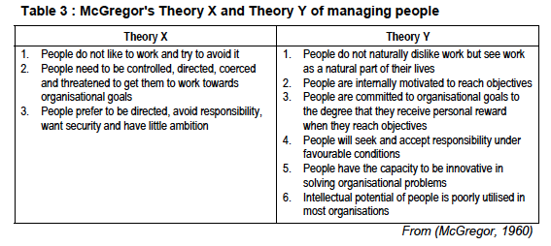
The next reading, was referred to in the previous session. It outlines three perspectives of human beings in organisations which represent three ways of thinking about and viewing organisations.
Reading
Blaauw, D. et al. (2003). Organisational Relationships and the “Software” of Health Sector Reform: Background Paper for the Disease Control Priorities Project (DCPP). Centre for Health Policy: Johannesburg. 9-33.

The table below summarises the three perspectives discussed by Blaauw as the “machine”, “economic” and “socio-cultural” perspectives of human behaviour. McGregor’s Theory Y has influenced the socio-cultural perspective, or what people also refer to as the “human relations” school of management. This approach recognises organisations in the health system as social systems. As such, they need to take into account human needs for belonging and social acceptance by promoting a shared understanding of organisational values and goals, creating supportive working environments and social networks, and building trust.
The other perspectives are also very influential in thinking about management of people in organisations. For example, many would view financial incentives (economic perspective) as a key lever of performance. The concept of “performance based financing” - where providers are rewarded financially for achieving specific service goals – is currently being promoted in many health systems across Africa. In the machine perspective, providers will perform if rules and procedures are clearly defined and clear lines of authority and systems of accountability (including sanction) are established.
The three different perspectives have also been summarised as the carrot (economic), stick (machine) and hug (socio-cultural) approaches to managing people.
 | Machine Perspective | Economic Perspective | Socio-cultural Perspective
View of organisation | Clearly defined parts working efficiently together in routinised ways | Atomistic economic actors engaged in market relations | Reflective, responsive people forming a complex social system
View of human behaviour | Compliant: Humans simply comply with organisational changes | Calculating: Humans are individualistic & motivated by self-interest | Social: Human behaviour is influenced by social networks and relationships
Coordinating mechanisms | Formal rules & procedures;  Authority | Prices  Competition  Financial incentives | Norms  Values  Trust  Shared meanings

Activity 3 – Identifying your own perspective

a. Which of the three perspectives in the table is closest to your view of working human beings and organisations?

b. Are there aspects of the other perspectives that you also recognise as important?

Most people would say that practically speaking a combination of the perspectives is the best and most realistic, although generally as individuals we tend to adopt a particular dominant view, depending on our underlying world views. Blaauw et al (2003:10) claim that, ‘A key question is to what extent the three perspectives are compatible or complementary.’ They go on to suggest that the three perspectives are not necessarily irreconcilable; there are areas of compatibility as well as areas of difference. They refer to the need for a different, more participatory and transformative approach to management and leadership in the health sector, which attempts to integrate the three perspectives.

There are many theories of human behaviour in organizations, in addition to those discussed in this section. You can refer to the following studies if you would like to read further on this topic. The full references are in the Further Reading section at the end of this session:
Maslow’s hierarchy of needs (Maslow, 1970)
Herzberg’s two-factor theory of job satisfaction (Herzberg et al, 1959)
Expectancy Theory (Vroom, 1964)

Motivation
Motivation has been defined “as an individual's degree of willingness to exert and maintain an effort towards organizational goals” (Franco, Bennet & Kanfer, 2002). Read Mbindyo et al, 2009: 1-10, on motivation and dimensions of it.

Reading
Mbindyo, P., Gilson, L., Blaauw, D., & English, M. (2009). Contextual Influences on Health Worker Motivation in District Hospitals in Kenya. Implementation Science, 10: 1–10.

The article is a report on an empirical study done in eight rural hospitals in Kenya, of the factors influencing motivation in the workplace, and the impact of these on staff members and their performance.

The study uses a conceptual framework for understanding the pathways to motivation (see Figure 1 reproduced below). The framework highlights the role of both “intrinsic” and “extrinsic” motivation, where intrinsic motivation refers to inner drives that are not reliant on external rewards, and “extrinsic” motivation as responding to rewards – both financial and non-financial.

The study found that there were many factors influencing workers’ motivation; these were linked and complex, and operated at different levels – individual, institutional and national. The study found that some institutional and national factors, such as unfairness of wages and lack of infrastructure and resources, could be mitigated by good management. For example, in hospitals where there was transparent communication, support for staff and acknowledgement of good performance, motivation was better than in hospitals where this was lacking, even though institutional constraints in the hospitals were similar.

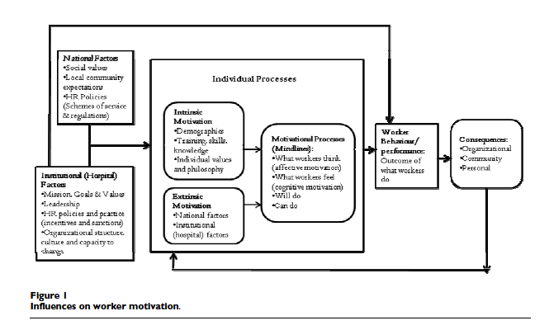
Incentives
Incentives are the externally driven rewards which influence motivation and ultimately performance. They can include both financial and non-financial rewards.

In the Kenyan study described above, it was found that incentives were an effective part of motivating staff, mediating the effects of other demotivating factors. However, most of the incentives reported on were ‘soft’ (non-financial) rewards, such advocating for staff increases and promotions, and providing access to appropriate skills development. Other incentives mentioned were apparently minor, yet proved effective, such as providing refreshments when staff worked long hours. It seems that the important underlying factor was that staff members were motivated if they felt acknowledged for their efforts and professional skills: financial incentives were important, but were not seen as the only possible rewards.
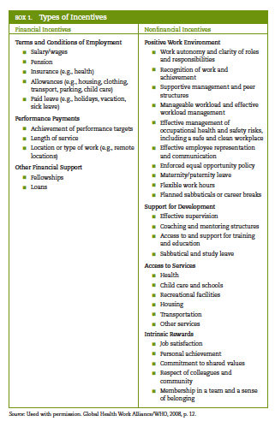

Look at the table on the left, taken from MSH 2010, ehandbook 5: 14, about financial and non-financial incentives. In this table, MSH have suggested that intrinsic motivation can be regarded as some kind of non-financial incentive to performance, and that this can be nurtured by building shared values, respect and a sense of belonging in the workplace.

7 Running an effective meeting

Most of us have to attend meetings of various kinds in the course of our work. Because of pressure of time and workload, as well as lack of training and experience, many of these meetings are poorly chaired or organised. It is not difficult to think of an example of a long, frustrating meeting we have attended, where there was a sense that some peoples’ voices had not been heard, and that the purpose of the meeting was not achieved.

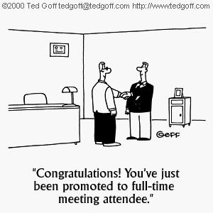
Yet meetings are often crucial forums for planning, making important decisions, resolving problems and building team work in organisations. For a meeting to be effective, it needs to have a carefully planned agenda, and be well managed by a chairperson who is well organised and a good communicator who knows how to facilitate discussions in order to reach goals.

Now read the extract from MESOL “Meetings: Making them Work”. Use the reading to help you with Activity 4 below:

Reading
Management Education Scheme by Open Learning (MESOL). (2002). Meetings: Making them work. pages 69-76. In: Skills Pack for Module 1: The Manager. Adapted from The Open University Managing in Health and Social Care Series for South Africa by the South African Institute for Distance Education. Pretoria: Department of Health.

Activity 4 – Making meetings work for you

Draw up a table. In one column make a list of the meetings you’ve attended in the last week, and in the other columns provide a brief commentary on what was good or bad about each.

Meetings | Good points | Bad points
Has anyone ever given you feedback about your meetings and chairing style? A good way to learn about running meetings is to get feedback on your own performance. Try the activity below if you are keen to improve your skills.

Activity 5 – Evaluate your ability to conduct a meeting

Based on the reading (and any other material you can get), draw up a checklist for conducting a good meeting in your work place.

If possible, and if you feel confident enough, ask a colleague to evaluate your conducting of the meeting. You can either work out a rating on the checklist, or your colleague can write a few comments (or give you oral feedback) describing your strengths and weaknesses related to the points on the checklist.

8 Summary of Session
We started this session by looking at the importance of knowing your staff members and their needs, by observing how they respond to their work and to management strategies that you introduce. From this we moved on to job satisfaction surveys as a way of starting to address staff needs.

The next section dealt with some theories of human behaviour in relation to organizations. Here we looked at McGregor’s Theory X and Theory Y, and Blaauw et al’s three perspectives on organizations and people in them. This lead on to the reading of a Kenyan hospital study of staff motivation, and what is meant by motivation, and incentives in this context.

The last section of this session focused on running effective meetings, as an important component of a manager’s role. Here you planned and evaluated meetings for your own context.

9 References and Further Reading

Franco, L., Bennett, S. & Kanfer, R. (2002). Health Sector Reform and Public Sector Health Worker Motivation: a Conceptual Framework. Social Science & Medicine, 54(8), pp.1255–66.

Herzberg, F., Mausner, F. & Snyderman, B. (1959). The Motivation to Work 2nd ed., New York: John Wiley and Sons.

Maslow, A. (1970). Motivation and Personality, New York: Harper and Row.

Vroom, V. (1964). Work and Motivation, New York: John Wiley.
Unit 3 - Session 3: Managing Conflict
1 Introduction
Conflict is an inevitable part of organisational life and of the change process itself. As a manager you can be involved in conflict with any of the actors – up, down and across – in your workplace; you may be called upon to resolve conflict amongst staff members. Conflict may manifest as inter-personal differences but can have many possible underlying causes, and there is no single way of managing it.

While conflict may be uncomfortable, it is not necessarily negative – it may enable individual and organisational learning and growth, and greater mutual understanding. Fearing conflict is however problematic, as it can inhibit development and problem-solving and keep difficult but important issues hidden.


This session discusses causes of conflict in organisations and some ways of dealing with these. We draw on one main text – a training module developed by MESOL. We also ask you to watch three videos from the Everyday Leadership series which discuss how different managers deal with conflict. You will analyse these videos using the “assertive-cooperative” behaviour model.

Source: http://everydayleadership.org/training-module/mastering-conflict

The attitudes to conflict and strategies you might develop to address it will depend a lot on your appetite and comfort zone for conflict. We provide a self-assessment tool for you to complete at the end of the session, which you can score, to find out where you fit into a range of approaches to conflict.

2 Learning Outcomes
In the course of this session, you will be addressing the session outcomes in the first column in the box on the following page; they are part of the overall Module Outcome/s in the second column:

Session Outcomes | Module Outcome
- Be able to describe and apply a framework for understanding conflict in organizations;  - Rreflect on your attitude to conflict in the workplace;  - Formulate an approach to managing conflict or conflict “norming”. | - Understand the scope of human resource management and the systems and skills required for managing relationships with people - below, up and out – in your organisational environment.

3 Readings and video material

The readings are available on your USB flash drive, and on the internet, at the addresses given.

Handy, C. (1993). Understanding Organizations. 4th ed., On Politics and Change. 10: 291-319. London: Penguin Books.

Management Education Scheme by Open Learning (MESOL). (2002). Unit 3: Managing Conflict, 49-69.
In: Module 2: Managing People. Book 3: Choosing Your Team and Managing Conflict. Adapted from The Open University Managing in Health and Social Care Series for South Africa by the South African Institute for Distance Education. Pretoria: Department of Health.

Video clips, self assessment tool, and course materials from Everyday Leadership http://everydayleadership.org/training-module/mastering-conflict

I-tech. (2011). Mastering Conflict Facilitator Guide (LMI Module). [Online], Available: http://everydayleadership.org/training-module/mastering-conflict [Accessed 18 Jan 2013].

4 Timing
This session contains four activities to help you engage with the readings and concepts introduced. There are also two fairly extensive and important texts to read, and a slide presentation and four short videos to watch. The session will probably take you at least 10 hours to complete.

5 Definition, symptoms and causes of conflict
‘Conflict can be defined as the struggle between opposing interests, principles, values or feelings.’ (MESOL module on Managing Conflict, 2002: 51)
Although the concept of conflict usually carries negative connotations, with images of winners and losers, anger and violence, it can be a positive force in the workplace if harnessed skillfully by those involved. Conflict is often the basis of creative plans and solutions to problems, and can build cohesion in teams; the challenge for leaders is to develop ways of managing conflict productively.

Various writers on the topic have theorized about the concept of conflict. Handy (2009), for example, distinguishes between competition and conflict: ‘Competition is useful and beneficial, conflict is damaging and harmful.’

The MESOL module distinguishes between ‘cold’ and ‘hot’ conflict. ‘Cold’ conflict is often characterized by stony silences or a veneer of unnatural politeness and cheerfulness covering discontent; ‘hot’ conflict is often easier to handle, as it consists of hostility, and outbursts of emotion and anger. ‘Cold’ conflict is less easy to identify, but you are probably aware of the common symptoms which indicate the presence of conflict, or potential conflict in the workplace. These may include poor communication and low morale in the organisation generally, and a strong reliance by management on enforcing roles and procedures, as well as recurrent recourse to arbitration to address dissatisfaction and issues that arise.

The two types of conflict (‘cold’ and ‘hot’) described above relate to three modes of conflict identified in the i-Tech module. These modes range from the passive to the aggressive. Read more about them in the i-Tech module, Mastering Conflict, on your USB flash drive:
- Artificial harmony exists where individuals are afraid to hurt others’ feelings or are afraid of repercussions if they speak out;
- Constructive conflict happens where issues are addressed in a positive manner;
- Personal attacks can take place where there are unmediated emotions and power struggles.

Activity 1 – Thinking about conflict in your workplace

Which of the two types (hot or cold) and three modes of conflict mentioned above (artificial harmony, constructive conflict, or personal attack) are the predominant ones in your workplace currently?

What is the reason for this; is conflict driven by a particular person or people in the organization, or is it driven by structures, policies, work demands, or some other force?

Causes of conflict
In the workplace, as in political or personal arenas, conflict is caused by differences in goals and ideologies, by poor communication, authority and power issues and by competition for resources and ‘territory’. It originates in a breakdown of expectations between parties or individuals, which is exacerbated in situations where change is taking place. Conflicts however need to be seen not as isolated incidents, but as part of the bigger contexts in which they occur, and in relation to the different sets of values and interpretations of those involved.

Now read the MESOL module, Managing Conflict, on the definition, symptoms and causes of conflict. Note that this reading makes reference to and requires you also to read Chapter 10 in Charles Handy’s book Understanding Organisations.

Readings
Management Education Scheme by Open Learning (MESOL). (2002). Unit 3: Managing Conflict, 49-69.
In: Module 2: Managing People. Book 3: Choosing Your Team and Managing Conflict. Adapted from The Open University Managing in Health and Social Care Series for South Africa by the South African Institute for Distance Education. Pretoria: Department of Health.

Handy, C. (1993). Understanding Organizations. 4th ed., On Politics and Change. 10: 291-319. London: Penguin Books.

6 A framework for understanding and managing conflict

One way of identifying types of conflict-behaviour is by looking at it in terms of cooperativeness and assertiveness. Cooperative behaviour is that which aims to satisfy others’ needs and concerns, whereas the aim of assertive behaviour is to satisfy own needs and concerns. The matrix below illustrates the five behaviours which can be represented in this way – avoiding, accommodating, compromising, collaborating and competing.

Find out more about these five types of behaviour in relation to conflict, in the MESOL module, pages 63 – 68 (An Alternative Model of Managing Conflict).

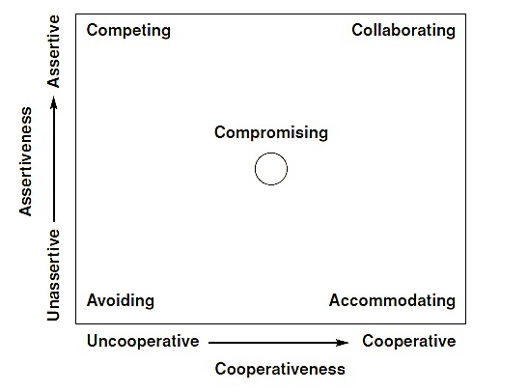

Now watch four short I-TECH video clips about different aspects and examples of conflict in the workplace, provided to you on the USB flash drive. You can also access them by clicking on the link below, then searching for each one by typing in the name in full in the search box in the top right hand corner of the home page. The clips are entitled:
- Mistakes will happen
- Reaching a compromise
- Confronting conflict
- Knowing what the boss needs

http://everydayleadership.org/training-module/mastering-conflict

Activity 2 – Analysing video clips about conflict in the workplace

a. Analyse each clip using the cooperative-assertive behaviour model below. Where would you place each situation discussed?
b. Why do you think this was the approach taken? Do you think that it was a good one?

We identified the following behaviours in the video clips; you might have seen others as well:
1. In ‘Mistakes will happen’, the speaker describes a situation in which cooperation and collaboration are used to solve problems and deal with mistakes.
2. In ‘Reaching a compromise’, the situation described involves co-operation, compromise, and even some accommodation.
3. ‘Confronting a conflict’ discusses avoiding – in the sense that it is not helpful - and also accommodating, as an alternative strategy
4. In ‘Knowing what the boss needs’ the focus is on accommodating.

7 Tools for managing conflict
In this section we draw substantially on the text in the box below, which is part of Everyday Leadership training course notes on dealing with conflict in health sector organisations. It is on your USB flash drive. Please go through the slides before continuing with this session. Focus particularly on slides 24 – 32, about tools and skills for mastering conflict.
Reading
I-tech. (2011). Mastering Conflict Facilitator Guide (LMI Module). [Online], Available: http://everydayleadership.org/training-module/mastering-conflict [Accessed 18 Jan 2013].
You will have noted the information on tools and skills for mastering conflict which are given in the presentation. To reinforce these, we summarise the key points below.

a. Some useful tools identified in the notes for the leader or facilitator to use in mastering conflict include:
- Build trust in the team
- Develop conflict norms or ground rules with the group
- Model and practice effective communication skills
- Bring the conflict into the open; then build acceptance of others’ points of view
- Reinforce healthy debate

b. Once you have a group commitment to resolving the conflict, how do you go on to resolve it constructively? What skills and behaviours are needed by a leader?
Mindset and attitude:
- Believing that a solution exists
- Commitment to finding a solution
- Validation of the existence of many perspectives
Skills:
- Prepare for conflict
- Understand cultural factors
- Be an active listener
- Show respect
- Validate all speakers
Helpful behaviours:
- Confront disrespect
- Enforce norms
- Balance participation
- Observe behaviours
- ‘Take the temperature’
- Allow constructive venting
- Facilitate solutions
Establishing norms or ground rules for working with conflict (Conflict norming) e.g.:
- Speak one at a time
- All ideas are valid and respected
- Paraphrase the others’ idea before speaking
- No personal attacks - separate the person from the position
- Use simple language and respectful tone
- Be conscious of body language

The MESOL module and Handy have broader sets of strategies for managing conflict, which take a slightly different approach from, but do not contradict the I-Tech module.

The MESOL course outlines five broad strategies for handling conflict:
- Allowing
- Smoothing
- Preventing
- Containing
- Reducing

These strategies are detailed in the MESOL reading, pages 60-61. You will need to read the section before doing activity 3 below. In this section, the five MESOL strategies are compared with those of Handy, which you can also read about if you are interested in exploring this area in more depth. Handy offers two broad strategies for handling conflict – firstly, making conflict healthy or productive, and secondly, controlling it. For each of these he describes a number of actions that could be taken. (Handy, 1993: 309-313)

Activity 3 – Applying conflict resolution strategies to your own context

Which of the five MESOL basic strategies for managing conflict would you use in the following workplace situations:
1. A dispute between two departments which both need crucial equipment over which department should be allocated the funds from the limited budget.

2. A conflict between two staff members over a particular incident that happened at work, which threatens to cause disruption in the department as other staff members start to take sides.

3. A disagreement between two mid-level managers over the best way to proceed with a project.

8 Everybody has a nemesis
It is important to accept that not everybody will agree with you in the workplace – some would say that everybody has a nemesis, a rival or opponent. Read the blog excerpt below for an interesting take on the ‘workplace nemesis’.

http://www.stratfordmanagers.com/blog/1077/workplace-nemesis

Your Workplace Nemesis
Frequent readers know that I’m a fan of Dilbert comics. Recently, Dilbert tried to recruit a new nemesis at work since his old one had retired. According to Dilbert, the physics of work require that each employee be matched by an “anti-employee” called a nemesis. It’s the nemesis’ job to continually thwart your progress and generally make your work life miserable.
It rings true doesn’t it? We all run into the naysayers, political backstabbers and surly gatekeepers that interfere with making progress at work. They test our patience, cause our blood pressure to rise and, in the worst cases, can lead to disillusionment and abandonment of good ideas. And it all happens under the radar of upper management. There’s no doubt about it, facing a nemesis in the workplace can be a toxic experience.
Yet even if it is sometimes justified, it’s often too easy to blame others for our failure to achieve our goals. The truth is, a big part of our jobs is to influence people and build consensus for our ideas. Those who actively oppose our initiatives are simply more extreme cases of everyone else that is neutral but still needs convincing. Sure, it means more effort but there’s always a way around an obstacle if you are clever and committed enough.
The toughest nemesis though, is the one that knows us best. Too often we subvert our own success through self-doubt, lack of preparation or lack of effort. Facing a little bit of resistance, we throw up our hands and throw in the towel, conveniently blaming others for our own lack of conviction. In doing so we further undermine ourselves by strengthening our inner nemesis.
So, the next time you run into an immovable object, tap into your inner irresistible force and redouble your efforts. Believe in your own capabilities and you will find a way to overcome. After all, you didn’t get this far by giving up, did you?

Activity 4 - Rate your own comfort with conflict and reflect on your learning

Complete the survey at the end of this session, taken from the Everyday Leadership program on Mastering Conflict, and consider where your approach to conflict fits on the assertive-cooperative behaviour axes. You could also reflect on how you might apply in your workplace what you have learned in this session.

9 Session Summary

In this session we have looked at some definitions, symptoms and causes of conflict. We then considered a framework for situating and describing types of conflict, based on a matrix with assertiveness/cooperativeness axes. You watched some video clips and used the matrix to analyse them. We then went on to find out more about tools for managing conflict, with reference to I-Tech, MESOL and Handy. Lastly you took a look at a blog about the workplace nemesis, and rated yourself on a conflict-comfort survey.
Handout 1: Conflict Profile (from www.everydayleadership.org)
Please respond to the questions below by circling a number between 1 and 9 that corresponds to the following scale.
1 = No Conflict. Complete avoidance of debate or argument. Individual opinions are not shared if they differ from common or dominant opinions.
3 = Some Conflict. Occasionally conflict occurs. Sometimes it is resolved, sometimes it is not.
5 = Conflict Happens. Parties participate in passionate debate when issues arise. Opinions are fully shared. Resolution of issues usually happens.
7 = Much Conflict. More conflict than can be resolved. Some injury occurs from conflict.
9 = Extreme Conflict. Arguments are common. Active, often loud discourse takes place with raw, emotional content. Resolution is rare-almost never happens.
- What did conflict look like in your family home when you were a child?
1 2 3 4 5 6 7 8 9
No Conflict Some Conflict Conflict Happens Much Conflict Extreme Conflict
- How did conflict occur in the most impactful community separate from primary family (i. e. neighborhood, church community, etc.) that surrounded you in your early years?
1 2 3 4 5 6 7 8 9
No Conflict Some Conflict Conflict Happens Much Conflict Extreme Conflict
- Think about your worst professional experience – how would you describe conflict in that situation?
1 2 3 4 5 6 7 8 9
No Conflict Some Conflict Conflict Happens Much Conflict Extreme Conflict
- Now think about your best professional experience – how would you describe conflict in that situation?
1 2 3 4 5 6 7 8 9
No Conflict Some Conflict Conflict Happens Much Conflict Extreme Conflict

- How would you prefer conflict to be in your personal life?
1 2 3 4 5 6 7 8 9
No Conflict Some Conflict Conflict Happens Much Conflict Extreme Conflict
- How would you prefer conflict to be in your professional life?
1 2 3 4 5 6 7 8 9
No Conflict Some Conflict Conflict Happens Much Conflict Extreme Conflict
- How would you prefer conflict to be in your immediate team (in a work setting)?
1 2 3 4 5 6 7 8 9
No Conflict Some Conflict Conflict Happens Much Conflict Extreme Conflict
What rules about conflict have you learned from your personal, professional and community life?
Sum up the scores
Scores | Attitude to conflict
7-14 | Prefers no conflict
15-48 | Acceptance of conflict
49-63 | Embraces conflict

Unit 3 - Session 4: Human Resource Management Systems
1 Introduction
In sessions 1-3 we dealt extensively with the management of people and teams, and the role of the manager in building positive work climates and staff motivation. These are the relational or “software” dimensions of health systems. To be effective, however, such people processes need to be anchored in a set of human resource policies and systems, the “hardware” of people management.

Human resource management systems are the “procedures, policies and practices [required] to recruit, maintain, and develop employees in order for the organization to meet its desired goals” (MSH, 2009: 1). There are five main elements to human resource systems:
- Ensuring the supply (capacity) of human resources
- Personnel policies and procedures such as recruitment and disciplinary procedures
- Human resource information systems
- Performance management systems
- Training

These are elaborated in table below, copied from the MSH ehandbook:5.6.
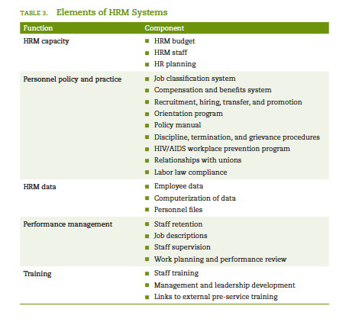

In this session we focus on aspect of human resource management systems, firstly focusing specifically on aspects of performance management, and the core practice of giving feedback. We then introduce you to a tool for doing a rapid assessment of your organisation’s human resource management systems.

For those of you who will be involved in or are interested in the design or implementation of aspects of human resource management systems, we strongly encourage you to consult MSH electronic resource centre, for their wealth of resources and tool kits relating to every dimension of HRM.

 | Internet Resource  http://erc.msh.org [Downloaded: 26.9.12].

2 Learning Outcomes
In the course of this session, you will be addressing the session outcomes in the first column below; they are part of the overall Module Outcome/s in the second column:

Session Outcomes | Module Outcomes
- Be aware of the importance, role and elements of human resource management systems, and how to go about assessing this in organizations;  - Be able to describe the dimensions of a performance management system;  - Be able to design a performance; management system for your own setting  - Describe the do’s and don’ts of giving feedback. | - Understand the scope of human resource management and the systems and skills required for managing relationships with people - below, up and out – in your organisational environment

3 Readings

You will not be asked to do these readings separately, but you will be referred to them as part of the activities in the session.

Management Sciences for Health. (1998). The Health and Family Planning Manager’s Toolkit: Performance Management Tool. Cambridge, MA: MSH.

Management Sciences for Health. (2009). Human Resource Management Rapid Assessment Tool.

Management Sciences for Health. (2010). Managing Human Resources Ch. 5. In: Health Systems in Action: an ehandbook for leaders and managers, Cambridge, MA: Management Sciences for Health.

4 Timing

The three readings for this session consist of detailed, practical tools which require close engagement; they are not a quick read. There are also three substantial activities which require you to read, think and apply your knowledge and experience. The session should take you about six hours.

5 Performance management

The area of performance management is thoroughly covered in the MSH (1998) document, which provides a tool for designing and implementing a regular Performance Planning and Review (PP&R) system. Such a system is important to enable an organisation or department to manage staff performance by helping staff members answer their key questions: What am I supposed to be doing? How well am I doing it? Does it matter to the organization? How can I develop in the organization? Without feedback or answers to these questions, it is difficult for employees to remain motivated.

Performance appraisal and management is also useful for the organization, as it provides crucial information for HR planning, career and remuneration decisions. Performance management should revolve around a cycle of work planning, performance reviews, and performance planning, (as in the diagram on the left) with an emphasis on performance being the basis for management decisions.
Performance reviews
Performance planning
Work planning

A performance management system will only work if certain conditions are met however:
- Management should commit to the process, and performance objectives should be set for all staff levels.
- The process should be collaborative and involve joint planning, with good communication between supervisor and staff member.
- The performance management system should aim to develop staff skills, motivation and career paths, but at the same time link their performance objectives to the goals of the organization or department.

Performance objectives need to be specific, realistic, measurable, and linked to a time-scale, in order to assess whether they have been met. Criteria for standards of performance, decided collaboratively, should provide employees with a clear idea of expectations. Criteria for assessing staff performance could include: teamwork, planning, cooperation, motivation, organization, initiative, punctuality and attendance.

Criteria for assessing management’s or supervisor’s performance, on the other hand, could include assessing whether the supervisor: gains respect and confidence of staff, communicates priorities and assesses results, actively develops staff performance, maintains confidentiality, responds promptly to needs, defines roles and delegates.

The planning and review process
Planning and reviewing performance involves one-on-one engagement between managers and staff. The following should be in place to facilitate the process:
- Clear job descriptions;
- Identification of "key results" areas;
- Jointly developing performance objectives and action plans;
- Developing a schedule of meetings to review performance and plan for the next designated period.
We look at the first three of these points in more detail below.

Job descriptions
In order to hire and orientate new staff, to review performance, to plan and supervise effectively and to decide on salary levels, it is important to have job descriptions in place for all posts. Job descriptions outline the scope and objectives of the tasks needed for the organization to reach its goals, as well as giving staff members a clear framework for their jobs.

Activity 1 – Compiling a Job Description

Fill in the job description outline below, for a HR Manager. Use your own experience and context to guide you, as well as the notes and examples of job descriptions in the Performance Management tool (MSH, 1998:12-17).

If you prefer, do the job description for a person you are supervising in your workplace.

Job Description – Human Resource Manager

Date:
Reports to

Job Purpose
Responsibilities/ Key Result Areas
Qualifications required for the job
Personal Qualities needed

Feedback
If you have written a job description for someone in your workplace, try to show it to a colleague, to check if s/he agrees with your assessment of the requirements for the job.

Key Result Areas and Performance Objectives
For each job there should be a set of specified activities, to be performed in a designated time, which have been agreed by both supervisor and staff member, for the purpose of assessing performance during the review process. They are key to successful supervision, and can be used as the basis for HR planning, promotions and salary increases. These performance objectives are linked to Key Results Areas, which in turn relate to the job description.

Activity 2 – Setting your Key Result Areas and objectives

Read pages 8-11 of MSH’s Health and Family Planning Manager’s toolkit, then write a list of key result areas for your own job, and the corresponding objectives for the next three months.

6 Providing effective feedback

The final, crucial stage of the performance management process, and part of an effective supervisory role, is giving feedback to staff on their performance. Feedback can take place formally in the performance review process, but should also happen informally on an ongoing basis to make sure staff are not ‘in the dark’ about their performance.

The following extract is taken from the MSH electronic resource centre. It gives guidelines and some examples of performance feedback to staff in a CBD (Community based distribution) programme (similar to a home-based care programme in South Africa).

Internet Resource
http://erc.msh.org/mainpage.cfm?file=2.2.2n.htm&module=hr&language=English
[Downloaded 20/11/13]

Providing Effective Feedback
Principles of effective feedback
Feedback means communicating to the staff your reaction regarding their work performance. Your feedback lets the employees know what they are doing well, where they need improvement, and how they can improve.
In order to make sure your feedback is effective, your comments should be:
- Task-related. Your comments should be related to the actual tasks carried out by the staff and should be based on your own observations of how these tasks are done.
- Prompt. Give feedback after your observations of employees' work and your conversations with them and in the presence of other staff members who are involved. The longer the delay, the weaker the effect of the feedback.
- Action-oriented. Your comments should relate to improvements that employees can make through their own efforts.
- Motivating. Start with positive feedback, then progress to what needs improvement.
- Constructive. Discuss with the staff how they can improve their performance, taking care to emphasize that their work has value.

In reality, feedback takes place almost continuously during on-site supervision or during a supervisory visit.

Example of Ineffective feedback from a supervisor to a CBD agent:
"I've been meaning to tell you, I don't like the way you handled the visit to Mrs. R's house last month. You spent too much time talking about unimportant things. This program is not an excuse to sit and chat with your neighbors! She said she'd been having headaches and you didn't ask her if she'd had them before. You obviously haven't remembered our training sessions very well. Are you too lazy to re-read the manual? Don't you remember what to do when a client complains of headaches? Go back and read the manual, and don't let me catch you making that mistake again!"

Example of Effective feedback from a supervisor to a CBD agent:
"During the visit to Mrs. R's house today, you were very friendly and warm, and I see that you have established a good relationship with her. Your reminders to her about how to take the pill were clear and complete, and it is excellent that you remembered to repeat them, since she is a first-time user who just started last month. You listened well when she told you the problems she has been having with taking the pill.
"However, there are two things that you should do differently next time you see a client with these complaints. She is a new pill user, and it is important to reassure new pill users that their nausea will probably disappear by the second month. Her headaches could be due to many causes. Next time a pill user complains of headaches, ask her whether she had these headaches before she started taking the pill. Take her blood pressure.* Also, keep track of who is complaining about headaches. If a woman has this complaint two months in a row, refer her to the health center. If her headache is severe and accompanied by nausea, refer her at once. "Later this afternoon, I'll review our policies for treatment of side effects of the pill with you, to refresh your memory."
* Not possible in some CBD programs.

Activity 3 – Evaluating feedback in action

Think about: What do you think are the main differences between the effective and ineffective feedback above?

7 Assessing human resource management

The MSH (2009) reading consists of a Rapid Assessment tool for assessing human resource management. In the next activity we ask you to look at this tool and fill in a section of the form, to give you an opportunity to engage with the tool, as well as to practice assessing aspects of your organization.

The Rapid Assessment HRM tool is designed to assess an organisation’s strengths and weaknesses in order to lead to an action plan to improve priority areas of the Human Resource system. It consists of a form which details 22 components in 5 broad HR areas, and enables an assessor to analyse these in terms of four stages of development. The components are therefore not seen as ‘successes’ or ‘failures’, but as part of a continuum of development. For example, for an area which is rated at level 2, improvement can be planned by setting the level 3 descriptor for that area as a developmental goal.

A strong, effective HR system is crucial to help an organization develop its HR plans, and to adapt to changing service delivery needs. It also helps to improve the morale of the workforce, and in the retention and recruitment of staff.

Activity 4 – Working with the HRM assessment tool

1. Look at pages 11-12 of the HRM tool, the section on ‘Performance Management’. You will see that there are four HR components in this section:
- Staff retention
- Job descriptions
- Staff supervision
- Work planning and performance reviews
2. For each of these components, read the descriptions of each stage (1 – 4), and note:
a. What is your organization’s or department’s current stage for this component?
b. What evidence is there for your analysis?

(These two points correspond with the two blank columns an assessor would complete in the HRM tool.)

The section you have completed should have given you an idea of what is involved in doing a Rapid Assessment of human resource management. You can decide whether this would be a useful tool for your organization or department to use in its’ planning and evaluation processes.

8 Summary of Session
In this session we have focused on a key element of Human Resource Management Systems - performance management. We aimed to develop your performance management skills in three areas - writing job descriptions, designing performance objectives, and giving feedback to staff on their performance. Finally, we looked in detail at a tool for the assessment of HRM systems – Rapid Assessment. We hope this session has given you confidence as well as practical tools to better manage, or at least contribute to the management of human resources in your organization or department.

