Introduction

UNIT

1

What is Health Promotion?

Welcome to Unit 1!

This Unit provides an introduction to Health Promotion, what it means and the ideas underlying this concept.

In this Unit there are two Study Sessions

Study sessions
Study Session 1: Defining Health Promotion
Study Session 2: The determinants of health

In the first session, we explore how one’s concept of health determines the way we see Health Promotion. In Session 2, we look at different perspectives on the causes or determinants of health and ill-health in order to develop a deeper understanding of Health Promotion and its approaches. The second session builds on the first, and it is only by the end of the Unit that you are expected to be able to define the concept.

There are a number of academic skills which have been integrated into the Unit. They include learning selected concepts related to Health Promotion, clustering or categorising information and comparing and summarising concepts in texts as well as interpreting diagrams. Much of the Unit is devoted to critical analysis of concepts and perspectives: try to discuss your understandings with fellow students or colleagues in the workplace as this is a very good way to clarify your understanding. Analysis cannot take place by reading passively, so try to engage in the activities before you read the feedback.

Before you start, look back at your Assignment topic and analyse what sorts of information you will need to complete it. Have this next to you while you study, so that you study with focus. You can then mark relevant parts of the Study Sessions as you work through them.

In many of the sessions, you are referred to a very useful publication by Coulson, N., Goldstein, S. & Ntuli, A. (1998) called Promoting Health in South Africa: An Action Manual published by Heinemann. We strongly advise you to buy a copy as it contains more than we can provide in the Reader.
A number of websites are also listed in the units: they will always be listed under Readings at the beginning of each session. If you have a chance to use the Internet, run through them and get familiar with the all the resources which are available to you. At the end of the last session of each unit is a list of further readings. Be aware of these resources next time you are in a library.

Good studying, and keep focused on completing sufficient sessions per week to meet your deadline. Working consistently gives one a sense of control and will make a real difference to your enjoyment of your studies.

Intended learning outcomes

By the end of this session, you should be able to:

Health Promotion outcomes:  - Define Health Promotion.  - Describe how perceptions of health and the determinants of health influence approaches to Health Promotion.  - Examine different concepts and models of health.  - Consolidate your understanding of Health Promotion.  - Describe key determinants of ill-health including social determinants and how they are linked.  - Describe how perceptions of health and the determinants of health influence approaches to Health Promotion.  - Understand the difference between Health Promotion and Health Education. | Academic outcomes:  - Define new concepts.  - Critically analyse points of view.  - Classify and rank information and explore your reasons for this ranking.  - Extract information from a text.  - Interpret diagrams  - Critically analyse definitions.  - Interpret diagrams.  - Anticipate and solve problems.  - Summarise information.
Unit 1 - Study Session 1

Defining Health Promotion

Introduction

Nowadays we hear a lot about Health Promotion. People refer to it in workshops and meetings. Directors of Health Promotion in the Department of Health use this term to describe the nature of their work and development workers discuss Health Promotion in relation to health campaigns. But what is Health Promotion? What does it aim to do? What ideas underpin Health Promotion? These are some of the questions which we will explore in this session.

Contents

1 Learning outcomes for this session

2 Readings
3 Different definitions of Health Promotion
4 Different concepts of health
5 Session summary

6 References

Timing of this session

This session contains one reading and five tasks. It will take you about three hours to complete. A logical point for a break is after Section 3.

1 LEARNING OUTCOMES FOR THIS SESSION

By the end of this session, you should be able to:
Health Promotion outcomes:  - Define Health Promotion.  - Describe how perceptions of health and the determinants of health influence approaches to Health Promotion.  - Examine different concepts and models of health. | Academic outcomes:  - Define new concepts.  - Critically analyse points of view.  - Classify and rank information and explore your reasons for this ranking.  - Extract information from a text.  - Interpret diagrams and use diagrams to summarise information.

2 READINGS

There is only one reading for this session which is listed below. You will be directed to it in the course of the session. The reference list is at the end of the session. Further readings can be found at the end of Session 2.

Author | Title
Reynolds, L. & Sanders, D. | (2007). Our children are dying in droves - and this is why. Cape Times. August 22.

3 UNDERSTANDING HEALTH PROMOTION

We will examine Health Promotion by focusing on different concepts and issues which affect our understanding. Let us begin by looking at what your understanding of Health Promotion is. You will of course be exploring this throughout the module, but this first task is to assist you in thinking for yourself about what it might mean.

TASK 1 – Defining Health Promotion
How would you define Health Promotion? Quickly jot down your own definition and keep this for later.

FEEDBACK

You might have spent some time thinking about which Health Promotion programmes you know about. This might have been a difficult task, as Health Promotion programmes are often not flagged or labelled as such. Instead, they are often found embedded within the broad activities of health and development organisations. They are also found in a variety of different settings, and assume different approaches. This is particularly true at a local or district level, where the delivery of health services is tackled in a comprehensive way, where there are more opportunities for inter-sectoral action, and consequently where Health Promotion activities are hidden within these integrated health activities.

Now let us look at the World Health Organisation’s (WHO) definition of Health Promotion:

“Health Promotion is the process of enabling people to increase control over, and to improve, their health. To reach a state of complete physical, mental and social well-being, an individual or group must be able to identify and to realize aspirations, to satisfy needs, and to change or cope with the environment. Health is a positive concept emphasizing social and personal resources, as well as physical capacities. Therefore, Health Promotion is not just the responsibility of the health sector, but goes beyond healthy life-styles to well-being.” (Ottawa Charter for Health Promotion, WHO, 1986)

The Ottawa Charter
The Ottawa Charter is a key document in Health Promotion. It was developed In Ottawa, Canada, at the first international Health Promotion conference that was held. It is what some people call the ‘mantra’ of Health Promotion. We will go into more detail about the Ottawa Charter later on and will refer to it throughout the module to show its relevance to Health Promotion.

You will need to read the above definition a few times to fully grasp its meaning. Let us look at some of the key aspects mentioned:
- “...enabling people to increase control over...” This means to give people the ability to be able to do something about their own health.
- “...complete physical, mental and social well-being...” This implies that Health Promotion does not only address physical health but all the other dimensions of health which we will come back to further on in this session.
- “Health is a positive concept...” This means that we do not look at health in a negative light such as ‘not being ill’ but rather at what it is that contributes to well-being.
- “...not just the responsibility of the health sector...” From this definition we can see that it is not only physical health that is referred to, and therefore in order to address all dimensions of health we need to involve other sectors so that people can fully realise their potential to live in healthy ways and to be healthy.

Your definition might have been different to the WHO one, so let us see why this might have been the case. We will look at how the interpretation of this concept is based on your understanding of health. This builds on some of the ideas discussed in the Introduction to Public Health module.

4 DIFFERENT CONCEPTS OF HEALTH

TASK 2 – Explore different understandings of health

- Speak to four or five people that you come into contact with in your work, e.g. other health professionals, teachers, social workers, engineers and lay or community people in your neighbourhood. Ask them: “What would you need in order to feel healthy and to live a healthy life?” List their ideas.

- Now show them the pictures and ask them whether they think the people in the pictures are healthy or not and why they think so.

- Look at your final list and consider the similarities and differences in people’s ideas about health. Ask yourself why they see the issue differently.

FEEDBACK

You probably found that lay or community people and other professionals have different perceptions of health from you and your health colleagues. When we showed people in our department the pictures this is what they said;

 | Administration | Academic
Picture 1 | - Man sweating is sick because of the conditions he is working in  - He is stressed because he is being sacked  - The other two are healthy because they can do the physical work.  - The environment they are working in however is not conducive to health. | - He might not look healthy but because he has been paid, he will be able to sort out his financial problems and this will mean that he will be happier and therefore healthier.  - The expression on the middle man’s face shows that he is really exerting himself which cannot be good for his health.
Picture 2 | - The man is sick because he is old and thin.  - The children are healthy because they are smiling and look healthy. | - The old man looks emaciated and must therefore be malnourished.  - Even if the man looks thin and old he can still be healthy because if he lives in a society where elders are respected then he will have the attention of the younger children which is good for his well-being and health. But if it is in a different context then the children might be laughing at him which might make him feel unhappy and that is not good for his well-being

In most societies there are many ways of interpreting health and illness. Kleinman (1980, cited by Helman in Gilbert et al, 1996) has suggested that when we look at any complex society, we can identify three overlapping sectors of health: the popular sector, i.e. the lay or non-professional sector; the folk sector, i.e. the traditional, sacred or secular sector; and the professional sector, i.e. the legally-sanctioned sector such as western scientific medicine. Each sector contributes to how we experience and interpret what being healthy or sick means.

Here is an example of how these sectors overlap in practice: We might start constructing our idea about health and illness from our personal experiences. Our ideas may be based on our own experience of being sick, or of having to take care of a family member who is sickly. Our ideas about health and illness may be derived from listening to neighbourhood or community beliefs or advice about how to keep away colds in winter, or how important it is to eat certain foods to combat a particular illness. Such ideas form part of the popular sector. However, we might also construct our ideas about health and illness from the folk sector, e.g. a traditional healer, a diviner or a spiritualist, or from what in South Africa is called an alternative healer such as an acupuncturist, polarity therapist or homeopath. Health and illness is viewed by many in this sector as holistic with all aspects of the individual’s life being considered as equally important. In other words, our relationship with others, the natural environment, supernatural forces and any physical and/or emotional symptoms would all be considered in a consultation with such a healer.

Often a health worker will move between the popular, the folk and the professional sector. The latter sector is traditionally known as western scientific medicine or allopathy. It includes medical practitioners such as doctors, nurses, and psychiatrists; and institutions like hospitals and clinics. Helman notes that, “in most countries the practitioners of scientific medicine form the only group of healers whose positions are upheld by law … [and] those who practice medicine form a group apart …” (In Gilbert et al, 1996: 63) Whilst the last sector holds a dominant position in our society, people’s ideas about health and illness will not be constructed from this sector alone – nor will they necessarily seek relief from illness from a single health practitioner or healer.

We now look in detail at some of these perceptions and at a way of understanding and working with these differences.

Health is something which is difficult to define as everyone has a different concept of health. It is so much easier to define something that is relatively simple. For example, a table can be defined as a flat surface with legs (although even this could get complicated, as tables can have four legs, two legs or one leg!). More complex or abstract things are more difficult to define and are thus explained conceptually. A concept like health is difficult to define but it can be conceptualised or understood mentally. In other words, you can describe your concept of health but not necessarily define it. The important thing is to think about your concept of health and to be able to articulate and communicate it to others. We also need to respect other people’s concepts of health. If, to my neighbour or my colleague, being healthy means being fit and never being ill, whereas to me it means to have a sense of wholeness, well-being and peace – I should acknowledge and respect this difference in opinion.

“We experience health and illness as individuals, yet it is through influences such as culture, class and gender [and age] that these are shaped” (Jones, 2000:23). Studies have suggested that older people are more likely to view health in terms of resilience and coping, rather than fitness (Williams, 1983; Blaxter, 1990). “Young people define it in terms of fitness, energy, vitality and strength, emphasising positive attainment and a healthy lifestyle” (Jones, 2000: 23).

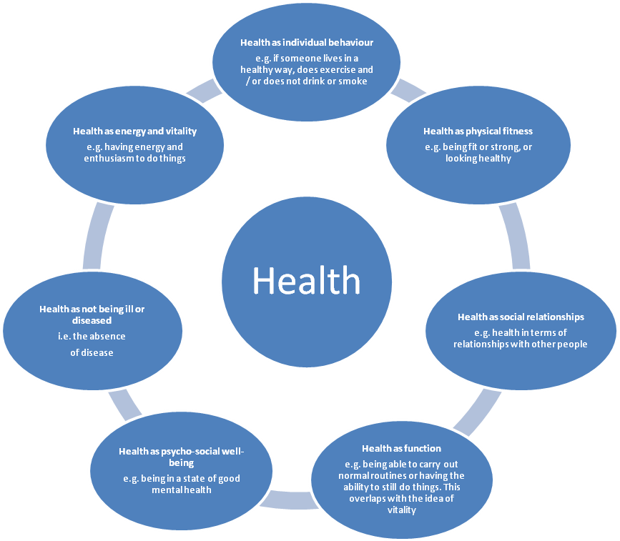
Many researchers and writers have explored how different people have different definitions or concepts of health. Sometimes this is discussed in terms of lay and health professional concepts or definitions of health. For example, Blaxter (1990, in Baum, 1998) working from a British sample of 9 000 people, grouped their lay definitions of health into a number of different perspectives. Health was generally defined as follows:

d’Houtard, et al (1990, in Bowling, 1997) suggest that lay perceptions of health might also include references to good living conditions. They might also include a spiritual dimension. For some people, health, ill health and the process of healing are influenced by external religious or supernatural powers (Baum, 1998: 10-11).

Consider how important it would be if you were developing a national Health Promotion campaign (for example with the 9 000 individuals that Blaxter included in her sample), to bear in mind just how diverse people’s ideas about health are. It would also be important to bear in mind the influence that the popular, folk and professional sectors have on influencing your audience’s interpretation of health.

When people turn to discussing professional as opposed to lay perceptions of health, it is still often notable that their perceptions have been influenced by the particular model of health or illness that has influenced their interpretation. Health professionals will, for example, be influenced by the training that they have received.

In Health Promotion literature there are often references to two opposing views of health: the Bio-medical Model and the Social Model of health. Let us briefly consider each model.

4.1 Medical and Social Models – two different views of health
The Bio-medical Model defines health as, “the absence of disease” and is based on the assumption that disease is generated by specific agents (such as a virus or a bacillus) which lead to changes in the body’s structure and function (Bowling, 1997: 19). This is a rather mechanistic and negative definition of health, and emphasises the importance of alleviating symptoms or curing diseases, using medical technology.
Naidoo & Wills (1994) note that definitions such as these originate in a western scientific medical paradigm. The western scientific medicine paradigm tends to define health “… more by what it is not than what it is” (Naidoo & Wills, 2000:9). A person is only healthy when s/he has no disease or no illness. In a sense this model halts its analysis at the actual disease – and those who support it have little interest in exploring what other determinants – (apart from what specific agent, like a virus or bacillus) caused the disease. It also places limited emphasis on prevention, as the traditional training of health professionals focuses on the benefits of treatment rather than the prevention of disease (National Forum for CHD prevention, 1990, cited in Naidoo & Wills, 2000:12).
Paradigm:
A particular model or pattern of well-established academic ideas that create a framework of understanding.

The Social Model of health, on the other hand, views health and ill health as being caused not by diseases alone but also by social conditions. These could include poverty, poor environment and a lack of work. For example, if we consider HIV, people that subscribe to the Bio-medical Model of health would focus simply on the HI virus being the cause of the current epidemic. People who subscribe to a Social Model of health would also consider the role that factors such as poverty, gender and violence play in contributing to the increase in the epidemic.

The Social Model emphasises the positive side of health, and defines it in terms of a state of well-being. The link between the physical, psychological and social processes also suggests that health is more holistic in nature. This is illustrated by the WHO’s definition of health as, “a complete state of physical, mental and social well-being, and not merely the absence of disease or infirmity” (WHO, 1948).

More recently, in a discussion document entitled Health Promotion: A Discussion Document on the Concept and Principles, the WHO broadened the definition of health to include health as a human right and something which requires prioritisation and social investment by all, including governments, organisations, business and others (WHO,1984).

“[Health is] the extent to which an individual or group is able, on the one hand, to realise aspirations and satisfy needs, and, on the other hand, to change or cope with the environment. Health, therefore, is seen as a resource for everyday life, not an object of living; it is a positive concept emphasising social and personal resources, as well as physical capacities” (WHO, 1984).

TASK 3 – Classify different perceptions of health

We interviewed a range of people – from those living in informal settlements and wealthy suburbs, to people who were physically healthy or living with HIV. We asked them: “What would you need in order to feel healthy and live a healthy life?”

Below are some of the answers we received. Classify these responses according to the two different models of health described above.

- Having no money
- No natural disasters (e.g. floods)
- Having interesting, challenging work
- Having a flushing toilet
- Good roads
- Feeling secure from danger or threat
- Not to have diseases I can’t easily cope with
- Not to have TB
- Not smoking
- Protected from discrimination
- Having good friends
- Having a job
- Having a house
- No violence
- Feeling happy
- Having enough food
- Feeling well, happy, stimulated by life and spiritually content
- A clean environment
- Feeling spiritually fulfilled
- Being fit and lean
- To feel strong and keen to take on new challenges

FEEDBACK
There are different ways of classifying these responses. This is how we classified them:

BIO-MEDICAL MODEL OF HEALTH

- Not to have diseases I can’t easily cope with
- Not to have TB

COMMUNITY
INDIVIDUAL

- To quit smoking
- To be fit and lean
- To feel strong and keen to take on new challenges
- Having money
- Having a job
- To be happy
- Protection from discrimination
- Having good friends
- No violence
- Good roads
- A clean environment

- Feeling secure from danger

- Having a house
- Having a flushing toilet
- Having enough food
- No natural disaster (e.g. floods)

- Having interesting work
- Feeling spiritually fulfilled
- To feel well, happy and stimulated in my life, and to be spiritually content

SOCIAL MODEL OF HEALTH

You will see from the diagram that most of the responses fell into the Social Model of health framework. We thought it was also interesting to look at whether the responses focused on individual needs or on needs which were linked to others, suggesting that health was often linked to community.

We found it difficult to place the decisions about individual behaviour changes, such as not smoking, into the models because of the limited emphasis on prevention in the Bio-medical Model. In the end, we felt that they fitted best in the Bio-medical Model as they are directly related to the prevention of diseases. You may disagree, and consider that they should rather be in the Social Model. Later on we will deal with the issue of individual behaviour versus other approaches and this will help you to think more about these issues. Using the Social Model is useful when you are thinking about Health Promotion as it gives you an idea of how different people view health and then you can examine what influences these perceptions. Which model do you think is closer to your way of thinking about health and ill health?

TASK 4 – Explore factors influencing health

- List the factors that you think influence the way people perceive being healthy?
- Why is it important for a health promoter to understand how different people perceive being healthy?

FEEDBACK

- Being healthy means different things to different people as alluded to earlier on. The responses we received from people were influenced by:

- the context in which they were living, e.g. geographical or physical location, housing, income, employment status
- their current health status
- their knowledge, experiences and beliefs about health.

As a health promoter, it is always important to reflect on what being healthy means to you and what it means to your clients, as this will have an important influence on the approach you adopt to Health Promotion.

- It is important for a health promoter to understand how different people perceive being healthy because that will influence the way you go about planning your interventions for your particular target group. Invariably there will be things that you as cannot directly help your clients with. For example, ensuring that there is an accessible, well maintained and safe public transport system in the country falls outside of the health service’s responsibility. However, to take a local example, a health worker might work with her/his clients to start lobbying the local government council to put more traffic officers on duty around schools and parks, or to run educational campaigns about road safety at primary schools. Health workers might begin to work inter-sectorally with other departments to reduce the high rate of traffic accidents or to increase road access to rural villages. In this way they will be contributing their professional perspective or experience as a health worker to broader developmental issues.

4.2 The dimensions of health

As you can see, when people speak about being healthy, they refer to a number of different areas of their daily lives. These different areas have been conceptualised as different dimensions of health (Aggleton & Homans, 1987; Ewles & Simnett, 1999). Adapting the work of these authors, Naidoo and Wills (2000) illustrate the seven dimensions of health in the following diagram.

In the diagram, the inner circle represents the more individual or personal dimension of health, whereas the outer two circles represent the broader or societal dimension of health and the individual’s interaction with the world.

Ewles and Simnett suggest that identifying the different dimensions of health is a useful exercise in that it alerts us to the complexity of the concept of health. They note however that, “… in practice, it is obvious that dividing people’s lives into ‘physical’, ‘mental’ and so on often imposes artificial divisions and unhelpful distortions of a situation … All aspects of health are interrelated and interdependent …” (Ewles & Simnett, 1999: 7). This is what many people refer to as a holistic concept of health.

Now let’s look at the second word that makes up the concept Health Promotion.

TASK 5 – Define (Health) Promotion

- What does promote or promotion mean to you? Jot down some ideas, or check the meaning in a dictionary.
- Given your concept of health, what does Health Promotion mean to you now?
- In order to promote health what information do we first need to understand?

FEEDBACK

- To promote means to advance, assist, encourage, lend support to, market, publicise, help the progress of something, or push for.
- Simply put, Health Promotion means to advance, to assist or to push for a better, healthier life for people. To use an analogy: health and development workers often feel like they spend all their time standing on the banks of a fast flowing river lifting people to safety. In a sense, the health promoter works upstream and tries to find out why people are falling into the river from the beginning and how we can work together to prevent such things from happening in the future. See the reading by Reynolds & Sanders (2007) as an illustration of this analogy.

- In order to promote health effectively with individuals and communities, we first need to understand the causes or determinants of health and ill-health which we will discuss in the next session.

TASK 6 – Upstream –Downstream approach

READING

Reynolds, L., & Sanders, D. (2007). Our children are dying in droves-and this is why. Cape Times. August 22.

Look at the above reading and the illustration that goes with it. You will see how Reynolds and Sanders have used Under 5 mortality to show the importance of looking ‘upstream’ at the underlying causes of ill health. In other words they emphasise the need to recognise and address the social determinants of health. They have used examples of under-nutrition, causes of HIV/AIDS, respiratory diseases, and diarrhoea.

- What implications do you think this approach has for health promotion?
- Think now of a very different, significant health problem in the world, including in sub-Saharan Africa – that of the growth in obesity and the subsequent increase in type 2 diabetes and hypertension. Think of the upstream factors that are having an impact on this increase in obesity, focusing particularly on people moving from the rural to the urban areas. Make a list of some of the factors you think are involved.

FEEDBACK

- When looking upstream, you inevitably have to look at solutions that are broader than the responsibility of the health department. In other words, you have to work in partnership with others.
- Upstream causes of obesity: Changes in ‘lifestyle’ (diet and exercise) are often described as being the reasons for the increase in obesity. However, if you then look upstream, you will see that there are many factors that influence these changes, and they are important to recognise and address where possible. These include:

Changes in diet
- Poverty and density of living conditions – for the most part, people are no longer able to produce their own food, and need to buy their food. They will usually go for the cheaper options – often fatty meats, chicken skins, etc.
- Availability – their food choices will be dependent on availability. This is often limited in the poor urban areas, so that healthy choices are not only expensive but often not even available.
- Fast foods – one of the consequences of moving to the urban areas is the adoption of a more ‘western’ lifestyle, which includes buying fast foods, such as Kentucky Fried Chicken. This may be favoured because it is easier than cooking, particularly in areas where there is limited water and electricity. It is also seen as ‘progress’. The marketing of these fast foods is recognised as a factor in making them seem attractive.

Reduction in physical activity
- Employment/unemployment – jobs in the urban areas tend to be of a more sedentary nature compared to the physically active farming activities that people have been used to in the rural areas. There are also high rates of unemployment among people migrating to the urban areas, so their mobility is limited.
- Transport – people have access to transport, which means they walk less on a daily basis.
- Violence – a less obvious, but nonetheless important reason for a reduction in physical activity is the extent of violence in many poor urban areas, which means that people (in particular women) are more nervous of being outdoors – especially at night.

Culture
- These practical constraints are often accompanied by a cultural practice that encourages obesity among women as being an indicator of success, and of being looked after by your husband.

Clearly these upstream factors are difficult to address. However, giving a health message of adopting a healthy lifestyle without considering these factors can be equated to a downstream approach. People’s ability to make the changes would be significantly influenced by the above determinants, and consequently, just telling them to change their lifestyles could be ineffective.

We will examine approaches for developing programmes that involve other sectors later in this module.

5 SESSION SUMMARY

In this session, we looked closely at how different understandings of the concept of health affect our definition of Health Promotion. Through critical analysing your own understanding and the understanding of others, and by applying some issues and models to your understanding, you are hopefully developing a deeper understanding of what is meant by Health Promotion. In the next session, we will continue this exploration by studying another dimension which affects our understanding of Health Promotion – the determinants or causes of health.

6 REFERENCES AND FURTHER READING

Baum, F. (1998). The New Public Health: An Australian Perspective. Melbourne: Oxford University Press.

Bowling, A. (1997). Research Methods in Health: Investigating Health and Health Services. Buckingham: Oxford University Press.

Ewles, L., & Simnett, I. (1999). Promoting Health: A Practical Guide, Fourth Edition. London: Bailliere Tindall.

Jones, L. (2000). What is Health? Chapter 2 in Promoting Health: Knowledge and Practice. Eds. Katz, J., Peberdy, A., & Douglas, J. (2nd edition). Oxford University Press. London..

Kleinman, (1980). In Helman, C. (1996). Chapter 6: Caring and curing. In Gilbert L., Selikow, T.A. & Walker, L. Society, Health and Disease: An Introductory Reader for Health Professionals. Randburg: Ravan Press.

Naidoo J., & Wills, J. (2000). Health Promotion: Foundations for Practice, London: Bailliere Tindall.

Renolds, L., & Sanders, D. (2007). Our children are dying in droves-and this is why. Cape Times. August 22.

WHO. (1948). Preamble to the Constitution of the World Health Organization as adopted by the International Health Conference, New York, 19-22 June 1946, and entered into force on 7 April 1948.

WHO. (1984). Health Promotion: A Discussion Document on the Concept and Principles. Copenhagen, WHO Regional Office for Europe.
Unit 1 - Study Session 2

The Determinants of Health

Introduction

In this session we continue to examine the concept of Health Promotion and the ideas which underpin it. When working in the field of Health Promotion, it is important that you clarify for yourself what you and others understand by health, and what the causes or determinants of ill-health are. This will affect the way you and others view the purpose of Health Promotion, the ideals and values upon which Health Promotion activities are based, and the choices you make about which Health Promotion interventions to develop. Now we will look at the determinants or causes of health and ill health, including social determinants such as inequity; and we will explore how these causes impact on our definition and understanding of Health Promotion. You have already explored determinants of health and ill health in earlier modules, but we will now look at them in relation to Health Promotion.

At the end of this session we will review our definition of Health Promotion to ensure that it includes the determinants of health and ill health. We will also explore mechanisms for dealing with these broader aspects.

Contents

1 Learning outcomes of this session
2 Readings
3 Examining the determinants of health
4 Equity and health
5 Review of Health Promotion – a broad-based concept
6 Session summary

7 References and further readings

Timing of this session

This session contains three readings and seven tasks. It will take you about two and a half hours to complete. A logical point for a break is at the end of section 3.

1 LEARNING OUTCOMES OF THIS SESSION

By the end of this session, you should be able to:
Health Promotion outcomes:  - Consolidate your understanding of Health Promotion.  - Describe key determinants of ill-health including social determinants and how they are linked.  - Describe how perceptions of health and the determinants of health influence approaches to Health Promotion.  - Understand the difference between Health Promotion and Health Education. | Academic outcomes:  - Define concepts.  - Classify and rank information and explore the reasons for this ranking.  - Critically analyse definitions.  - Interpret diagrams.  - Anticipate and solve problems.  - Summarise information.

2 READINGS

The readings for this session are listed below. You will be directed to them in the course of the session. At the end of the session, we have included a number of references and some further readings.

Author | Title
Coulson, N., Goldstein, S, & Ntuli, A. | (1998). What is health promotion? Promoting Health in South Africa: An Action Manual, Sandton: Heinemann
Catford, J., & Nutbeam, D. | (1984). Towards a definition of health education and health promotion. Health Education Journal. 43(2 & 3): 38
Nutbeam, D. | (1998). Health Promotion Glossary. Health Promotion International. 13(4): 349-364

3 EXAMINING THE DETERMINANTS OF HEALTH

In this section we will focus on identifying and examining causes or determinants of health. Reflect back on the discussion in Session 1 on understanding how people perceive health and how this influences the way they respond to the range of health needs that people have. Remember that we referred to road traffic accidents and education as examples. As with your definition of health, what you view as the determinants or causes of health also influences your interpretation of Health Promotion. They affect the way you view the purpose of Health Promotion and the kinds of interventions that you choose to make.

Naidoo and Wills remark that, “… ill health does not happen through chance or bad luck” (1994: 25). Our health status is not determined by a single variable, but rather by the interaction between many factors or variables. Think back to the stories of Luis and Rakku’s child from the module Population Health and Development: A Primary Health Care Approach I. What factors determined the health or ill health of the people in those stories? How could you classify these factors? For instance, ill-health can be caused by a virus, which would fall under the category of biological factors. In Health Promotion we often use the Dahlgren & Whitehead Model (1991) to classify the determinants (causes) of health. You may recognise this model from Population Health and Development: A Primary Health Care Approach I.

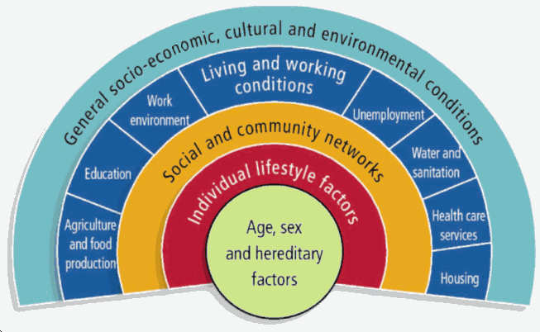
Dahlgren & Whitehead, 1991

We can group the factors which determine health or ill-health into the following levels:

- Genetic factors which determine an individual’s predisposition to disease
- Biological factors in which disease is caused by bacteria or viruses
- Individual behavioural factors which contribute to disease, such as smoking, drinking, lack of exercise
- Social and community factors, such as traditional or religious beliefs and practices
- Factors around work and living conditions, such as housing, sanitation, transport, access to health services, income, adequate nutrition and employment opportunities
- Environmental factors, such as pollution, level of violence
- Broader political, economic and social factors, such as a country’s constitution and laws, the prevailing economic system, and the available resources and how these are distributed. These factors affect the way in which a society is structured or stratified, e.g. in terms of class, gender, race, and age. They also impact upon the other factors.
(Adapted from Naidoo & Wills, 1994: 25)

How these determinants are ranked or prioritised will be influenced by your view of health and ill-health, and will in turn influence where you, as a health promoter, place your efforts. This ranking will depend on your judgement of the issues, the perspectives of those you work with, and the feasibility of any intervention. For example, if you were working with a group of youth in a disadvantaged area and if you believed that individual behavioural factors were the most important or most realistic determinant to tackle, you might focus your energy on individual skills building sessions. These could include running discussion sessions on how youth could stop smoking or taking drugs or how they should practise safer sex. You might even encourage youth to take up some form of sport.

However, if environmental factors such as the high levels of violence or factors associated with poor living conditions were seen as priorities, you might focus your energy on advocating for the development of community safety programmes, or for changes in the design and layout of low-cost housing schemes. You might work with the local communities to become involved in lobbying for stricter legislation regarding gender-based violence or support for a gun-free society. It is useful to categorise or classify the determinants in this way to see how the one level can impact on another, and how they are interconnected. This will help you identify what interventions are possible at the different levels and to also realise that intervening at one level only will not do much to bring about the desired change.

3.1 How the levels interact

The category, broad political, economic and social factors, affects the other categories in various ways. Let’s look at an example. Consider how the following government laws and policies could determine and change economic and social conditions, and how those changes would impact on health:

- Providing housing subsidies for the poor
- Expanding local health facilities to rural areas
- Ensuring equal work opportunities for men, women and the physically challenged
- Restricting the levels of industrial pollution
- Asserting the property and inheritance rights of women married under customary law
- Supporting the right of women to the termination of pregnancy
- Banning smoking in public places and prosecuting drunken drivers.

These broad determinants all have a major impact on the health of the population. They could improve the environment as well as the working and living conditions of people. They could also challenge unhealthy cultural and social practices, and reduce the negative effects of these factors, particularly on the health status of disadvantaged or vulnerable groups (meaning those who are at risk).

From the third to the seventh level of the Dahlgren & Whitehead Model, are what we would classify as social determinants of health. From living and working conditions onwards it becomes increasingly difficult for an individual to have control over those determinants because of the factors that influence these determinants.

The first task provides a different example to help you further explore the determinants in health. You are asked to classify the determinants of health and to explore the context of women’s experience of HIV/AIDS. Classifying the determinants of health will help you to get a good overview of the determinants and understand them better.

TASK 1 – Classify the determinants of HIV/AIDS

- In Column 1 of the table below write down the different levels of determinants.
- In Column 2, jot down all the determinants that you can think of in relation to women’s experience of the HIV/AIDS epidemic in South Africa.
- Then write down different ways in which any of these levels of determinants are linked.

Classify the Determinants of HIV

Column 1: Determinants | Column 2: Determinants in relation to women’s experience of HIV/AIDS in South Africa
Genetic & biological factors | Anatomically, women are more at risk of HIV infection than men.
Individual behavioural factors | Men and women who have many sexual partners and do not use condoms or practice safer sex.
Include further determinants here.

⬇

FEEDBACK

Below are some possible determinants of HIV/AIDS in relation to women, classified according to category. What we are trying to illustrate here is the complexity of the situation and the fact that many different factors contribute to this health problem. Addressing it as health promoters therefore requires you to be aware of the complexity of the determinants and their inter-connectedness.

Classify the Determinants of HIV

Column 1: Determinants | Column 2: Determinants in relation to women’s experience of HIV/AIDS in South Africa
Genetic & biological factors | Anatomically, women are more at risk of HIV infection than men, as there is a larger exposed surface area of the vagina and labia, compared to the penis, through which HIV can enter. In addition, mucosal surfaces in the vagina are more susceptible or likely to be affected when compared to the hardened penile skin (Abdool Karim, 1998).
Individual behavioural factors | Men and women who have many sexual partners and do not use condoms or practise safe sex, intravenous drug-users who share needles and syringes, and health workers who do not practise universal precautions, place themselves and others at risk of HIV transmission.  Alcohol is commonly associated with an increase in the level of violence, including sexual violence, which would then place women in a position of risk. Violent, rough and forced sex or rape, results in a woman being forcibly placed in a position in which she is unable to say no to sex, or to protect herself by insisting that her male partner uses a condom.
Factors around work and living conditions | In some communities, particularly rural communities, women do not have equal access to on-going training and tend to be excluded from the formal economy. Where women have been able to access skills and training, they have not always had the power to negotiate equivalent work positions or conditions, unlike their male colleagues.  Having had less choice around what work they are able to do, women have often had to explore other work options, such as sex work, or in some cases, accepting gifts, favours, or a place to stay, in return for sex. In these situations, where women are economically dependant on their clients/men, they are likely to be placed in a situation where they accept money for sex without using a condom, or have to suffer abusive sexual situations.
Environmental factors | General degradation of the environment, for example, lack of street lighting creates an environment which is not safe for women to walk in, placing them at greater risk.
Broader political, social and economic factors | In general, women have less power in their intimate relationships and are therefore not in a position to talk about and negotiate safer sex practices. A woman is also more at risk of violence, abuse or rejection by her partner if she asks him to use a condom (either within or outside of his relationship with her), or if she says no to unprotected sex.  The apartheid legacy and the associated migrant labour system resulted in many families having to live apart from one another. Away from home, men often had multiple sexual partners, which placed their primary partner at risk of HIV infection when he returned home.  Women were left to work at home, often in rural areas, and suffered considerable hardship and poverty. In the case of men falling ill or dying, women were left in an even more vulnerable position. In many instances, women had no other choice but to have sex in exchange for food, shelter and support for their children

As you can see from these examples, the broader political, economic and social factors are linked to other determinants and have an influence, either negatively or positively, on the way in which the other levels of determinants connect or interact with one another.

For example, broader social, political and economic factors such as the ones below have affected women’s working and living conditions:
- Apartheid system and its associated migrant labour system, and
- Laws which did not support the principle of equity or protect against discrimination.

Women were (and still are) not afforded the same status as men in society and not given equal access to formal employment and on-going training opportunities. Their earning power is thus reduced, and until recently, they have not had adequate legal protection against gender discrimination in the workplace, or gender violence at home or in the broader community.

Two further examples illustrate the link between socio-cultural, gender factors and biological factors. In a situation where a woman is placed at risk of HIV transmission for instance, when she is having sex with her partner, she might not have the confidence, the skills, the economic self-sufficiency or even the choice, to insist that she is protected from the risk of HIV transmission. Coupled with her biological susceptibility, a woman is thus placed in a significantly more vulnerable position.

Another example is the situation of an HIV positive woman who has to make complex decisions about motherhood. For instance, if she decides to have a child, she risks transmitting HIV to her child and then has to live with the consequences of this decision if her child is HIV positive. If she decides not to have a child, she might face rejection and even potential abuse from her partner and her family. Mother-to-child transmission also inadvertently carries with it a stigma, as women are seen as the carriers of the disease. This reinforces a commonly held belief that women are in fact to blame for the epidemic.
3.2 The importance of considering the different levels and their
interconnectedness

Ultimately all these determinants have a role to play in determining the health status of the individual or community. Because of the relationship between all these factors, people working in the area of Health Promotion need to consider all of the determinants when developing and implementing an intervention, e.g. in relation to women and HIV/AIDS, whether targeted at the general public, at men, at the youth, or at women themselves.

In Health Promotion, recognising how determinants are interlinked, we try to tap into and work with the different levels. For example, with HIV, we might try to encourage young women to delay practising sex, or to ensure that they seek immediate treatment for STDs. This is an intervention that taps into the most individual or local level of determinants. However, working with only one level of determinants could be detrimental to our health development work in the long term. For example, in this case, whilst we may be ensuring that women receive early treatment for their STDs, we have not adequately dealt with the fact that women also need to be provided with the skills to prevent STD infection. For instance, they need easy access to condoms and to be sufficiently empowered to be able to communicate effectively with their partners.

As health promoters, we have to keep our eye on the different levels of determinants so that they can assist us in our development of realistic Health Promotion interventions for the context in which we live.

Here is another example to consider: The large numbers of children with scalds and burns that Red Cross Children’s Hospital, Cape Town sees every year. As a health promoter working in such an institution, you would begin to think about an appropriate intervention the team could develop to assist in reducing such accidents. Perhaps asking the question “Why?” could begin a brainstorm session with the Health Promotion team, for example:

- Why are we seeing so many children with burns and scalds?
- Is it because families are living in crowded, informal houses without adequate cooking and cleaning facilities? Why are they living like this?
- Is it because adults are unaware of the care and precautions that need to be taken when using paraffin, gas or hot water near children? Why are they unaware?
- Is it because children are being left at home unsupervised – without adequate adult supervision? Why would this be so?

By asking the question “Why?” the Health Promotion team is able to focus on the cause upstream. You could then begin to plan an intervention that focuses on both those determinants that are close to the individual (like educating parents and caregivers about safety in the home), as well as broader determinants like housing regulations, access to electricity and water, and economic opportunities. It would be problematic to try to solve the problems at an individual level only, as if they are not tackled at a broader level they will recur. The team might consider the following:

- Setting up a joint project with the local Housing Department to ensure that members of the Informal Housing Association, the local municipality or the Health Committee host an awareness raising workshop on the importance of child safety in the home.
- They might also consider advocating that the Local Council support a small business initiative to establish childcare centres in some of the informal settlements so that working parents can leave their children in the safety of more formalised day care arrangements.
- The team might also consider working with local businesses that sell gas, paraffin and cooking utensils to support a child safety campaign. For example, they could ask shop owners to display posters about safety and to stock and sell paraffin safety caps. Such a campaign could be supported by a local community-based radio station.
- The team might look at regulations to ensure that only paraffin and gas stoves approved by a South African Bureau of Standards are sold. The local municipality or the Health Committee can ensure that businesses comply with these regulations.

By addressing the issues at the different levels, there is a much better chance of the problem not recurring. However, a single Health Promotion intervention aimed at a particular set of causes or level of determinants, would also have an impact on the other levels of determinants. For example, running an educational workshop on gender and violence for local councillors in a community is a Health Promotion intervention aimed at increasing awareness about the issue. It is thus aimed at determinants that are close to the individual. However, it might also encourage the participants to reflect on how safe their community is for women. They might then lobby for changes in their environment and in local government regulations that try to reduce the current level of gender violence. Such interventions might include:

- Advocating that life skills programmes be run in all the local schools
- Installing more street lights in each neighbourhood
- Training the local health workers and police force on gender issues and gender violence
- Increasing the allocation of resources to the police service in order that more community police officers can be employed at local police stations
- Introducing new regulations on the handling of domestic violence by the police.

You will notice that the first intervention is associated with the determinants that relate to the individual, the second two are related to the living and working environment, and the last two interventions are associated with determinants relating to broader economic, political and social causes and associated systems, laws and regulations.
Whilst it is often rather difficult (and somewhat unnecessary) to divide determinants into discrete categories, it is a useful analytical tool which helps you to recognise the importance of addressing the different levels of causes of ill health. It is important in the process of planning a Health Promotion intervention to consider firstly, how the different levels of determinants interact with one another in causing ill health or a disease, and secondly, how Health Promotion interventions aimed at different levels of determinants could work alongside and complement one another.
Generally, an intervention aimed at only one level of determinant will have less chance of success than a Health Promotion intervention that recognises the different levels of determinants and seeks to develop interventions that cut across all levels. It may not be possible for you as a health promoter to work across the different levels. But it could be part of your role to involve others, to place health on the agenda of other sectors. (This will be picked up again later on in this module.)

4 EQUITY AND HEALTH

Think about the different determinants you have just explored. Reflect also on the discussions about root causes (determinants) that you learnt about in the module, Population Health, Development: A Primary Health Care Approach I, including the story of Luis and Rakku’s child. What conclusions have you come to about the relationship between the determinants and inequality or disadvantage?

You will have noticed that the poorer people are, the worse their living and working conditions are, and consequently the worse their health is. Coulson, et al (1998:3) describe this as follows, “Individuals, communities and countries with the least resources unfairly carry the burden of ill-health and mortality.”

So inevitably, when we talk about health determinants, we are raising the issue of disparities in opportunities for health, and consequently, of health itself. This is generally described as equity, or inequity in health.

4. 1 What is meant by equity and inequity?

Before reading about equity and inequity in health in more detail, give some thought to what you think is meant by these terms. Jot some ideas down before you read any further.

Now look at some of the aspects that are included in definitions of equity and inequity:
- Fairness
- The right to health
- Social justice in responding to health needs
- Fair distribution of health services and resources
- Equal access to health resources and services according to needs
- Positive discrimination.

Whitehead, who has been one of the main writers on the subject, describes inequity as follows:
“The term ‘inequity’ has a moral and ethical dimension. It refers to differences, which are unnecessary and avoidable but in addition are also considered to be unfair and unjust. So, in order to describe a certain situation as inequitable, the cause has to be examined and judged to be unfair in the context of what is going on in the rest of society.” (Whitehead, 1985: 5)

In other words, the distribution of ill health is weighted towards those with fewer resources or opportunities. In South Africa, there is a historical political link between poverty and ill health, which is illustrated by the stark differences that exist between the different sectors of our society. This can be demonstrated by looking at infant mortality statistics in South Africa as a whole, the Western Cape Province, and then Cape Town.

Data from the South African Demographic and Health Survey (SADHS) 2003 provides the following information:
- Infant Mortality Rate (IMR) for South Africa is 42.5 per 1 000 live births. There are vast differences in the different provinces so these figures represent an average across all provinces.
- IMR for the Western Cape is 43.5 per 1 000 live births.
- IMR for Cape Town, which is the most privileged city in the Western Cape, is much lower, at 24.5 (Groenewald et al, 2008).
- If you look at the breakdown of health districts within Cape Town, you will see a vast discrepancy between the IMR in the wealthier districts, such as Southern (formerly South Peninsula) which was 16.7 per 1 000 live births, and the most deprived, which is Khayelitsha at 42.3 per 1 000 live births.

What do you think are the causes of the different IMRs in Cape Town?

Now look at the graphs showing data for different indicators in Cape Town, produced by the then Cape Town Equity Gauge. These graphs refer to old health districts, but the message is clear. Note how Khayelitsha has either the highest or second highest levels regardless of the indicators being used, while South Peninsula (SPM) has among the lowest, demonstrating the inter-relationship between the determinants and health. Also note the difference in the two photographs, showing housing conditions in the respective areas.
% households below the poverty line
Infant Mortality Rate

HIV prevalence 2000 (estimate)
% unemployed



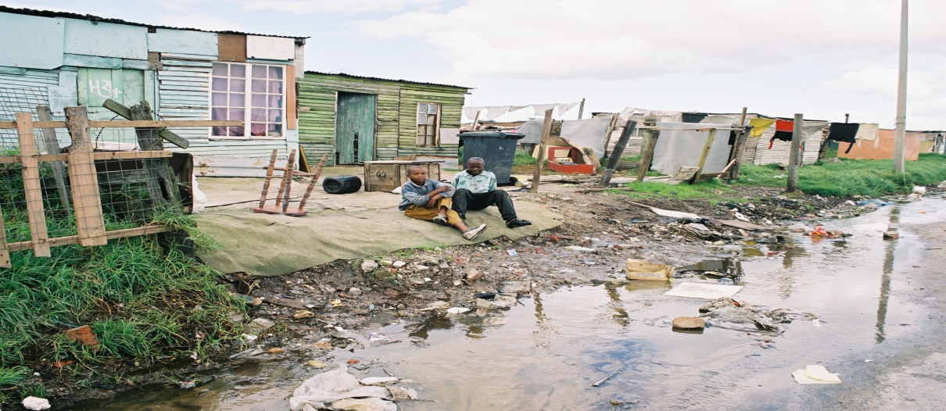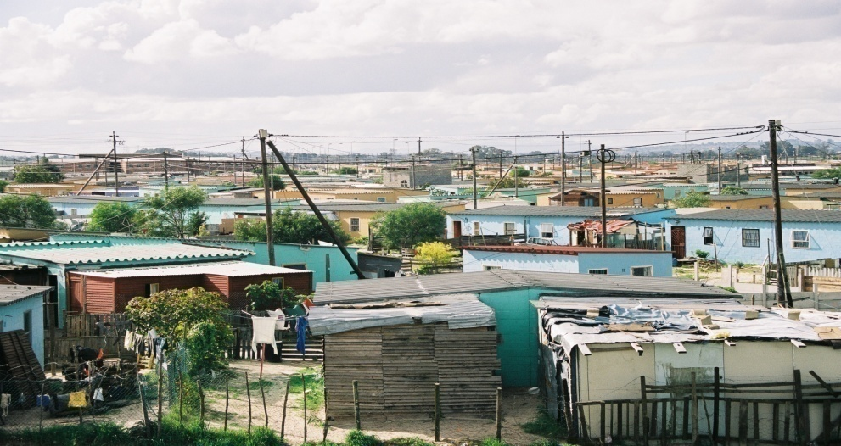

Housing in Sea Point and Khayelitsha

Returning to the definitions of equity and inequity, are these conditions or determinants fair? Are they providing health rights to people? Can they be remedied?

While we have used socioeconomic conditions to illustrate inequities, it is important to remember that there are other groups in society who may be marginalised or discriminated against, resulting in inequities for these groups. The list includes:

- Racial/tribal groups
- People living in rural areas versus urban areas
- Women versus men
- Disabled people
- Older people
- Gay people
- People with certain diseases, e.g. HIV/AIDS

4. 2 Why is this understanding of equity and inequity important?

Finally, why is equity/inequity important, and how does it relate to Health Promotion? There is ample evidence that more equitable societies are healthier societies (Wilkinson 1996). Recognising inequities is a first stage towards remedying them. To tackle the wider determinants and to redistribute resources, including staff, any health plan needs to deal with the inequities. As health promoters we can focus our attention on population groups that are disadvantaged rather than on population groups that are more privileged and are more likely to remain healthy, and more able to adopt healthier lifestyles and access health services to make themselves healthier. Remember, the importance of equity and inequity in health as you work through the rest of the module, and in your assignment.

5 REVIEW OF HEALTH PROMOTION – A BROAD-BASED CONCEPT

Now that we have looked at these additional factors which influence our understanding of health, we return to our understanding of Health promotion. The reading below explores the issues which affect our understanding of Health Promotion.

TASK 2 - Summarise the factors which affect our understanding of Health Promotion

READING

Coulson, N., Goldstein, S., & Ntuli, A. (1998). What is health promotion. Promoting Health in South Africa: An Action Manual. Sandton: Heinemann. Pp1–3.

Take 10 minutes to make a mind-map of your understanding thus far of the factors
which affect our understanding of Health Promotion e.g. inequity. Then add the ideas from the above reading.
FEEDBACK

From your mind-map and through the discussions so far, you will be aware that Health Promotion includes some very broad socioeconomic concepts. You will probably have noted that it also includes some very specific individual behaviour changes. These are all part of Health Promotion. So far we have looked at definitions, perceptions and determinants of health, including social determinants such as equity. These ideas helped us to clarify what we mean by health. They are also crucial to understanding what we mean by Health Promotion, to which we now return.

We will now unpack the concept of Health Promotion a bit further, starting with looking at how Health Education fits into Health Promotion.

5.1 Differentiating Health Education and Health Promotion

Since the mid-1980s, there has been considerable debate about the difference between Health Promotion and Health Education. Discussions have focused on the difference in their definitions, the scope of their activities and on their underlying philosophies. This is discussed in the next reading.

TASK 3 – List the differences between Health Education and Health Promotion

READING

Catford, J., & Nutbeam, D. (1984). “Towards a definition of health education and health promotion.” Health Education Journal. 43(2 & 3): 38.

Read the short article by Catford & Nutbeam and briefly summarise the main differences between Health Education and Health Promotion in terms of their:

- Aims
- Activities and strategies.

FEEDBACK

The article suggests that whilst Health Education and Health Promotion both have the same aim, namely “to improve or protect health”, the scope of their activity varies. In the case of Health Education, most activity centres on providing learning opportunities for individuals and communities so that they are able to voluntarily change their behaviour. In other words, they acquire information and skills to help them initiate a change that enhances their well-being and their health. Educational activities range from individual counselling and self-development to the use of mass media and communication campaigns.

Health Promotion activity is much broader and includes both Health Education and:
- The provision of preventative health services
- Measures to protect the physical environment and make it conducive to health
- The mobilisation of community resources
- The implementation of organisational policies which promote health
- Economic and regulatory activities.

In other words, it includes the broad socioeconomic determinants as well as the educational component. The two concepts, Health Education and Health Promotion, are symbiotic strategies. This means that they are closely associated or related and that they benefit from each other.

Naidoo & Wills (1998) suggest that a key feature that distinguishes Health Promotion from Health Education is that Health Promotion involves environmental and political action. Similarly, Tones and Tilford (2001) have suggested that it is possible to distil the concept of Health Promotion into an essential formula:

Health Promotion = Health Education x Healthy Public Policy (This will be explored later.)

This formula serves to illustrate how central both Health Education and policy are to the achievement of individual, community and national health status, and how symbiotic or inter-connected the relationship is between Health Education and the broader activity of Health Promotion.

Ewles and Simnett (1999) note that there has been considerable debate about the use of the terms Health Promotion and Health Education over the last two decades. Some people viewed Health Education in a rather stereotypical way, reflecting a narrow field of activity and focusing on the individual. Health Promotion, on the other hand, has been positioned as the more politically correct approach to challenging health status. Many authors, however, now support the view that it is not constructive and too simplistic to distinguish between the two concepts in this way. In addition, viewing Health Education in this manner does not do justice to its varied history. They prefer to view them as symbiotic concepts, with Health Education being seen as an important part of the wider process of Health Promotion.

Now that we understand the relationship between Health Education and Health Promotion let us come back to the definition of Health Promotion. As we have said, there are numerous definitions of Health Promotion which are based upon the particular concepts and values to which people subscribe. We will now analyse some definitions of Health Promotion and examine what ideas underpin them. (see definitions in figure on next page).

Definitions (a) to (d) emphasise the Social Model of health, that is, they look at the broader determinants of heath and at equity. They support the idea that health is a positive, holistic concept and that the health of individuals and communities is affected by a range of determinants (social, political, economic and cultural).

Definitions (e) and (f) are somewhat narrower and seem to imply a focus on promoting the health of individuals. They emphasise biological and individual behavioural determinants.

Some of the common themes which underpin the first three definitions are:
- Health Promotion is a process – it does not happen overnight, but is rather a longer-term set of sustained activities and interventions.
- Health Promotion aims to improve the health status of individuals and communities and enable them to gain increased control over their health.
- Health Promotion is based on the philosophy of self-empowerment.
- Health Promotion entails different strategies, such as providing information and building skills, to developing policy and legislation.
- Health Promotion is not equivalent to health education, but encompasses it.
- Health Promotion involves inter-sectoral action and working in partnership with other sectors.

The last two definitions of Health Promotion are considerably more individualistic in their emphasis and would most likely be focused on working towards attitude and behaviour change within a health care setting. They assume that individuals have considerable influence over their environment, and that a healthy outcome would automatically result from the changes made in behaviour.

We have placed considerable emphasis on the concepts and definition of health and Health Promotion so that you are aware of the complexities and different interpretations. One of the challenges that a health promoter may be faced with is working in an environment where different parties hold different understandings of Health Promotion. In that our conceptualisations affect our responses to health problems and our strategies for Health Promotion, health promoters need to develop a way of dealing with these differences. The next task offers you an opportunity to prepare yourself for this problem.

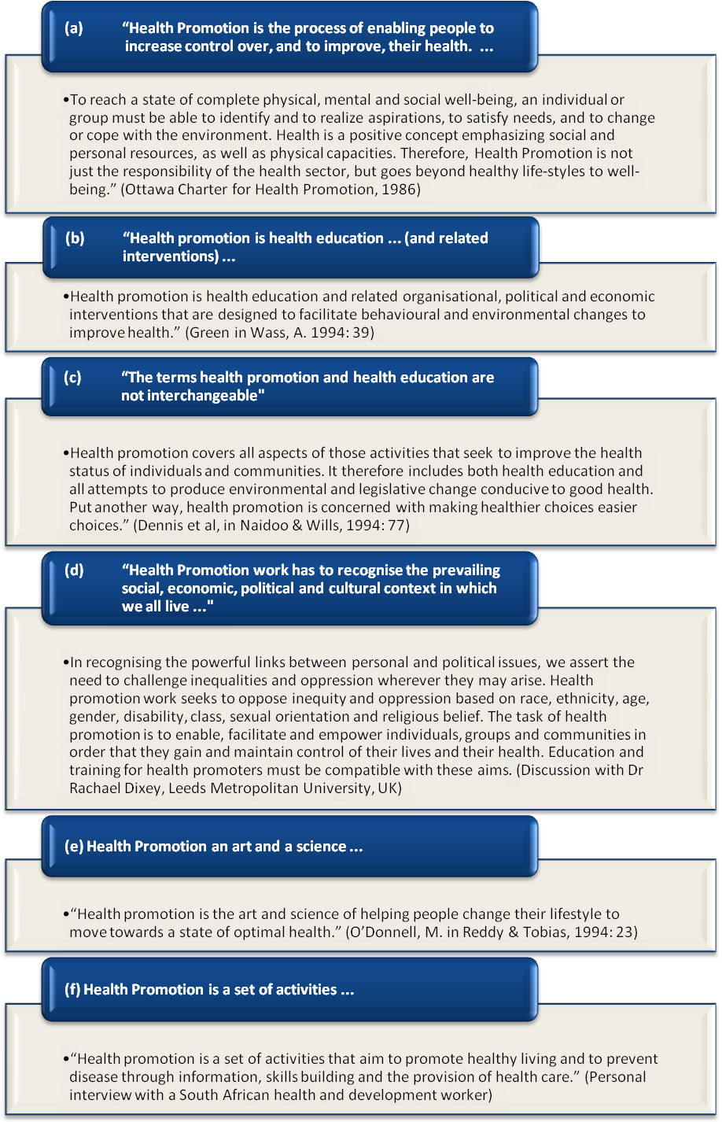

TASK 4 – Manage different understandings of Health Promotion

Imagine that you are going to set up a Health Promotion project involving health colleagues, other professionals (such as teachers and engineers) and community members. It is likely that everyone does not share the same understanding of health and of the role that determinants play in influencing health or ill health. People are also likely to have had different experiences, and thus have different levels of familiarity with the concept of Health Promotion.

1. How would this affect the project?
2. How would you cope with this situation?
3. What would you do at the start of the project?

FEEDBACK

Universally, it is unlikely that a single concept of health, which is acceptable to all, will ever be developed. Instead, diverse and at times competing definitions are inevitable. This can lead to confusion, misunderstanding and lack of true co-operation when setting up a Health Promotion project. Ultimately this can undermine the success of the project. To address these problems and to work successfully with colleagues and the community, it is important for everyone involved to share their understanding of health and Health Promotion.

You could suggest that this be done as part of an ice-breaker or introductory exercise in your first meeting or workshop. You could then reach consensus on the main elements of these definitions through group discussion. This awareness-raising exercise could be the first step towards establishing a good working relationship and forging a closer understanding of what Health Promotion means for your team members. It might also allow the group to start thinking about the appropriate level of determinants to target the Health Promotion intervention.

5.2 Reviewing your own definition of Health Promotion

We end this study session with a simple drawing to summarise our definition of Health Promotion, the broad aim of Health Promotion, and the principles and methods underpinning it. Try drawing your own diagram before you look at our summary drawing below.

DEFINITION
AIM
Health Promotion
A process of enabling people to increase control over the determinants of health and thereby improve health.
PRINCIPLES & METHODS

- Directed at strengthening the skills & capacities of individuals and groups so that they can change and cope with the environment.

It embraces actions

- Directed towards changing social, environmental & economic conditions to alleviate their negative impact on public or collective health and individual health.

- Participation and partnership is essential to sustain health promotion.
- Health Promotion action is not the responsibility of the health sector alone - it involves all sectors, systems and structures that govern our social, economic and physical environment.

The next reading provides an excellent glossary of Health Promotion terms. Don’t worry if some of the terms are still unfamiliar to you. You will come across them later in the module. Preview the reading now so that you can use it to review your understanding of Health Promotion. You may want to refer to it in the course of studying this module or doing your assignment.

TASK 5 – Reflect on your initial definition of Health Promotion

READING

Nutbeam, D. (1998). Health Promotion Glossary. Health Promotion. International. 13(4): 349–364.

Look back at your definition of health promotion in Session 1 Task 2. Are you still comfortable with this definition? If you are, that’s fine! However, if you feel that you have a different understanding of Health Promotion now, try rewriting your original definition to fit with your new thinking.

Finally, Health Promotion can be seen as the umbrella term that includes a whole range of activities, such as health education, policy development, environmental or social action and organisational development, as well as community participation.

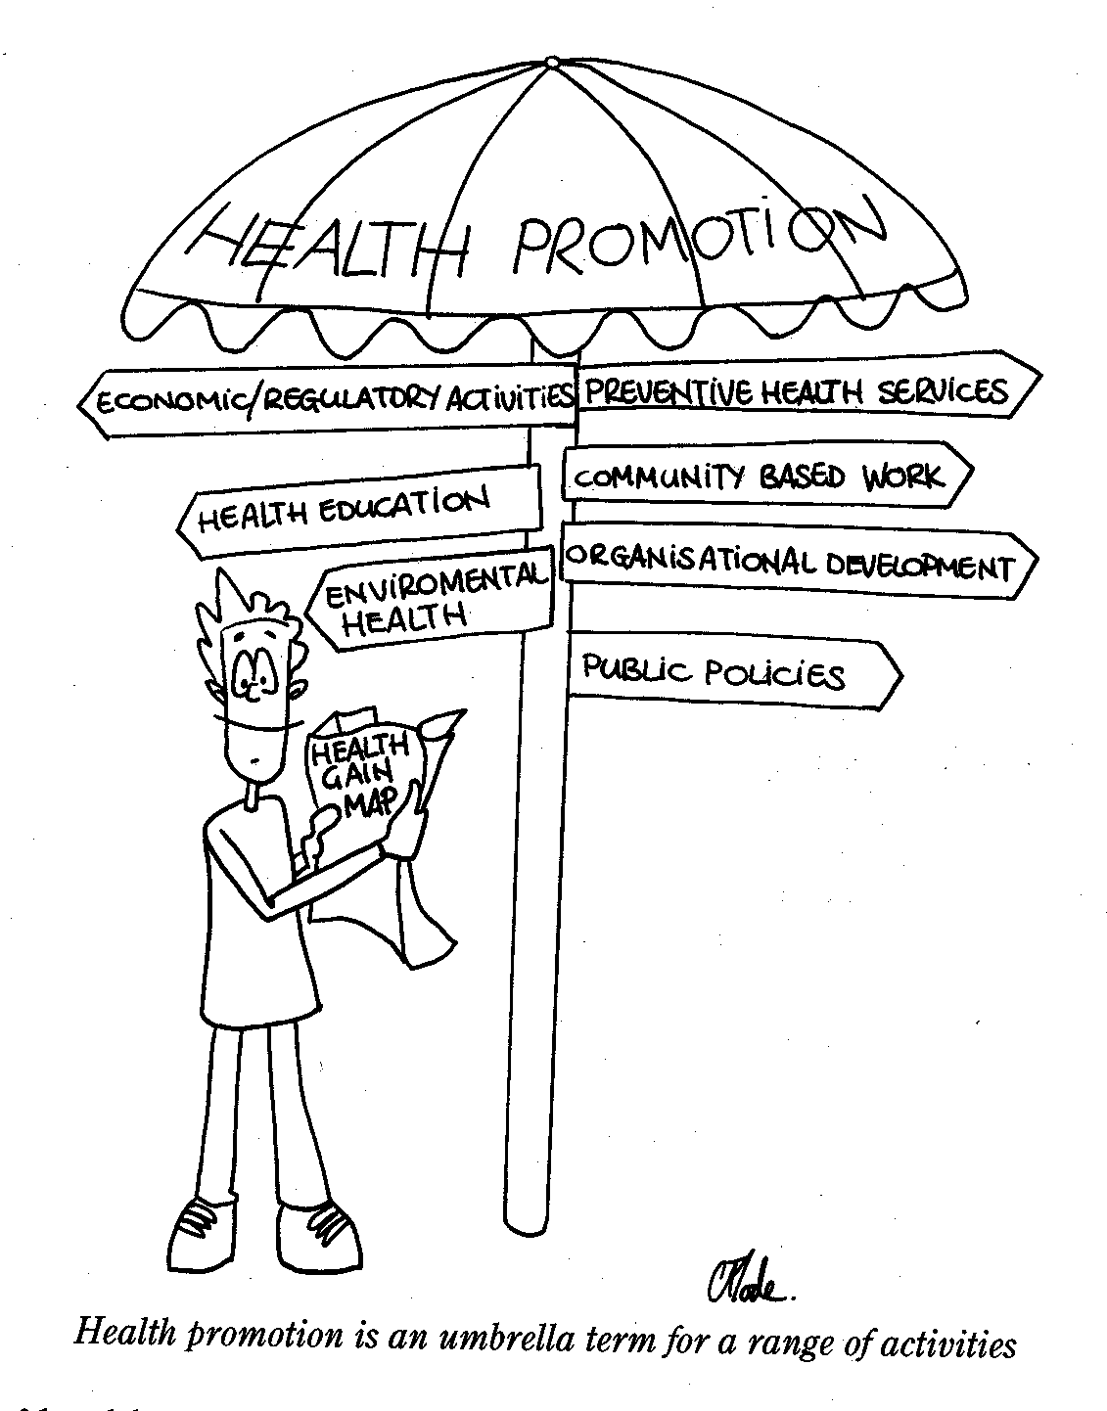

Ewles & Simnett, 1999: 25

6 SESSION SUMMARY

In this session, we have added more factors to our conceptualisation of Health Promotion. We have looked at the different determinants of health including the social determinants of health. By now, you probably have a fairly strong sense of how our values, experiences and our own critical perspectives influence the way we conceptualise Health Promotion, and therefore the strategies we use.

In order to develop our understanding even further, we need to look at the history of the Health Promotion Movement to find out where Health Promotion originated. This is the focus of the next Study Session in Unit 2.

7 REFERENCES AND FURTHER READINGS

Abdool Karim, Q. (1998). Women and AIDS: the imperative for a gendered prognosis and prevention policy. Agenda, 39.

Bradshaw, D. (1997). The Broad Picture: Health Status and Determinants. Chapter 1. South African Health Review. Durban Health Systems Trust.

Cape Town Equity Gauge. (2004). Equity in Health: Cape Town, 2002. Cape Town, SOPH, UWC.

Coulson, N., Godstein, S.E., & Ntuli, A. (1998). Promoting Health in South Africa: An Action Manual. Sandton: Heinemann.

Dennis, J., et al. (1982). In Naidoo, J. & Wills, J. (1994). Health Promotion: Foundations for Practice. London: Bailliere Tindall.

Department of Health, MRC, et al. (1998). The South African Demographic and Health Survey. Preliminary Report. South Africa.

Ewles, L., & Simnett, I. (1999). Promoting Health: A Practical Guide, Fourth Edition. London: Bailliere Tindall.

Green. (1979). Cited by Fisher, et al. (1986). In Wass, A. (1994). Promoting health: the primary health care approach. Sydney: Bailliere Tindall.

Groenewald, P., Bradshaw, D., Daniels, J., et al. (2008). The cause of death and premature mortality in Cape Town, 2001 – 2006. SA Medical Research Council, Cape Town.

Islam, M., & Piot, P. (Sept-Nov 1994). All about STDs. AIDS Action 26.

Naidoo, J., & Wills, J. (1994). Health Promotion: Foundations for Practice. London: Bailliere Hall.

O’Donnell, M. (1986) quoted in Reddy, P. & Tobias, B. (1994). Tracing the Health Promotion Movement. CHASA Journal, 5 (1 & 2).

Tones, K., & Tilford, S. (2001). Health Promotion: effectiveness, efficiency and equity. Third Edition. Cheltenham: Nelson Thornes Ltd.

Whitehead, M. (1995). The Concepts and Principles of Equity and Health. Copenhagen, WHO.

Wilkinson, R.G. (1996). Unhealthy Societies. The Afflictions of Inequality. London Routledge.

