**Introduction:**

**Unit 1**

Overview of Health Promotion

# Introduction

Welcome to the first unit of the Health Promotion for Public Health module. We hope that the module will be stimulating and relevant to your practice.

Health Promotion includes a wide range of strategies aimed at improving people’s health. This is a departure from the earlier emphasis on disease prevention, and as such it has increasingly become part of the responsibility of a range of professionals. This focus on positive health and on prevention has been recognised not only as a cost-effective approach, but also one which responds to the ethics and morality to which our society might aspire.

The process of planning and implementing a Health Promotion programme involves many stages. It also involves different ideological stances and practical approaches. This module guide will take you through a selection of approaches, highlighting the different interpretations at different stages of the development of Health Promotion, and the merits and problems of these interpretations.

This module is based on a case study about Nomhle, a newly appointed Health Promotion Manager to the district of Mfula, given to you as a part of your Reader. In the case study, Nomhle has been given the task of developing a plan for a Health Promotion programme for the district to address the key issues of importance. The case study, School of Public Health (2012), which spells out what she will have to address, is in the accompanying Module Reader. Additional information will be provided as you progress through the Module Guide. The case study will also form the basis of your assignment. Detailed instructions on the Assignment are in Section 3.5 of the Module Introduction.

Unit 1 explores a number of concepts that are fundamental to Health Promotion, as well as some of the debates and dilemmas which have entered the discourse – debates that are inevitable in a growing field. They are also debates that you are likely to encounter in your professional practice. It is therefore important for you to understand them and be able to interact with and contribute to them.

The overall aim of this unit is therefore to introduce you to the current debates and challenges in Health Promotion, and its relationship with related disciplines.

There are three Study Sessions in this unit.

Study Session 1: A Context for Health Promotion

Study Session 2: Global Strategies for Health Promotion

Study Session 3: Current reflections about Health Promotion

In Session 1, we will present an overview of Health Promotion, provide you with an opportunity to consider your thoughts about it, and introduce you to what the literature says. The session will also look at the determinants of ill health, already explored in earlier modules, but this time with the focus on its relevance to Health Promotion. The session also looks at the concept of equity, and its importance in terms of the right to health, fairness and social justice.

Session 2 provides a survey of recent developments in the international field of Health Promotion and presents some of the key debates.

Session 3 serves as a consolidation, preparing you for the more practical components of the module.

### Learning Outcomes of Unit 1

|  |
| --- |
| By the end of this unit, you should be able to: |
| * Demonstrate a critical understanding of the current debates around Health Promotion. * Demonstrate awareness of health determinants and their influence on Health Promotion. * Take equity into account in planning Health Promotion interventions. |

Because there is a substantial amount of reading in this module, we have included a small amount of academic support in the form of focus questions to help you to read actively and strategically.

In addition, you will remember that you are encouraged to develop your Assignment as you work through the module. This involves interacting with the case study as you work through each unit. Do this in an Assignment Notebook which can take any form e.g. an exercise book, a set of typed notes. Record your own thinking about Nomhle’s programme as you proceed through the units. This will enable you to study actively and with focus, as well as ensuring that you reach your Assignment deadline in good time.

We hope that you will find the unit stimulating and challenging and that it will enable you to situate your role more clearly within the field of Health Promotion, and thereby develop your practice as a health promoter, or to enable you to integrate health promotion into the area of work that you are involved in.

**Unit 1 - Session 1**

A Context for Health Promotion

# Introduction

In this session, we explore what Health Promotion is, illustrating this by introducing the case study of Nomhle, a newly recruited Health Promotion Manager. In the case study, Nomhle’s task is to develop a plan for an integrated health promotion programme for the community of her district. By exploring the issues confronted by Nomhle, you will be expected to review your understanding of the goals and vision of Health Promotion. This exploration will be assisted by a series of tasks and readings. During this process, you will be considering the complexity and levels of the determinants of health, thinking about how poverty affects health in both urban and rural settings and addressing the importance of equity or fairness in guiding Health Promotion programmes. In the process of exploring these issues, you will have the opportunity to reflect on and clarify your own values and beliefs in relation to Health Promotion.

There are two Assignment Preparation Tasks in this session, so start your Assignment Notebook now. Remember that this symbol  **A**  serves to remind you that the task relates to your assignment, and so you include the task in your Assignment Notebook. As you work through the session, it may also be useful to list references to any relevant parts of the readings in your notebook, and to note down conclusions you reach in the course of the tasks. The topics in this session which may be relevant to your assignment are: debates about the determinants of health, as well as equity issues in relation to the assignment.

###### Session Contents

# 1 Intended learning outcomes of this session

2 Readings

# 3 An overview of the issues in Health Promotion

# 4 Determinants of health and equity

5 Equity and the right to health

6 Different levels and approaches

7 Session summary

8 References and further reading

###### Timing of this session

This session contains **three** **tasks** and **three readings**. It could take about **three hours** to complete. A logical place to break the session would be after section 4.2.

**1 Learning Outcomes of this Session**

|  |
| --- |
| **By the end of this session, you should be able to:** |
| * Give a broad overview of Health Promotion. * Analyse and discuss the implications of different health determinants. * Reflect on your own values with regards to equity issues. * Take the issues of equity into account when planning Health Promotion interventions. * Analyse and compare Health Promotion interventions in rural and urban contexts. * Identify strategies for Health Promotion intervention at different levels. |

### 2 Readings

The readings for this session are listed below. You will be directed to them in the course of the session.

|  |
| --- |
| SOPH (2012). Case Study of Nomhle, the District Health Promotion Manager in the Mfula District. Bellville: School of Public Health, UWC. |
| Ehiri, J. & Prowse, J (1999). Child health promotion in developing countries: the case for integration of environmental and social interventions? *Health Policy and Planning,* 14 (1): 1-10 |
| Wise, M & Jha, S. (2001). Future challenges: reflections on the XVIIth World Conference on Health Promotion and Health Education. *IUPE – Promotion and Education. Supplement* (2): 50-52 |

**3 An overview of the issues in Health Promotion**

Health, as you know from your experience and studies so far, is a broad concept that is influenced by a range of factors. To remind you, the WHO definition of health is:

*Health is a state of complete physical, mental and social well-being and not merely the absence of disease or infirmity.*

(WHO 1948)

The Ottawa Charter, which you will study later in this Unit and again in more detail in Unit 2, describes health as “*a resource for everyday life, not the*

*objective of living”*, and a “*positive concept emphasizing social and personal resources, as well as physical capacities*”

(WHO 1986)

It is evident, therefore, that most of the factors that influence health, and consequently the responsibility for Health Promotion, extend beyond the remit of the traditional health sector. In order to explore how these broader factors relate to Health Promotion, we are commencing this module with the Case Study you will use for your assignment.

**READING**

SOPH (2012). Case Study of Nomhle, the District Health Promotion Manager in the Mfula District. Bellville: School of Public Health, UWC.

Read the situation analysis in the case study about Nomhle and the Mfula health district. This demonstrates the complexity of the issues in what could be a typical district in sub-Saharan Africa. You will see that responses to the health problems are enormous, probably beyond the scope of what you would imagine would be that of the traditional role of a health promoter.

Now look at the task set out for Nomhle. You will see that she has been asked to develop a Health Promotion Plan for her health district. You will see that the issues here are more complex than just giving people information or advice. To develop a comprehensive approach, Nomhle will have to consider many factors that influence health, or, as they are referred to in the health literature, ‘determinants of health’.

**4 Determinants of health and equity**

In the first module, Population Health and Development: a Primary Health Care Approach II, you looked at health determinants. In that module you were introduced to the interpretation by Birn, Pillay and Holtz, 2009: 310. Another helpful way of looking at the determinants of health is by using the Determinants ‘rainbow’, developed by Dahlgren and Whitehead (1991).

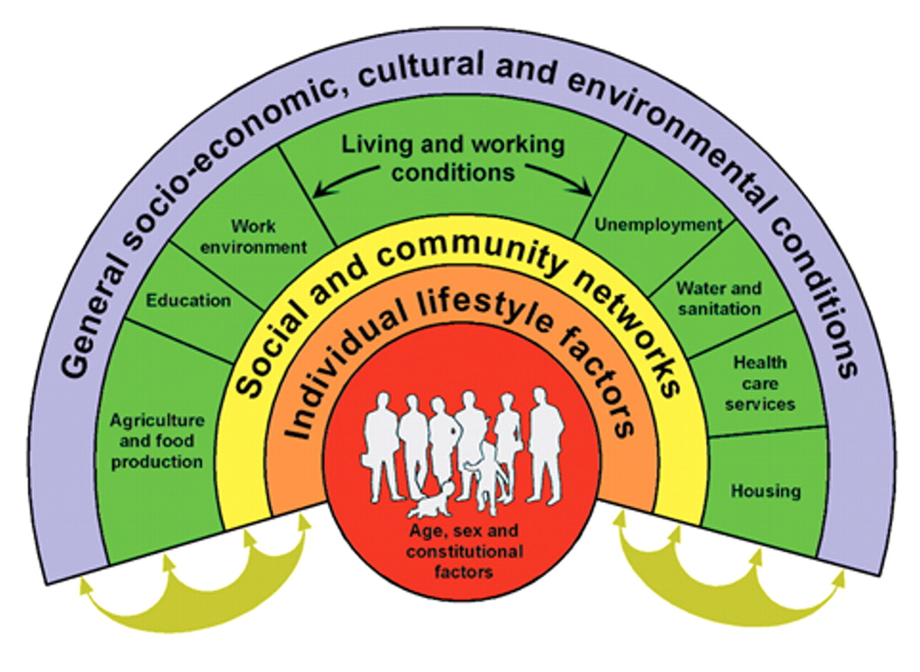

As you will see, the determinants near the centre reflect the concerns that are more personal and individual, whilst those on the outer circle are concerned with the broad determinants that are largely out of our personal control. These different levels of determinants have important implications for the way we develop Health Promotion programmes.

For example, what would be the implication for the Health Promotion programme if Nomhle did not consider the general social, economic and cultural conditions in her district, but rather concentrated on the individual or family level? Would her programme be effective? Would it be well-received by the local community? The answer to this question is complex and we will therefore address it in the course of the module. What is clear, though, is that when considering a Health Promotion programme, one has to consider the wider social determinants. A more general discussion about the importance of tackling social determinants therefore follows below.

4.1 Living conditions as determinants of health

Addressing the issue of context inevitably raises a range of health determinants arising from both rural and urban living conditions. The next Reading provides an overview of the impact of poor living conditions, including inadequate water and sanitation. The issues described in the first part of the article should be very familiar to you, as they are about Primary Health Care and the limitations of selective Primary Health Care. Focus your reading, therefore, from ‘The prevalence of childhood diarrhoea’, (page 4). The issues raised in the reading could easily relate to the circumstances in Mfula.

**READING**

Ehiri, J. & Prowse, J (1999). Child health promotion in developing countries: the case for integration of environmental and social interventions? *Health Policy and Planning,* 14 (1): 1-10

It is now time to begin to do your own analysis. Task 1 is based on the reading by Ehiri and Prowse, and it will assist you with your assignments.

TASK 1 – Analyse the determinants in this study

From the Reading, list the factors that influence diarrhoea in young children. Then categorise them according to the diagram by Dahlgren & Whitehead above. Finally, consider these questions:

a) What is the range of determinants noted in this article?

b) What approaches do you think are required to remedy these problems?

c) Would you consider these approaches part of a Health Promotion programme?

# FEEDBACK

1. Through this task, it will hopefully have become clear that in order to promote health, particularly among poor people, one needs to look broadly at the conditions in which people live. It also illustrates the unfairness of these situations i.e., the inequities.
2. You will probably have found that some of the determinants could be placed in several sections of the rainbow, depending on how you interpreted them. Many of the so called behavioural problems, such as poor food storage, are probably directly related to poverty, rather than individual ‘lifestyle’ choices. This will influence how to position them, and also, importantly, what you see as remedies.

# In terms of addressing these situations, you will have noticed that medical approaches on their own are not sufficient. The example of the impact of immunisation on poor children is a good example.

# d) If one looks at Health Promotion in its broadest sense, then these conditions are part of the responsibility of Health Promotion programmes. Poverty, in particular when associated with inequity, is one of the critical determinants of health, and for this reason, it has become recognised as a paramount concern of Health Promotion.

# 4.2 Tackling the determinants

The emphasis being given the social determinants is not new. However, it has received a considerable profile in recent years due to the establishment of a Commission on Social Determinants of Health (CSDH) by the WHO, which ran between March 2005 and May 2008. The report of the Commission, published in 2008, is called ‘*Closing the gap in a generation: health equity through action on the social determinants of health’* and it provides a comprehensive overview of the impact of social determinants on health, and strategies for tackling them.



<http://whqlibdoc.who.int/publications/2008/9789241563703_eng.pdf>

The full report and an executive summary can be accessed online through the WHO website, or see Further Reading at the end of this session. This report will be easier to access by using the USB flash drive you were given with the course. Just click on the link and go to the report directly. It has not been included as a course reading due to its length, however, we highly recommend that you have a look, scanning it for sections of relevance to you.

**5 Equity and the right to health**

The impact of social determinants on the health of a community or population raises the issues of equity, given the disparity in the living and working conditions between rich and poor. The CSDH report therefore, inevitably has a strong emphasis on equity. This is made very clear from the start, in the introduction of the report. To quote:

*A girl born today can expect to live for more than 80 years if she is born in some countries – but less than 45 years if she is born in others. Within countries there are dramatic differences in health that are closely linked with degrees of social disadvantage. Differences of this magnitude , within and between countries, simply should never happen.*

*These inequities in health, avoidable health inequalities, arise because of the circumstances in which people grow, live, work, and age, and the systems put in place to deal with illness. The conditions in which people live and die are, in turn, shaped by political, social, and economic forces.*

*(CSDH 2008: introduction)*

Professor Sir Michael Marmot, the chair of the CSDH provides a clear overview of the importance of addressing social determinants and equity in the presentation on u-tube on ‘How Social, Political Economic Policies Affect Health’. This can be accessed easily from your course USB flash drive, by clicking on the following link. You can also access it by Googling the title of the talk.

<http://www.youtube.com/watch?v=LdoGi7IyQ2Q&feature=related>

These extracts clearly demonstrate the importance of recognising and working towards social and economic justice and the right to health, which is enshrined in, among others, the WHO constitution, the Declaration of Alma Ata and the Ottawa Charter for Health Promotion. (You will have addressed this already in your Primary Health Care module).

Tackling equity, however, can be a daunting task. Naidoo and Wills (1994), two British HP authors, suggest a practical approach for addressing equity. This involves activities at three levels. The first is the macro level, which involves broad, intersectoral approach with an emphasis on public policy. An anti-poverty strategy is given as a suggestion. The second is at the meso level. This would focus more on activities that highlight equity at an organisation level, such as through needs assessments. The third, and easiest level, is the micro, or personal level. Once again this relates to health professionals, but this time in relation to their interaction with clients. Understanding and raising awareness of the constraints of people living in poverty would assist in finding appropriate activities, rather than blaming the clients for not responding to advice.

Think about these levels and their relevance to equity when planning Nomhle’s activities. We will be addressing activities at these levels later in the module in Units 4 and 5.

Let us now therefore look at what is meant by Health Promotion to explore how we as health promoters can respond to situations like those above.

**6 Different Levels and Approaches**



Having reminded you of the complexity of tackling health, we are now going to look at how this relates to Health Promotion, or rather, what Health Promotion’s role is in tacking these complex issues. To start, we would like to you think about your own view of Health Promotion by jotting down some ideas of what it means to you in your notebook.

Now, explore these ideas further, looking at the suggestions given by Ewles & Simnett, (1999: 40) in Task 2 below. Note this is *not* a test. Rather it is an exercise to help you explore the different aspects of Health Promotion and to set the context for the rest of the module.

# TASK 2 – Analysing your philosophy of Health Promotion

Clarify your view of Health Promotion by doing the following task. Consider the following statements A and B:

|  |
| --- |
| *A. The key aim of Health Promotion is to inform people about the ways in which their behaviour and lifestyle can affect their health, to ensure that the information is understood, to help them explore their values and attitudes, and (where appropriate) to help them to change their behaviour.* |

|  |
| --- |
| *B. The key aim of Health Promotion is to raise awareness of the many socio-economic policies at national and local level (e.g. employment, housing, food subsidies, advertising, transport and health service policies) which are not conducive to good health, and to work actively towards change in those policies.* |

a) Taking statement A:

* List arguments in support of this view;
* List any points about the limitations of this view, and any arguments against it.

b) Do the same with statement B.

c) Do you think that the views in A and B are *complementary* or *incompatible*? Why?

d) Imagine these two views at either end of spectrum.

A I …. I ….I …. I …. I …. I B

1 2 3 4 5

Indicate the two positions on the scale of 1 to 5 which most closely reflect:

(i) what you actually do in practice

(ii) what you would like to do if you were free to work exactly as you wish

(Ewles & Simnett, 1999: 40)

FEEDBACK

1. The approach taken in statement A draws on an individualistic Health Education approach. The advantages of this approach are that it works with people to increase their awareness of situations that affect their health; it informs them of measures that they can adopt to reduce risk behaviours, such as smoking or to engage in health enhancing activities such as exercise. The disadvantage of the approach is that it does not look at the *bigger picture* that influences the behaviour of that person such as the socio-economic or environmental conditions that determine the choices they make. This can lead to *victim blaming* where the person is make to feel responsible for their health problems. Yet the issues that determine their choices may be quite complex and even beyond their control. For example, people living in stressful situations often smoke to reduce their stress, and people living in unsafe areas are less likely to take exercise for fear of violence. This approach therefore works against equity – it is the people with the least personal resources that are the least able to “look after” themselves.

b) Statement B, by contrast, does focus on the *bigger picture* that impacts on people’s health. Tackling these determinants through policy can make a significant difference to whole populations. By improving the living conditions of individuals it makes them more likely to be able to make the healthier choices proposed in statement A. This approach therefore works to promote equity. This interpretation should remind you of the description of promoting health as part of a Public Health approach, as discussed in Health Development and Primary Health Care, a primary health care approach. However, these changes are more difficult to implement as they require the commitment and contribution of a host of stakeholders and departments. They are also slow. Finally, they overlook the possibility of people doing things for themselves.

c) The views in A and B form part of a continuum. Both are important, but have limitations. Many Health Promotion programmes have a focus on working with individuals whilst at the same time striving for policy change. In fact, many programmes include an ”empowerment” or community development approach with individuals that leads to them becoming involved in the wider policy development activities.

d) Your views will probably have included some aspects from box A and some from box B, and you may find that you would like to do more from box B than you are able to in practice. Ewles and Simnett (1999) suggest that there is no right and wrong aim or approach for Health Promotion. This view is reflected in the definitions of Health Promotion, as is illustrated above.

You will now be aware that the term Health Promotion can be, and in fact, is used in many ways, often without much clarification about what it encompasses.

Read the report of the XVIIth World Conference of Health Promotion and Health Education by Wise and Jha to gain more insight into the way health promoters are responding to the challenges of these broad based problems.

**READING**

Wise, M & Jha, S. (2001). Future challenges: reflections on the XVIIth World Conference on Health Promotion and Health Education. *IUPE – Promotion and Education. Supplement* (2):50-52

**FEEDBACK**

You will notice that this reading reflects the view of statement B in the Ewles and Simnett task. Are these circumstances familiar to you? Think about your experience or those of others you work with. Do you have any experience of dealing with these challenges, or are you more familiar with working on very specific health problems at an individual level?

Do the challenges only relate to the broader social determinants, and is there a role for Health Promotion at an individual level (i.e., approach A) within these problems? Let’s return to the situation analysis in Mfula and look, for example, at low percentage of households with electricity. This could lead us to assume a high use of paraffin, which, as you will be aware, is a significant cause of burns and severe respiratory problems. A role for health promoters could be to work with communities to lobby the council for safer sources of energy for cooking. It could also be to heighten their awareness of the health hazards of using paraffin and assist them to develop strategies to use it more safely. Or of course, one could do both.

What is important is to remember that Health Promotion is not a simple information-giving discipline. It has a set of values which relates to the values discussed in your Primary Health Care module. That is not to say that information giving is unnecessary or in appropriate. However, it is important to recognise that information is given within the context in which people live.

In the following task, we ask you to translate these ideas into practice for your assignment. You will have seen in the explanation about Assignment 2 that you will be developing a health plan, as if you were Nomhle, in response to the requirements given to her in her new post as health promotion manager. Task 3 below is the start of your preparation for the assignment.

A Task 3 - Clarify your understanding of the concepts and values of Health Promotion

(Please remember that this task should be done in your Assignment Notebook)

a) From your readings, draft a Vision Statement for the District using Nomhle’s job description and Reading 3 (Wise and Jha). As you study the two readings, try to clarify what the District Integrated Programme aims to do in terms of health promotion. The purpose of doing this is to help you actively review and question the aim of a health promotion programme. If you want to check how a Vision Statement is written, look at the School of Public Health’s Vision Statement in the introduction. Yours can be longer. Remember that a Vision Statement is a succinct statement of the aims of the organisation, but that it also embodies the values of the organisation.

b) Now decide on a health promotion goal. What do you think Nomhle will need to strive for to realise the vision.

c) Now think about the first steps Nomhle should take to initiate the project. Jot these down.

Treat this task as a draft and revisit when you have completed the unit, and again when you are writing the assignment.

# FEEDBACK

1. Your vision statement will be useful to provide a shared perspective for the organisation. Vision statements are often developed as part of a team building exercise, as they can facilitate shared ownership.

b) The first thing that Nomhle will have to do is to persuade the people with whom that she is working on the scope of her role as the Health Promotion Manager. Whilst her colleagues are aware of, and accept that they all have a part to play in programme, they may not necessarily recognise the breadth of the programme that Nomhle hopes to develop. Health Promotion, as Nomhle is aware, is generally considered to be a broad concept that includes all the activities intended to prevent disease, improve health, and enhance well-being. However, she is aware that there is not always a shared view about the concept of Health Promotion, nor about its practice. This is inevitable in a field such as Health Promotion – as will be discussed later.

# 7 Session Summary



In this session, you have reviewed your vision of Health Promotion and used Whitehead and Dahlgren’s model to categorise determinants of health. You have also read studies of in the impact of poverty on health and explored the importance of equity or fairness guiding Health Promotion programmes at different social levels. Remember these issues as you progress through the module, bearing in mind the challenges, but also the potential of working for change at different levels i.e. as individuals, communities, local government and health districts, as well as at national government level and globally.

In the next session, we develop some of the debates which are relevant to Health Promotion by reviewing the historical development and changes in the Health Promotion movement.

# References and Further Reading

* Baum, F. (2002). *The New Public Health.* Second Edition*.* Melbourne: Oxford University Press.
* CSDH (2008). *Closing the gap in a generation: health equity through action on the social determinants of health.* Final Report of the Commission on Social Determinants of Health. Geneva: WHO. Available: <http://whqlibdoc.who.int/publications/2008/9789241563703_eng.pdf>
* Naidoo, J. & Wills, J. (1994). Ch 4 - Promoting equity in health promotion: health and poverty. *Practising Health Promotion.* London: Bailliere Tindall
* Whitehead, M & Dahlgren, G. (2006). *European strategies for tackling social inequities in health: Levelling up. Part 2*. Denmark: WHO Regional Office for Europe.
* Dahlgren, G. & Whitehead, M. (1991). Tackling inequalities: a review of policy initiatives. In M. Benzeval, K. Judge & M Whitehead (Eds). *Tackling Inequalities in Health: An Agenda for Action.* London: Kings Fund.
* Tones, K. & Tilford, S. (2001). *Health Education: Effectiveness, Efficiency and Equity.* Third edition. Cheltenham, UK: Nelson Thornes.
* Werner, D. & Sanders, D. (1997). *The Politics of Primary Health Care and Child Survival.* Palo Alto, CA: Health Wrights.

**Unit 1 - Session 2**

Global strategies for HP

# Introduction

In the first session, we looked at the importance of recognising and tackling the determinants of health as part of a Health Promotion programme, along with the need to address equity. In this session, we present an overview of recent developments in the discourse of Health Promotion internationally. In the process we raise some of the reasons for shifts in focus within the Health Promotion Movement. This session is, therefore, more than just an historical overview as it raises many of the issues and debates within the field today.

**Session contents**

1 Learning outcomes of this session

2 Readings

3 Health Promotion before and after the Ottawa Charter

4 Consolidation

5 Session summary

6 References and further readings

# Case study update

You will remember from the Case Study (School of Public Health: 2012) that Nomhle’s job description implied a fairly narrow interpretation of what a Health Promotion programme would entail. Hopefully, through her proposal, she would be able to argue for a broader approach which takes into account the wider determinants of health discussed in Session 1, and propose strategies to address them. Before arranging any meetings, she therefore used the opportunity to remind herself of recent developments in the *discourse* of Health Promotion; by *discourse*, we mean the issues, thinking and debates within the field. To acquaint herself with these debates, she was able to use key documents contained in her Course Reader.

As well as strengthening the arguments she would use in her plan, she saw this as a useful way to place her recommendations within contemporary Health Promotion discourse. You are asked to do the same, taking note of any new information which would guide your thinking and help you to strengthen your arguments for your proposed programme.

### Timing of this session

This session aims to give you a good grounding in the documents which have helped to shape current understandings of Health Promotion. There are **five** **readings** and **three** **tasks**. It could take you up to four hours spread over two or three sessions. Logical points to break the session are after Tasks 1 and 3.

### Learning Outcomes of this Session

|  |
| --- |
| By the end of this session, you should be able to:   * Place Health Promotion within a wider conceptual and global framework. * Provide an overview of recent developments in the discourse of Health Promotion. * Develop an overview of the debates which underpin changes in the field during the past three decades. |

### Readings



The readings for this session are listed below. You will be directed to them in the course of the session.

|  |
| --- |
| Catford (2010). Implementing the Nairobi Call to Action: Africa’s  opportunity to light the way, *Health Promotion International,* 25 (1):1-4 |
| WHO(1986) Ottawa Charter for Health Promotion: First International Conference on Health Promotion, Ottawa, 21 November 1986. [Online] Available: <http://www.who.int/hpr/NPH/docs/ottawa_charter_hp.pdf> |
| WHO (August, 2005). *The Bangkok Charter for Health Promotion in a Globalized world*. [Online]. Available: http://www.who.int/healthpromotion/conferences/6gchp/bangkok_charter/en/index.html |
| WHO (2009). The Nairobi Call to Action for Closing the Implementation Gap in Health Promotion. [Online] Available:  [Online] available <http://www.who.int/healthpromotion/conferences/7gchp/en/> |

**3 Health promotion before and after the Ottawa Charter**

# In this section, we will provide a brief overview of the recent historical development of Health Promotion. Clearly there have always been cultural and religious traditions aimed at promoting health, although many of them are not documented.

# This description builds on the practices that grew out of developed countries of the North, but which have relevance to, and have been adopted by countries of the South. It is interesting to note that many of the recent additions to the approaches were adopted by the North from the South, for example, community empowerment and development.

# 

# A convenient way to grasp the significant changes in Health Promotion that have taken place over the last three decades is to look at its interpretation and practice before and after the Ottawa Charter (1986). This was a landmark document which has had significant influence on Health Promotion and beyond.

3.1 Health Promotion before the Ottawa Charter

Prior to the Ottawa Charter, emphasis was placed on a narrow Health Education focus. There have been many criticisms of this early interpretation of Health Education in recent years, chiefly because it was seen as focusing primarily on educating individuals. By implication, this was seen as overlooking the social, economic and environmental contexts in which people were living. An example of this is blaming people with heart disease for being overweight and smoking, whilst reasons such as the lack of affordable healthy food and high levels of stress are overlooked (Ewles & Simnett, 1999). This kind of criticism has therefore been referred to as the “victim blaming” approach, as it implies that if people are given information or advice and do not adhere to it, then their health problems are their own fault.

An often cited analogy of this failure to consider the broader environment is the “upstream/downstream” model described by Zola (1970), and included in the Health, Development and Primary Health Care module. To remind you, the analogy goes as follows: a practitioner, standing at the side of a river, is so busy pulling the drowning people out of the river, that s/he is unable to go *upstream* to find out why they have been pushed in. In other words, the model suggests that practitioners may overlook the reasons why people behave in the way they do, when giving health enhancing advice. However, these arguments and criticisms may overlook the history of Health Education and its wider interpretations. We will return to this debate later in the session.

**3.2 The Ottawa Charter and beyond**

The Ottawa Charter grew out of the New Public Health, which you have already encountered in the PHC module. This period is marked by the *Health for All by the Year 2000* campaign (now replaced by *Health for All in the 21st Century*), the Alma Ata Declaration, 1978, and the Ottawa Charter, 1986.

Since it was launched at the First International Conference on Health Promotion in Ottawa in 1986, the Ottawa Charter has become a focal point of recent Health Promotion theory and practice. There were two driving forces behind the development of the Ottawa Charter - the first being the failure of developed countries to adopt the Health for All (HFA) strategy, and the second, the limitations of the lifestyle change and behavioural approaches in Health Education, referred to above. We will return to the Ottawa Charter in Unit 2, where we will go into more details on how to use it in practice.

Since the Ottawa Charter, there have been other important International Health Promotion Conferences since, each using the Ottawa Charter as its foundation, and then focusing on, or developing specific aspects in response to the changes in the climate of health promotion. These were:

* the Adelaide Conference in 1988, which focused on Healthy Public Policy,
* the Sundsvall Conference in 1991, which focused on Sustainable Environments,
* the Jakarta Conference in 1997, which had Investments in Health as its focus,
* the Mexico City Conference, in 2000, which focused on bridging the equity gap, and
* the Bangkok Conference in 2005, which launched the second Health Promotion Charter, the Bangkok Charter. The focus of this is tackling the determinants of ill health in a globalized world.
* the Nairobi Conference in 2009, the first in Africa, which included a focus on the growing inequalities gap
* the Helsinki Conference in 2013, which returned to the theme of Healthy Public Policy in its focus on Health in All Policies.
* The Shanghai Conference in 2016, which focused on promoting health in relation to the 2030 Agenda for Sustainable Development. The emphasis was on political commitment and partnerships with different sectors. There was also a commitment to reduce health inequities.

You can find information on the different Health Promotion conferences by going to the WHO website: <http:///www.who.int/healthpromotion/conferences/en/>

We are including the Ottawa and Bangkok Charters and Nairobi Call to Action as readings. If you wish to, you can access the Conference Statements from all the other conferences by logging on to the WHO website, <http://www.who.int/en/> and searching for International Health Promotion Conferences.

**READINGS**

WHO (1986).Ottawa Charter for Health Promotion: First International Conference on Health Promotion, Ottawa, 21 November 1986. [Online] Available: http://www.who.int/hpr/NPH/docs/ottawa_charter_hp.pdf

WHO (August, 2005). *The Bangkok Charter for Health Promotion in a Globalized world*. [Online].

Available:http://www.who.int/healthpromotion/conferences/6gchp/bangkok_charter/en/index.html**.**

# TASK 1 - Analysis of the key Health Promotion documents

Read the Ottawa Charter, looking carefully at the five action areas and the approaches.

Now read the Bangkok Charter

Consider the following aspects of the above documents:

* Their inter-relationship.
* Their interpretation of health – that is, their values and approach.

# FEEDBACK

The values adopted by the documents are in line with the view put forward in the first session of the module – that health is viewed holistically, and should include the broad socio-economic interpretation of health.

The Ottawa Charter has, since its inception, been seen as a very significant document for health promoters. One of its main strengths is its ability to integrate so many of the different perspectives on Health Promotion: it was able to build on the foundations of the New Public Health, that is, that the pre-requisites of health are peace, shelter, education, food, income, a stable ecosystem, social justice and equity. At the same time, it kept its focus on behavioural and lifestyle approaches by placing emphasis on acquiring personal skills.

The Bangkok Charter builds on the values, principles and action strategies of the Ottawa Charter. In addition, new concepts and commitments have been added in response to the changes of globalisation. While the Ottawa Charter is generally viewed favourably, there has been an active debate on the merits of the Bangkok Charter. Comments in favour of it include the value of having a strong foundation in developing country issues. Against it, are comments about it representing a shift in discourse in health promotion from a democratic people’s approach to one concerned with technocratic law and policy work (Porter, 2006) and a description that calls in an inadequate and timid document that falls far short of what is required to tackle global health problems today (People’s Health Movement, 1005, cited in Mittelmark, 2007). For those interested, you can read more about the debate online by logging on to the Bangkok Global Conference on Health Promotion.

**3.3 A developing country perspective**

The origins of the Ottawa Charter, as noted, were in a developed country context, although its relevance is as applicable to developing countries. The more recent International Conferences, as noted above, have had more of a developing country focus. Of particular significance for us is the 7th International Conference held in Nairobi in 2009. Having taken place in Africa, this focused on issues of particular relevance to us on this course.

Read this document and the article associated with it to consolidate the ideas so far.

**READINGS**

WHO. (2009). The Nairobi Call to Action for Closing the Implementation Gap in Health Promotion. [Online] Available:

[Online] available <http://www.who.int/healthpromotion/conferences/7gchp/en/>

Catford. (2010). Implementing the Nairobi Call to Action: Africa’s

opportunity to light the way, *Health Promotion International*, 25 (1):1-4

**A TASK 2 - Applying these documents to your project**

This task should be done in your Assignment Notebook. It will help you to consider the needs in Mfula and to select relevant principles and strategies for your proposed plan for Mfula.

* Which of the proposals in “The Nairobi Call to Action …” , reflected in the Catford editorial, pose a particular challenge, or will be necessary, but difficult, to implement in your district and in the Mfula district? Why?
* What action areas from the Ottawa Charter will be relevant to your Mfula plan, and why? Just note these briefly now. You will be studying the Ottawa Charter in more detail in Unit 2

# FEEDBACK

No feedback is provided on the first question as this reflects your own experiences.

You will probably have found that whilst the issues and priorities are different in developed and developing country contexts, the concepts and approaches are generally applicable to both contexts. The principles and approaches in the Ottawa Charter and those that followed encompass the important issues of development, and are clearly reflected in “The Nairobi Call to Action for Closing the Implementation Gap in Health Promotion”. These are therefore very useful documents to draw on in practice, and so will be useful to Nomhle in her endeavours to broaden her programme to include other sectors.

It is, however, also worth noting that the practical implications of the principles are not always possible to implement: for example, some centralised government policies make it difficult to work on policy issues at a local level. This may apply to you and you will have to bear this in mind when devising your programmes. Talk to people involved in policy development in your field to establish how you can best work within, but at the same time, try to influence your government’s policies.

# Consolidation



So far, we have looked at the broadening of Health Promotion to encompass a wider agenda. This has included exploring the determinants of health and the way in which they have influenced the global agenda. We have also begun to look at some of the levels at which health promoters can tackle this broad agenda. To consolidate this discussion, we will now invite you to reflect once again on the breadth of Health Promotion by looking at some definitions and we will provide you the most recent glossary of Health Promotion terms. Finally, we will provide you with two recent optional readings which bring the Health Promotion discourse up to date. These readings provide the sort of understanding – both encouraging and discouraging, that Nomhle would have to understand if she is to be a strong advocate of her plan.

In Session 1, we noted that there is general consensus that Health Promotion is an overarching, or ‘umbrella’ term to cover all interventions that promote health. The cartoon below provides a good indication of some of these interventions. These include health education, healthy public policy, community participation, legislation and environmental changes.

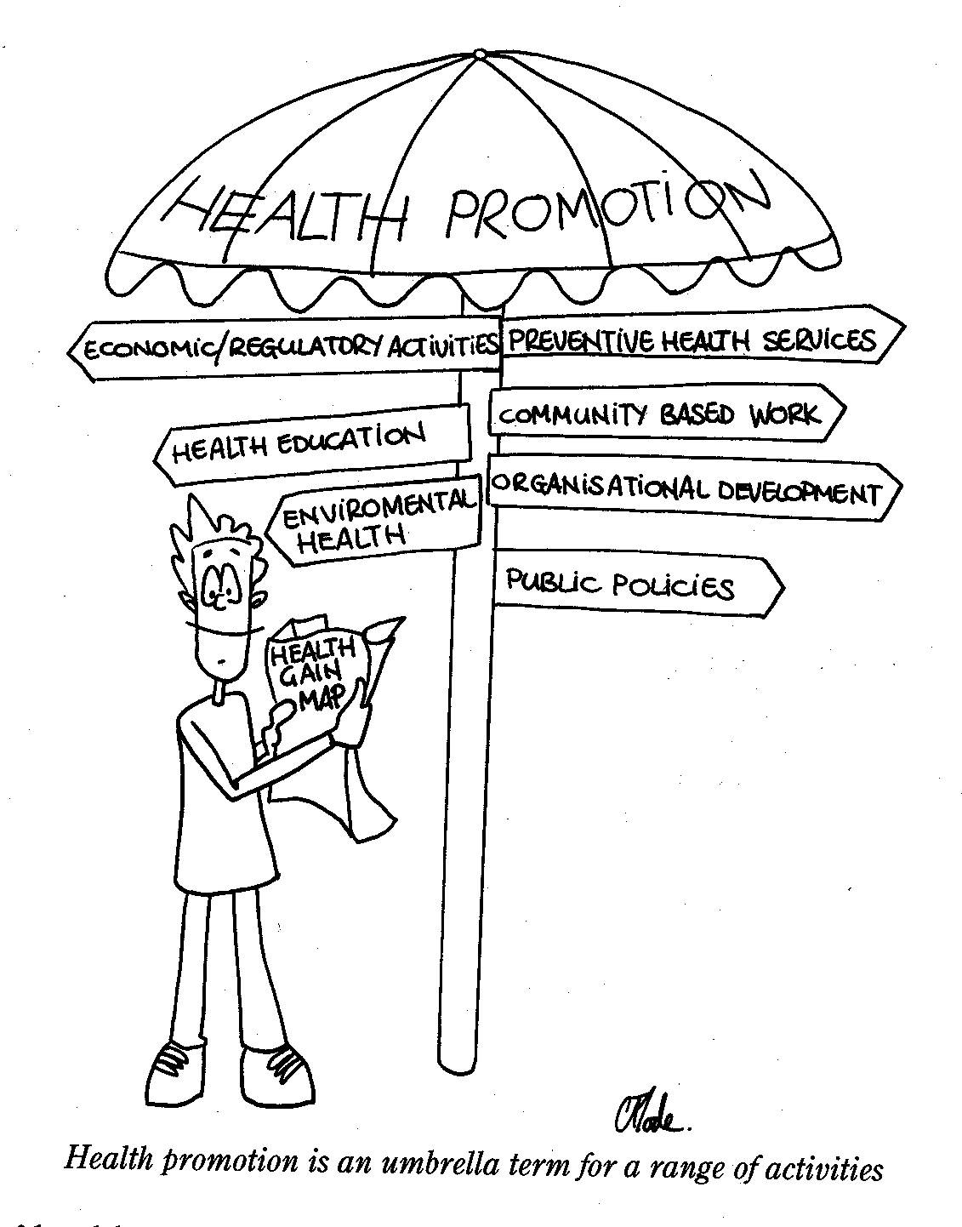

(Ewles & Simnett, 1999: 25)

Health promotion is an evolving discipline, and as you saw in the comparison between the Ottawa and Bangkok Charters, there has been a shift in emphasis in Health Promotion approaches. The next two readings provide an overview of Health Promotion terminology and concepts used in the field of Health Promotion. The first is a glossary developed in 1998 (an update of the original glossary developed in 1986), and the second, a further update to include 10 new terms. Skim through these so that you know where to look should you need to clarify your understanding.

**READINGS**

Nutbeam, D. (1998). Health Promotion Glossary. *Health Promotion International*, 13(4): 349-364

Smith B.J, Tang, K.C, Nutbeam, D. (2006). WHO Health Promotion Glossary: new terms, *Health Promotion International,* 21 (4): 340-345

The table below was developed by Tilford, Green and Tones and shows some of the shifts in the use of terminology between the original glossary in 1986 and the revised version in 1998. Identify those terms which are no longer used in the 1998 version of the glossary and question why this might have changed in relation to shifts in the aims and vision for Health Promotion e.g. “community action for health” only appears in the 1998 version. This suggests that the strategy of directing communities to address the determinants of health themselves is a recent development and recognises the importance of community participation in addressing their own health.

In the 1998 document, there appears to be greater emphasis on evaluation and related issues such as goals, outcomes and indicators. Strategies are more explicitly addressed, notably empowerment for health, settings, supportive environment, inter-sectoral collaboration, partnership, mediation, and sustainable development. There is concomitantly less emphasis on individual behaviour modification and mass media which perhaps signals the direction in which Health Promotion has evolved. New terms to emerge include health literacy, health development, investment for health, social responsibility for health and social capital.

|  |  |  |  |  |  |
| --- | --- | --- | --- | --- | --- |
| **Term** | **1986** | **1998** |  | **1986** | **1998** |
| Basic Concepts |  |  |  |  |  |
| Health | ü | ü | Healthy islands |  | ü |
| Health promotion | ü | ü | Healthy public policy |  | ü |
| Health education | ü | ü | Inter-sectoral policy | ü |  |
| Health for All |  | ü | Infrastructure for health promotion |  | ü |
| Disease prevention | ü | ü | Intermediate health outcomes |  | ü |
| Primary health care | ü | ü | Intersectoral collaboration |  | ü |
| Public health |  | ü | Intervention programme | ü |  |
| Lifestyle | ü | ü | Investment for health |  | ü |
| Action Research | ü |  | Lay care | ü |  |
| Alliance |  | ü | Legislation | ü |  |
| At risk group | ü |  | Life events | ü |  |
| Behavioural modification | ü |  | Lifeskills | ü | ü |
| Community | ü | ü | Lifestyle conducive to health |  | ü |
| Community action for health |  | ü | Living conditions | ü | ü |
| Community development | ü |  | Mass campaign | ü |  |
| Community involvement | ü |  | Mass media | ü |  |
| Consciousness raising | ü |  | Mediation |  | ü |
| Consumer group | ü |  | Medicalization | ü |  |
| Consumerism | ü |  | Network |  | ü |
| Coping | ü |  | New public health | ü |  |
| Decision-making skills | ü |  | Occupational environment | ü |  |
| Determinants of health |  | ü | Occupational health | ü |  |
| Ecology of health | ü |  | Ottawa Charter |  | ü |
| Economic environment | ü |  | Partnership |  | ü |
| Empowerment for health |  | ü | Perceived health | ü |  |
| Enabling |  | ü | Physical environment | ü |  |
| Epidemiology | ü | ü | Positive health | ü |  |
| Equity in health |  | ü | Pressure group | ü |  |
| Fiscal policy | ü |  | Quality of life | ü | ü |
| Health advocacy/advocacy for health | ü | ü | Re-orienting health services |  | ü |
| Health behaviour | ü | ü | Risk behaviour | ü | ü |
| Health choice | ü |  | Risk factor | ü | ü |
| Health communication |  | ü | Self help | ü | ü |
| Health development |  | ü | Self help group | ü |  |
| Health expectancy |  | ü | Self care | ü |  |
| Health gain |  | ü | Self esteem | ü |  |
| Health goal |  | ü | Self-empowerment | ü |  |
| Health indicator | ü | ü | Settings for health |  | ü |
| Healthism | ü |  | Social capital |  | ü |
| Health knowledge | ü |  | Social epidemiology | ü |  |
| Health literacy |  | ü | Social inequality | ü |  |
| Health outcomes |  | ü | Social movement | ü |  |
| Health policy | ü | ü | Social networks | ü | ü |
| Health professional | ü |  | Social planning | ü |  |
| Health promoting hospitals |  | ü | Social responsibility for health |  | ü |
| Health promoting schools |  | ü | Social support | ü | ü |
| Health promotion evaluation |  | ü | Stress | ü |  |
| Health promotion outcomes |  | ü | Supportive environment for health |  | ü |
| Health-related behaviour | ü |  | Sustainable development |  | ü |
| Health sector |  | ü | Total environment | ü |  |
| Health services | ü |  | Victim-blaming | ü |  |
| Health status | ü | ü | Well-being | ü |  |
| Health target |  | ü | Wellness | ü |  |
| Healthy cities |  | ü |  |  |  |

(Table from: Tilford S, Green, J. & Tones, B.K., 2002)

Now look at the additional terms in the 2006 article by Smith et al. This notes the impact on Health Promotion of globalisation and the need for political advocacy to address the determinants of ill health, the issues raised at the Bangkok Conference on Health Promotion noted in Session 1. However, despite this, you will notice that among the definitions are some that have a disease based, and a re-emphasis on individual or marketing focus, (burden of disease, self-efficacy, wellness and social marketing), which work against the principles of the Ottawa Charter and many of the trends noted in the Tilford, Green and Tones table. Others, however, tend towards more integrated approaches (capacity building and health impact assessment). Some of these terms will be picked up later in the module in more detail in Units 2, 4 and 5.

4.1 Definitions

# This unit began by noting that Health Promotion is broad in its scope, and that there are different interpretations about its implementation. This is reflected in the lively discussion about the concept of Health Promotion in recent years. Inevitably, this is reflected in the way health promotion is defined. By their nature, definitions are summaries, so they will inevitably be unsatisfactory, and the subtleties of the objectives and processes are often missed or misrepresented.

Have a look at the range of descriptions of Health Promotion listed in Task 3 below to see whether you think they capture the ideas discussed so far.

# TASK 3 – Analysing descriptions of Health Promotion

Read the definitions and descriptions below and then answer these questions.

1. What do you think are the common themes in these definitions or descriptions?
2. What are the differences between the definitions?

Definitions of Health Promotion

“Health Promotion is a unifying concept for those who recognise the need for change in the ways and conditions of living in order to promote health. Health Promotion represents a mediating strategy between people and their environment, synthesizing personal choice and social responsibility in health to create a healthier future.”

(WHO, 1984)

“Health Promotion is the process of enabling people to increase control over, and to improve their health. To reach a state of complete physical, mental and social well-being an individual or group must be able to identify and to realise aspirations, to satisfy needs, and to change or cope with the environment. …Therefore Health Promotion is not just the responsibility of the health sector, but goes beyond healthy lifestyles to well-being.”

(WHO, *The Ottawa Charter,* 1986)

“Health Promotion incorporates all measures deliberately designed to promote health and handle disease. A major feature of Health Promotion is undoubtedly the importance of ‘healthy public policy’ with its potential for achieving social change via legislation, fiscal and economic and other forms of ‘environmental engineering’.“

(Tones, 1990)

More recent descriptions have added aspects such as:

Health Promotion being:

“a key investment [where] social responsibility for health is reflected by the actions of decision makers in both public and private sector to pursue policies and practices which promote and protect health.” (Jakarta Declaration, WHO, 1997)

And finally,

“Health Promotion is the process of enabling people to increase control over their health and its determinants, and thereby improve their health. It is a core function of public health and contributes to the work of tackling communicable and non-communicable diseases and other threats to health.”

WHO *Bangkok Charter for Health Promotion in a Globalized World* (2005)

**FEEDBACK**

There are clearly many overlaps in these descriptions as they all build on the themes of the Ottawa Charter and adopt a broad definition of health.

However, there are also some differences in emphasis. For example, you will notice how the earlier definition (Tones) included a focus on education and disease prevention, whilst the more recent descriptions have developed more of a focus on investments for health (Jakarta Declaration) and a focus on tackling diseases (Bangkok Charter). This shift in focus was evident when comparing key terms included in the *Health Promotion Glossaries* referred to above.

# 4.2 The relationship between Health Promotion and Health Education

You will have noticed that we have used the term Health Education for the activities prior to the Ottawa Charter, and Health Promotion for the period after. This reflects the broadening out - from the individualistic focus of Health Education - towards the holistic process of Health Promotion which combines action on public policy for health and environmental action with Health Education. You will have noted that Ewles and Simnett (1999) include Health Education under the umbrella of Health Promotion.

Yet, there has been considerable criticism of what was seen as the limitations of Health Education’s individualistic approach, as was noted above. Tilford et al (2002) counter this criticism by pointing out that whilst the limitation of focusing on knowledge as a means of influencing behaviour is well-recognised, it is worth noting that knowledge still remains a pre-requisite for health.

Furthermore, they argue, education is often simply equated with the development of knowledge, with little acknowledgement of its contribution to the development of skills, values and motivations. Tilford et al (2002) point out that critics of Health Education often overlook the contribution of education to achieving social and political change. Tones and Tilford (2001) have argued for an expanded view of education in line with Paulo Freire, the Brazilian adult educator’s thinking and the concept of emancipatory education. This approach includes consciousness-raising and the development of a sense of community motivation and skills to take action to address health concerns. We will comment further on this debate in the next unit when reflecting on the Ottawa Charter.

* 1. **An illustrative model showing different components of Health Promotion**

# The final section in this session provides an illustration of a Health Promotion model that we hope you will find helpful in bringing together the different components of health promotion discussed above. We will be discussing models in more details in Unit 4, but felt it was useful to look at this model by Beattie at this stage as it provides a good overview of the range of Health Promotion inputs, and the way that Health Promotion is underpinned by values and moral principles. Importantly, it shows the importance of empowerment, which will be addressed more in later Units in relation to the Ottawa Charter and community participation in general.

# Beattie’s model of Health Promotion

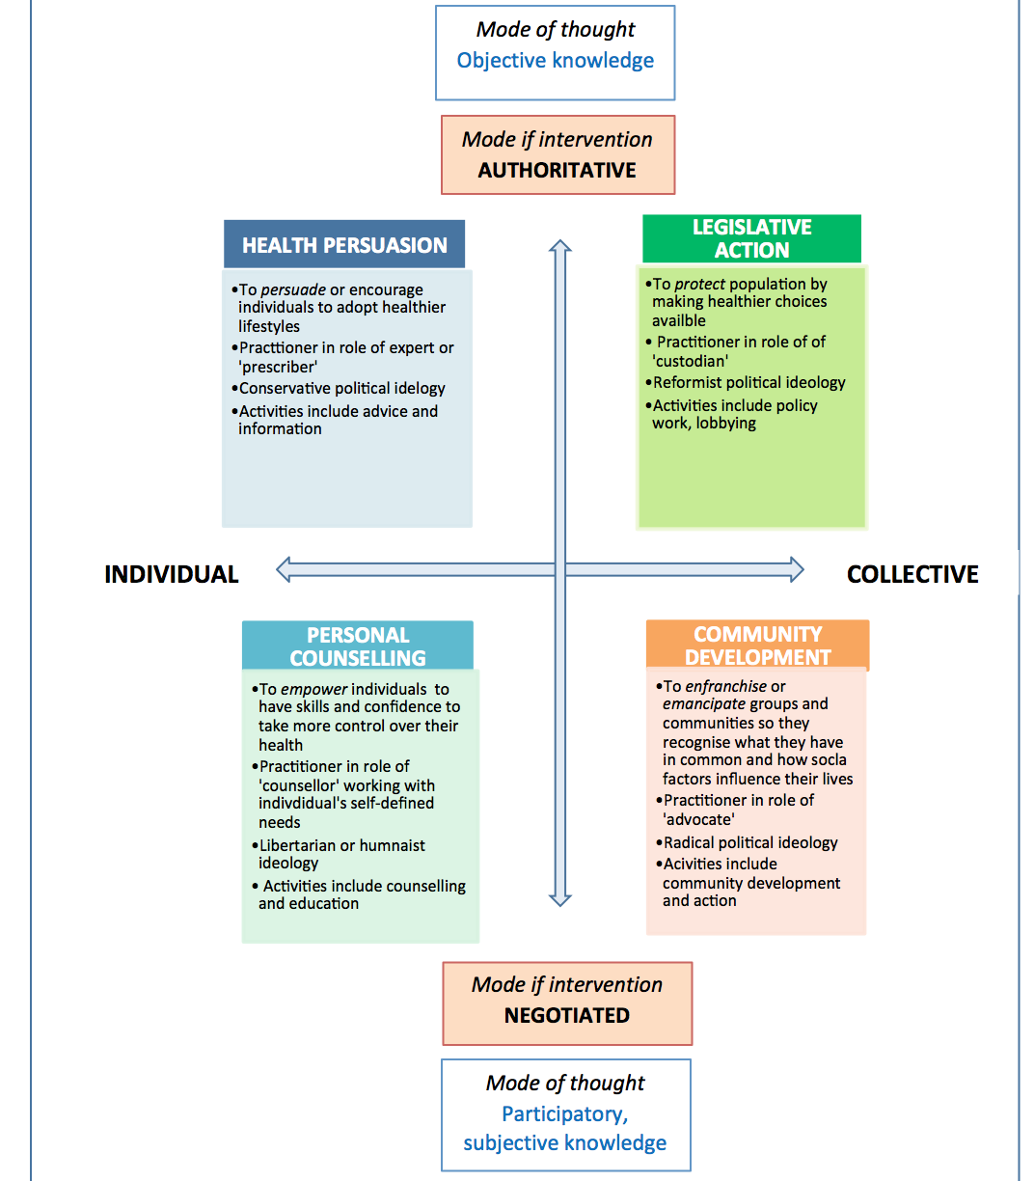

As you will see, Beattie’s model uses two axes to generate four quadrants. The vertical axis runs from ‘authoritative expert-led interventions’ typically based on an objective knowledge of health risks, to ‘negotiated interventions’ that acknowledge and use people’s lay knowledge of health. You will notice that it acknowledges that knowledge is both expert-defined and defined by lay people themselves. Activities in Health Promotion may be traditionally hierarchical in nature or more egalitarian and negotiated. The horizontal axis runs from activities directed towards individuals to activities directed towards whole populations. The model thereby encompasses the more ‘top-down’ or medically-driven interventions directed towards individuals, as well as the more ‘bottom up’ public health or sociologically-driven interventions directed towards groups and populations.

The four quadrants generated by the model encompass Health Promotion activity that reinforces the status quo (health persuasion): Health Promotion that is benevolent but forceful (legislation), Health Promotion that is communal and radical (community development), and Health Promotion that is aimed at empowering individuals (personal counselling). The right hand quadrants highlight the importance of social change, whereas the left hand quadrants emphasise social continuity and consensus. The model as a whole therefore embodies very different social philosophies and values, but demonstrates that each kind of activity has a role to play in promoting health. (Beattie, 1991, in Naidoo and Wills, 2001: 295-296)

Reflect back to Task 2 in Session 1, where you had to consider your own view of Health Promotion, based on Ewles & Simnett (1999: 40). How do you think the individual versus societal focus relate to the Beattie model? (There is no feedback on this. Just an opportunity for you to reflect on your own judgement about these levels).

# 5 Session Summary

You have reached the end of Session 2. In it we looked at some of the key documents in the recent development of Health Promotion thinking and approaches to it. The session highlighted how the broad determinants of health which we discussed in Session 1 have become an integral part of Health Promotion thinking, and noted some of the criticisms of earlier practice. Finally, the concept of Health Promotion was “unpacked” into some of its component parts. The third and final session of this contextual unit is an overview of some theoretical contemporary challenges for health promoters.

# 6 References and Further Reading

* Ewles, L. & Simnett, I. (1999). *Promoting Health: A Practical Guide.* Edinburgh: Bailliere Tindall
* Freire, P. (1974). *Education and the Practice of Freedom*. London: Writers and Readers Co-operative.
* Mittlemark, M (2007) Setting an Ethical Agenda for Health Promotion, *Health Promotion International,* Advance Access, Published, Nov 2007
* Naidoo, J. & Wills, J. (2000). (2000). Ch 11 – Strategies and methods. *Health Promotion: Foundations for Practice.* Bailliere Tindall, London: 226-231
* Porter, c (2006). From Ottawa to Bangkok: changing health promotion discourse, *Health Promotion International,* vol 22, 72-79
* Tones, K. & Tilford, S. (2001). *Health Promotion: Effectiveness, Efficiency and Equity.* Chelmsford, UK: Nelson Thorne.
* Tones, K. (1990). Why theorise: ideology in health education. *Health Education Journal*. 49 (1).
* WHO. (1984). *Health Promotion: A discussion document on the concepts and principles.* Copenhagen: WHO Regional Office for Europe.
* WHO (2009). Nairobi Call to Action of Closing the Implementation Gap in Health Promotion. 7th Global Conference on Health Promotion, WHO Geneva. [Online] available: <http://www.who.int/healthpromotion/conferences/7gchp/en/>
* Zola, I. K. (1970). *Helping – does it matter? The problems and prospects of mutual aid groups.* Address to United Ostomy Association.

**Unit 1 - Session 3**

Current reflections about Health Promotion

# Introduction

So far we have looked at the importance of addressing a broad context for Health Promotion, at some different approaches and at the historical development of Health Promotion, noting the importance of the Ottawa Charter (1986) in this development. This final session in Unit 1 looks at two readings taken from a special Health Promotion edition of a journal called Critical Public Health. These readings raise some of the ‘bigger picture’ issues dealt with, so they should be useful in deepening your understanding of both the issues and also some of the strategies for dealing with the challenges. It is deliberately a short session, based only on the two readings.

**Session contents**

1 Learning outcomes of this session

2 Readings

3 Challenges and opportunities for Health Promotion

4. Session Summary

5. References and Further Reading.

### Timing of this session

This final session of Unit 1 is based on **two readings**. The session will probably take about an hour to complete. The first looks critically at a historical perspective of Health Promotion in Africa, noting the challenges, and the second at an article by one of the Commissioners on the Commission on Social Determinants of Health.

### 1 Learning Outcomes of this Session

|  |
| --- |
| By the end of this session, you should be able to:   * Provide a critique of the development and current status of Health Promotion in Africa * Describe the opportunities for health promoters based on the Report of the Commission on Social Determinants of Health. * Demonstrate some impacts of globalisation on health |

### 2 Readings

The readings for this session are listed below. You will be directed to them in the course of the session.

|  |
| --- |
| Sanders D, Stern R, Struthers P, Ngulube TJ, Onya H.(2008). What is needed for HP in Africa: band-aid, live-aid or real change? *Critical Public Health* Volume 18 (4): 509 - 518 |
| Baum F.(2008) The Commission on the Social Determinants of Health: re-inventing health promotion for the 21st Century? *Critical Public Health* Volume 18 (4): 457 - 466 |

**3 Challenges and opportunities for Health Promotion**

Read the following two articles, which will go deeper into some of the challenges and opportunities for health promoters. The first reading is an article by Sanders et al (2008) (Sanders is the founder director of SOPH, Stern is convenor of this module and Struthers coordinates the Health Promoting Schools activities at UWC). It is one of the few articles on HP in Africa, particularly articles that are written as a critique of the current situation.

**READING**

Sanders et al (2008). What is needed for Health Promotion in Africa: band-aid, live-aid or real change? *Critical Public Health* Volume 18 (4): 509 – 518

The poster below has been produced by the SOPH giving a summary of the article.



The second article is by Baum, who was one of the Commissioners on the CSDH discussed earlier. This is a more general article, applicable to all regions and countries.

**READING**

Baum F. (2008). The Commission on the Social Determinants of Health: re-inventing Health Promotion for the 21st Century? *Critical Public Health* Volume 18 (4) p 457 – 466

**FEEDBACK**

Both articles illustrate the breadth and depth of Health Promotion, positioning it in a social determinants/equity/right to health context. They also demonstrate the impact of global influences on health and therefore on Health Promotion.

Sanders et al provide an analysis of the direction that Health Promotion has taken in Southern Africa, through a chronology that includes the pre Ottawa/Alma Ata period, to the time when the article was written (2008). It provides a fairly pessimistic view of the state of Health Promotion, other than some interesting experiences in Mozambique, Zimbabwe and South Africa during times of political transition. The article, however, ends with positive reflections on what could be done to strengthen Health Promotion in the 21st century by building on the local culture of ‘ubuntu’ (which defines people in relation to others); on strong civil society organisations and traditions and by adopting approaches that address the social determinants of health, approaches that are discussed in this module. Examples of good practice are used to illustrate this potential.

The article by Baum provides a forward looking and therefore optimistic assessment, by looking at how Health Promotion can build on the findings of the CSDH. She also calls for the growth in social movements to advocate for improved health, and argues for the use of the report of the CSDH to provide legitimisation for re-orientation of the health sector.

We end this Session and this Unit with a quote from the Baum article:

*The Health Promotion movement has the possibility of reinventing itself in the twenty-first century to offer the holistic understanding of health, the skills, passion and commitment required to be the core of a social movement which advocates for new healthy, equitable and sustainable economic and social structures globally and within countries.*

*(Baum 2008: 464).*

We conclude this session, therefore, with a revised determinants rainbow which shows the additional layer to illustrate the impact of globalisation.



# It is beyond the scope of this module to explore globalisation further. However, some of these issues will have been raised in the first unit of the Master in Public Health, ie. *Population Health & Development: A Primary Health Care Approach*. For those of you wanting to explore the issues further, there is an elective module on Globalisation which you could consider. You can also get more information on the impact across a range of issues by reading Global Health Watch, Global Health Watch 2 and Global Health Watch 3. These are available online. The details of these are listed in the Further Reading section below.

# 6 Session Summary

This short session pulled together two recently written articles which are part of a series of articles reflecting on the state of health promotion in the early 21st century. These and the other articles in the journal (see reference below) demonstrate the impact of the challenges that resulting from global and national trends.

# 7 References and Further Reading

* *Critical Public Health* Volume 18 (4) pp 509 – 518. Special edition devoted entirely to Health Promotion. It includes a reflection on the position of health promotion globally and in some countries.
* Global Health Watch (2005 – 2006), Unisa Press and Zed Books
* Global Health Watch 2 (2008), Zed Books
* Global Health Watch 3 (2011) , Zed Books

All are available online: <http://www.ghwatch.org/>