Unit 1 -­‐ Session 1

Thinking about the health workforce

INTRODUCTION

In this session we introduce you to the scope of human resource development. You will be introduced to different ways of thinking about or conceptualising human resource development, and will take the first steps in reflecting on the human resource situation within your organisation, a process that will continue throughout this module.

LEARNING OUTCOMES OF THIS SESSION

By the end of this session you should be able to:

§▪ Demonstrate an understanding of the key components of human resource development

READINGS

You will be referred to the following reading during this session:

Details

WHO (2006). Working Together for Health. World Health Report 2006. Geneva: WHO. url: http://www.who.int/whr/2006/en/

George A, Scott K, Govender V, editors (2017). Health policy and systems research reader on human resources for health. Geneva: WHO. url: http://www.who.int/alliance-­‐hpsr/resources/publications/9789241513357/en/.

THINKING ABOUT THE HEALTH WORKFORCE

Introduction

'Human resources' is the term used today to describe the most important part of any health system, namely the people who run it -­‐ from the cleaner and the gardener to the heart surgeon, the volunteer, nursing staff and the top administrator.

Alternative terms for 'human resources' are ‘health workforce’ and 'health manpower', which has problematic gender connotations. In this module we will use the terms ‘human resources’ and ‘health workforce’.

The term ‘human resources’ flags the fact that the people running the health system are indeed a resource that has to be developed and nurtured. In fact, they are the most crucial and the most expensive resource in the health system. Conventionally, between 65% and 80% of the entire health budget of a country is spent on human resources, leaving a relatively small proportion for everything else: drugs, buildings, equipment, transport and other running costs.

Furthermore, human resources require the longest preparatory time of all health resources and cannot be improvised. While the training of the health workforce is subject to the rigidities of the health and education systems, human personnel cannot be stored or discarded unlike other health resources. They have to be available in the right numbers and types at the right time – no more and no less than is needed. This makes the education and training of health professionals the most important challenge of human resource planning and production.

Lastly, because their skills are subject to obsolescence, particularly in these times of rapidly developing technology and knowledge, human resource abilities and skills need to be updated and improved through continuous development, training and supervision. This is a major challenge for human resource production and management.

Strangely, what is often forgotten or neglected in health planning is the fact that this most crucial and expensive of health resources consists of human beings -­‐ people with hopes, aspirations and values, who live within families and communities. We will see in this unit that the neglect of the human aspect of human resource development has severe

Internet resources:

Apart from a growing volume of printed publications on health human resources, there are now some fascinating websites with information on the topic. Visit one or all of the following to whet your appetite:

- http://www.who.int/hrh/en/.
This is the World Health Organisation’s website dedicated specifically to human resource development. It contains a wealth of extremely useful and interesting information.

- http://www.who.int/whr/2006/en/index.html.
The 2006 World Health Report focusses specifically on human resource development and is a key reference document in this field.

- http://www.human-­‐resources-­‐health.com
This is an international academic journal focussing on HRD for health. Although this is an academic journal, its articles are firmly rooted in, and based on, HR practices with a commitment to improving health service delivery.

- http://www.who.int/alliance-­‐ hpsr/resources/publications/9789241513357/en/ Under the leadership of colleagues from the SOPH the Alliance for Health Policy and Systems Research recently published A Health Policy and Systems Research Reader on Human Resources for Health. The idea for this Reader emerged from the need for guidance on and examples of excellent and innovative Human Resources for Health (HRH) research, embracing health workers as creative and dynamic agents who work alongside patients, community members, managers and policy-­‐makers to address contemporary health system complexities.

Many of the materials for this module have been drawn from the above sources. Detailed references are given in the text.

consequences for the system as a whole, and has contributed to the negative track record of HRD within health sector transformation in the past decades.

After decades of relative neglect, recent years have seen an increasing focus on the role of health workers for the development and strengthening of health systems. Between 2002 and 2004 the Joint Learning Initiative on human resources for health engaged more than 100 experts internationally “to understand and propose strategies for health workforce development”1. In 2006 the World Health Report, published by WHO and entitled Working together for health, focussed on the importance of health care workers. We use this report as the core text for this module.

Emanating from the Joint Learning Initiative, the Global Health Workforce Alliance (GHWA) was formed in 2006 as an international partnership of national governments, civil society, international agencies, finance institutions, researchers, educators and professional associations dedicated to identifying, implementing and advocating for solutions. Its mission is,

“[t]o advocate and catalyze global and country actions to resolve the human resources for health crisis, to support the achievement of the health-­‐related millennium development goals and health for all”

(http://www.who.int/workforcealliance/about/vision_mission/en/index.html).

In 2016 the WHO published a Global strategy on human resources for health: workforce 2030 (see: http://who.int/hrh/resources/global_strategy_workforce2030_14_print.pdf). You can watch a brief video of key international role players speaking about the strategy and its background here: https://www.youtube.com/watch?v=QXpp4kmUCLU).

Conceptualising human resource development

There are many ways of thinking about the components of and processes involved in human resource development. The World Health Report 2006 (or WHR 2006 for short) introduces several frameworks for conceptualising these components and processes.

The Forces Driving the Workforce framework below aims to illustrate the importance of the context for human resource development:

1 From the preface of the final report of the JLI, entitled Human Resources for Health.
Overcoming the Crisis. Harvard University Press, 2004. The full report is also available on
http://www.who.int/hrh/documents/JLi_hrh_report.pdf.

Forces driving the workforce

Driving forces Workforce

Health needs Demographics Disease burden Epidemics

Health systems Financing Technology Consumer preferences

Context
Labour and education Public sector reforms Globalization
Numbers
Shortage/excess

Skill mix
Health team balance

Distribution
Internal (urban/rural) International migration

Working conditions
Compensation
Non-­‐financial incentives Workplace safety

Source: World Health Report 2006, p. XVII

If we in the School of Public Health had developed this framework, we would probably have added two aspects in the left-­‐hand column which we think are particularly important and often overlooked, and which particularly my colleague, David Sanders always emphasises:

- The fact that HRH is, by its very nature, inter-­‐sectoral, i.e. has to interact with other sectors, such as education, public service, social development, water and sanitation.

- The transversal nature of HRD: human resource development can only be effective, if it interacts closely with health planning more broadly and the needs of health services at different levels and health programmes. The importance of this interaction will be discussed in Unit 2.

So a slightly adapted version of the framework might look something like this:

Forces driving the workforce

Driving forces Workforce

Health needs Demographics Disease burden Epidemics

Health service needs: Needs across levels of care (community, primary, ... tertiary)
Programme needs (MCH, Child Health, HIV, ...)

Health systems Financing Technology Consumer preferences

Associated systems:
Education
Public Sector
Social Development
Numbers
Shortage/excess

Skill mix
Health team balance

Distribution
Internal (urban/rural) International migration

Working conditions
Compensation
Non-­‐financial incentives Workplace safety

Adapted from: World Health Report 2006, p. XVII

Context
Labour and education Public sector reforms
Globalization

Activity 1: Identify factors driving the workforce

  - To start with, please click on this link:
http://www.who.int/whr/2006/06_overview_en.pdf?ua=1;

Or, if you want to download the whole report:
http://www.who.int/whr/2006/whr06_en.pdf?ua=1

Read pages 3 to 8 of the overview chapter of the World Health Report and make some notes of the factors identified in the text.

You can also read the text via Ikamva by clicking on this link: https://ikamva.uwc.ac.za/x/r01os2 for the overview chapter; or https://ikamva.uwc.ac.za/x/Lc1Vyf for the whole report.

  - Then take a bit of time to reflect on how the text and the factors identified in the figure above resonate with your own experience and context. Are they similar or very different? Give some thought to the question what you think the most important contextual factors are in your environment.

  - Lastly, choose one of the workforce factors above and think quite concretely about which driving forces impact on this factor and how. One way to do this is to develop a mind map.

Feedback Activity 1:

This feedback will not focus on all aspects of the task, but will provide an example of a mind map which links driving forces to a workforce factor.

The factor I have chosen here is “Skills Mix”. This refers to the question of what skills are needed, in what combination, to render what services. This is about the range of suitably trained health workers needed to render the necessary services. A typical example is that in many countries nurses are responsible for the full spectrum of primary care services in level 1 and/or level 2 health facilities. There are usually no doctors available at these facilities. However, nurses are often trained in hospitals and work under close supervision of medical doctors. As a result they do not acquire the necessary skills to run health facilities and primary-­‐level programmes during their training.

So: what are the driving forces that impact on the skills mix in health generally in your country and, more specifically, in the health team balance (i.e. the combination of cadres in a team and their respective skills)? This is my mind map of the issue in the context of primary health care in South Africa:

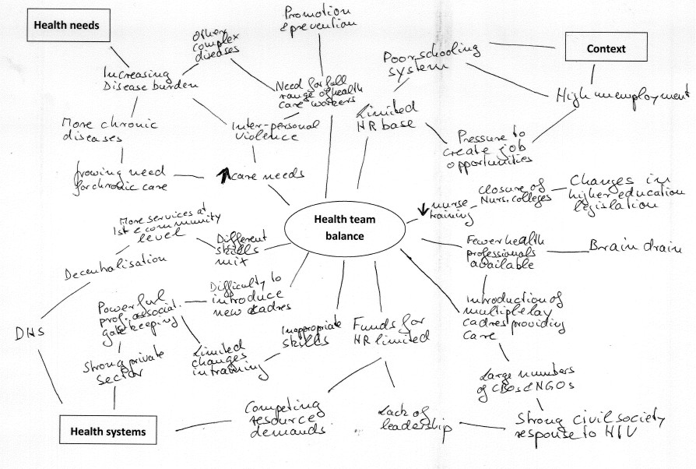

There are other ways of thinking about the factors that impact on the health workforce, its availability and how it is configured; as well as how the health workforce impacts on health services in a country. Below is a conceptual framework which was developed by Canadian colleagues a few years ago. It illustrates that health, health services and human resources live in a wider societal context (the outer circle). It furthermore shows that planning and

forecasting interacts with the health needs of the population, the available supply of people and financial resources; with what happens with training and education, and the way in which human resources are distributed, utilised and managed. Through the resource utilisation emanating from planning, the different outcomes impact on how well resources are being used, how well services are provided, and ultimately, how they respond to population health needs.

Framework for analysing health human resources

Economic

Political

Supply
Production – Education & Training

Health outcomes

Social
Population health needs

Planning and forecasting

Financial Management –

Resource Deployment
& Utilisation

Provider outcomes

System

Efficient use of resources (human and non-­‐human)

resources
Organisation and Delivery of services across Health Continuum
outcomes

Technological

Geographic

O'Brien-­‐Pallas, L., Tomblin Murphy, G., Baumann, A., & Birch, S. (2001). Framework for analyzing health human resources (p.6). In Canadian Institute for Health Information. Future development of information to support the management of nursing resources: Recommendations. Ottawa: CIHI

While the two frameworks above focus on the inter-­‐relationship between wider society (global and local), health-­‐ and other services and human resources, the following two frameworks, illustrate the different elements within human resources for health and how they interact with each other. They are the HRD cycle and the Working Lifespan Framework. Again, there are different ways of thinking about these elements and their interactions.

The HRD cycle

The traditional framework which was used for many years, distinguishes HR planning, HR production and HR management. It views health workforce development very much through the lens of the human resource function within departments or ministries of health, and reflects the organisational separation between policy and planning, production and (personnel) management in many departments:

The HRD Cycle

Socio-­‐economic planning

Employment:
-­‐ job analysis
-­‐ job description
-­‐ recruitment and selection
-­‐ personnel records and databases
-­‐ induction
-­‐ distribution of personnel Retention & Change:
-­‐ career structure
-­‐ promotion
-­‐ grievance and dismissal procedures
-­‐ working and living conditions
-­‐ reward system incentives Support
-­‐ forms of supervision
-­‐ forms of communication and consultation
-­‐ employer-­‐employee relations

Human Resource
Health planning

Human Resource Planning

Health Service Development

    - Available information (HRIS)
    - Estimating and planning supply and requirements;
    - Estimating and planning numbers, categories, distribution, skills, competencies

      - Undergraduate Education
      - Postgraduate

and collective representation Development
-­‐ individual performance review
-­‐ training
Management
Human Resource Production
training
    - Continuing education

Within this framework Human Resource Planning includes the estimation of staff numbers, categories, knowledge, competencies and attitudes of personnel required both in the immediate and long-­‐term future; the allocation of resources to train and pay these staff; the communication of this information to trainers and managers.

HR planning is essentially concerned with future and long-­‐term needs for personnel, and ensuring that these match future health service needs. HR planning is usually carried out at national and provincial levels. Some functions -­‐ such as resource allocation and the determination of the requirements for specialist health services -­‐ can probably be done most efficiently and equitably only at the central level of an organisation or system (Green, 1992). However, the more a service is decentralised, the more regional and district managers may be expected to do HR planning.
Human Resource Training and Development includes all aspects of the education and training of health personnel (both basic and post-­‐basic) to meet the requirements of the system. In the literature it is often called human resource production, which is a slightly dehumanising term, but which is actually meant to set it apart from the broader and overarching term of human resource development (HRD).

Institutions involved in the production of health personnel include nursing colleges, paramedical training schools, medical, pharmacy and dentistry schools usually located in universities and technikons.

Human Resource Management (HRM) includes the employment, retention and replacement, support and development of staff. It plays a crucial role in determining the productivity, and therefore the coverage of the health services system. Anybody responsible for the management of people in an organisation is responsible in some way or another for HRM.

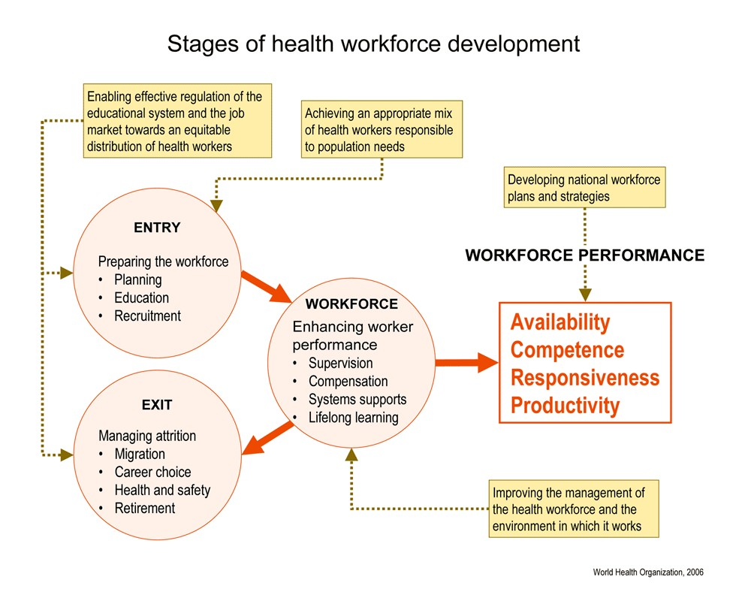However, in larger, more complex organisations, a great deal of HRM will be carried out by a specialised personnel department. The policies and practice of HRM consist, in part, of a series of techniques and procedures concerning, for example, recruitment and selection, job description and performance appraisal. The techniques are, however, not neutral but take on the social and political characteristics of their immediate environment. When the same technique is used in different social and political settings, then the political consequences of the technique will differ.

The Working Lifespan Framework

The 2006 World Health Report introduced the ‘Stages of Health Workforce Development’ framework below (also called Working Lifespan Framework). It focuses on ‘strategies related to the stage when people enter the workforce, the period of their lives when they are part of the workforce and the point at which they make their exit from it. At each stage, specific policy interventions can be designed and implemented, starting from the development a national health workforce development plan, and continuing with the regulatory frameworks for education and practice’ (WHR 2006, XX).

This framework is not dramatically different from the HRD cycle, but its lens is the health care worker her/himself, the different stages of her or his existence in the health sector, and the systems functions needed to manage and support health workers.

Remember that these aspects of HRD are embedded within a wider context: health needs and health service needs, education and public sector policies, plans and activities in social developments, etc.

Human Resources as part of complex health systems

Health systems are complex – a fact you have discussed in previous modules. To refresh your memory of what health systems complexity means watch the following two short videos on youtube:

- https://www.youtube.com/watch?v=HzT1-­‐BZIJQA : Systems Thinking and Complexity in Health: A Short Introduction
- https://www.youtube.com/watch?v=wX4p-­‐7p765Y : Jamkhed as an Example of Complex Systems Thinking in Health

These animations remind us of the multiple factors contributing to health systems complexity, and very centrally they remind us if the fact that health systems are complex, because they are driven by people.

Also read the first pages (Foreword and About this Reader of the Health Policy and Systems Reader on HRH to better understand how we think about human resources as part of complex and people-­‐centred health systems. In the following session we will deepen this discussion.

FURTHER READINGS

- Joint Learning Initiative (2004). Human Resources for Health – Overcoming the Crisis.
http://www.who.int/hrh/documents/JLi_hrh_report.pdf.

- Sheikh, K., et al. 2014. People-­‐centred science: strengthening the practice of health policy and systems research. Health research policy and systems. 12:19. url: http://www.health-­‐policy-­‐systems.com/content/12/1/19.

- Van Olmen, J. et al., 2012. The Health System Dynamics Framework: The introduction of an analytical model for health system analysis and its application to two case-­‐studies. Health, Culture and Society, 2(1), pp.0–21. url: https://hcs.pitt.edu/ojs/index.php/hcs/article/view/71/96.

SESSION SUMMARY

In this session we have introduced you to the scope of human resource development and different ways of thinking about and conceptualising its component parts within context. You have taken first steps to reflect on the human resource situation within your organisation, a process that will continue throughout this module.

In the following session we will place human resource development within a broader political and historical context, looking at the impact that health sector reform has on human resources – and vice versa.

