Unit 1 -­‐ Session 2

Health workforce challenges in Africa – past and present

1 INTRODUCTION

For the past few decades most countries throughout the world have been engaged in efforts to reform their health systems, with waves of reform initiatives following each other in quick succession. Whatever their specific objectives, these reforms often focussed on changes in financing, organisations and structures, often to the neglect of the key resource – staff. Staff are fundamentally affected by and, in turn, fundamentally affect the success of any kind of reform of the health sector.

The first and second part of this study session will look at some of the main reform initiatives of the past 25 years, their effect on health human resources and vice versa. The last part will focus on other challenges which are facing HRH internationally today. It draws particularly on work done by an international consortium of health experts in the Joint Learning Initiative (JLI) on health human resources and on the World Health Organisation’s work in this area.

This will be a reading session, aimed at locating HRD in a broader political and socio-­‐ economic context.

Each reading will come with a number of key questions, which will guide you through the text.

2 LEARNING OUTCOMES OF THIS SESSION

By the end of this session you should be able to:

§▪ Demonstrate an understanding of the role of HRD in the health sector.

§▪ Discuss HRD in the context of health sector reform.

§▪ Demonstrate an understanding of HRH challenges in an international context.

§▪ Discuss the key findings of the Joint Learning Initiative on HRH.

§▪ Locate your own country’s HRH situation in an international context.

READINGS

You will be referred to the following readings during this session:

Details
Igumbor, E., Sanders, D., Dovlo, D., Meeus, W. & Lehmann, U. (2009). Public health in Africa. In: Beaglehole, R. Global Public Health – A New Era. Chapter 8. Oxford: OUP. https://ikamva.uwc.ac.za/x/AUdXRB
Joint Learning Initiative (2004). Human Resources for Health – Overcoming the Crisis. Executive Summary. https://ikamva.uwc.ac.za/x/QZWiNY
WHO. (2006). Working Together for Health. World Health Report 2006. Geneva: WHO.
Lyons, M. (2004). The crisis in human resources for health: A clue in the colonial past through the example of Uganda. JLI Working Paper 1-­‐1. https://ikamva.uwc.ac.za/x/LCvkR3

HRD AND HEALTH SECTOR REFORM

In this session we start you off with a number of tasks straight away. The first is a reading exercise, followed by two tasks that will draw on the text.

Activity 1:

Answer questions on an academic text dealing with the historical context of health sector reform

Read Sanders D. et al, (2009). The chapter places human resource development and health sector reform in the context of socio-­‐economic and political developments in public health on the African continent over the past few decades. It thus provides a broad historical and political context for the discussions that follow.

You find the reading at: https://ikamva.uwc.ac.za/x/AUdXRB

Answer the following questions in writing:

q What have been the main challenges facing health ministries in post-­‐colonial Africa?

q What distinguished the PHC approach fundamentally from other approaches to health care delivery?

q What would you consider the main human resource implications of the PHC approach?

q How have human resources for health been affected by the health sector reform initiatives of the past decade?

q The authors talk about the inability to develop appropriate capacity. What does this mean practically?

q Which HR strategies should be put in place to counter the crisis? Do you agree with the authors' suggestions?

You don't need to focus so much on the tables at the beginning of the text, except to understand that health status in Sub-­‐Saharan Africa has begun to deteriorate again after a period of substantial gains. The article elaborates the various historical, political and global developments that have contributed to this situation, before it focuses on the key HR challenges in the present situation and possible future solutions.

In answering the above questions, think back to the module on Health, Development and Primary Health Care you did earlier in your studies. That module introduced the concept and implications of the PHC approach and its differences from other approaches.

Activity 2: The role of colonialism and post-­‐colonialism

Spend about half an hour reflecting on how colonialism and post-­‐colonialism have affected human resource structures in ways that impact on health systems to this day.

You can do this using a mind map, writing a mini-­‐essay, drawing a table or using any form of writing you are most comfortable with.

Also draw on Lyons’ paper to inform your thinking: https://ikamva.uwc.ac.za/x/LCvkR3

She describes, briefly and in broad strokes, the character and size of the current brain drain in the sector, as well as other aspects of maldistribution – after which she investigates the underlying historical reasons for brain drain, maldistribution and inappropriate skills.

The above reading and tasks have placed health human resources in a broad historical and political context.

KEY HR CHALLENGES IN THE HEALTH SECTOR TODAY

The second part of this session outlines key international challenges in health workforce development. It contains the executive summary of the Joint Learning Initiative’s final report, and an extract from an unpublished manuscript in the box below. You are further expected to continue to engage with the 2006 World Health Report to find information and answers to some of the questions below.

The JLI’s Executive Summary describes the key challenges facing the health workforce in low-­‐ and middle-­‐income countries, including shortages, skills imbalances, poor work environments, and the impact of old and new diseases. It then outlines key strategies needed to reverse the HR crisis and how these can be put into practice.

The shaded text box below very briefly outlines the global context, within which HRH debates are presently taking place.

The Joint Learning Initiative on Health Human Resources

In November 2004, the Joint Learning Initiative on Health Human Resources published its report Human Resources for Health – Overcoming the Crisis. The report was the climax of two years of work of a group of over 100 academics and practitioners, who felt that

“… the most critical factor driving health systems performance was overlooked. At a time of opportunity to redress outstanding health challenges, there is a growing awareness that human resources rank consistently among the most important barriers to progress. Paradoxically, in countries of greatest need, the workforce is under attack from a combination of unsafe and unsupportive working conditions and workers departing for greener pastures. While more money and drugs are being mobilised, the human foundation for all health action, the workforce, remains under-­‐recognised and under-­‐appreciated. To address this gap, the JLI was designed as a learning exercise to understand and propose strategies for workforce development” (JLI: vii).

The report is the outcome of this work and represents a compilation of a great amount of collective experience and wisdom internationally. While now a bit dated, its findings remain valid and relevant today.

You can find details of the JLI, its participants, the full report and supporting documents on the internet at http://www.who.int/hrh/documents/JLi_hrh_report.pdf.

Both the full report and the executive summary are also loaded on Ikamva. Full report link: https://ikamva.uwc.ac.za/x/Ij4mwE
Executive summary link: https://ikamva.uwc.ac.za/x/QZWiNY

Activity 3: Identify key challenges in HRH

This session is rather reading-­‐intensive. It contains three chapters from the JLI report, as well as one additional JLI document and an extract from an unpublished manuscript in the box below.

Chapter 1 of the JLI report, “The power of the health worker” (https://ikamva.uwc.ac.za/x/raa40j), argues why health workers are essential to health systems functioning and why many, particularly developing, countries are presently faced with a human resources crisis in the health sector.

Chapter 2 (https://ikamva.uwc.ac.za/x/6S1Lrh) focuses on the need to incorporate a wide range of community-­‐based health workers into conceptualisations of human resources for health.

Chapter 3 (https://ikamva.uwc.ac.za/x/uqZOjI) outlines what country governments and stakeholders could and should do to strengthen the health workforce internally.

The box below very briefly outlines the global context, within which HRH debates are presently taking place.

Read all four documents, making notes, as you go, on the following questions:

- What are the key HRH challenges emerging from the readings?

- How are globalisation and its policies impacting on HRH? What policies appear to be stoking the crisis and why?

- Why and how is Africa’s colonial past still impacting on today’s brain drain and lack of capacity to render appropriate health services in Africa?

- What is the triple burden of the HIV/AIDS crisis and why is it threatening health systems?

- What are the different levels of health care workers? What is the role of non-­‐ professional health care workers?

- What capacity-­‐building mechanisms have to be put in place to strengthen the health workforce?

- What other interventions at national level and below could strengthen the health workforce?

You will have to read across all texts in this session for answers to these questions, but you should end up with a very good overview of key challenges.

1 Locating HRH in developing countries in a global context

Despite the expressed concern with the stability of health systems within them, there is growing evidence that global policies such as PRSPs and the GATS will potentially continue to harm health systems.
There is now quite widespread agreement that Structural Adjustment Programmes (SAPs) have contributed to the weakening of systems through the enforced reduced public expenditure on health (Labonte et al., 2004). But a number of authors further argue that more recent policies can be seen in much the same light, despite pronouncements to the contrary.
"Two of the major vehicles by which G8 macroeconomic policy preferences have been
imposed globally are the SAPs and PRSPs of the World Bank and the IMF, which are dominated by the G8 countries. The effects of SAPs on health care and health status have been studied for almost two decades, with largely negative findings. While PRSPs emphasize country 'ownership' and civil society participation, their requirements for a macroeconomic framework with recommended elements almost identical to those of SAPs have raised criticism from civil society groups, international development organisations and several UN agencies" (Labonte et al., 2004), particularly the UNDP and UNCTAD. GATS agreements aggravate the situation by locking in"existing service privatisation and liberalisation policies. (…) The key concern is that GATS will unavoidably lead to increased privatisation of such essential public services as health care, education and water/sanitation" (Labonte et al., 2004).
The way in which global contexts impact deleteriously not only on health systems in developing countries in general, but on human resources in particular has been illustrated by work recently conducted by the Joint Learning Initiative (JLI) on health human resources. Graph 1 (Chen, 2004) illustrates the correlation between health worker density and infant, under-­‐five and maternal mortality across different countries.

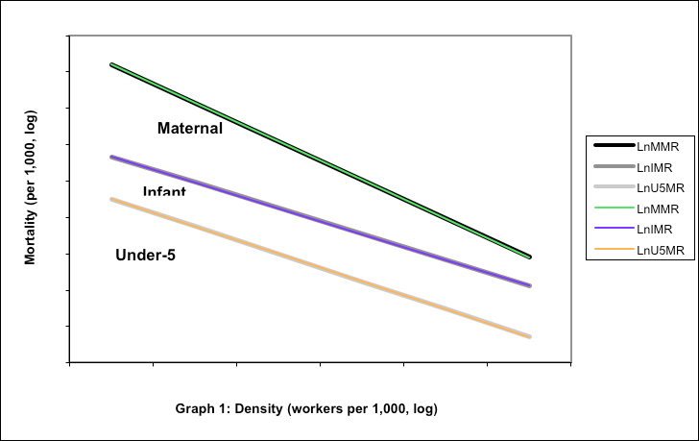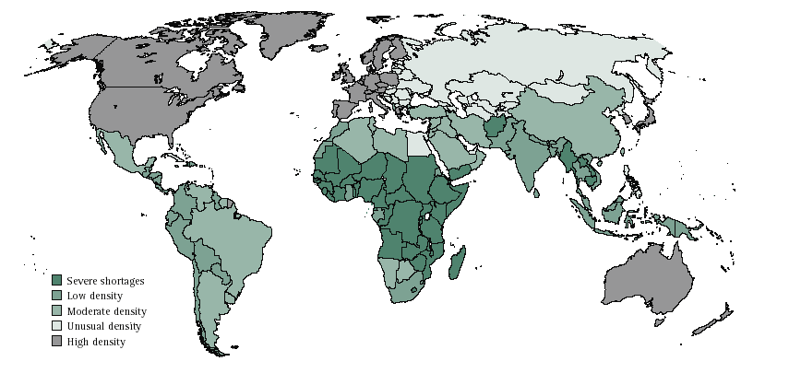

It clearly shows that the more health workers are available in a given community, the fewer women, babies and small children die. This graph is usefully contrasted with the following map which illustrates that countries with the highest disease burden, particularly on the African continent, have the lowest health worker density. In other words, those countries which have need health workers the most have the smallest numbers per population. To make matters worse, "the predominant flow of health professionals is from developing countries, where they are scarcest relative to needs, to developed countries, where they are more plentiful" (Woodward, 2003). Woodward highlights this situation as a fatal paradox: "this perverse trade arises to a great extent because relative income levels for health professionals in developed and developing countries do not reflect relative scarcity relative to need, but relative to effective demand for their services". The issue of maldistribution will be discussed more fully in the next section.

Lastly, based on their concerns, donors are now proposing, or are already in the process of implementing, the infusion of large amounts of money into programme areas, particularly HIV/AIDS, again without sufficient planning and attention to systems requirements. The effect can again be poorly planned and vertically implemented programme interventions which weaken rather than strengthen health systems. Already there are examples of donor agencies offering higher than normal salary rates to health workers in HIV programmes. The result is a worsening brain drain from the public sector as health workers stream to better paid posts in NGOs. Mainstream (public) health services then end up further under-­‐staffed and weakened. To avoid such deleterious development, attention to systems and close collaboration with local health services has to become an urgent priority for the donor community.

Feedback: Obviously everybody will read the texts above slightly differently, depending on your own experience, conceptual frameworks and value systems. However, themes which you should have identified include the following:

- Past and present World Bank and IMF policies, in particular Structural Adjustment Programmes (SAPs) and the General Agreement on Trade in Services (GATS) are thought by many to encourage and facility maldistribution and the brain drain.
- HIV/AIDS places crucial additional burdens on already very weak health systems through the loss of health workers, increasing workloads and aggravated work stresses..
- When conceptualising the HRH sector, all levels of health care workers, from family-­‐level carers to professional specialists have to be included and their role in the health system considered in line with local needs. In particular the role of community-­‐level and traditional health workers has to be re-­‐considered, as it is often these cadres who can ensure universally accessible health care in resource-­‐poor contexts.
- Developing countries are burdened by the often inappropriate Western orientation of their health care systems and the training for these systems. Countries should reconsider and strengthen their capacity building programmes to support local requirements. They furthermore have to build local capacity to strengthen the area of HRH through a host of interventions which are discussed particularly in chapter 3 of the JLI report.

HUMAN RESOURCES AND SOCIAL CONTEXTS

“Health workers, in addition to working for health, are first and foremost human beings. Their empathy, intuition and ingenuity, alongside their technical skills, are critical in negotiating the social contexts that shape their work environment and professional practice. This emphasis on human agency and social context is a key characteristic of people-­‐centred health systems (Sheikh et al., 2014). While this reader highlights health workers as active agents in multiple places, this chapter in particular focuses on the social relations and social systems that embed and are negotiated by health workers. These include the broad social norms and structural forces that foster equity and solidarity or, conversely, that constrain livelihoods and survival. These social dynamics also shape and are shaped by the markets in which

health workers practise or to which they are compelled to move” (George et al, 2017: 41).

The above quote introduces the second chapter of the HPSR HRH reader on Social contexts and relations shaping health workers.

Social contexts cover many different issues: social norms and cultures as mentioned above; issues of gender and gender discrimination; the impact of other sectors on health workers (eg. access to education).

Activity 4: Reading on health workers and their social context

As a last reading activity in this session please read the second chapter of the HPSR HRH reader (http://www.who.int/alliance-­‐ hpsr/resources/publications/HRH_Chapter2.pdf ).

Then choose one of the papers discussed in the chapter (choose one whose topic particularly interests you), and deepen your understanding of the role of social contexts and relations by reading this paper.

When you get to your assignments, consider thinking specifically about the less researched issues of social context: maybe consider a gender analysis, or focus on issues of equity and social justice, or think more about the impacts of history and social economy. Please contact me if you want more reading material on any of these issues, but use the HPSR reader as a first port of call.

Activity 5: Locate your own country within the international debates

Having engaged with the above discussions, now consider to what extent the arguments advanced in these debates are valid for your own context. Do you recognise most of the issues raised, or are the challenges you are experiencing quite different?
You could draw up a table which compares the identified international challenges with those you are experiencing. This would also help you to identify which of the suggested actions and interventions might be valid and suitable for your context.

FURTHER READINGS

- Chen et al. (2004). Human Resources for Health: Overcoming the crisis. Lancet,
364:1984-­‐90.

- Woodward D. et al. (2002).Globalization, global public goods and health. In: WHO & PAHO. Trade in Health Services: Global, Regional and Country Perspectives. Washington DC: Pan American Health Organization, Program on Public Policy and Health, Division of Health and Human Development. Chpt 1. url: http://www.who.int/trade/resource/THS/en/

- Labonte, R., Schrecker, T., Sanders, D., Meeus, W. (2004). Fatal Indifference: the G8, Africa and Global Health. UCT and IDRC, Cape Town.

- Martinez J., Martineau T. Rethinking human resources: An agenda for the millenium.
Health Policy and Planning 1997, 13(4): 345-­‐358.

SESSION SUMMARY

This was a very reading-­‐intensive session which gave you insight into some of the presently very lively global debates on HRH challenges particularly in low-­‐ and middle-­‐income countries. Evidently, it has been widely accepted by now that it is impossible to run fully-­‐ functioning health systems without motivated, well-­‐equipped health workers. The much more difficult question now is how to ensure that these insights are translated into better practice and outcomes.

