Unit 2 -­‐ Session 3
Addressing shortages and imbalances

INTRODUCTION
The 2006 World Health Report makes the point forcefully that many countries, particularly in Africa, are today suffering critical workforce shortages. The report estimates that these shortages are “equivalent to a global deficit of 2.4 million doctors, nurses and midwives” (p.XVIII). The report furthermore emphasizes that “skills mix and distributional imbalances compound today’s problems” (ibid.), again most prominently in Africa. This picture has not changed dramatically in the past ten years.
In this session we will discuss some of these shortages and distributional imbalances and what strategies have been developed to address these by countries and by the global health community. In particular we will focus on the revision of skill and staff mixes, the introduction of mid-­‐level and community-­‐based health workers, particularly in primary health care, and debates about task-­‐shifting.

LEARNING OUTCOMES OF THIS SESSION

By the end of this session you should:
§▪ have an understanding of the “size and shape” of workforce shortages within countries;

§▪ understand different country responses to the crisis;

§▪ have an understanding of the complexity and diversity of mid-­‐level and community health worker programmes; and

§▪ be able to critically engage with the rationale, benefits and pitfalls of task shifting.

READINGS

You will be referred to the following readings during this session:

Details
WHO. (2006). Working Together for Health. World Health Report 2006. Geneva: WHO.
WHO (2016). Global Strategy On Human Resources For Health: Workforce 2030. WHO: Geneva. url: http://www.who.int/hrh/resources/globstrathrh-­‐2030/en/
WHO (2008). Task shifting: Rational redistribution of tasks among health workforce teams: Global recommendations and guidelines. http://www.who.int/healthsystems/TTR-­‐ TaskShifting.pdf
Vaz F, Bergström S, Vaz Mda L, Langa J, Bugalho A. Training medical assistants for surgery. Bull World Health Organ. 1999;77(8):688-­‐91. http://www.who.int/bulletin/archives/77(8)688.pdf?ua=1 .

Lehmann, U., van Damme, W., Barten, F., Sanders, D. (2009). Task-­‐shifting – The answer to the HR crisis in Africa? Human Resources for Health Journal, 7(49) https://human-­‐ resources-­‐health.biomedcentral.com/articles/10.1186/1478-­‐4491-­‐7-­‐49.

SHORTAGES AND IMBALANCES

The first part of the session aims to give you a very brief overview of shortages and imbalances, to contextualise the discussions that follow. Please study the following in conjunction with chapter 1 of the World Health Report 2006.

WHO’s strategy document on the health workforce, Global Strategy on Human Resources for Health: Workforce 2030, estimates that Africa presently has a shortfall of health workers needed of 4.2 million, which may rise to 6.1 million by 2030 (see below).

In addition to a huge overall shortfall worldwide, there are dramatic regional imbalances: while all regions face some shortfalls, These are dramatically greater in Africa than, for example, in Europe, which has a shortfall of 0.1 million health workers (and only of nurses, many of whom are recruited from regions with serious shortfalls).

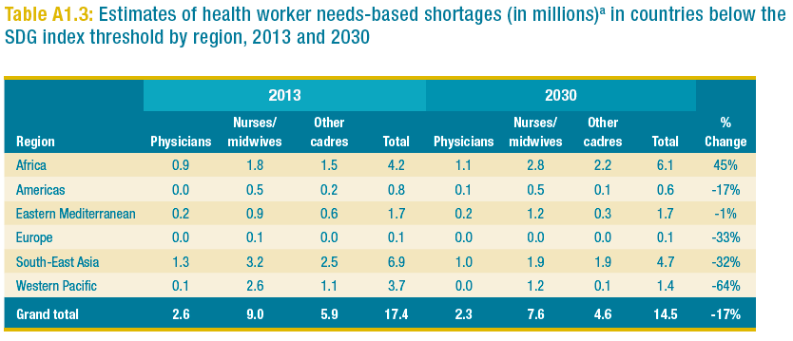
Source: WHO (2016). Global Strategy On Human Resources For Health: Workforce 2030. WHO: Geneva. url: http://www.who.int/hrh/resources/globstrathrh-­‐2030/en/. P 44

The chart below illustrates the global size and shape of health worker imbalances in selected countries, using only the examples of doctors and nurses. It shows that the UK, for example, has two doctors and twelve nurses per 1,000 population, and Cuba has almost six doctors and six nurses per every 1,000, while Malawi has hardly any doctors or nurses at all.

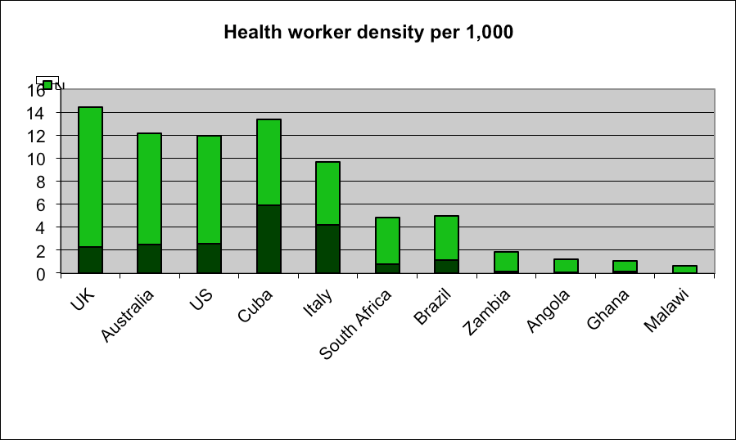

Source: World Health Report, 2006

Activity 1: Health worker density in your country
This task has two parts:
- Firstly, consult Annex 4 of the WHR 2006 (pp 190 – 199)
https://www.who.int/whr/2006/annex/06_annex4_en.pdf to find the
health worker density figures for your country. Compare your country’s health worker density for doctors, nurses and midwives with the chart above. Where does your country fit in?

- Secondly, make a list of the most important health worker cadres in your country, and rank them in order of their importance for health care delivery in your country. Make this list based on YOUR knowledge of the country.

In unit 3 you will be introduced to the WHO Global Workforce Statistics website to look at more recent data and to familiarize yourself with data sources etc. If you want to take a peak, here is the website: http://www.who.int/hrh/statistics/hwfstats/en/ .

CHANGING STAFF CATEGORIES AND STAFF MIXES

The list of important health worker cadres in your country may have looked similar to this:

  - Medical doctors

  - Nurses

  - Midwives

  - Pharmacists

  - Dentists

  - Physiotherapists.

Or it may have looked more like this:

Please note: in many countries traditional healers and birth attendants play a vitally important role in rendering health care to communities. We will not be discussing these cadres here as they are usually not part of the formal health system. However, HR planners and managers are well advised to engage with these cadres and to factor them in when planning service delivery.

  - Medical assistants

  - Nurses

  - Nursing auxiliaries

  - Community health workers (called different names in different countries: like ‘health surveillance assistants’, ‘health extension workers’, ‘agente polivalente elementar’)

  - Medical doctors.

In Unit 1 you read a paper by Sanders et al which, among other things, discusses the colonial legacy of health worker cadres. Western medicine focuses on the cadres in the first list above, and it places medical doctors (MOs) at the apex of the health hierarchy. However, the reality is that in most African countries medical doctors have always been in very short supply. The crisis of the past few years has aggravated the situation with regard to doctors and has furthermore made professional nurses an increasingly rare commodity.
One response to these shortages, old and new, has been the use and introduction of new
cadres, such as mid-­‐level (technicians and assistants) and lay cadres.

Mid-­‐level workers
Mid-­‐level workers are health care providers who have received less training and have a more restricted scope of practice than professionals. In contrast to community or lay health workers, however, they have a formal certificate and accreditation through their countries’ licensing bodies.
A review conducted in 20081 suggests that for over a hundred years various categories of mid-­‐level workers have been utilised successfully to provide health care, particularly to underserved communities. In many low-­‐income countries mid-­‐level doctors (then called

1 The full review can be found at http://www.who.int/hrh/MLHW_review_2008.pdf.

auxiliaries) originated in colonial times, when they were trained and deployed to render care to indigenous populations as professional health care remained the privilege of Europeans.

The use of mid-­‐level workers has been widening in both high-­‐ and low-­‐income countries. They are used to assist professionals or to render care independently, particularly in rural health centres and district hospitals, making up for the scarcity or absence of traditional professionals such as therapists, doctors, dentists, pharmacists, or nurses.

Utilisation, skills, length of training and management practices vary substantially across cadres and countries. Asian countries in particular have, over the years, developed a large number of local mid-­‐level worker categories, from birth attendants to health assistants. These are not modelled on traditional health professions, but respond to specific country needs. In African countries, on the other hand, most mid-­‐level cadres appear to have developed from traditional professional cadres, such as medical doctors, pharmacists, etc. Some countries have developed a multitude of these categories, most notably Mozambique.

The 2008 review found that the evidence regarding the impact of mid-­‐level workers on health outcomes is not good. Most studies show that mid-­‐level workers improve access to and coverage of health services, and argue that well trained and motivated mid-­‐level workers provide better quality and more accessible services than better qualified but less motivated professionals. But there are very few studies which rigorously link health outcomes or health status to these cadres. Similarly, information on the cost and cost effectiveness of using mid-­‐level cadres only exists in very few countries. Undoubtedly, this lack of evidence contributes to the continued ambiguity regarding the legitimacy and roles of mid-­‐level workers in some circles and in particular among professional bodies -­‐ even in countries where they are widely used and health service delivery actually depends on them.

One of the countries that has seen some rigorous investigation of their mid-­‐level worker programmes, and in particular their medical assistants programme, is Mozambique. Amongst the most successful categories of medical assistants in this country are the so-­‐ called “Técnicos de Cirurgia” (or TC), advanced mid-­‐level medical practitioners who are able to perform emergency surgery, obstetrics and traumatology under difficult conditions in district hospitals.

“The TC in Mozambique does not have a medical degree; candidates are recruited mainly among the best mid-­‐level medical practitioners and nurses, with substantial experience in rural areas. They undergo an intensive training programme, learning under the tight supervision of senior surgeons, comprising two years of training at Maputo Central Hospital and one year internship in a provincial hospital”. (Cumbi et al. 2007: 2).
Evaluations of their performance and cost-­‐effectiveness showed no significant differences in patient outcomes when compared with results obtained by trained medical specialists -­‐ and they cost 10 times less than training medical specialists (Ferrinho and Omar, 2004; Pereira et al., 1996; Vaz et al., 1999).

Activity 2: Mid-­‐level workers in Mozambique
Please read the article by Vaz et al to gain a better understanding of the Mozambican Técnicos de Cirurgia programme as one example of a successful mid-­‐level worker programme.

I would also encourage you to have a look at the WHO review (http://www.who.int/hrh/MLHW_review_2008.pdf ) to get a sense of other mid-­‐level worker categories and programmes, and how these compare with programmes in your country.

Community-­‐based or lay health workers
If the policies, practices and experiences with mid-­‐level worker programmes are diverse and varied, the situation with community-­‐based cadres is even more complex, wide-­‐ranging and uneven.

Like mid-­‐level workers, lay or community health workers (CHW) are not a new phenomenon. Using community members to render certain basic health services to the communities they come from is a practice which has been around for at least 50 years. All over the world -­‐ but particularly in countries in Asia, Africa, and Latin America – CHWs, who are mainly mature women with little formal education, have been providing health education to their communities, helping pregnant mothers and new-­‐born babies and treating basic illnesses. Since the arrival of HIV/AIDS, community health workers furthermore counsel and test community members, provide peer support and home-­‐based care and ensure that people on ARVs take their treatment.

Early CHW programmes emphasised the role of the village health workers (VHWs), the term most commonly used at the time. Not only were they (and possibly not even primarily) a health care provider, but they were also advocates for the community and agents of social change, functioning as a community mouthpiece to fight against inequities and advocate community rights and needs to government structures. This is reflected in the Alma Ata Declaration which identified CHWs as one of the cornerstones of comprehensive primary health care.

Examples of CHW programmes implemented as part of wider health sector reform processes, aiming to enhance accessibility and affordability of health services to rural and poor communities within a PHC approach, can be found in numerous low-­‐income countries in the 1970s and 80s.

But it is the recent human resource crisis, fuelled by a mix of increasing care needs, insufficient health expenditure and the brain drain which has revived and given new currency and impetus to the idea of comunity health worker programmes. Within this context their role as advocates for social change has largely been replaced by predominantly technical and community management functions, although the fundamental tension between their roles as extension worker and change agent remains.

With the revival of the CHW concept and programmes has come a revival of debates and research about CHWs roles, their location, relationships to the formal health sector, and

efficiency. One of the great weaknesses of these debates is that they homogenise exceptionally heterogeneous programmes and policies. The concept of community health workers programmes conflates the national Programa Agente Comunitário de Sáude in Brazil, in which CHWs are state employees, working in health teams which also routinely have doctors and nurses who function as supervisors; the Ethiopian Health Extension Worker programme which sees CHWs independently rendering the first level of health services; large-­‐scale volunteer programmes like in Chhattisgarh, India; small-­‐scale NGO-­‐funded projects; and HIV-­‐related peer support and self-­‐help groups. It furthermore often discusses CHWs who have received one full year of accredited training in the same breath as CHWs who never received any training, but became CHWs to assist family members or neighbours battling with the impact of HIV/AIDS.

Clearly, there is need for a much more differentiated understanding and debate about what different types of roles lay or community health workers can play, how they are located within local versions of community and primary health care delivery, and how they can be planned and managed. HR planners and managers as well as academics have work to do in this area.

But despite these conceptual weaknesses and despite the enormous diversity of CHW programmes, the available evidence from all these programmes is in agreement on a number of issues, as outlined in a WHO policy brief on Community Health Workers -­‐ what do we know about them?:

Firstly, CHWs can make a valuable contribution to community development and, more specifically, can improve access to and coverage of communities with basic health services. There is robust evidence that CHWs can undertake actions that lead to improved health outcomes, especially, but not exclusively in the field of child health. However, although they can implement effective interventions, they do not consistently provide services likely to have substantial health impact and the quality of services they provide is sometimes poor.

Secondly, for CHWs to be able to make an effective contribution, they need to be carefully selected, appropriately trained and, very importantly, adequately and continuously supported. Large-­‐scale CHW systems require substantial increases – compared to what they have generally enjoyed -­‐ in support for training, management, supervision, and logistics.

Thirdly, CHW programmes are therefore neither the panacea for weak health systems nor a cheap option to provide access to health care for under-­‐served populations. Numerous programmes have failed in the past because of unrealistic expectations, poor planning and an underestimation of the effort and input required to make them work. This has unnecessarily undermined and damaged the credibility of CHWs.

Fourthly, by their very nature, CHW programmes are vulnerable, unless they are driven, owned by and firmly embedded in communities themselves. Where this is not the case, they exist on the geographical and organisational periphery of the formal health system, exposed to the moods of policy swings, without the wherewithal to lobby and advocate for their cause, and thus are often fragile and unsustainable. Evidence suggests that CHW programmes thrive in mobilised communities but struggle where they are given the

responsibility of galvanising and mobilising communities. Examples of successful programmes can thus be found in the wake of community mobilisation efforts, either as part of large-­‐scale political transformation, such as in China or Brazil; or through local mobilisation, often facilitated by non-­‐governmental, community-­‐based or faith-­‐based organisations. In many cases programmes last through the life span of the mobilisation effort and wither or collapse entirely as the momentum of mobilisation is lost. A key challenge lies in institutionalising and mainstreaming community participation. To date the largest and most successful programme in this regard is the Brazilian Family Health Programme, which has integrated CHWs into its health services and institutionalised community health committees as part of municipal health services to sustain social participation. This means that community participation does not become an alternative but an integral part of the state’s responsibility for health care delivery.

Fifth, the question as to whether CHWs should be volunteers or paid in some form remains controversial. There exists virtually no evidence that volunteerism can be sustained for long periods: as a rule community health workers are poor and expect and require an income. Although in many programmes they are expected to only spend a small amount of time on their health-­‐related duties, leaving time for other bread-­‐winning activities, community demand often requires full-­‐time performance. The reality is that CHWs as a rule and by their very nature provide services in environments where formal health services are inaccessible and people are poor. This also complicates the issue of community financing, which is rarely successful, unless institutionalised as in China in the 1970s and 1980s. Most of the evidence reflects failures of community financing schemes, leading to high drop-­‐out rates and the ultimate collapse of programmes.

Given present pressures on health systems and their proven inability to respond adequately, the existing evidence strongly suggests that, particularly in poor countries, CHW programmes are not an easy, but a good, investment, since the alternative in reality is NO care for the poor living in geographically peripheral areas. While there is a lot to learn, there is a lot we do know about making programmes work better: appropriate selection, continuing education, involvement and reorientation of health service staff and curricula, improvement of supervision and support are non-­‐negotiable requirements. These need political leadership and substantial and consistent resourcing. We need to learn from examples of large-­‐scale successful programmes in this regard, particularly providing longitudinal evidence of what works and what does not work. This presently constitutes the biggest knowledge gap.

(Excerpt from Community Health Workers -­‐ what do we know about them? A policy Brief. Evidence and Information for Policy, Department of Human Resources for Health. WHO: Geneva 2007.
http://www.who.int/hrh/documents/community_health_workers_brief.pdf)
.

There is a vast academic and non-­‐academic literature on community health workers. In the past eight years around 400 articles, reviews and substantial reports discussing community health workers in Africa have been published.

There also are numerous literature reviews by now. One conducetd by the Global Health Workforce Alliance can be found on http://www.who.int/workforcealliance/knowledge/resources/chwreport/en/. Particularly the country case studies in this report make for interesting reading.

The best guide for large-­‐scale CHW programmes has been complied by the Maternal and Child Health Integrated Program (MCHIP), and can be found on their website: https://www.mchip.net/sites/default/files/mchipfiles/CHW_ReferenceGuide_sm.pdf .

And CHW Central is an excellent online resource on a range of topics relating to CHWs:

http://chwcentral.org/.

TASK SHIFTING

Recent suggestions for the “appropriate delegation” of tasks (or “task shifting”) are closely linked to the discussions above. Fundamentally the questions which need to be answered by HR planners and managers (in close consultation with programme planners and managers) are:

- What services can and should be rendered where (i.e. at what level of service)?

- What skills are required to render these services?

- Who has or can acquire the skills to render these services?

- What health workers cadres (lay and professional) are or can be made available to render health services?

The 2006 World Health Report (p. 23) suggests the following:

“Greater efficiencies in workforce performance can be achieved by applying two of the cardinal rules for scaling up interventions effectively: simplification and delegation. Simplification often improves staff productivity by allowing more to be done, with greater consistency, and often by less skilled colleagues. ... Simplification facilitates but is not a prerequisite of task delegation. Tasks related to service delivery can often be carried out as or even more efficiently by less senior staff. Task delegation is especially important in resource-­‐constrained settings where skilled staff are in very short supply”.

WHO has furthermore developed “Global Recommendations and Guidelines for Task Shifting” which you have received with your resources. The guidelines can also be found on http://www.who.int/healthsystems/task_shifting/en.

But while task-­‐shifting undoubtedly holds great potential, not only to address shortages of health workers, but also to bring more appropriate health services closer to communities, it

also holds dangers and pitfalls. We wrote a brief commentary with some international colleagues a few years ago to draw attention to the benefits and pitfalls of task shifting.

Activity 3: Task shifting – the answer to the HR crisis in Africa?

Please read Lehmann, U., van Damme, W., Barten, F. and Sanders, D. (2009). Task-­‐shifting – the answer to the HR crisis in Africa? Human Resources for Health Journal. 7(49).
In this commentary, we argue that to be more than just a short-­‐term stop-­‐gap measure, task shifting requires long-­‐term political and financial commitment and a revisiting of the concept of community participation.
First of all, do you agree with the arguments made in this paper? Which arguments resonate with your own experience? What would you argue differently?
Secondly, think about how task-­‐shifting, community participation, the use of lay-­‐ and mid-­‐ level cadres is viewed in your context.
- Are issues of long-­‐term planning, funding, training, supervision, career-­‐pathing, incentives – all considered vital to successful programmes – addressed systematically?

- Who are the key actors involved in designing, planning for and managing these programmes?

- Is there systematic monitoring and evaluation which will allow continuous learning and improvement?

SESSION SUMMARY

This session has entailed thinking and reflecting rather than “doing”. It asked you to engage critically with some of the very complex questions raised by the HR crisis and global and country responses.

But imbalances and staff mixes are not the only aspects which need to be addressed by planners and managers. We will discuss other issues, such as training, supervision, support, work environments, etc. in the following sessions – with the following session looking at questions of education and training in more detail.

