Unit 2 -­‐ Session 4
BUILDING CAPACITY THROUGH TRAINING AND SUPERVISION

INTRODUCTION

This session will focus on issues of training and supervision. It will not discuss specific training curricula but will concentrate on who is trained, broad orientation of training programmes and where training takes place.

LEARNING OUTCOMES OF THIS SESSION

By the end of this session you should be able to:
§▪ understand the extent and training capacity shortages in Africa;

§▪ understand some of the key reasons for these shortages;

§▪ discuss how innovations in health worker education can address these shortages;

§▪ understand the importance and principles of supportive supervision.

READINGS

In this session you will be referred to the following readings and media resources:

In this session you will work with Chapter 3 of the 2006 World Health Report, and you will return to the film we introduced in the first Unit, Salud!
Frenk, J., Chen, L., Bhutta, Z. A., Cohen, J., Crisp, N., Evans, T., … Zurayk, H. (2010). Health professionals for a new century: transforming education to strengthen health systems in an interdependent world. The Lancet, 376(9756), 1923–1958. (url: http://www.thelancet.com/pdfs/journals/lancet/PIIS0140-­‐6736(10)61854-­‐5.pdf) (go through your UWC library account to access this article).
Brief podcast on Lancet website discussing the above paper: http://www.thelancet.com/pb/assets/raw/Lancet/stories/audio/lancet/2010/9756_04dece mber.mp3
Talk by Julio Frenk on Youtube: Health Professionals for the 21st Century: Transforming Education for an Interdependent World: https://www.youtube.com/watch?v=kKo76WlnV-­‐U
Children’s Vaccine Program at PATH. Guidelines for Implementing Supportive Supervision: A step-­‐by-­‐step guide with tools to support immunization. Seattle: PATH (2003). Available at URL
https://vaccineresources.org/files/Guidelines_for_Supportive_Supervision.pdf
George A, Scott K, Govender V, editors (2017). Health policy and systems research reader on human resources for health. Geneva: WHO.

url: http://www.who.int/alliance-­‐hpsr/resources/publications/9789241513357/en/.

TRANSFORMING HEALTH PROFESSIONALS EDUCATION

The focus of the previous session was on the critical health worker shortages and imbalances, particularly in African countries, and some of the strategies adopted by countries and advocated by multilateral organisations to expand the available cadres. The introduction or expansion of new cadres of health workers is, of course, an important strategy. However, it can only succeed if both new and old cadres are trained in sufficient numbers and equipped with adequate and appropriate skills. This is one of the most complex areas of human resource development.

In 2010 the Lancet published an extensive report entitled Health Professional for a New Century; Transforming Education to Strengthen Health Systems in an Interdependent World (link in your list of readings above). This report, authored by a number of very well known international academics (but with limited participation from LMIC countries), presents an
assessment of the state of health professionals education at the beginning of the 21st
century, coming to the conclusion that the science-­‐based education approach of the 20th century does not serve today’s health care and health systems needs anymore. It develops a framework and recommendations for what needs to happen to ensure education that enskils health professionals for the needs of populations and systems.

In its analysis the report shows, for example, that at present, training capacity and output in African countries is patently insufficient:

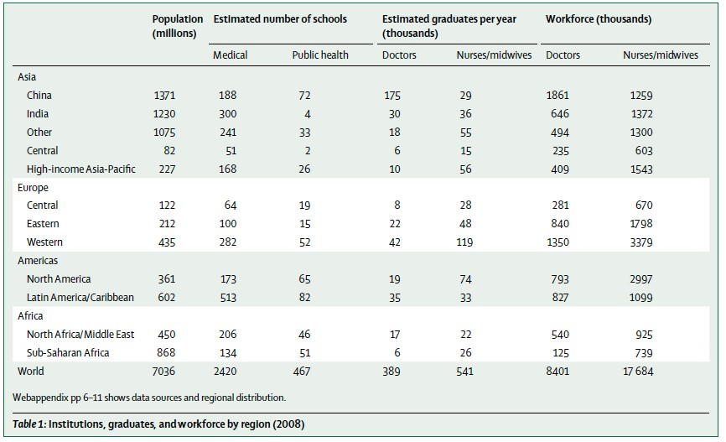
Source: Frenk et al (2010). Health professionals for a new century: transforming education to strengthen health systems in an interdependent world. P 1934.

Also have a look at the fascinating maps on page 1935 of the report.

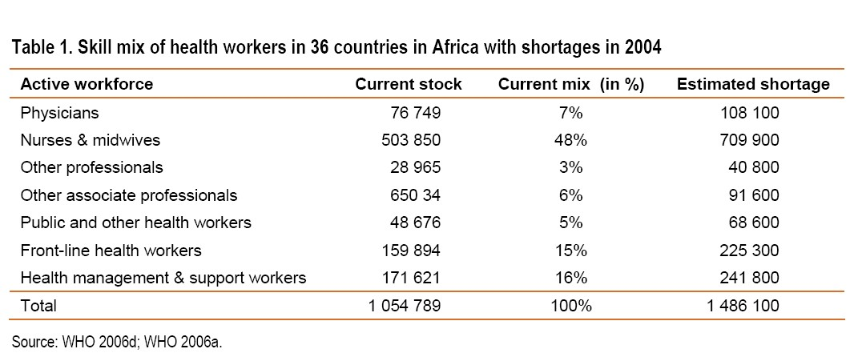The table below illustrates the estimated shortages in key staff categories in Africa in absolute numbers:

Source: Scaling up -­‐ a concept paper towards the implementation of World Health Assembly resolution WHA59.23. Geneva: WHO, 2007. http://www.who.int/hrh/documents/scalingup_concept_paper.pdf.

According to this table, Africa has to train more than double the number of its health workers to have an adequate supply. Of course these are estimates based on a set of assumptions about appropriate health-­‐worker: population ratios, population estimates, and appropriate health worker mixes. We discussed in the previous sessions that none of these assumptions are “objective truths”; that there are many ways of thinking about needs, demands and skills mixes; and that there are therefore many ways of arriving at estimates of what is required. Nonetheless, there is agreement among all stakeholders that most African countries face often critical shortages in most staff categories.

We saw in the previous session that the introduction of mid-­‐level and lay cadres is one promising strategy to improve not only access and coverage, but also appropriateness of health services – if sustainably planned, funded and supported.

But the mobilisation of mid-­‐level and lay health workers, even if carefully planned and supported, is not enough. There is no doubt that we have to train more health workers across virtually all cadres, and that there is an urgent and ongoing need to ensure that health workers are adequately and appropriately trained.

Chapter 3 of the 2006 World Health Report makes a wide range of recommendations for, as they say, “getting it right in the beginning”, i.e. “giving the right training to the right people to create an effective workforce for the delivery of health care”. The chapter emphasises several key shortcomings which require attention:

- the ineffectiveness of training institutions in many countries to respond to changing health needs;

- the lack of high-­‐quality and motivated teaching personnel;

- the inappropriateness of teaching content and materials; and

- the shortage of public health and management personnel to lead change in the field of public health.

1 Two fundamental tensions lie beneath these shortcomings:

- In many countries, the training and education of health workers -­‐ at least of advanced professionals -­‐ is the joint responsibility of both the Ministry of Health and the Ministry of Education. This can be a source of considerable tension (or lack of attention), as ministries have different priorities and agendas which determine the size and shape of funding for higher education. By their very nature universities do not respond easily and quickly to changing societal needs, making curriculum change slow and cumbersome. Calls for changing research and teaching agendas are often countered with an insistence on academic freedom.

- In addition to these, a third set of powerful stakeholders in determining the construction of health worker training (content, process, location, student selection) are professional associations, who act as custodians of quality and standards in their discipline, but can also act as gate keepers and barriers to innovation.

The Lancet report reflected and picked up some of the themes above, but went much further in its recommendation, calling for a fundamental reorientation of health professionals education, and “a series of instructional and institutional reforms” (p. 1924).

Activity 1: Transforming education to strengthen health systems ……

For this activity I want you to engage with the Lancet commission report. The report itself is really worth studying, but I am aware that it is dense and
not light reading. At least read the executive summary, and take a good look at the maps, tables and figures.

You can supplement the reading by listening to the 11 minute podcast about the report on the Lancet website, which is an interview with the second author of the report, Dr Lincoln Chen (http://www.thelancet.com/pb/assets/raw/Lancet/stories/audio/lancet/2010/9756_04 december.mp3).

And if you want to delve a bit deeper, but prefer listening, go to youtube and listen to the main author of the report, Prof Julio Frenk, give a lecture about the work of the commission and its findings (https://www.youtube.com/watch?v=kKo76WlnV-­‐U).

INNOVATION IN MEDICAL EDUCATION

You will now return to the film Salud! that you watched at the beginning of this module.

The last three chapters of the film deal with three innovations in medical education initiated by Cuba. They introduce two medical schools located in remote settings, in rural South Africa and the Gambia, the Latin American School of Medicine in Cuba, and micro-­‐medical schools in Venezuela.
Two central elements of these innovations are
- the location of medical training within primary and community health care settings; and,

- the selection of students from remote communities.

Activity 2: Reflecting on innovations in Cuban medical education
Please watch the last three chapters of Salud! (7 – the new

Discussion group 3

doctor; 8 – a step further; 9 – what lies ahead) and make notes in response to the following questions:
- What, in your view, constitute the most important differences between traditional training and the training described in the film?
- What do you think of the concept of taking students from indigenous and poor communities and giving them a free medical education? What might the challenges be?
- What do you think of the concept of locating large parts of training in under-­‐served
communities? What would be the advantages and challenges in your own context?
- The Venezuelan system rests on a very large number of Cuban doctors practicing in communities as family health doctors, and teaching, tutoring and supervising medical students. Could you envisage such a system in your country? Why -­‐ or why not? What would need to change in order for this to happen?
- If you had to provide arguments for and against the establishment of rural and
micro-­‐medical schools in your country, what would these arguments be?
- The film focuses on medical training. Would similar training arrangements work for nurses and other health worker cadres?

Please share your answers to these questions in a discussion group on Ikamva, and comment on other colleagues’ contributions. I want to see some debate about these issues, many of which are quite controversial.

Please check the module diary under the Course Outline tab for the submission date.

2 ESTABLISHING A SUPPORTIVE SUPERVISORY SYSTEM

The PATH document identifies several elements which are essential to establishing and/or maintaining good and supportive supervision. A central tenet is that supervision should NOT be punitive but developmental. It should be a learning experience both for the individual being supervised, but also for the supervisor and the organisation who are able to identify areas of concern, emerging problems, service gaps, etc., before they become serious problems.

The PATH document furthermore talks about the following cornerstones of a supervision system:

- Understanding the country context and mobilise national support for supervision: This involves understanding and building on existing supervision systems; advocating for financial support and ensuring that supervision becomes part of health and human resource planning and is considered in job descriptions and work load considerations; and working towards the institutionalisation of supportive supervision within the government system. It is here that policy briefs and other advocacy tools are important.

- Involving supervisors in training: To ensure that identified training needs are addressed, and to facilitate the re-­‐enforcing of training in supervision.

- Ensuring that supervisors have the ability and support to conduct supervision: This means that supervisors need to be trained to provide supportive supervision (many may have been trained in traditional forms of supervision or not trained at all); that supervision is an explicit part of their work load, rather than something they do by default and when they have time; and that the outcomes of supervision are used for performance improvement and planning.

Making staff motivation an integral part of supervision.

On the importance and complexity of motivation read the excellent chapter 5 in the HPSR HRH reader: https://ikamva.uwc.ac.za/x/3lpGpL.

Activity 3: Study principles and examples of supportive supervision

- Study pages 1 – 9 of the PATH document

(https://vaccineresources.org/files/Guidelines_for_Supportive_Supervision.pdf) and make notes of what strikes you as particularly important, unusual, useful for your on context and practice.

- Then read the four case studies on supervision in Tanzania, Kenya and Guinea, Honduras and India.

7 SESSION SUMMARY

This session focused on key issues of health workforce capacity: who is trained, broad orientation of training programmes and where training takes place, and reform requirements in health professionals education. It also explored one of the key elements of good HR management, the supportive supervision of staff. Although acknowledged as important by most managers, supervision all too often falls by the wayside under the pressures of day-­‐to-­‐day management. However, all evidence agrees that careful supervision can contribute dramatically to personnel satisfaction and productivity.

