Unit 3 -­‐ Session 1
Research lenses on HWD: What questions do we ask?

INTRODUCTION
In this first session of Unit 3 we will take a look at the types of research that are presently being conducted in the field of HWD: the questions being asked, the gaps in research, etc. You will particularly look at one journal, the HRH Journal, which dedicates itself to this field and is hosted by the WHO. Of course there are many other journals publishing articles with relevance to the field. Furthermore, there is a lot of research that does not necessarily identify itself as HR research, but in effect addresses HR issues either directly or indirectly; such as health systems research more broadly and health policy research.

LEARNING OUTCOMES OF THIS SESSION

By the end of this session you should be able to:

§▪ Discuss some trends and gaps in HWD research.

READINGS

You will be referred to the following reading during this session:

Details
Sheikh, K., Gilson, L., Agyepong, I. A., Hanson, K., & Ssengooba, F. (2011). Building the Field of Health Policy and Systems Research : Framing the Questions. PLoS Medicine, 8(8), 1–6. URL:
https://journals.plos.org/plosmedicine/article?id=10.1371/journal.pmed.1001073
Sheikh, K., & George, A. (2010). Health Providers in India: On the Frontlines of Change
(p. 301). New Delhi, India: Routledge. Introduction. URL: https://goo.gl/WyQpZh

Framing HR questions

HRH research is health systems research, because health workers, as individuals and as a group, are at the core of health systems; and because health workforce development is at the core of health systems development. The very well know diagram, “The dynamic architecture and interconnectedness of the health system building blocks” (below) from de Savigny and Adams’ book Systems Thinking for Health Systems Strengthening illustrates this point well.

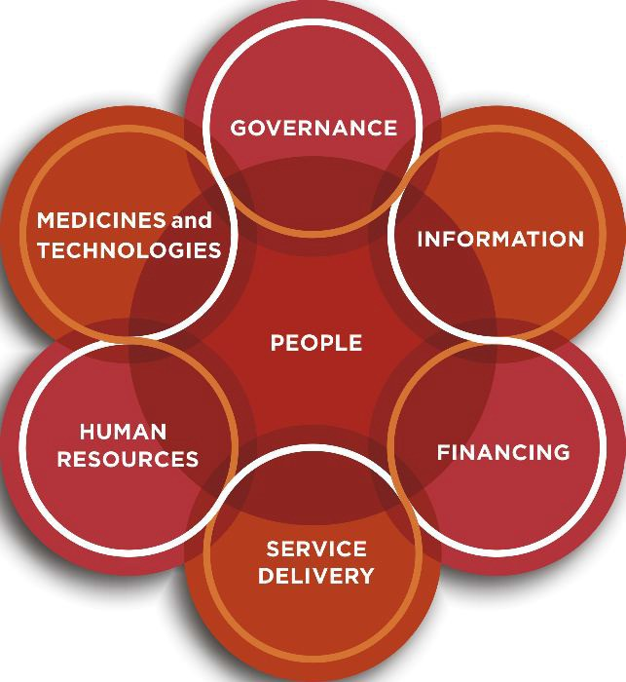
Source: de Savigny and Adam 2009 (http://www.who.int/alliance-­‐ hpsr/resources/9789241563895/en/)

HRH research by its very nature is multi-­‐ or inter-­‐disciplinary, with roots in sociology, psychology, political science, organizational and management sciences, economics, and others. The questions asked, the subject matter addressed, and the methodology, are diverse, yet often frustratingly unvaried, given the many dimensions and facets of the field. The following two tasks, which make up this session, aim to
  - Locate HRH research in the broader field of health systems research;
  - Provide you with a sense of the topics covered and questions asked (as well as some of the gaps);
  - Encourage you to develop ideas of HRH research questions that could be asked in your own contexts (we will get back to methodologies in session 3 of this module).

Activity 1: Read and discuss the papers by Sheikh et al 2011 and Sheikh and George 2010.
Sheikh et al 2011 do not write about HR research, but about health policy and sy stems research (HPSR), making an argument for the inter-­‐disciplinary nature of HPSR, and for paying

Discussion group 4

attention for what they call the ‘hardware’ and ‘software’ of health systems. These latter
terms have particular importance for and resonance with HRH research, as they speak to the centrality of human behaviors, relationships and values. They then develop a typology of HPSR question.

Please read the paper and share in the discussion group whether the paper ‘makes sense’, how you understand its relevance to HRH research, the questions you may have, ideas the paper may generate for you.

I added the introductory chapter in Sheikh and George’s book on health care providers in India, because in my view it raises very interesting questions and makes useful suggestions for HRH research, coming from a country with an enormously diverse HRH field.

Again, please read the chapter, and share your thoughts, questions, ideas in the discussion group. You may find that the readings will also generate ideas for your second assignment (what the focus of a situational assessment would be), and even a thesis topic.

Please check the module diary under the Course Outline tab for the submission date.

Activity 2: Explore the HRH Journal (http://www.human-­‐resources-­‐ health.com/)
This task aims to develop a sense of what one HRH Journal looks like, what types of articles it publishes, and what topics it covers.
The HRHJ is a free access online journal, with the aim to write for an academic and policy
audience.
§▪ Please take some time to browse through the articles of the journal.

§▪ Explore what the key topics are that the journal covers.

§▪ Think about the gaps, given the two papers you just read, and also your own experience.

§▪ Identify a few papers of particular interest to you, and read them more fully

Share both your views on focus and gaps, and a brief assessment of one or two articles you fond particularly interesting in the blog space.
§▪ Also use the opportunity to identify papers of value for assignment 2.
NB! Here is a link to a very useful website that discusses how to summarise, critique and

compare articles: https://libguides.randolph.edu/summaries/summary . It is a resource developed by the Australian National University.
At this stage I do not expect you to write a review, but encourage you to take a look at the website. It is useful for work on assignments, and will be VERY useful when writing the literature review for your thesis.

- SESSION SUMMARY

In this session we began to discuss the nature, topics and gaps in HRH research. In the following session we will shift focus to M&E in HWD and explore data and evidence routinely available for monitoring, evaluation and research. You will be introduced to the WHO HR and other data bases.

FURTHER READINGS & REFERENCES

No specific further readings for this session, but you may want to browse the HRHJ further or read the other two articles in the PLOS1 series.

