Unit 3 -­‐ Session 2
What about HR data? Sources, availability, use?

INTRODUCTION
In the previous session you looked at research, which is presently being conducted in this field, what questions are being asked, and what questions are not being asked. In this second-­‐last session of the module we will take a closer look at different types of health workforce data, their sources and availability, and, importantly, challenges of availability, completeness and use. We will focus specifically on routine data generated for HR M&E and planning, although such data are of course also relevant for research.

LEARNING OUTCOMES OF THIS SESSION

By the end of this session you should be able to:

- Find and use HR data;
- Demonstrate an insight into the availability, gaps and use of HRH data.

READINGS

You will be referred to the following reading during this session:

Details
World Health Organization, World Bank, & USAID. (2009). Handbook on Monitoring and Evaluation of Human Resources for Health: with special applications for low-­‐ and middle-­‐income countries. Retrieved from http://www.who.int/hrh/resources/handbook/en/
Mathews, V. (2005). Information for human resources management. In P. Ijumba & P. Barron (Eds.), South African Health Review (pp. 190–200). Durban: Health Systems Trust. http://www.hst.org.za/publications/South%20African%20Health%20Reviews/sahr05.pdf

WHAT ARE HUMAN RESOURCE DATA?

As in health information generally, human resource information is divided into routine and non-­‐routine information.

Non-­‐routine information is collected either once off or periodically, through surveys and censuses, or through a number of other research methods, both qualitative and quantitative.

Routine information, as the name suggests is collected regularly and through routine administrative processes. It can be collected at many points within or even beyond the health system.

WHO’s Handbook on Monitoring and Evaluation of Human Resources for Health, which I uploaded in the course resources, lists basic HR indicators and numerators in table 3.1 (pp 28-­‐29). In it, and throughout the handbook you will find a strong emphasis on national-­‐level data, generated by national governments, professional bodies, etc, and for national and international HRH monitoring. Table 3.2 provides examples of typical data sources, from censuses to payroll and professional registries, emphasizing their strengths and weaknesses.

The BIG issue with routine data for all levels of HRH M&E is reliability (quality) and completeness of data.

There are data that are reasonably easily and reliably available:

  - Health workers registered with professional bodies (eg nursing councils)

  - Health worker ‘production’ data (i.e. how many trained in any one year) for formal professional groupings – much less available for eg traditional birth attendants, traditional healers, community health workers – often the most important and biggest number of ‘first contact’ health workers.

  - Distribution of registered health cadres within countries (who is working where?), although some countries experience difficulties with data accuracy as data bases, eg pay roll registries, are not always updated.

Other data are notoriously badly collected and kept (either not at all, or in many parallel systems, or incompletely). These include:

  - Information on cadres not formally registered and accredited (eg. TBAs, CHWs, etc).

  - Information on training (who has been trained for what?).

  - Information on leave, absenteeism, turn-­‐over.

  - Information on workloads, performance and morale.

  - Very often any HR information disaggregated by district or facilities.

Does anything strike you as noteworthy when you look at the two bulleted lists above? Pause a moment and contemplate. We will get back to this question in a moment.

WHO has over the past ten years or so spent a great deal of effort to reach agreement on how to name different cadres of health workers (International Standard Classification of Occupations or ISCO) to allow for comparability of HR situations across different countries; and they have set up an international data base, the Global Health Workforce Statistics within the Global Health Observatory Data Repository (http://apps.who.int/gho/data/node.main?showonly=HWF).

The data in the repository are primarily concerned with health worker density by professional groups, and WHO uses these data to monitor international stocks and flows of

health workers (admitting that there is very considerable variability of quality and completeness of data). They provide rough international comparisons, which direct international debate, as they did in the Joint Learning Initiative, or the code of conduct of migration of health workers.

The screen shot below, coming from the WHO site, gives an idea how these data are useful. I encourage you to trawl around the repository a bit to get a sense of what it has to offer.

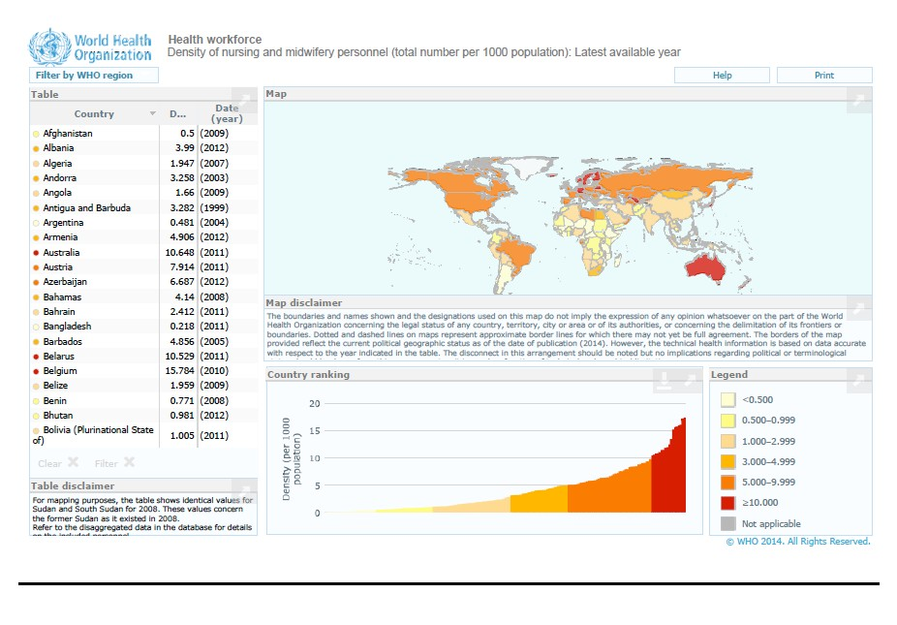
http://gamapserver.who.int/gho/interactive_charts/health_workforce/NursingMidwiferyDe nsity/atlas.html?geog=0&indicator=i0&date=Latest%20available%20year&bbox=-­‐ 303.3892917650162,-­‐
34.40520881418485,296.893398270799,111.28840241325781&printmode=true

Activity 1:

Read chapters 3 and 9 in the WHO handbook to get an overview of what data are internationally collected, how these data are used in HR planning and management, and what key challenges are.

Other very good illustrations of health workforce data are some of Hans Rosling’s Gapminder graphs (http://www.gapminder.org/), although not in the first instance directed at health and health workers.

In South Africa we furthermore have the data base of the Health Systems Trust, which has been collecting and collating health and health workforce data over many years and disaggregating them by provinces and sometimes by district. Again, have a look at what is

available: http://www.hst.org.za/healthindicators. Those of us doing research on health workers in South Africa have always heavily relied on these data.

HUMAN RESOURCE DATA NEEDS – A QUESTION OF PERSPECTIVE

But now to return to the question about the bulleted lists raised above. What I find noteworthy is that the data that are hard to access or that are unreliable or incomplete are data needed for human resource planning and management at district, facility and community levels. This is not because they are not collected at this level or are not important. After all, the long data pipeline starts in facilities or districts: How many posts exist? How many are filled? What cadres? What training have they received?

Policy makers and national planners need this information – as do frontline managers, charged to manage and monitor performance and well-­‐being of people and services. They also need to know: Who is on leave? For what purpose? Who has resigned? Who is new? How is workload spread? How are staff performing? .... Information, which is often inaccessible or unavailable or inaccurate.

One reason for the lack of availability of relevant and accurate HR information for planning and management at district and particularly at primary care facility and community level lies in the fact that HR management is often performed in silos, separate and some distance from line management functions. Another reason is that in decentralized health systems the HR management function often lags behind with regard to decentralization. For example, leave records of staff in facilities may be kept by a HR office at district or even provincial level, but a line manager in a facility may have to grant or withhold permission for leave, often without up to date information available to her. And HR offices are often staffed by personnel administrators, with little or no knowledge of the information needs of line managers.

The information needs and monitoring roles of middle and frontline managers, in charge of staff and services, are rarely reflected in national and international policies and plans concerned with HRH M&E, or in discussions about the format of national HR Information Systems. Colleagues of the UWC SOPH are among the few who think and write about the character and need of decentralized HRIS and its links to decision-­‐making capacities of managers.

My colleague Verona Mathews wrote about the challenges of decentralized human resource management ten years ago. Much of what she concluded then still holds today. I have uploaded her article in the South African Health Review 2005 in the course resources.

And another colleague, Vera Scott, just published a chapter for the 2014 South African Health Review, which is focusing on the HR information needs of frontline managers, and the information facility managers need to make decisions in their running of primary care facilities. The chapter provides an unusual perspective on the interaction between data,

information and decision-­‐making and is very worth reading. It can be downloaded from the HST website: http://www.hst.org.za/publications/South%20African%20Health%20Reviews/Complete_SAHR_2014_ 15.pdf.

Data and evidence needs for HRH research are, of course, a third cluster of needs. Researchers often draw on routine information available (though just as often do not as it is so unreliable and/or inaccessible), as well as generating additional, non-­‐routine data. These will include surveys, questionnaires, observations, interviews to investigate a range of topics as discussed in session 1 of this unit.

SESSION SUMMARY

In this session we explored data and evidence routinely available for HR planning, management, monitoring, evaluation and research. In the last session of the module we will discuss the differences between monitoring, evaluation and research, and hold a ‘journal club’, reading a few examples of different types of HR research.

FURTHER READINGS & REFERENCES

No specific further readings for this session (other than those mentioned above), but you may want to browse the HRHJ further as well as explore the data bases mentioned in the text.

