Unit 3 -­‐ Session 3
Evaluation & research – similarities, differences & uses

INTRODUCTION

In the previous session you explored data and evidence routinely available for HR monitoring, but also planning, management, evaluation and research. We looked at what sources of information exist, who uses this information, who generates it, and what the gaps are.

Routine information is of course also of great importance when doing an evaluation or conducting research. It should be a first port of call. We should always ask ourselves: what information and evidence is available already? How is its quality? What are the gaps?

In this last session of the module we will turn our attention to evaluation and research. Both share similarities with monitoring in that they too endeavor to answer questions about performance, progress and inform planning, and in that way generate new knowledge. In contrast to routine monitoring (i.e. tracking of progress) both evaluation and research are, to state the obvious, not routine. Both research and evaluation are conducted to answer specific questions. In this session we will firstly, engage with the differences and overlaps between evaluation and research generally, and secondly discuss examples of good HRH research, using different research methodologies.

LEARNING OUTCOMES OF THIS SESSION

By the end of this session you should be able to:

- Distinguish HR evaluation and research;

- Read HR research critically and with understanding.

READINGS

Details
Blog by Patricia Rogers on differences between research and evaluation: http://betterevaluation.org/blog/framing_the_difference_between_research_and_eva luation
Ann Emery blog http://www.viaevaluation.com/so-­‐what-­‐is-­‐the-­‐difference-­‐between-­‐ research-­‐and-­‐evaluation/ and https://annkemery.wordpress.com/
Humphries N, Brugha R, McGee H. Sending money home: a mixed-­‐methods study of remittances by migrant nurses in Ireland. Hum Resour Health. 2009 Jul 30;7:66. http://www.human-­‐resources-­‐health.com/content/7/1/66
Mumtaz Z, Salway S, Waseem M, Umer N. Gender-­‐based barriers to primary health care provision in Pakistan: the experience of female providers. Health Policy Plan. 2003 Sep;18(3):261-­‐9. http://heapol.oxfordjournals.org/content/18/3/261.long
Blanchet K. How to facilitate social contagion? Int J Health Policy Manag. 2013 Aug 19;1(3):189-­‐92. doi: 10.15171/ijhpm.2013.35. eCollection 2013 Sep. http://www.ncbi.nlm.nih.gov/pmc/articles/PMC3937890/pdf/ijhpm-­‐1-­‐189.pdf
Huicho L, Miranda JJ, Diez-­‐Canseco F, Lema C, Lescano AG, Lagarde M, Blaauw D. Job preferences of nurses and midwives for taking up a rural job in Peru: a discrete choice experiment. PLoS One. 2012;7(12):e50315. http://journals.plos.org/plosone/article?id=10.1371/journal.pone.0050315
Gilson L, Elloker S, Olckers P, Lehmann U. Advancing the application of systems thinking in health: South African examples of a leadership of sensemaking for primary health care. Health Res Policy Syst. 2014 Jun 16;12:30. https://health-­‐policy-­‐ systems.biomedcentral.com/articles/10.1186/1478-­‐4505-­‐12-­‐30
You will be referred to the following reading during this session:

What are the differences between evaluation and research?

If you google the question in the heading above you will find loads of sources discussing the differences between research and evaluation, scholarly as well as non-­‐scholarly articles, blogs, powerpoint presentations, whole websites run by evaluators. Check out just a few of them.

One blog I found particularly useful is the one below, hosted by Patricia Rogers, who is an internationally renowned evaluator, with a particular interest in developmental evaluation. It also is an excellent website for anybody who wants to do or better understand evaluations in the fields of health, education and development.

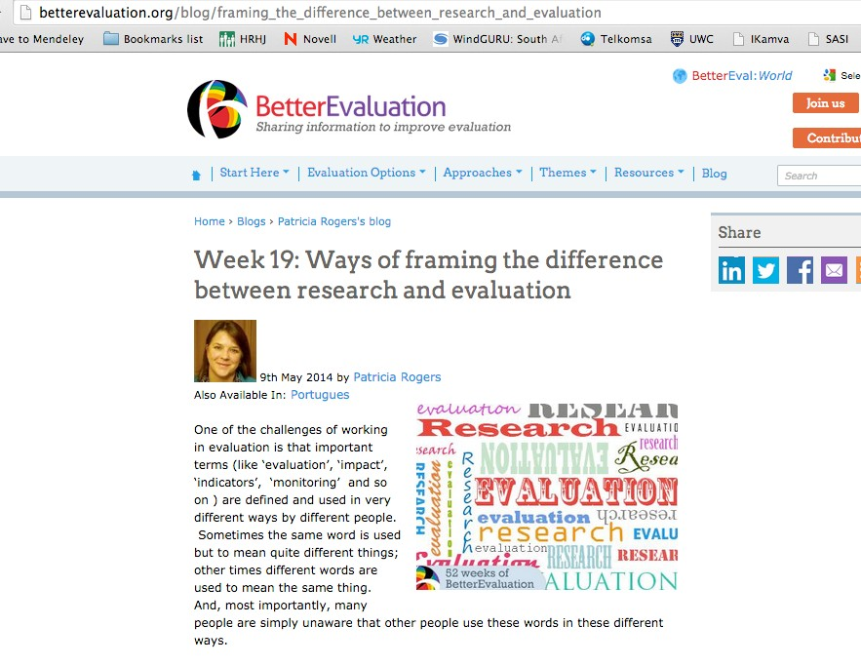

Activity 1: Read Patricia Roger’s blog and comments: http://betterevaluation.org/blog/framing_the_difference_between_research_and_evaluati on. You will see that there are many views on the differences, similarities and overlaps.

  - What are your own experiences with both; their differences, similarities and purposes?

  - Have you been in the role of evaluator or being evaluated? Of researcher or being subject of research?

In summary, Patricia Rogers distinguishes 4 different ways in which evaluation and research can relate to each other:

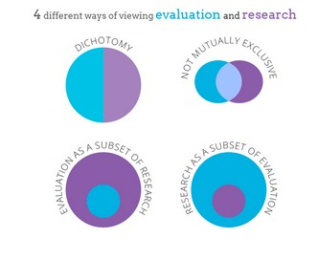

In the quote below Michael Quinn-­‐Patton, one of the international gurus, particularly in development al evaluation, summarizes his view on the differences:

What do you see as the difference between research and evaluation?
There’s a whole continuum of different kinds of evaluation and different kinds of research. However, on the whole, the purpose of evaluation is to produce useful information for program improvements and decision making. And the purpose of research is to produce knowledge about how the world works. Because research is driven by the agenda of knowledge production, the standards for evidence
are higher, and the time lines for generating knowledge can be longer. In evaluation, there are very concrete deadlines for when decisions have to get made, for when program action has to be taken. It often means that the levels of evidence involve less certainty than they would under a research approach and that the time lines are much shorter.

http://www.idrc.ca/EN/Resources/Publications/Pages/ArticleDetails.aspx?Publicatio nID=771

In summary, because there are many different types and purposes of evaluation and of research, there are diverse ways in which they can be similar or different, in which they overlap, in which the one can be a sub-­‐set of the other. Fundamentally, however, research aims to produce new knowledge on a particular topic, whereas evaluation aims to answer very specific questions about an intervention, practice, policy. The latter usually has more

immediate use value than the former, and quite specific stakeholders in or owners of the evaluation who judge its use.

The section above focuses generically on differences and similarities between research and evaluation. But what about HRH research more specifically? What are examples of research questions?

This is something we began to discuss in Session 1 of this unit, when you explored the HRH Journal, and read the two papers by Kabir Sheikh et al., which 1) frame HRH research as health systems research, and 2) identify HRH themes, questions and research gaps.

RESEARCH THEMES AND DESIGNS FOR HRH RESEARCH

We discussed in session 1 of this unit that there are very common themes in our field, and themes that are either absent or very poorly developed.

Themes follow waves of interest and policy priorities. So, for example, a focus on the health MDGs in the very recent past has led to more research on human resources for maternal and child health. For a number of years HRH research was dominated by HIV/AIDS service delivery needs and impacts. For the past 10-­‐15 years brain drain, retention and turn-­‐over has been a recurring topic, as has been research to measure health worker needs and shortages.

Topics much less frequently addressed concern HRH ‘software’: health workers experiences, values, mindsets; relationships between cadres and between cadres and communities/clients, capacities and capabilities other than qualifications and measurable skills.

Sheikh and George, in their chapter on health care providers in India, in particular point to the absence of research about health workers other than doctors:

In India, qualified doctors alone total over a million — the population of a small country. Other groups of health providers match that number, maybe even exceed it. Many questions can and should be asked about the individuals and communities that make up these numbers. What are the different worlds that these health providers live in? What roles do they play and what drives them? How do they respond to change in policies, systems and society? What relationships do they have with their patients and their peers? What kind of personal and professional struggles do they face?

Another silence in the literature is publications, which reflect on the process of research with health workers, users, managers themselves; how knowledge is produced in research relationships1.

In part these gaps reflect researchers’ and policy makers’ perspectives, agendas and blind spots; who has voice; who is considered influential – the politics of research. In part they also have to do with research design: what are considered strong and weak designs; the continuing preponderance of bio-­‐medical perspectives in a field that requires social science perspectives for better knowledge production as explained by Sheikh et al.; what is considered ‘researchable’ rather than what is important to research. The most important and meaningful questions we should be asking often defy easy measurements because they are about people, their worlds and their relationships. Understanding and writing about these worlds in rigorous ways is complex.

But of course there exists very interesting, innovative research in this field, asking critical questions and using a wide variety of quantitative or qualitative methodologies, eg.:

  - Case studies

  - Mixed methods research

  - ‘Discrete Choice Experiments’

  - Ethnographies

The very last section of the module will showcase a few examples of different research designs, and what I consider excellent HRH research.

READING HRH RESEARCH – A JOURNAL CLUB

Activity 2: Reading and discussing HRH papers
Discussion

Read two of the papers below (uploaded in Ikamva course resources), guidgedroup 5

by the following questions:

- What research questions informed this research?

- How does the research design fit the question being asked/topic being explored?

- What would you consider the strengths and weaknesses of this paper in relation to the contribution it makes to HRH knowledge production?

- Was there anything in particular that stood out for you when reading the paper?

Please share your responses to these questions for at least two of the papers in the last discussion group of this module. Once you have made your own contribution also read what

1 If you are interested, it is a topic we have written a bit about in: Lehmann U, Gilson L. Action learning for health system governance: the reward and challenge of co-­‐production. Health Policy Plan. 2014 Aug 26

other colleagues have written and comment on their views and contributions. Please check the module diary under the Course Outline tab for the submission date. Papers:
Humphries N, Brugha R, McGee H. Sending money home: a mixed-­‐methods study of
remittances by migrant nurses in Ireland. Hum Resour Health. 2009 Jul 30;7:66.
http://www.human-­‐resources-­‐health.com/content/7/1/66

Mumtaz Z, Salway S, Waseem M, Umer N. Gender-­‐based barriers to primary health care provision in Pakistan: the experience of female providers. Health Policy Plan. 2003 Sep;18(3):261-­‐9.

http://heapol.oxfordjournals.org/content/18/3/261.long

Blanchet K. How to facilitate social contagion? Int J Health Policy Manag. 2013 Aug 19;1(3):189-­‐92. doi: 10.15171/ijhpm.2013.35. eCollection 2013 Sep. http://www.ncbi.nlm.nih.gov/pmc/articles/PMC3937890/pdf/ijhpm-­‐1-­‐189.pdf

Huicho L, Miranda JJ, Diez-­‐Canseco F, Lema C, Lescano AG, Lagarde M, Blaauw D. Job preferences of nurses and midwives for taking up a rural job in Peru: a discrete choice experiment. PLoS One. 2012;7(12):e50315. http://journals.plos.org/plosone/article?id=10.1371/journal.pone.0050315

Gilson L, Elloker S, Olckers P, Lehmann U. Advancing the application of systems thinking in health: South African examples of a leadership of sensemaking for primary health care. Health Res Policy Syst. 2014 Jun 16;12:30. https://health-­‐policy-­‐ systems.biomedcentral.com/articles/10.1186/1478-­‐4505-­‐12-­‐30

FURTHER READINGS

As you will have seen by now, there is a world of interesting material out there. Freely accessible academic articles, interesting videos, thought-­‐provoking blogs. Make use of this material, in your MPH thesis, but also in your professional practice going forward.

SESSION SUMMARY

In this session you first explored different understandings and approaches to research and evaluation as applied to HRH research, and then studied and discussed a variety of HRH research papers, in particular appraising the questions the asked and the design chosen to answer the question.

