Unit 6- Special Topics

6

Introduction
The focus of this unit is to introduce some special topics in epidemiology and implications of epidemiological information for public health and ways of making sense of such information through use of systems and information. The topics specifically addressed here are as follows:
Session 1: Environmental, Occupational and Social Epidemiology
Session 2: Demographic Transition and Epidemiological Transition
Session 3: Screening
Session 4: Critiquing epidemiological studies
Session 5: Surveillance

Unit 6 – Session 1: Environmental, Occupational and Social Epidemiology

Introduction
As you learned in Unit 1, the concept of causation in epidemiology is complex and faceted, and modern epidemiology acknowledges that health disease are the results of multiple causes acting both at individual and at contextual level.
This session briefly introduces the subfields of epidemiology which deal specifically with contextual determinants of health, and presents the most important concepts underlying this kind of investigation.

Learning outcomes
- Know the definitions and basic concepts of social, occupational, environmental and lifecourse epidemiology;
- Understand the difference between individual and contextual determinants;

Timing

This is a relatively short session with two readings and you shoud work your way through the readings and task within 2 hours.

Different branches of epidemiology
Social epidemiology is the branch of epidemiology that studies the effects of socioeconomic factors in shaping the health of populations. Occupational and environmental epidemiology deal, respectively, with the effects of working conditions, and environmental factors on the occurrence of disease and maintaining of heath. They have in common an interest in contextual rather than individual factors.
Life course epidemiology introduces a further dimension in the epidemiological investigation, and it studies the cumulative, long-term effects of the exposure of physical and social factors on later health or disease risk.
The following excerpts from the Dictionary of Epidemiology edited by Porta provide a formal definition of each term:

Reading

Porta, M. (2008). A Dictionary of Epidemiology. New York: Oxford University Press. p 65,79, 174, 231.
Now read the following reading by Berkman & Kawachi, which offers an historical overview and a concise exposition of the basic concepts underlying social epidemiology.
Reading
Berkman, L., & Kawachi, I. (2000). Social Epidemiology. New York: Oxford University Press. p. 3-10

Task 1 – Read and respond to an article

Read the Introduction & Methods section of the following article by Harling et al, then answer these questions:
The authors make an explicit reference to the social-epidemiological approach in the title of the article. Do you agree that the article follows this kind of approach?
Can you explain the reasons for your answer with reference to the guiding concepts in social epidemiology as expressed by Berkman & Kawachi in the reading above?

Reading
Harling, G., Ehrlich, R. & Myer, L. (2008). The social epidemiology of tuberculosis in South Africa: a multilevel analysis. Soc Sci Med, 66(2), 492–505.

Task Feedback

The reference to the socio-epidemiological approach in the title is fully justified by the article content.
With reference to the Berkman & Kawachi's guiding concepts in social epidemiology we can briefly observe:
- The article takes a population perspective, in which the outcome of interest is the prevalence of the considered disease (TB) in the population, rather than the individual risk of developing the disease;
- Contextual variables are taken into account as key determinants: not only individual-level variables, but also household-level and community-level socioeconomic variables are considered as possible determinants of TB prevalence;
- The analytical approach is multi-level ("hierarchical models" is another way of referring to "multilevel" model, in which both individual and contextual variables are taken into account simultaneously).

Unit 6 – Session 2: Demographic Transition and Epidemiological Transition

Introduction
This session aims at providing an overview of the two interlinked phenomena of the demographic and epidemiological transition, and describing their main characteristics and public health implications.

Learning outcomes
- Understand the concept of demographic and epidemiological transition and their phases;
- Know the factors commonly considered as the major drivers of the transition;
- Understand the major public health implications.

Timing
This session has one reading and one short task. You shoud work your way through the readings and task within 1 hour.

Demographic and epidemiological transition
The demographic transition is a phase of development characterised by a sudden and stark increase in population growth rates, followed by a re-levelling of population growth from subsequent declines in fertility rates. A typical example of this type of change is shown in the figure below.

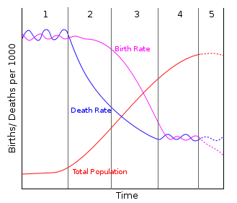
Figure: Changes in death and birth rates during the different phases of the demographic transition
Image from Wikimedia Common, available at http://en.wikipedia.org/wiki/File:Stage5.svg [Accessed 10/11/2013]
The demographic transition is strictly interlinked with the parallel phenomenon of the epidemiological transition (or health transition), characterised by the replacement of infectious diseases with chronic diseases over time due to expanded public health and sanitation.
The theory of the epidemiological transition was originally posited by Abdel Omran in 1971 and subsequently updated by other scholars.
The following reading by Farmer & Lawrenson gives a concise account of the main concepts underlying the demographic and epidemiologic transition and their public health implications.
Reading
Farmer, R. D. T. & Lawrenson, R. (2004). Lecture notes on epidemiology and public health medicine (Fifth Edition). Malden: Blackwell Publishing. p 69-81.

Task 1 -
- Describe the five phases of the Epidemiological transition as presented by Farmer & Lawrenson.
- Think about the relevant characteristics of your country of origin (mortality and birth rates, prevalence of communicable and chronic diseases: if you don't know them, doa bit of research...).
- In which phase of the transition would you classify your country? Why would you classify it in such a way?

Task Feedback
- The answer is in the reading;
- Sorry! No model answer for that. Discuss your work with the lecturer. You can send your answer to us and we will respond to you.

Unit 6 – Session 3: Screening

Introduction
Screening is a strategy used in a population to identify an unrecognised disease in individuals without signs or symptoms. This can include individuals with pre-symptomatic or unrecognised symptomatic disease. Screening tests are different from diagnostic tests because they are performed on persons apparently in good health.
Screening interventions are designed to identify disease in a community early, thus enabling earlier intervention and management in the hope of reducing mortality and suffering from a disease.
This session presents the most important characteristics required by screening programs (and screening tests as a part of screening programs) in order to be beneficial from an individual and public health perspective, and how some of these characteristics can be measured by numerical indices.

Learning outcomes
- Define screening and understand its role in epidemiology and public health;
- Know the criteria for the introduction of screening programmes;
- Understand the common measures of validity of screening tests (Sensitivity, Specificity, Predictive values) and how they vary with the prevalence of the disease.
Timing
This session has two readings and a task that requires you to do some calculations. It is important that you attempt the calculations before you refer to the feedback. You should complete the session within 2 hours.

Screening programmes
A definition of a screening programme, and the criteria used for its evaluation are presented briefly in the reading by Bonita et al.
Reading
Bonita, R., Beaglehole, R. & Kjellstrom, T. (2006). Basic Epidemiology. Geneva: WHO. p 110-114

The next reading, by Bruce, defines and explains in greater detail how the central component of any screening programme (i.e. the screening test) can be evaluated. It presents the most important indices which allow us to quantify the characteristics of a screening test and to compare different tests.

Reading
Bruce, N., Pope, D. & Stanistreet, D. (2008). Quantitative Methods for Health Research: A Practical Interactive Guide to Epidemiology and Statistics. Chichester: John Wiley & Sons. p 448-451.

Among the measures of validity, the most commonly employed are Sensitivity, Specificity, Positive predictive value and Negative predictive value. All these measures are interlinked, but each of them, as explained in the reading, answers different questions.

An important difference between the first measures and the predictive values, is that Sensitivity and Specificity are characteristics of the test itself (And they do not change if the test is applied in different populations), while predictive values depend also on the prevalence of the disease in the population. Specifically, if the same test is applied in populations with different prevalence of the disease, the Positive predictive value (PPV) increases with increasing prevalence, while the Negative predictive value (NPV) decreases (and vice versa when the prevalence decreases).

Task 1 – Using screening tests

You are running a programme to decrease the prevalence of a particular health condition. You have done a screening test on 2000 subjects to determine whether you are succeeding, and have produced the summary of your results in the tables given below.

a) Calculate the indicators listed to the right of each table, and comment on both the efficacy of the test and the apparent success or failure of your health programme.

(Note the first two tables show the screening results before and after a disease control programme. The third table provides a template for calculating the indictors.)

b) What kinds of studies are usually used in screening programmes?

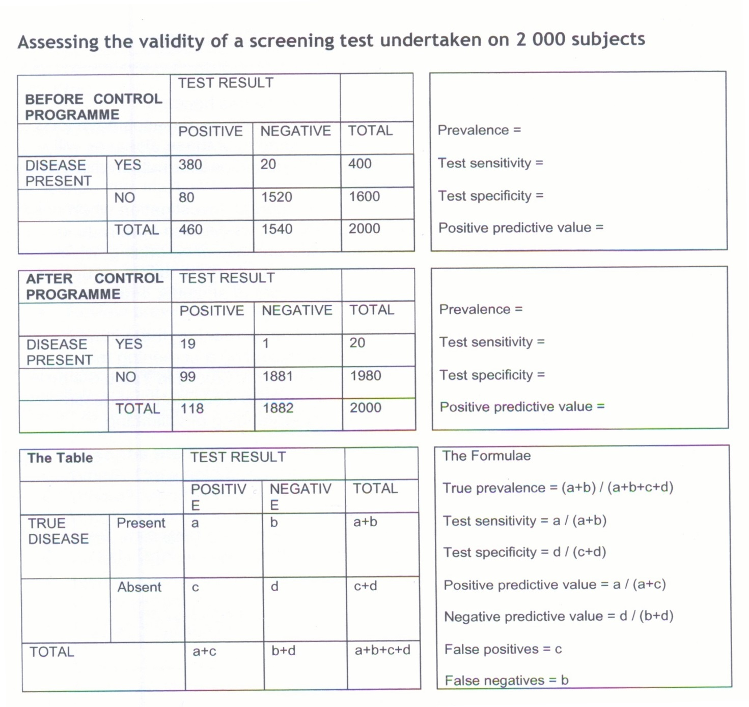

Task Feedback

a) Using the 3rd table above you should obtain the following results:
Prevalence | Sensitivity | Specificity | Positive predictive value
Before control programme 20% | 95% | 95% | 83%
After control programme 1% | 95% | 95% | 16%

The high sensitivity and specificity values suggest the test is a valid one to use. A concern could be that the Positive predictive value has decreased to 16% after the control programme, but this has been greatly influenced by the low prevalence value after the control programme.

This highlights that the sensitivity and specificity of the test are not impacted by prevalence, but the Positive predictive value of a test is affected by the prevalence of the disease in the community being screened.

Based on the results above you would probably conclude that your control programme was a success. Note that if the Sensitivity/Specificity of the tests had changed over time (perhaps a better test had been developed during your control programme) then the results before and after might be confounded by the change in the testing.

The choice of screening test being used must be taken into account when monitoring changes in disease. For example in South Africa at the beginning of the prevention of mother to child transmission (PMTCT) of HIV programme, screening of newborns after programme participation was originally recommended for 9 months after birth. However, shortly after the programme was initiated newer more sensitive tests for HIV antibodies were released for rapid screening in clinics. These tests picked up more maternal antibody and substantially raised the rate of false-positive tests.

Therefore, the government had to change the follow-up screening period from 9 months to 12-15 months after birth to reduce the occurrence of false-positives due to left-over maternal antibodies in the baby, and not true infant infection with HIV.

b) Most screening programmes are in the form of periodic cross-sectional studies.

Unit 6 – Session 4: Critiquing epidemiological studies

Introduction
Following the considerations about possible sources of error in epidemiological studies (Unit 3) and the concept of validity (Unit 5), this session we will present some practical indications on how an epidemiological study can be critically evaluated in terms of the validity of its results.

Learning outcomes
- Critically appraise an epidemiological report/article.
Timing
This is a very short session, and should take you less than an hour to go through.

Assessing validity of results

Suppose you are reading an article reporting the results of an epidemiological study. How can you judge if the results of the study are "valid" in an epidemiological sense? How much can you trust them as "true" to the population who has been studied (internal validity) and how much can you apply them to other population?

An absolute answer to this question does not exist (scientific knowledge is always "work in progress"), but a reader with adequate epidemiological training (as you will be at the end of this course!) has many possibilities of appraising the overall quality of a study and its validity. This article by Zaccai offers some (motivated) guidelines on how an epidemiological report should be analysed and critiqued before taking its results as "true".

Besides their practical utility on the appraisal of epidemiological literature, these guidelines constitute sort of a "summary" of the most important concepts which are presented in this course. You are therefore strongly advised to read these short considerations carefully and be sure that you thoroughly understand the reasons for each proposed step.

Reading
Zaccai, J.H. (2004). How to assess epidemiological studies. Postgrad Med J 80 p.140–147.

Task 1 – Write a review of an epidemiological study

Choose one of the papers you read for the literature review and appraise it critically following the guidelines provided by Zaccai in his article.

Write a short (one page) critical report and conclude with two paragraph summarising the main strengths and weaknesses of the study.

Task Feedback

Depending on the paper you chose and on your personal preferences, the report can assume different forms.

In any case, your single page critical appraisal should at least include a brief answer to these basic questions:

Is there a rationale for the study?

Is the objective or hypothesis clearly stated and related with the problem?

Is the method (study design, measurements, statistical analyses, etc.) appropriate for the study objective?

Did any aspect of the method bias the results?

Was the possibility of confounding adequately taken into account?

Was the study sample appropriate?

Were the results warranted by the analyses that were undertaken?

Unit 6 – Session 5: Surveillance
Introduction
Surveillance is an integral part of the control of communicable diseases and is often achieved by means of the routine notification system. Surveillance can therefore be used as a way of detecting trends or changes in disease patterns to allow a swift and effective response from the Public Health authorities.

Timing
This session is relatively short and shuld take you about an hour to complete.

Learning outcomes
By the end of this session you should be able to:
- Describe the role of epidemiological surveillance
- Apply criteria for the introduction of surveillance programmes

Surveillance Systems
The World Health Organization (WHO) defines surveillance as: ‘the process of systematic and routine collection, collation, and analysis of data with prompt dissemination to those who need to know for relevant action to be taken’. Disease surveillance is thus the application of this definition to diseases. Surveillance is an integral part of the functioning of local, national and international health agencies. Most countries have specific routine health information systems for the collection and processing of data needed to guide decision making pertaining to the health of populations- for example, in South Africa, routine data on: mortality, diseases, births, population, injuries etc. are collected annually. Below are the key features and uses of a surveillance system:
- Establish long-term trends in disease occurrence
- Detect epidemics,
- Document distribution and spread of diseases
- Estimate the magnitude of a health problem
- Routine, therefore ongoing activity
- Systematic, and happens in a standardized and organized manner
- May guide prioritization of research and therefore guide resource allocation in Public Health
- Should lead to prevention and control of diseases

Surveillance can be categorised as active or passive surveillance. Active surveillance involves the search and use of patient reports on a regular basis while passive surveillance refers to a process where participant reports are awaited- thus no active seeking of participant reports in the surveillance system.

Reading
Joubert G., Ehrlich R.,Katzenellenbogen J.,& Karim SA (2007). Ch 13-Routine health information systems and disease surveillance. In Epidemiology: A Research Manual for South Africa. Cape Town. Oxford University Press. p 172-185

Task 1
What conditions are notifiable in South Africa (or your country)?
Task 1 Feedbak
Refer to your prescribed reading for this session, Table 13.2, page 176 for a list of notifiable diseases in South Africa.

Task 2
The list you have just reviewed is extensive, but does not include HIV. Consider the inclusion of HIV as a notifiable disease in South Africa.
Inclusion of HIV notification in the list of notifiable diseases is a long standing debate, and has caused somewhat a divide on the matter between politicians, some healthcare workers, and human rights groups. What advise would you give to the ministry of health if the inclusion of HIV notification was under consideration?
HIV notification enters national debate regularly, often introduced by politicians and supported by many individual healthcare workers. We argue that its proponents advance confused or poorly informed rationales for making HIV notifiable. We present reasons why making HIV notifiable would be inappropriate in South Africa, why the public health benefits of a notification programme are not even likely, and why there are risks of public health and human rights harms
Task 2 Feedback
In the late 1990s, the South African ministry of health (MOH) decided to add HIV to the list with the hope that such notifications would provide insights on the growth rate, size and shape of the epidemic. This proposal meant that any individual testing HIV positive was by law identified, and would have their name and address listed in the notifiable disease records of their local health authority. Summaries of such records would be available to most health personnel and management in the local health authority area. However, HIV notification would be problematic and possibly not provide any benefits to public health due to the following reasons:
- HIV/AIDS still carries a profound social stigma and a potential for the discrimination against against people with HIV.
- This would pose some ethical dilemas, for example; abreach of confidentiality between patient and doctor
- Consequently, due to the above reasons, HIV notification poses risks of public health and human rights harms

Can you think of other consequences of adding HIV to the list?

Omran, A. R. D. (1971). The epidemiologic transition: a theory of the epidemiology of population change. 1971. Milbank Meml Fund Q, 41(4), 509–538.

