The burden, distribution and pattern of ill-health in the world

UNIT 1

Welcome to Unit 1!

In this unit we begin to tackle important questions around health and disease, such as:

- How serious is ill-health in the world and in Africa today (burden)?
- Which people are mostly affected and where do they live (distribution)?
What are the main health problems and what are the main causes of ill-health (pattern)?

Study Sessions

There are four Study Sessions in Unit 1:

Study Session 1: Burden of disease in Africa and the world

Study Session 2: Distribution and pattern of ill-health in the world and in developing countries

Study Session 3: Pattern of ill-health in developed, developing and underdeveloped countries

Study Session 4: Situational analysis

Intended learning outcomes

By the end of this session, you should be able to:
Public Health Outcomes  - Analyse the burden and distribution of ill-health in selected contexts  - Conduct a situational analysis in a local environment | Academic Learning Outcomes  - Preview texts  - Make notes and summarise ideas.  - Interpret, compare and draw conclusions from various diagrams.  - Use the writing process cycle

Unit 1 – Study Session 1
Burden of disease in Africa and the world

Introduction

In the Module, Introduction to Public Health, you learnt what the term ‘burden of disease’ means. In this unit you will increase your understanding of the seriousness of ill-health in Africa and the world and you will discuss the four main disease groups. You will see how the burden of disease if measured and how this measurement helps to direct health policies and resources.

Session contents

1 Learning outcomes of this session
2 Readings and references
3 What is the quadruple burden of disease?
4 How is the burden of disease measured?
5 Session summary

Timing of this session

There is one reading and four tasks in this session. It is likely to take you up to three hours to complete.
1 LEARNING OUTCOMES FOR THIS SESSION

By the end of this session, you should be able to:
Public health outcomes:  - Identify the four main disease groups.  - Understand how health is measured.  - Understand the difference between under-5 mortality and infant mortality. | Academic outcomes:  - Compare and draw conclusions from diagrams.  - Make notes and summarise ideas.

2 READINGS AND REFERENCES

There is one main reading for this session. You are asked to preview it in Task 3 and then read it in detail. You will be directed to reading the relevant section in the course of the session.

Author | Title
Werner, D. & Sanders, D. | (1997). Ch 11 – Questioning the solution: The politics of Primary health care and Child Survival: 75.

Reference:
Lopez, A. D., Mathers, C. D., Ezzati, M., Jamison, D. T. & Murray, C. J. Global and regional burden of disease and risk factors, 2001: systematic analysis of population health data. In Lancet: 2006: Jul 29: 368(9533):365.

3 WHAT IS THE QUADRUPLE BURDEN OF DISEASE?

Below are four case studies which illustrate the quadruple burden of disease.

Burden of disease:
A comprehensive measure of the health status of the nation by assessing ill health and causes of death; it includes fatal and non-fatal outcomes.

Case study 1
Mary had no family history of diabetes, heart disease, or other serious conditions; she never imagined she was at any risk. However, she overlooked the fact that environmental factors as well as genetic factors play a crucial role in the development of diabetes. At the age of 30, Mary was obese and led a sedentary lifestyle after moving to the city from the rural area. Over a few months, she started experiencing an unusual thirst, dizziness, blurred vision, and an awkward feeling of numbness in her right foot.

Friends advised her to seek medical help. She was worried but nonetheless wanted to know what was wrong. The clinic diagnosed her with Type 2 diabetes.

Case study 2
In India, most rural households do not have toilet facilities. This means that over 700 million people defecate in open fields. Even when toilet facilities are available, people still prefer to defecate in the field. ‘Open fields’ often includes: along roadsides, in drains, in farmland, and in municipal parks. This poses two major issues, both of which can lead to major public health problems:
1. Where does the waste go to especially when it rains?
2. How do people wash their hands after defecation?

Case study 3
Lulama arrived at the trauma unit with multiple gun shot wounds. On arrival the doctor in-charge had to take a statement from her, however this was impossible as Lulama could not speak. Later that evening Lulama’s neighbours came to see her. They told the nurse on duty that Lulama was involved in a fight with her husband and he had threatened to kill her and their children. She took the children to a neighbour’s house as she was worried about what her husband would do. She returned home but when her husband discovered that the children were not at home he became angry and started shooting. After a while there was silence. The neighbours rushed to Lulama’s house and found her and her husband lying in a pool of blood. The husband was announced dead on the scene, but Lulama was still breathing and was rushed to the hospital.

Case study 4
Mandla was a very healthy man who exercised regularly. He had a well-paid job and he was quite popular amongst the women. A few months ago he started feel tired all the time and thought that this was caused by the high demands posed by his job. He took supplements, thinking that they could help. After taking a holiday he felt a lot better and his life continued as normal.

A month ago Mandla received a call from his insurance company asking him if he wanted to increase his life cover. He agreed to this but was then asked to have an HIV test. A day after his test he was called by his doctor with the results. To his surprise he was HIV-seropositive.

TASK 1- Identify the disease groups

1. Identify the disease groups from the case studies 1, 3 and 4.

2. What type of diseases could result from the situation described in case study 2?

3. What disease group does this disease fall under?

FEEDBACK

1. Case study 1 - Non-communicable disease
Case study 3 - Injury
Case study 4 - HIV/AIDS

2. Diarrhoeal diseases

3. Communicable diseases

Many developing countries are experiencing an emergence of degenerative diseases, which are also known as non-communicable diseases. These non-communicable diseases are becoming a greater problem in poor countries and they affect a greater proportion of the disease burden. In addition to these degenerative diseases, injuries, HIV and communicable diseases are also a problem, thus resulting in a quadruple burden of disease.

The graph in Figure 1 shows the mortality rates due to the different disease groups, in different regions. You can see that sub-Saharan Africa (SSA) is the worst affected region, with the majority of deaths being due to HIV/AIDS. However, the region also has the highest death rates due to other infectious and parasitic infections as well as injuries. This illustrates the quadruple burden of disease. Moreover, in sub-Saharan Africa, unlike all other regions except Europe and Central Asia, there has been an overall increase in death rates of adults between 1990 and 2001.

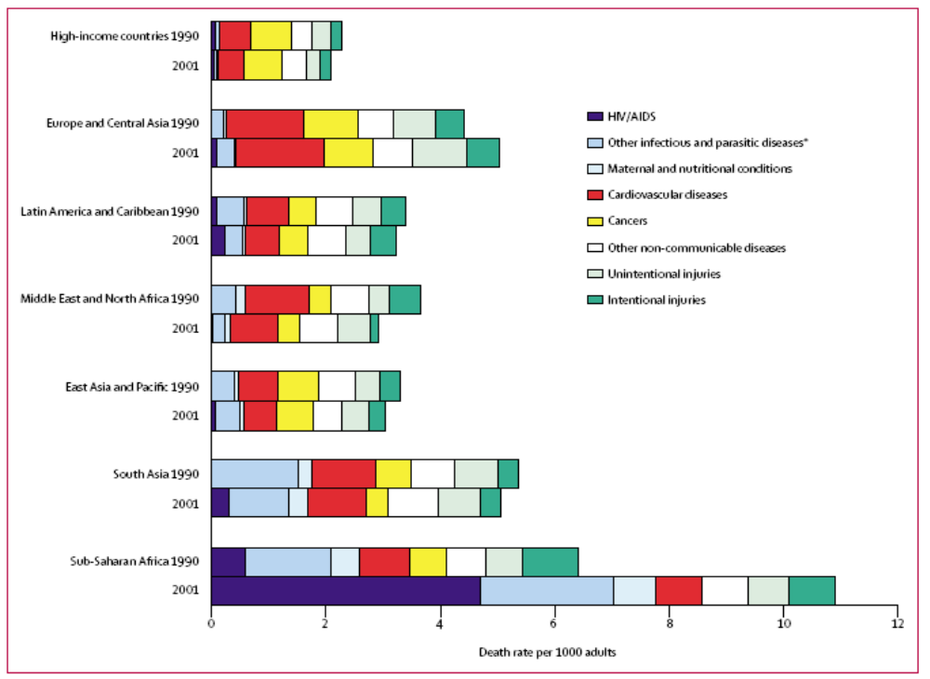
Figure 1: Death rates by disease and region in 1990 and 2001 for adults aged 15–59 years
*Includes respiratory infections.
(Source: Lopez et al, 2006; Lancet)

Causes-specific death rates for 1990 estimated from Murray and Lopez might not be completely comparable to those for 2001 because of changes in data availability and methods, plus some approximations in mapping 1990 estimated to the 2001 regions East Asia and Pacific, South Asia and Europe and Central Asia.

For all geographical regions, high income countries are excluded and shown as single group at top of graph. The geographical regions therefore refer to low-and-middle income countries only

The scenarios in the case studies are individual cases. However, when we start adding each individual case together, a picture similar to that shown in the above graph begins to emerge and we begin to realise the impact these diseases have on society.

TASK 2 - Describe the burden of non-communicable diseases

Look at the graph in Figure 1 again.

1. Name two regions that are most affected by non-communicable diseases (NCDs).

2. Why would these regions have a higher burden of NCDs compared to sub-Saharan Africa?
FEEDBACK

1. When looking at the burden of NCDs you need to consider the category of cardiovascular diseases, cancers and other non-communicable diseases. Taking all these conditions into consideration, you will find that the three regions that are most affected are:
- Europe
- Central Asia
- South Asia
2. A region such as Europe and Central Asia includes more developed and industrialised countries compared to sub-Saharan Africa which mainly includes developing countries.

Looking at the population pyramid for developed and developing countries, (highlighted in Unit 2 of study session 4 in Introduction to Public Health) Europe and Central Asia have a large elderly population that is most affected by NCDs; while in sub-Saharan Africa there is a lower percentage of elderly people than younger people.

NCDs mainly affect the older population, thus the burden of NCDs is lower in sub-Saharan Africa.

4 HOW IS THE BURDEN OF DISEASE MEASURED?

TASK 3 – Identify ways of measuring health

READING

Werner, D. & Sanders, D. (1997). Ch 11 – Questioning the solution: The politics of Primary health care and Child Survival: 75.

Preview the above text: Skim the headings, illustrations, first and last paragraphs of the above text. Read the first sentences of each paragraph. Remember that this helps prepare you for reading the text and for identifying its main purpose.

1. Now read pages 75–76 carefully and look at the table below. Identify three ways in which we measure the health of a population. Explain what these measurements mean. Identify a drawback or a limitation of research figures.

2. What do you think is the main reason for the decrease in life expectancy in South Africa?

Table 1: Health measures of different populations

COUNTRY | U5MR |  | IMR |  | TOTAL POP in millions |  | GNI per capita (US $) 2007 | Life expectancy at birth |  | Total Adult Literacy rate (%) 2000-2007 | % share hold of household income 1995-2005
 | 1990 | 2007 | 1990 | 2007 | 1993 | 2007 |  | 1993 | 2007 |  | Lowest 40% | Highest 20%
BANGLADESH | 151 | 61 | 105 | 47 | 122.2 | 158.7 | 470 | 53 | 64 | 54 | 21 | 43
BOTSWANA | 57 | 40 | 45 | 33 | 1.4 | 1.9 | 5840 | 61 | 50 | 83 | 9x | 65x
BRAZIL | 58 | 22 | 49 | 20 | 156.6 | 191.8 | 5910 | 66 | 72 | 91 | 9 | 61
CHINA | 45 | 22 | 36 | 19 | 1205.2 | 1328.6 | 2360 | 71 | 73 | 93 | 13 | 52
COSTA RICA | 18 | 11 | 16 | 10 | 3.3 | 4.5 | 5560 | 76 | 79 | 96 | 13 | 53
CUBA | 13 | 7 | 11 | 5 | 10.9 | 11.3 | C | 76 | 78 | 100 | - | -
EGYPT | 93 | 36 | 68 | 30 | 56.1 | 75.5 | 1580 | 62 | 71 | 72 | 22 | 42
GABON | 92 | 91 | 60 | 60 | 1.3 | 1.3 | 6670 | 54 | 57 | 86 | - | -
HONG KONG |  |  |  |  | 5.9 | 0.0 |  | 78
INDIA | 117 | 72 | 83 | 54 | 896.6 | 1169.0 | 950 | 61 | 64 | 66 | 19 | 45
IRAN | 72 | 33 | 54 | 29 | 63.2 | 71.2 | 3470 | 67 | 71 | 85 | 17 | 45
JAMAICA | 33 | 31 | 28 | 26 | 2.5 | 2.7 | 3710 | 74 | 72 | 86 | 15 | 52
LIBYA | 41 | 18 | 35 | 17 | 5.1 | 6.2 | 9010 | 63 | 74 | 87 | - | -
MEXICO | 52 | 35 | 42 | 29 | 90 | 106.5 | 8340 | 70 | 76 | 92 | 13 | 55
MOZAMBIQUE | 201 | 168 | 135 | 115 | 15.3 | 21.4 | 320 | 47 | 42 | 44 | 15 | 54
NEPAL | 142 | 55 | 99 | 43 | 21.1 | 28.2 | 340 | 54 | 64 | 57 | 15 | 55
NIGERIA | 230 | 189 | 120 | 97 | 119.3 | 148.1 | 930 | 53 | 47 | 72 | 15 | 49
PERU | 78 | 20 | 58 | 17 | 22.9 | 27.9 | 3450 | 65 | 71 | 91 | 11 | 57
SINGAPORE | 8 | 3 | 6 | 2 | 2.8 | 4.4 | 32470 | 75 | 80 | 94 | 14 | 49
SOUTH AFRICA | 64 | 59 | 49 | 46 | 40.8 | 48.6 | 5760 | 63 | 50 | 88 | 10 | 62
SRI LANKA | 32 | 21 | 26 | 17 | 17.9 | 19.3 | 1540 | 72 | 72 | 92 | 18 | 48
SWEDEN | 7 | 3 | 6 | 3 | 8.7 | 9.1 | 46060 | 78 | 81 | - | 23 | 37
UNITED KINGDOM | 9 | 6 | 8 | 5 | 57.8 | 60.8 | 42740 | 76 | 79 | - | 18 | 44
UNITED STATES | 11 | 8 | 9 | 7 | 257.8 | 305.8 | 46040 | 76 | 78 | - | 16 | 46
VIETNAM | 56 | 15 | 40 | 13 | 70.9 | 87.4 | 790 | 64 | 74 | 90x | 18 | 45
(Werner & Sanders, 1997: 75)
FEEDBACK

Below are our notes:

1. Ways of measuring health
The following ways are used to measure the health of a population:
Infant mortality rate (IMR): This is the number of deaths of children less than one year old per 1 000 live births.
Under 5 mortality rate (U5MR): This is the number of deaths of children less than 5 years old per 1 000 live births.
Life expectancy: This is the average number of years that newborns are expected to live. It is important to know that life expectancy is determined by mortality in a specific geographic area.

2. Reasons for a decrease in life expectancy
In South Africa life expectancy has decreased from 63 in 1993 to 50 in 2007. This means that a newborn in 2007 was expected to live for 50 years. This decrease is mainly a result of the huge burden posed by HIV/AIDS and other infectious diseases, such as TB.

Under-5 and infant mortality rates are important measures of health because infants and children under-5 years are the most vulnerable age group. These indicators help to inform policy-makers about socio-economic conditions and health services in an area. The graph below (Figure 2) shows that the highest under-5 mortality rate occurs in the poorest sector of a population.

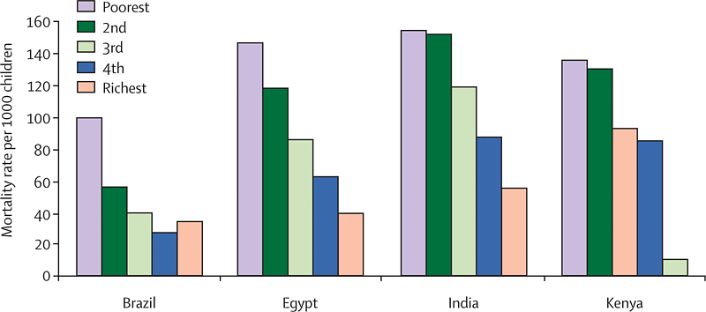

Source: Marmot, 2005; Lancet

Figure 2: Under-five mortality by country and income

TASK 4 - Compare infant mortality and under 5 mortality rates

Study the table below carefully.

1. What are the differences between infant mortality (IMR) and under-5 mortality rates (U5MR)?

2. Draw a bar graph to show the difference in IMR and U5MR. Use the countries and the four years indicated below for the x-axis; and the U5MR and IMR figures for the y axis.

Country | U5MR |  | IMR
 | 1990 | 2007 | 1990 | 2007
BANGLADESH | 151 | 61 | 105 | 47
BOTSWANA | 57 | 40 | 45 | 33
BRAZIL | 58 | 22 | 49 | 20
CHINA | 45 | 22 | 36 | 19
COSTA RICA | 18 | 11 | 16 | 10
CUBA | 13 | 7 | 11 | 5
EGYPT | 93 | 36 | 68 | 30
GABON | 92 | 91 | 60 | 60

FEEDBACK

1. IMR tells us about the number of children under the age of 1 year old who die annually, per 1 000 live births; while U5MR refers to the deaths of children under the age of 5 years per 1 000 live births. U5MR include IMR. IMR are always smaller than U5MR but, as you can see, a high proportion of U5MR occurs in infancy, the most vulnerable year of life.

2. See the bar graph below.

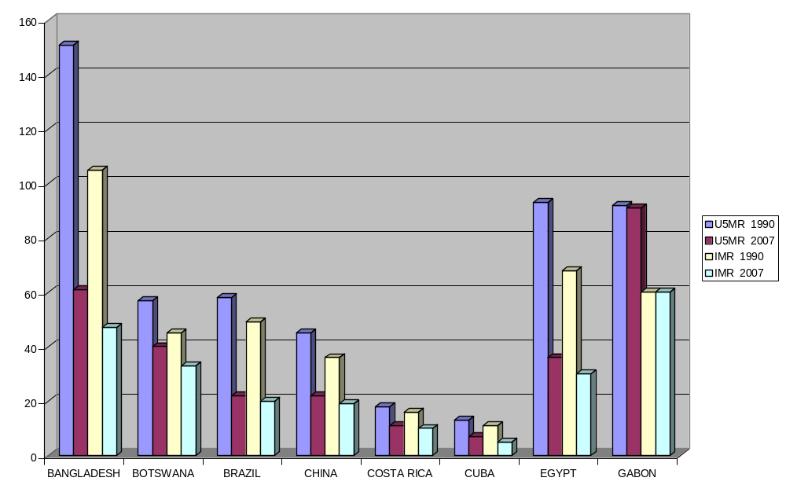
Figure 3: Infant mortality and under-5 mortality by country 1990-2007

IMR and U5MR are useful indicators as they provide information which can help to encourage or ensure the survival and healthy development of children in a community. A healthy childhood increases the chances of survival into adulthood, and increases the chances of a healthy life as an adult, as well as the likelihood of an individual being able to fulfill his/her potential.

5 SESSION SUMMARY

This study session has looked at the burden of ill-health in the world. So far you have learned that the burden of disease and death falls heavily on young children in the underdeveloped and developing countries. Tables and graphs were used to illustrate the burden. Although a number of indicators are used to measure health, this study session focused on infant mortality rate, under-5 mortality rate and life expectancy.
Unit 1 – Study Session 2
Distribution of ill-health in the world and in developing countries

Introduction

In the last study session you deepened your understanding of the burden of disease. In this study session you will answer the questions: Which people are affected by ill-health in the world? Where do they live? Before you can answer these questions, however, you need to understand various terms used to describe different regions of the world, such as developed, developing and undeveloped.

Session contents

1 Learning outcomes of this session
2 Readings and references
3 What does development mean?
4 What are developed, developing, undeveloped and underdeveloped countries?
5 How is development measured?
6 Who is most affected by ill-health in the world?
7 What is the impact or effect of diseases?
8 Session summary

Timing of this session
There are no extra readings in this session, but there are seven tasks. It is likely to take you up to three hours to complete.

1 LEARNING OUTCOMES FOR THIS SESSION

By the end of this session, you should be able to:

Public Health Outcomes  - Define ‘development’ and define ways of measuring it.  - Identify ‘developed’ and ‘undeveloped’ countries and terms used to describe them.  - Identify countries/regions most affected by ill-health.  - Identify who is most affected by ill-health.  - Describe trends in ill-health in Africa.  - Describe the impacts/effects of ill-health. | Academic outcomes  - Reading skills  - Use diagrams to analyse and summarise ideas, e.g. mind-maps.  - Read and analyse diagrams.  - Read research figures critically and extract information from diagrams.

2 READINGS AND REFERENCES

There are no extra readings for this session.

REFERENCES:
- Werner, D. & Sanders, D. Questioning the solution: The politics of Primary health care and Child Survival: 1997: 13.
- UNDP, Human Development Report, 1996: 136. Available: http://hdr.undp.org/en/media/hdr_1996_en_contents.pdf
- Worldmapper Population Cartogram: Maps 2, 261, 263. Available: www.worldmapper.org.
- WHO, Global Burden of Disease Report, 2004. Available: www.who.int/healthinfo/global_burden_disease/GBD_report_2004update_full.pdf
- UNAIDS, 2009. Available: www.unaids.org/pub/report/2009

3 WHAT DOES 'DEVELOPMENT' MEAN?

To begin, we cover some basic concepts which are important as they underpin the entire module and the readings. We will cover the following basic concepts:
Concepts
Ideas that help us understand and make sense of the world we live in. Concepts help us to organise our thoughts, to classify random ideas, to reflect on ideas, to analyse and examine them critically, to rethink, and to reconceptualise.

- What ‘development’ means and what are some ways of measuring it.
- Which countries are called ‘developed’ and which are called ‘underdeveloped’?
This first task helps to clarify the concept of development – the features of ‘developed’ and ‘underdeveloped’ countries; their location in the world’, the many terms used to describe them, and ways of measuring development.
TASK 1- Identify the disease groups

- What picture comes to mind when you think of ‘developed’ and ‘underdeveloped’ countries? How do they live? Where are these countries?
- Brainstorm what you understand by the concept, ‘developed’. Write down as many ideas as you can on the diagram below.

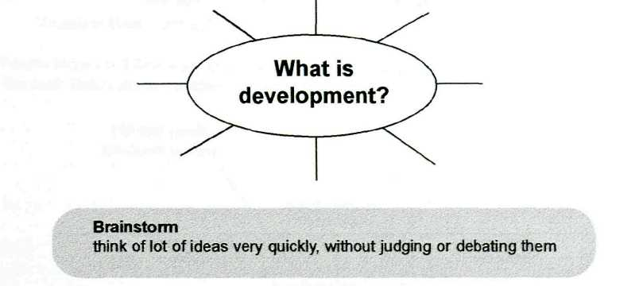

Academic learning skills: Using mind-maps

The above diagram is called a mind-map or spider diagram. It consists of a central question or concept in the middle and related ideas around it.
It is a learning tool which helps you to:
- Think freely, generate lots of ideas, and organise your thoughts
- Analyse a central idea to see how other ideas are connected to it
- Recognize patterns
- See complex issues as a whole

FEEDBACK
- Most people see 'developed' countries as rich, industrialised, technologically advanced places where the majority of people earn high incomes and enjoy a high standard of living. People are adequately housed, well-fed and have access to good health care and education. The state supports the unemployed, elderly, sick and disabled and provides support to preschool children. In contrast, 'underdeveloped' countries bring to mind images of desperately poor, starving people without any visible source of income or access to adequate shelter, health care or education. The state provides very little, if any support for the unemployed, elderly, very young, sick and disabled.

- Below are some of our ideas about development. Note: These features or characteristics of development are idealised. One example is that in reality, most developed countries have few equal opportunities for men and women.

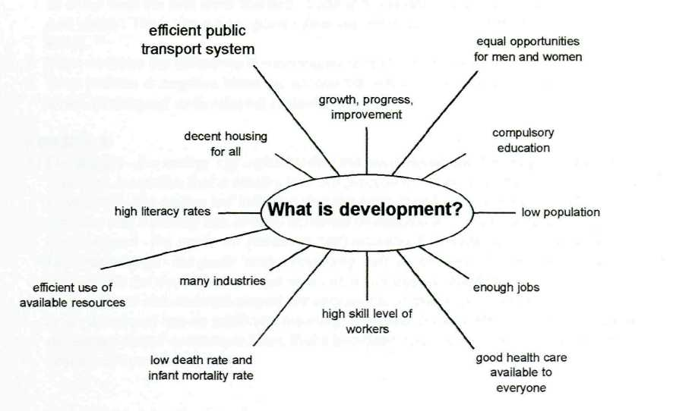

4 DEVELOPING, DEVELOPED, UNDEVELOPED, UNDERDEVELOPED COUNTRIES

Countries that are wealthy are usually referred to as the 'developed' countries. Countries that are very poor are usually referred to as the 'underdeveloped' countries. In the past, most underdeveloped countries were colonies of one or more of the rich, developed countries.

TASK 2 - Clarify the concepts, ‘developed’, ‘developing’, ‘undeveloped’ and ‘underdeveloped’

- Look at the four words: ‘developed’, ‘developing’, ‘undeveloped’ and ‘underdeveloped’. They all come from the root word ‘develop’. Write down what you understand by each word. (Clue: Look at the endings, i.e. ‘ed’ and ‘ing’; and at the beginnings, i.e. ‘un’ and ‘under’).
- Use the world map below to identify some countries that you would call developed and underdeveloped.

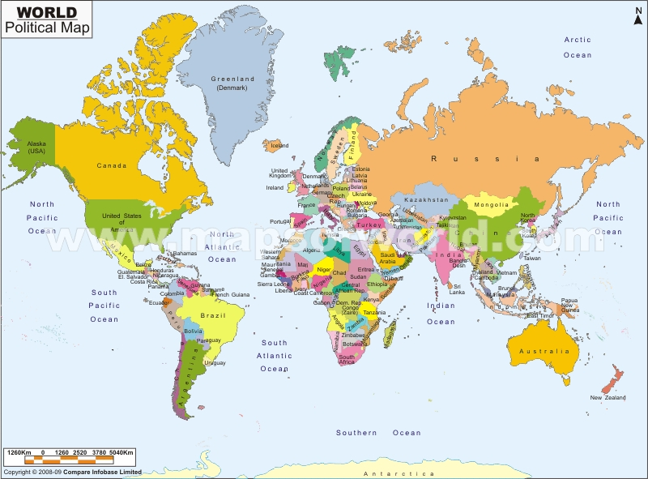
FEEDBACK

- Developed – This term usually refers to a country that is said to have already achieved a high level of development. It is usually described as wealthy (high-income), industrialised and technologically advanced. Examples of developed countries are United Kingdom (UK), Spain, USA, Sweden, Canada, Japan, and Australia.

Developing – This term refers to a country that is in the process of growing or improving today. Sometimes the distinction between developed and underdeveloped is not so clear-cut. For example, countries like South Africa, Mexico, Brazil, India, China and Russia contain aspects of development alongside underdevelopment. These countries are often called ‘emerging markets’, to indicate that they are in a transitional phase between underdeveloped and fully developed countries. These countries are also sometimes called Newly Industrialised Countries (NICs).

Undeveloped - This signifies that a country is not developed. It is similar to ‘underdeveloped’, although underdeveloped has an additional meaning (see below).

Underdeveloped – ‘Under’ means below, beneath or not enough. This signifies that a country is less developed than it could have been, that it has been made less developed or deliberately prevented from developing. Underdeveloped countries suffer conditions of extreme poverty and very low income. They may be agriculturally-based countries, in which the majority of people earn very little, and do not have access to adequate nutrition, health care and education. Many were colonies of one or more of the developed countries. Examples are Mozambique, Zambia, Zimbabwe, Mexico, Nicaragua, and Haiti. Some people would even call some of the NICs, e.g. India and South Africa, ‘underdeveloped’ because they are less developed than they could have been if their history had not been marked by colonial exploitation.

“Since colonial times, the ‘development’ of the so-called ‘undeveloped’, ‘less developed’ or ‘developing’ colonized lands in the South has been defined and directed by the more powerful nations of the North. The net transfer of wealth from the South to the North has always been the bottom-line of the development process. …the persistent high incidence of illness, death, and developmental delay in the world’s children is inseparably linked to the increasingly globalized forces of under-development – carried out in the name of development.”
(Werner & Sanders, Questioning the Solution, 1997: 13.)

The terms ‘developed’, ‘developing’, ‘undeveloped’, ‘underdeveloped’ are descriptive terms which contain assumptions and judgements. Although no one term is satisfactory, in this module we have used the broad categories ‘developed’ and ‘underdeveloped’ countries.

The table below explains the different terms used to describe these countries:

Developed countries | Underdeveloped countries
First World | Third World
High-income | Low income
Industrialised country | Industrialising country
Former colonial powers | Former colonies
Developed or established market | Least Developed Countries (LDCs)
Rich countries | Poor countries
Core countries | Countries of the periphery
Modern countries | Traditional countries
The North | The South

5 HOW IS DEVELOPMENT MEASURED?

There are many possible criteria that can be used to measure how developed a country is, such as the level of industrialisation, the rate of employment, the death rate, or how many people have access to education, housing and health care. In economic terms, development is usually a measure of the wealth of a country. This is measured by calculating the Gross National Income (GNI) or the GDP (Gross Domestic Product) of the country. These measurements are traditionally given in US dollars.

GDP (Gross Domestic Product) is calculated by adding the total value of all the goods and services (e.g. schooling, transport) produced by all the citizens of a country in a year. When this is divided by the total population, we arrive at the average GDP per person or per capita in the country. So, for example, if you have two countries that have the same GDP, but one country is twice as populated as the other, it will have a lower GDP per capita than the other country. In other words, the less populated country was more productive.

Gross National Income (GNI) used to be called Gross National Product (GNP). It is a similar measure to GDP but it includes income that individuals and companies, based in the country, earn overseas or that migrant workers send back to the country. It excludes income that foreign individuals and companies earn in the country. It is converted to international dollars using purchasing power parity (PPP) rates. An international dollar is a hypothetical unit of currency that has the same purchasing power that the US dollar has in the United States at a given point in time. GNI and GDP are often used interchangeably in the literature.
Per capita:
For each person

According to the World Bank, economies can be divided according to Gross National Income (GNI) per capita. The groups include:
Low income - $975 or less per capita per year
Lower middle income - $976 - $3 855 per capita per year
Upper middle income - $3 856 - $11 905 per capita per year
High income - $11 906 or more per capita per year

According to the table below, in 1993 South Africa was classified an upper-middle-income country and life expectancy was relatively good. If this surprises you, the following task helps to highlight a major problem with drawing conclusions from these kinds of figures.

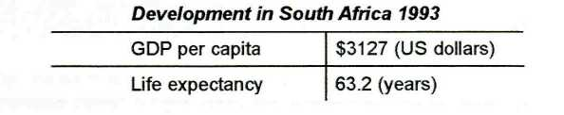
(UNDP, Human Development Report, 1996: 136.)

TASK 3 - Read figures critically

The bar graph below shows the average annual household income for each race group in South Africa in 1990. Notice that each bar represents a different race group and that the height of the bar indicates the amount of income that a household from that race group received on average per annum.

- What was the average annual income for a white, coloured, Asian and African household in 1990?

- How accurate and helpful are figures based on averages, in measuring the level of development of countries such as South Africa?

Bar graph:
A drawing, sometimes called a histogram, made up of bars or blocks which represent what is being measured, e.g. income, literacy rates, life expectancy. The height and length of the bars show the actual amount or figure.

Per annum:
Latin meaning 'for each year'
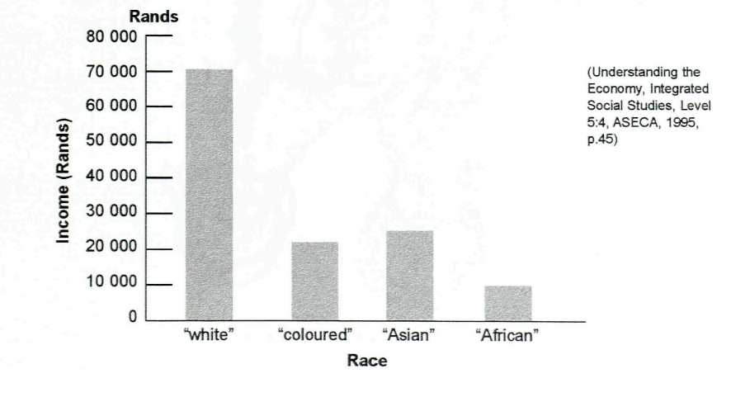

FEEDBACK
1. The average incomes per annum for the four race groups were approximately:
Whites R70 000
Asian R27 000
Coloureds R22 000
African R11 000

2. GNI per capita is a misleading measure because it only tells us about the total wealth of a nation. GNI only tells us about the average wealth per person in the country. It does not tell us about how income within the country is actually distributed amongst the different groups in the population. Average figures disguise the fact that there are huge inequalities in income and standard of living between groups of people within the country. This is because these figures are based on averages. They make a country like South Africa seem more evenly developed than it actually is. In reality, development within South Africa is very uneven.

Economic classifications on their own are not sufficient to explain the health levels of a country. The United Nations Development Programme (UNDP) uses a broader definition of development, focusing on human development. It defines human development as a country’s ability to develop its people and to improve the conditions in which they live. This includes creating a society in which people have:
- Access to resources and services to meet their needs
- Opportunities to have a decent standard of living
- The means and ability to fulfil their needs and interests
- Opportunities to develop their full potential and
- The opportunity to live long and healthy lives.

This concept of human development is based on the concepts of equity, sustainability, production and empowerment.
The UNDP ranks countries on a Human Development Index (HDI) using values between 0 and 1, with 1 representing the highest value. The ranking usually indicates where a country is on the scale of human development. Three basic indicators are used to measure average achievements of a country towards human development:
- A long and healthy life: Measured by life expectancy at birth
- Access to knowledge: Measured by the adult literacy rate and the combined gross enrolment ratio in education
- A decent standard of living: Measured by Gross Domestic Product (GDP) per capita in purchasing power parity (PPP) in US dollars.

According to the UNDP Human Development Report for 2009 (based on 2007 figures) and only looking at the top five countries in each category:
- Very high human development has been achieved by 38 countries surveyed, the top five being Norway, Australia, Austria, Iceland, Canada and Ireland.
- High human development has been achieved by 42 countries surveyed, the top five being Bahrain, Estonia, Poland, Slovakia and Hungary.
- Medium human development has been achieved by 75 countries surveyed, the top five being Armenia, Ukraine, Azerbaijan, Thailand and Iran.
- Low human development has been achieved by 23 countries surveyed, the top five being Togo, Malawi, Benin, Timor-Leste and Côte d'Ivoire. Bottom of this list are Mali, Central African Republic, Sierra Leone, Afghanistan and Niger.
While the HDI measures achievements towards human development, the Human Poverty Index (HPI) measures a country’s deficiencies or shortcomings in human development. In other words, it measures the extent of poverty in a country using the following indicators:
- The likelihood of death at a relatively early age (Infant mortality rate and Under 5 mortality rate)
- A lack of basic education, measured by the percentage of adults who are illiterate
- The lack of access to a decent standard of living.

You have now learnt more about the concepts development and underdevelopment, and some ways of measuring these. You can return to these concepts if you need to as you work through the module and do the readings. We can now return to an analysis of the distribution of ill-health in the world, particularly in the underdeveloped world.

6 WHO IS MOST AFFECTED BY ILL-HEALTH IN THE WORLD?

The map in Figure 1 is a map of the world, representing populations in various regions.

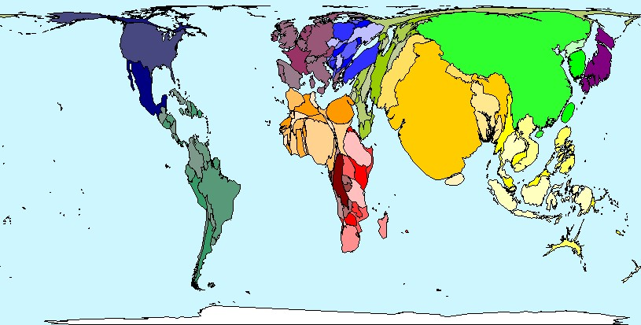

Figure 1: Map of the world (2002)
(Source: Worldmapper Population Cartogram: Map 2.)

In the previous session we spoke about infant mortality rate (IMR) and under 5 mortality rates (U5MR), which are some of the indicators used worldwide to measure the health status of a country. Remember that we said under 5 mortality rate (U5MR) also includes infant mortality rate (IMR). It is a harsh reminder of inequality in the world that most of the deaths of children who are under 5 years old occur in low-income and middle-income countries.

In the map below, the territory size shows the proportion of infant deaths worldwide that occurred there in 2002. The map below shows the distribution of deaths in children under the age of 5 years. We see that children from 0-5 year-old are the most vulnerable, especially infants (0-1 year). Compare the map below with the representations in Figure 1.

The map below shows that in 2002, there were 7.2 million infant deaths worldwide. The area with the most infant deaths was India (1.7 million) - for every 100 babies born alive, almost 7 died in their first year of life. In 22 areas in Africa, for every 10 live births, 1 baby died. The highest infant mortality rate was in Sierra Leone, where 16.5 babies died for every 100 born alive.

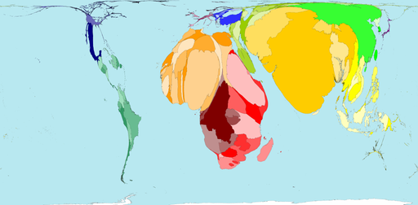 Figure 2: Infant Mortality (2002)
(Source: Worldmapper Population Cartogram: Map 261.)

The above map shows infant mortality in the world in 2002, while the map below shows the proportion of all deaths of children aged over 1 year and under 5 years old, that occurred in 2002. Worldwide, there were almost 3.2 million deaths of children between 1 and 5 years old. The distribution of these deaths was as follows: 29% in Southern Asia; 26% in Northern Africa; and 18% in South-eastern Africa. The region with the highest death rate in this age group was Central Africa, where there were 79 deaths per 1 000 live births. This is three times higher than the world average.
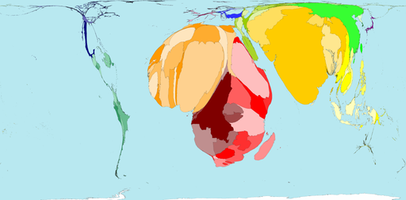 Figure 3: Mortality 1-4 Year Olds (2002)
(Source: Worldmapper Population Cartogram: Map 263.)

TASK 4 - Identify where the most deaths occur

- Look at Figures 2 and 3 again. What do you notice about where the most deaths of 1–4 year olds occur?
- Where do least deaths in this age range occur?

FEEDBACK

- Infant mortality as well as mortality of children aged 1–4 years is highest in Africa and in Asia.
- Mortality of children 1–4 years and infant mortality is lowest in North America, Europe and South America

When discussing the distribution of ill-health, it is important to look at age, sex and location/region. When looking at risk factors it is essential to consider age, as some conditions such as injuries and certain diseases such as HIV/AIDS are associated with age. Different regions of the world are affected by different types of conditions and diseases. For example diarrhoeal diseases and malaria mostly occur in African countries, while the high-income countries have the highest burden of non-communicable diseases, such as high blood pressure and diabetes. There are also gender differences in the occurrence of certain conditions, e.g. oesophageal cancers are higher in men than women, while women are more prone to anaemia than men. The table below presents information about the leading causes of death by income group in high-, low- and middle-income countries in 2001.
Table 1: Ten leading causes of death by country income group, 2001
 | Low- and middle-income countries |  |  | High-income countries
 | Cause | Deaths (millions) | % of total deaths | Cause | Deaths (millions) | % of total deaths
1 | Ischaemic Heart disease | 5.7 | 11.8% | Ischaemic Heart disease | 1.36 | 17.3%
2 | Cerebrovascular disease | 4.61 | 9.5% | Cerebrovascular disease | 0.78 | 9.9%
3 | Lower respiratory infections | 3.41 | 7% | Trachea, bronchus, lung cancers | 0.46 | 5.8%
4 | HIV/AIDs | 2.55 | 5.3% | Lower respiratory infections | 0.34 | 4.4%
5 | Perinatal conditions | 2.49 | 5.1% | Chronic Obstructive pulmonary disease | 0.30 | 3.8%
6 | Chronic Obstructive pulmonary disease | 2.38 | 4.9% | Colon and rectum cancers | 0.26 | 3.3%
7 | Diarrhoeal diseases | 1.78 | 3.7% | Alzheimer’s disease and other dementias | 0.21 | 2.6%
8 | Tuberculosis | 1.59 | 3.3% | Diabetes mellitus | 0.20 | 2.6%
9 | Malaria | 1.21 | 2.5% | Breast cancer | 0.16 | 2.0%
10 | Road traffic accidents | 1.07 | 2.2% | Stomach cancer | 0.15 | 1.9%

TASK 5 - Compare the leading causes of death in different countries

- Look carefully at Table 1. What are the similarities and differences in the leading causes of death between low- and middle-income countries and high-income countries?

FEEDBACK

- In both low- and middle-income countries and high-income countries the top two causes of death in 2001 were ischaemic and cerebrovascular diseases which are non-communicable in nature. However, the majority of people in low- and middle-income countries (if we add together all the other leading causes of death) die from mainly infectious/communicable diseases and road traffic accidents. In high-income countries people mainly die from non-communicable diseases, namely ischaemic heart disease, cerebrovascular disease and cancers. Lower respiratory infections account for 4.4% of deaths in high-income countries and 7% of deaths in low- and middle-income countries. However in children under 5 lower respiratory infection is in the top three causes of death.

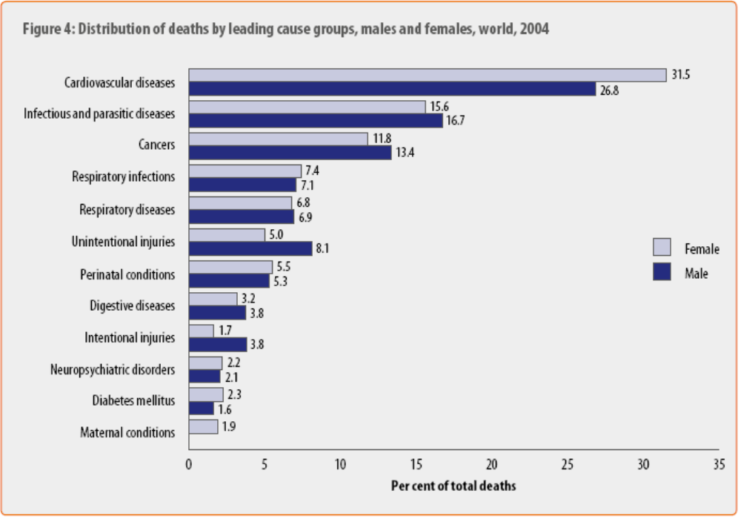
Figure 4: Distribution of deaths by leading cause groups, males and females, world, 2004
(Source: Global Burden of Disease Report, 2004)

The above bar graph shows the leading causes of deaths among males and females in the world. This graph further highlights the gender differences in the occurrence of diseases.
TASK 6 - Identify the leading causes of death in males and females

- Looking at the graph above, state the top three diseases/conditions that affect mostly males, as compared to females?

FEEDBACK

- Men are mostly affected by infectious and parasitic diseases (16.7%), cancers (13.4%), and unintentional injuries (8.1%).

By the end of 2008, an estimated 33.4 million people worldwide were living with HIV/AIDS, with women accounting for 50% of them. Table 2 shows the 2008 HIV and AIDS statistics for regions around the world. You can see that the majority of people living with HIV/AIDS live in sub-Saharan Africa (22.4 million), which also has the highest rate of new infections. In the next section we will think about the impact this has on the individual, their households, and their nations.
Table 2: HIV/AIDS Statistics per region for 2008
Region | Adults & children  living with HIV/AIDS | Adults & children  newly infected | Adult prevalence* | Deaths of  adults & children
Sub-Saharan Africa | 22.4 million | 1.9 million | 5.2% | 1.4 million
North Africa & Middle East | 310 000 | 35 000 | 0.2% | 20 000
South and South-East Asia | 3.8 million | 280 000 | 0.3% | 270 000
East Asia | 850 000 | 75 000 | <0.1% | 59 000
Oceania | 59 000 | 3 900 | 0.3% | 2 000
Latin America | 2.0 million | 170 000 | 0.6% | 77 000
Caribbean | 240 000 | 20 000 | 1.0% | 12 000
Eastern Europe & Central Asia | 1.5 million | 110 000 | 0.7% | 87 000
North America | 1.4 million | 55 000 | 0.4% | 25 000
Western & Central Europe | 850 000 | 30 000 | 0.3% | 13 000
Global Total | 33.4 million | 2.7 million | 0.8% | 2.0 million
* Proportion of adults aged 15–49 who were living with HIV/AIDS
(Source: UNAIDS, 2009)

7 WHAT IS THE IMPACT OR EFFECT OF DISEASES?
Different conditions or diseases have different impacts on health and well-being. Many conditions result in death or disability. Impact of ill-health can be measured are different levels, namely at individual level, household level, and national level.
Individual level

At individual level, diseases can lead to disability or even death. For example, a condition such as diabetes can result in a decrease in the quality of life. The individual can develop other conditions and also complications such as:
- Heart disease which is the leading cause of diabetes-related deaths
- Strokes (cerebrovascular disease)
- High blood pressure
- Blindness
- Nervous system disease which leads to loss of sensation especially in the lower extremities
- Amputations
- Kidney disease.

All of the above complications can compromise the person’s quality of life and independence.

TASK 7 - Identify the effect of ill-health on households

- Look at the complications that could result from the diseases at the individual level. Brainstorm the different kinds of impacts these could have on a

FEEDBACK

- At a household level, complications like blindness, heart disease and strokes could lead to loss of employment and earnings. This financial loss is aggravated by the fact that much of the household’s financial resources would now be directed to the treatment or rehabilitation of the ill individual. This could result in less money being spent on education and food. A shift in the utilisation of resources could lead to school dropout and child labour especially in poor households. This in turn could result in an increase in illiteracy. Lack of access to knowledge, represented by the percentage of adults who are illiterate, is a measure of a country’s level of poverty.

Household level
If we take diabetes as an example of the effects of a disease on the household, studies show that there are direct and indirect costs and economic impact associated with diabetes. Direct costs include money paid out to doctors, for medication, for hospitalisation and for rehabilitation services. Indirect costs include productivity loss due to time spent on visiting the doctor or clinic, which translates into absenteeism from work. This results in loss of working days and in some cases loss of income.

National level
Diabetes is a chronic condition and incurable. This means that people will live with the condition for several years and will therefore require long-term treatment, which translates into a substantial amount of money being paid out of the health budget for the treatment and management of the condition.

Different conditions or diseases impact differently on the individual, household and country. Information on the impact of conditions is useful when planning appropriate interventions.

9 SESSION SUMMARY

In this session you learnt about the population groups most affected by ill-health in the world. We further looked at where these people live and the impact their ill-health has on their own lives, households and countries.

Unit 1 – Study Session 3
Pattern of ill-health in developed, developing and underdeveloped countries

Introduction

In this session we will deal further with the pattern of diseases in underdeveloped countries. We will also look at the causes of ill-health, focusing mainly on diseases that affect developing and underdeveloped countries. We will discuss the difference between risk factors and causes of diseases and we will look at the links between undernutrition and infection.

Session contents

1 Learning outcomes of this session
2 Readings and references
3 Patterns of ill-health in underdeveloped countries
4 Differences between risk factors and causes
5 Causes of ill-health and disease
6 Links between undernutrition and infection
7 Session summary

Timing of this session

There are two readings in this session, and there are five tasks. It is likely to take you up to three hours to complete.

1 LEARNING OUTCOMES FOR THIS SESSION

By the end of this session, you should be able to:

Public Health Outcomes  - Describe the general pattern of diseases in underdeveloped countries.  - Explain the interaction between undernutrition and infection.  - Distinguish between a cause and risk factor.  - Discuss the causes of ill-health in relation to malnutrition and diabetes. | Academic outcomes  - Clarify concepts  - Preview texts  - Use words or phrases to communicate cause and effect.  - Make notes from a reading.  - Read and create your own flow diagrams and other diagrams.

2 READINGS AND REFERENCES

There are two readings for this session which you will be directed to in the course of the session.

Author | Title
Werner, D. & Sanders, D. | (1997). Ch 1 – Questioning the solution: The politics of Primary health care and Child Survival: 1–12.
Schaible, U. E. & Kaufmann, S. H. E. | (2007). Malnutrition and Infection: Complex Mechanisms and Global Impacts. PLoS Medicine, 4(5): 0806-0812.

ADDITIONAL REFERENCES:
Worldmapper Population Cartogram: Map 436. Available: www.worldmapper.org.
Werner, D. & Sanders, D. Questioning the solution: The politics of Primary health care and Child Survival: 1997: 62.

3 PATTERNS OF ILL-HEALTH IN UNDERDEVELOPED COUNTRIES

Pattern of diseases refers to the causes and spread of disease within a population. These differ from one country to another. For example, developed countries have a high prevalence of non-communicable diseases, while communicable diseases are a problem in developing countries and underdeveloped countries.

Figure 1 shows the spread of malaria in the world. You will notice that malaria occurs in tropical and subtropical regions. To understand why these areas have such a high prevalence of malaria we need to look at the causes of malaria. Malaria is a parasitic disease caused by a certain type of mosquito that thrives in warm, damp climates, especially in areas that have summer rains. The areas that have a high prevalence of malaria are referred to as ‘the tropics’.

Tropics: Areas between the tropic of Cancer and Capricorn. Along the tropics lie the tropical high-pressure zones, characterised by descending dry air and desert conditions. However, between tropics, the conditions vary seasonally between wet and dry.

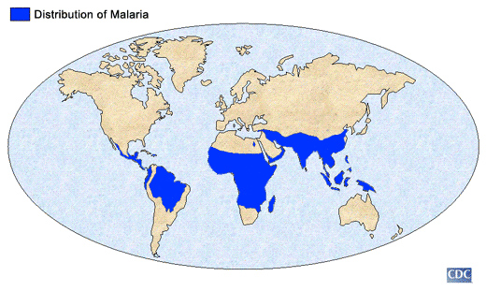

Figure 1: Distribution of malaria

Non-communicable diseases (NCDs), on the other hand, mainly occur in high-income countries, as well as to a lesser degree in middle-upper income countries. In poor countries NCDs occur amongst the affluent and also the poor. The emergence of these conditions amongst the poor and affluent is mainly due to the adoption of an ‘urban lifestyle’ which encourages sedentary living, diets high in fats, sugar and salt, and low in fibre and vegetable. The map below shows the deaths that are attributed to one NCD – diabetes. The countries that appear enlarged on the map have a high burden of diabetes. Countries whose shapes are reduced have a lower burden of diabetes.

Sedentary living: A term used in the field of medicine to describe a type of lifestyle that lacks physical activity. This type of lifestyle is usually characterised by activities such as reading, sitting, watching TV or using a computer. It includes activities that do not need too much energy to fulfil. The word ‘sedentary’ is synonymous with inactivity.

From the map you can see that Asia has the highest burden of diabetes. This is currently being fuelled by rapid economic development, as well as by a changing diet and sedentary lifestyle. NCDs such as diabetes or hypertension are caused by numerous factors, such as food high in calories and a decrease in physical activity. If we further analyse the causes that lead to a decrease in physical activity, we see that mechanisation and improved transportation have led to people leading sedentary lifestyles. This is especially the case in developed and developing countries. You will notice that a country such as India has a high burden, however these high numbers are partly due to its high population size. So even if the rate is low there are still large numbers of people with diabetes because of the large population base.

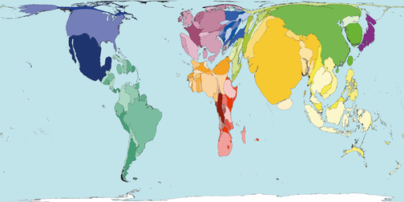
Figure 2: Deaths due to Diabetes
(Source: Worldmapper Population Cartogram: Map 436.)

4 DIFFERENCE BETWEEN RISK FACTORS AND CAUSES

Before we look at the cause of diseases or ill-health, it is important to first distinguish the difference between commonly-used concepts such as causes and risk factors.

TASK 1 - Clarify concepts

1. What do you think is the difference between a risk factor and a cause?

FEEDBACK

1. A CAUSE is something (i.e. a person, condition or an event) that is responsible for a result or an action. For example, a mycobacterium is the cause of tuberculosis.
A RISK FACTOR is something that is likely to increase one’s chances of getting a condition or disease. For example, smoking is a risk factor for lung cancer. This means that people who smoke are more likely to develop lung cancer as compared to those who do not smoke.

Express cause and result
Many English texts use special words or phrases to communicate the idea that something causes something to happen (result), or that something is the result or the outcome of another action (result/effect). In the health field we need to express cause and result clearly, for instance, we need to explain what causes an illness or what effect certain treatment has on a patient. Diagrams are often used to show the relationship between various factors, such as cause and result, or the effect of an action. In order to understand and be able to explain these diagrams we use linking words or phrases to express cause and result. Here are some examples of this kind of language.

Academic skills:
How to express result (what happens because of, or as a result of something else):
causes results in for this reason
is caused by leads to the result of
makes so the effect of
because of consequently due to
as a result, produces thus

How to express cause or reason why:
the reason is because as a result of
as on account of for
since the cause of comes/originates from

To check your use of the language to express cause and result, try the following task.

TASK 2 - Express cause and result/effect
1. The paragraph below explains the relationship between undernutrition and infection. Fill in the missing linking words or phrases in the paragraph. Use the lists of words and phrases above to express cause or result/effect between ideas.

The interaction between undernutrition and infection
Undernourishment causes a child to catch infection more easily. This happens ........... the child has reduced natural immunity and cannot resist infection. Undernutrition also................more severe infection...............the child's weakened physical condition and inability to fight off infection or to resist new infections. This ................two possible responses: either the infection changes in character, or it worsens and.............more serious infections such as pneumonia. Again these responses occur........... the child's weakened physical condition and inability to fight off infection or to resist new infections. Also, if the infection lasts longer, it .............other children being infected, including younger children.................they are exposed to the infection for a longer period of time and at a vulnerable age when their ability to resist infection is not fully developed. The younger the child, the worse the undernutrition becomes..............the child has less appetite, does not feel like eating and................ eats less. Also, children need more nourishment than normal when they have an infection.............their bodies have to work harder, they breathe faster etc. Lack of sufficient food in turn ................. physical weakness, which in turn............... more severe infection which tends to last longer than normal. And ................the vicious cycle continues.

FEEDBACK

Below is one way of explaining the interaction between malnutrition and infection and of expressing cause and result.

The interaction between undernutrition and infection

Undernourishment CAUSES a child to catch infection more easily. This happens BECAUSE the child has reduced natural immunity and cannot resist infection. Undernutrition also LEADS TO more severe infection, AS A RESULT OF the child's weakened physical condition and inability to fight off infection or to resist new infections. This RESULTS IN two possible responses: either the infection changes in character, or it worsens and LEADS TO more serious infections, such as pneumonia. Again these responses occur AS A RESULT OF the child's weakened physical condition and inability to fight off infection or to resist new infections. Also, if the infection lasts longer, it RESULTS IN other children being infected, including younger children, AS they are exposed to the infection for a longer period of time and at a vulnerable age when their ability to resist infection is not fully developed. The younger the child, the worse the undernutrition becomes SINCE the child has less appetite, does not feel like eating and SO eats less. Also, children need more nourishment than normal when they have an infection BECAUSE their bodies have to work harder, they breathe faster etc. Lack of sufficient food, in turn PRODUCES physical weakness, which in turn LEADS TO more severe infection which tends to last longer than normal. And SO the vicious cycle continues.

5 CAUSES OF ILL-HEALTH OR DISEASE

This activity provides another analysis of the causes of ill-health.

TASK 3 - Identify causes of ill-health

READING
Werner, D. & Sanders, D. (1997). Ch. 1 – Questioning the solution: The politics of Primary health care and Child Survival, Ch 1 - The Life and Death of One Child: Rakku’s Story: 11–12.

1. Preview the reading. Look at the title, the drawings, the first and last paragraphs and other headings in the text. What kind of reading is this? Where does it come from? What do you think it will be about?

2. Read Rakku's story. As you read, think about the illnesses that are described and why her child died. Jot down the main causes of death on this mind-map. While you are jotting down the causes of Rakku’s child’s death, constantly ask yourself the question WHY?

3. Use one of the causes of death that you have noted down to draw at least two chains in a map of causation to illustrate some of the underlying causes of death of Rakku's child. Use the diagram below. For example, if you said that no money to buy food caused Rakku’s child’s death then one chain in the map could start with the underlying cause: Received low wages. You then explore all the possible reasons for this cause in a ‘chain’. Another chain could be: Spent money to go to the hospital.
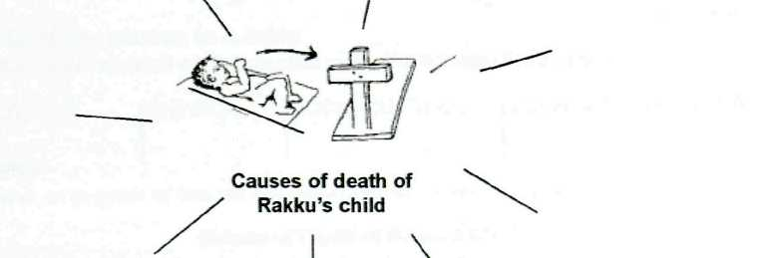

Map of causation:
This is similar to a mind-map in which you show how one condition or cause leads to another.

_____
_____
_____

FEEDBACK

1. From previewing the text, you probably could predict that Rakku's Story is a case study about a woman called Rakku, from India. The story describes how and why her child died.

2. The mind-map below shows some of the causes of Rakku’s child’s death.

3. From cause number 5 the mind-map separates into two chains, each of which explores further the underlying reasons for why Rakku had no money.

2. Poor nutrition

Diarrhoea & dehydration
5. No money to buy food
4. Lack of Food
3. Had to work
CAUSES OF RAKKU’S CHILD’S DEATH
Received low wages

Look at your map of causes. We can conclude that Rakku’s baby died as a result of many factors. The direct, immediate causes were biological, i.e. diarrhoea and malnutrition. However, indirect, basic economic, political, social and cultural factors contributed to the biological and physical conditions that led to the death of the baby. By analysing the causes of diseases like this we can identify the basic or root causes as ‘poverty’, ‘exploitation’, ‘discrimination’, etc. Therefore, in order to solve these problems we must also address the indirect, basic causes, and not just the direct causes. This is why promotive measures are so important, because they tackle the root causes of ill-health. At the same time, curative and preventive measures are required in order to deal with the immediate health and health care needs of people.

When explaining the causes of a communicable disease there is usually an agent and a host. For example HIV is a communicable disease which is caused by a virus (agent) and we know that every time an HI virus is passed, a person (host) becomes infected. However, this is not the case with non-communicable diseases. Risk factors are multi-factorial and there is no linear relationship between a risk factor and the condition, like there is in a communicable disease. For example, not every person who smokes gets lung cancer, however smoking predisposes a person to certain types of cancers and cardiovascular diseases.

Multi-factorial:
There are a number of factors that result in a condition or disease. There is no one factor that can be said to be the cause.

Predisposes:
To make something more probable or more likely to happen.
TASK 4 - Identify risk factors

Read the case study below and answer the following question.

1. What are the risk factors for diabetes that you can identify in this case study?

Case study 1
Mary had no family history of diabetes, heart disease, or other serious conditions; she never imagined she was at any risk. However, she overlooked the fact there are other risk factors apart from genetic factors that play a crucial role in the development of diabetes. At the age of 30, Mary was obese and led a sedentary lifestyle after moving to the city from the rural area. She enjoyed eating fatty meat and cool-drinks. Over a few months, she started experiencing an unusual thirst, dizziness, blurred vision, and an awkward feeling of numbness in her right foot. Friends advised her to seek medical help. She was scared, but nonetheless wanted to know what was wrong. The clinic diagnosed her with Type 2 diabetes.

FEEDBACK
1. The risk factors for diabetes include:
- Poor diet (e.g. fatty meat and cool drinks)
- Obesity (mainly because of poor diet)
- Sedentary lifestyle (Due to watching TV, lack or no physical activity).

6 LINKS BETWEEN UNDERNUTRITION AND INFECTION

The circle diagram below shows the link between diarrhoea (spelt 'diarrhoea' in British English and diarrhoea in American English) and undernutrition (malnutrition). The arrows indicate that one idea causes, leads to, or is linked in some way, to another idea.
Figure 3: Vicious cycle of malnutrition (Werner & Sanders, 1997: 62)
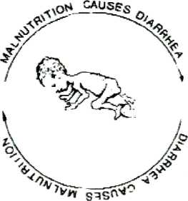
Malnutrition
Diarrhoea-infection
TASK 5 – Examine the link between infection and undernutrition
1. Study Figure 3 and explain the links between the ideas, using your own words.

FEEDBACK

1. In Figure 3 the arrow at the top points to 'diarrhoea' and states that malnutrition causes diarrhoea'. The second arrow points to 'malnutrition' and states that 'diarrhoea causes malnutrition'. At first glance, this diagram does not seem to make sense. How can diarrhoea and malnutrition be the cause and the result of each other? Does diarrhoea cause malnutrition or does malnutrition cause diarrhoea? This question has been hotly debated. To find out more, read the information below.

More about undernutrition (malnutrition) and infection

Recent research has shed more light on the link between undernutrition and infections such as diarrhoea. It has shown that undernutrition predisposes or makes a child more likely to catch infections such as diarrhoea, more often than a well-nourished child. Also, the infection is likely to be more serious in a malnourished child and to last longer. The disease can also become more serious and lead to diseases such as marasmus and kwashiorkor, which are types of severe undernutrition. So the arrows in the Figure 3 indicate that there is a constant interaction between undernutrition and infection.

The diagram below further explains the interaction between malnutrition and infection. It is important for us to know that the causes of malnutrition are complex and inter-linked. In this diagram we see that there are a range of factors, apart from medical ones, that impact on a person’s health, such as poverty, socioeconomic class, and non-functioning systems. And further, that ill-health leads to a range of factors which predispose the person to infection. Here, malnutrition leads to impaired child development, compromised immunity, infection and disease, and energy loss. These conditions lead the person into further vulnerability, for example, disease and loss of energy means a person cannot work and therefore has reduced productivity, which pushes the person into further poverty, and so on. This cycle continues until some chain in the link is broken so that a different outcome or result occurs.

A further reading titled Malnutrition and infection: Complex mechanisms and global impacts, helps to explain this phenomenon in more detail.
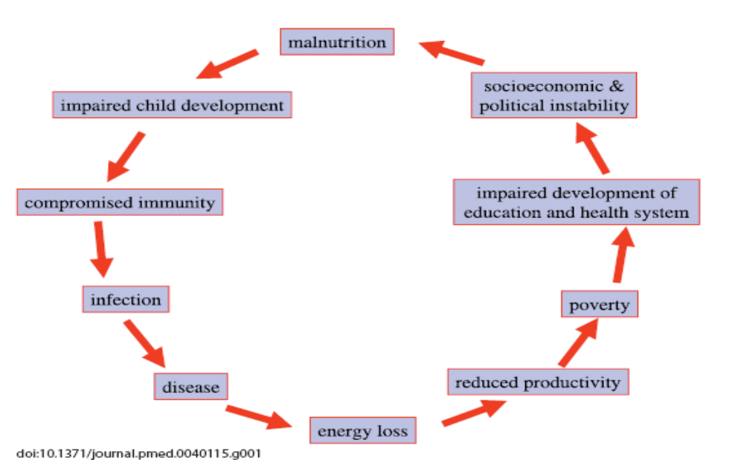
Figure 4: How malnutrition results and causes infection
(Source: Schaible & Kaufmann, 2007)

TASK 6 – Draw your own circular diagram to show causes and results

1. As a final task for this session, think of a common communicable disease in your own country. Draw a circular diagram to show the cycle of ill-health and the underlying causes and results. Think about all the interlinked factors such as class, race, gender, political conditions, environmental conditions, health care systems, and so on.

FEEDBACK

1. Each circular diagram will be different, but make sure you included the interlinked factors and showed the circular nature of cause and result.

7 SESSION SUMMARY

In this study session you focused on the pattern and main causes of disease and death in underdeveloped and developing countries. You used two case studies – one about the death of a young child in India and the other about diabetes – to analyse and classify the causes of disease. You further looked at how malnutrition and infection are linked and related.
Unit 1 – Study Session 4
Situational analysis

Introduction

In the previous three study sessions we looked at the burden of disease, and at the pattern and distribution of ill-health in various countries of the world. How can we find data about the burden, pattern and distribution of ill-health in a smaller, local setting so that we can use this data to help communities prioritise health problems and plan to implement projects that focus on these health problems? One way is to undertake a situational analysis.

Session contents
1 Learning outcomes of this session
2 Readings and references
3 What is a situational analysis?
4 What is the purpose of a situational analysis?
5 What type of data is needed for a situational analysis?
6 The challenges of different types of data collection methods
7 How do we prioritise health problems or diseases?
8 How to identify appropriate interventions?
9 Session summary

Timing of this session
There are no extra readings in this session, but there are six tasks. It is likely to take you up to three hours to complete.

1 LEARNING OUTCOMES OF THIS SESSION

By the end of this session, you should be able to:

Public Health Outcomes:  - Define a situational analysis.  - Understand the purpose of conducting a situational analysis.  - Identify the type of information sources for a situational analysis.  - Describe and discuss the different methods of data collection.  - Explain how to prioritise health problems/conditions.  - Explain how to select interventions for priority health problems/conditions.  - List the steps involved in conducting a situational analysis. | Academic outcomes:  - Interpret and use flowcharts to describe cyclical processes  - Make comparisons  - Summarise data

2 READINGS AND REFERENCES

There are no extra readings for this session.

References:
McCoy. D. & Bamford. L. How to Conduct a Rapid Situation Analysis. Health Systems Trust. 1998.
National Science Foundation, University of Hawaii. User-Friendly Handbook for Project Evaluation. Available: http://www.nsf.gov/pubs/1997/nsf97153/chap_3.htm.

3 WHAT IS A SITUATIONAL ANALYSIS?

In its broadest sense, a situational analysis is a process that is used to analyse and assess a situation in a defined setting, within its wider context. For example, you can analyse and assess the situation in your own community, within the wider context of your district or country.
A situational analysis is a systematic way of doing the following:

- Gathering information
- Identifying the main problems and needs within a community, population or district
- Identifying the main resources within that community that can be used to address the problem.

The information gathered during this process is used to isolate priority health problems/conditions in a particular community so as to facilitate the process of planning and implementing an intervention to address the problem/condition in a systematic, strategic and integrated way. The way the information is gathered provides an opportunity to establish partnerships among health workers, community members and other relevant groups and organizations.

Before we proceed, it is important to clarify the terms, ‘situational analysis’ and ‘needs assessment’, as they are often used interchangeably. A situational analysis is actually broader in scope than a needs assessment, in that it does not only focus on needs, but also on the wider context, including resources and capabilities that exist, as well as problems and needs. A needs assessment only focuses on problems and needs.

In a community setting, a situational analysis assists community members learn more about their current situation, their problems and needs, what assets and resources already exist to meet the needs and which are lacking. It helps community members prioritise issues, set objectives or goals, discuss various solutions and strategies for problem-solving, set tasks, implement action, and monitor and evaluate progress towards achieving objectives.

This process can be represented in a planning cycle as in Figure 1.

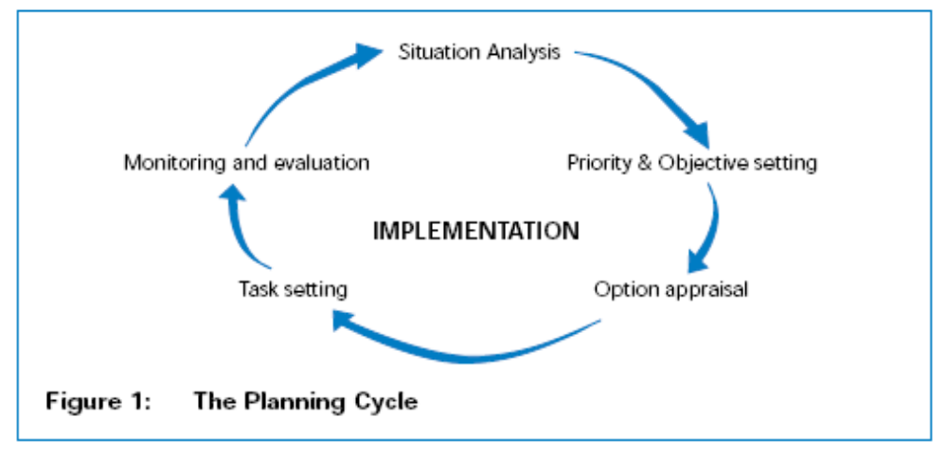
(Source: McCoy and Bamford, 1998)
4 WHAT IS THE PURPOSE OF A SITUATIONAL ANALYSIS?

A situational analysis is a tool that allows communities and programme planners to make informed decisions about the most appropriate interventions for addressing an identified problem or need. The analysis helps members prioritise community issues and problems, review strategies that can be used in a particular setting, identify resources available for solving problems, and identify obstacles that may hinder the process.

TASK 1 - Identify types of data

As a health worker who is tasked with conducting a situational analysis, you are required to gather data about a particular community.

1. List the type of data or information you need to collect in order to get a greater understanding of the community.
2. List the different types of data sources available in a community (where or from whom you would gather this data).

FEEDBACK

1. You will need the following information (you might have listed other types as well):
- Demographic information (e.g. characteristics of a community, size of the community, statistics regarding disease, births and deaths, etc.)
- Socio-economic profile of different groups in the community
- Geographical data about the community (e.g. a map of the community and where it is in relation to the nearest town or city)
- The types of services available
- the culture, norms, beliefs and attitudes in the community
- the community structures and committees that already exist, e.g. the health committees
- who the leaders are
- what decision-making processes are used in the community
- what the different sub-groups are in the community
- who are the most marginalised groups
- what power relationships exist between various subgroups in the community
- what resources and assets there are

2. When embarking on a situational analysis, it is important to first look at existing data. If the available data is insufficient, then you should look at other sources of information inside and outside the community. For example, community members, leaders, policy makers, service organisations in the community, institutions such as archives and libraries, and documents such as research reports, are all sources of data. You can use interviews, focus groups and participatory methods with the relevant people to gather the required information.
5 WHAT IS THE TYPE OF DATA IS NEEDED FOR A
SITUATIONAL ANALYSIS?

In order to conduct a situational analysis, you need to collect data regarding the setting. There are two main types of information you can collect - qualitative and quantitative information.

- Qualitative information: This is based on people’s perceptions, opinions and experiences. This type of information explains ‘why’ certain things in the community happen the way they do. Such information is important because it helps to explain practices and beliefs which may have an impact on the health of the community. For example, mothers of children under 5 years old may delay taking their babies to the clinic when they present with diarrhoea, as it may be a perception that diarrhoea is caused by bad spirits and therefore a spiritual healer should first be consulted. However, such delays could result in a child becoming dehydrated and eventually dying. Such a perception could begin to explain why the Under 5 Mortality Rate in this community is high.

- Quantitative information: This is obtained from surveys and censuses. It is based on numbers and usually answers the questions, ‘what’ (e.g. infant mortality rate) and ‘how’ (e.g. causes of deaths). Information such as unemployment and literacy rates is obtained through quantitative methods.
There are also a number of qualitative and quantitative methods that are used to collect the data, as shown in Table 1.

Table 1: Data collection methods
QUANTITATIVE |  | QUALITATIVE
1  2 | Interviews – questionnaires  Statistics | 1  2  3  4 | In-depth interviews  Focus group discussions  Observations  Participatory rapid action techniques, such as:  - Mapping  - Venn diagram  - Problem tree
6 THE CHALLENGES OF DIFFERENT TYPES OF DATA
COLLECTION METHODS

Both qualitative and quantitative data collection methods have their advantages and disadvantages. Before deciding on the type of methods that would be most appropriate to use, it is important to first weigh up the advantages and disadvantages of each method.

Quantitative data collection methods

Interviews
Interviews are usually administered using a structured questionnaire, which might contain both closed- and open-ended questions. Closed-ended questions limit the interviewees’ responses (e.g. a ‘yes’ or ‘no’ answer is given); while open-ended questions allow interviewees to express their own opinions in their own words (see the examples below). A questionnaire could be self-administered or administered through the use of an interviewer. Quantitative interviews can be conducted telephonically, face-to-face or by email.

Interviews can be intimidating or even threatening to some respondents because of the power dynamics between the interviewer and interviewee. Respondents may think that the interviewer wants to hear certain information and therefore responds by giving the interviewer what he or she wants to hear, rather than by giving a true reflection of what is happening. Often language is an obstacle and may result in incorrect information being collected or meaning being misunderstood. Despite these disadvantages, interviews are useful especially when you need to collect first-hand information. They also allow the interviewer to collect information in a short period of time.

Example of closed-ended and open-ended questions

An example of an open-ended question would be:
“How were you treated by the nurses at the clinic?”

A closed-ended question would be phrased as follows:
“When you visited the clinic were you ill-treated?” Yes or No

Qualitative data collection methods

In-depth interviews
These are a number of different types of interviews which allow the interviewee to openly express their views regarding the subject matter. The main purpose of in-depth interviews is to elicit rich data. The interviewee’s perceptions are captured in their own words and this allows the interviewer to obtain more in-depth and comprehensive information. One of characteristics that distinguish in-depth qualitative interviews from quantitative interviews is that the interviewer uses extensive probing and open-ended questions. Interview guides instead of questionnaires are used, and these assist in directing the conversation. Such guides are useful in making interviews comprehensive and systematic.

TASK 2 - Identify when to use of in-depth interviews

1. Brainstorm different situations when in-depth interviews should be used to collect information in a community.

FEEDBACK
In-depth interviews can be used when:
- the subject or topic is highly sensitive
- detailed information is required
- the subject is complex.

In-depth interviews allow the interviewer to clarify questions, thus eliminating any ambiguity. Topics are explored in depth, yielding detailed, qualitative or rich data and providing new insights into a particular subject. Regardless of such advantages this technique is expensive and time-consuming and interviewers need to be highly skilled. The data provided may be extensive, thus making it difficult to transcribe and condense.

Focus group discussions
A focus group is another type of interview, however it is conducted in a group and the interviewer acts as a facilitator who guides the discussion. The great benefit of the focus group is the information that spontaneously arises through the group interaction and group dynamics. Interaction between group members is used to elicit opinions and perception that are usually unlikely to arise without the group interactions. Eight to ten people usually form a group, and they should share some characteristic relevant to the study, e.g. they all come from the same community or have suffered a similar condition. The group discussion needs to be structured and focused so that the researcher can obtain the necessary information from the group.

TASK 3 - Identify when to use focus groups

1. Brainstorm different situations when focus groups should be used

FEEDBACK
Focus groups can be used to:
- Identify and define problems during programme implementation
- Identify programme strengths, weaknesses and recommendations
- Clarify and interpret quantitative findings
- Obtain perceptions of the programme outcomes and impacts
- Generate ideas or look at options.
Below are some other factors to consider when conducting in-depth interviews and focus groups. These are taken from the User-Friendly Handbook for Project Evaluation (http://www.nsf.gov/pubs/1997/nsf97153/chap_3.htm).

Factors to consider in determining the setting for interviews (both individual and group) and focus groups:

- Select a setting that provides privacy for participants.
- Select a location where there are no distractions and it is easy to hear respondents speak.
- Select a comfortable location.
- Select a non-threatening environment.
- Select a location that is easily accessible for respondents.
- Select a facility equipped for audio or video recording.
- Stop telephone or visitor interruptions to respondents interviewed in their office or homes.
- Provide seating arrangements that encourage involvement and interaction.

(Source: http://www.nsf.gov/pubs/1997/nsf97153/chap_3.htm)

Observation
This technique is especially useful during the evaluation phase of a programme/project. Observation allows you to gather first-hand data on programmes, processes or behaviours. It allows you to develop a holistic perspective and gain an understanding of the context within which the programme operates. Through observation you can see such things as, the effects of interventions (or the consequences of the lack of interventions) or the impact of various problems and solutions in the actual setting. Observations allow you to learn about issues that people may be unwilling or unable to discuss in a focus group or interview.

However, although observation is a useful technique, it too has disadvantages, namely:
- It is expensive and time-consuming
- Those observed may alter their behaviour during the observation
- There is little or no control over the situation
- The behaviour observed may be atypical.

Participatory rapid action techniques
These are methods that require the participation of communities or beneficiaries of programmes in which the situational analysis is conducted. Community involvement is crucial for these techniques to be successful. Examples of participatory methods are:
- Community mapping
- Seasonal calendar.

Community mapping involves the community members in gathering information about their own community. Community maps can be used to identify a number of things, such as different perspectives about the community, as well as resources and services that exist in the community. Mapping requires few resources and is not time-consuming. It can be adapted for different groups of people of different literacy and educational levels.

A seasonal calendar shows changes in seasonal labour supply and demand, household income patterns, food availability, and demands on public resources, such as schools and recreational facilities. The results can be used to determine appropriate times of the year to begin certain projects and to consider how these projects will affect different groups.

The techniques described above are only some of the techniques used in a situational analysis, there are others that have not been included in this session.

7 HOW TO PRIORITISE HEALTH PROBLEMS OR DISEASES TO
BE ADDRESSED

After you have collected and analysed the data, the findings may reveal a number of health problems that need to be addressed in the defined community. These problems may have been identified by community members, obtained from previous research studies conducted in the community, or may be a defined area of interest that you are studying. Numerous health problems or diseases will need to be addressed in any community, and so it is important to prioritise which problems are most important or appropriate to tackle, given the limited resources available to the community.

TASK 4 - Prioritise health problems

You have identified the following health problems in a community:
- HIV/AIDS
- Diarrhoeal diseases
- Acne
- Childhood osteosarcoma
- Stuttering

1. You have implemented interventions to help address HIV/AIDS in the community, and now have been asked to select another disease or condition from the above list that needs to be addressed. How would you go about choosing a disease/condition to address? Which condition would you choose and why?

FEEDBACK

When we prioritise health problems, we need to address two main questions:

- How common is the problem in the community?
- How serious is the impact (in terms of morbidity or mortality)?

Below is a matrix which helps to prioritise problems. It helps you to categorise the various issues you have identified into the following groups: serious/not serious; common/uncommon.

For example, in the matrix below, diarrhoeal disease in children is common and serious, while acne is common but not serious.

 | Serious | Not serious
Common | Diarrhoeal disease in children | Acne
Uncommon | Childhood osteosarcoma  (a form of cancer) | Stuttering

There are various methods which help to select priority health problems. Whichever method is chosen, there are two important factors:

1 The process of selection needs to be systematic and structured; and

2 Community members need to be involved in the process.

Steps for identifying health priorities

These steps will help you, the community and other stakeholders narrow down the list of health problems/conditions to be addressed. Each step helps you to eventually produce a shortlist of problems/conditions to work on.

1 Review the list of identified health problems and do the following:
a) Remove the conditions where evidence of impact is unknown
b) Remove the conditions and health determinants that are unimportant in size and severity.

2 Assess the severity of the remaining health conditions/problems. Ask the following questions to guide this process:

a) Does the health condition/problem affect the most important aspects of health?
b) Does the health condition/problem affect other issues of health?
c) Does the health condition/problem affect long-term health?
e) Does the health condition/problem result in death?

Remove health conditions/problems which do not affect the most important aspects of health functioning, do not affect issues or health, do not affect long-term health, and do not result in death. You should be left with the most severe health conditions/problems.

3 Analyse the incidence and prevalence of the health condition/problem. If you cannot find data for your population, then you may need to extrapolate data from other sources with similar populations. Use a table like the one below to record impact and size of the health condition/problem in the community.

Incidence - The frequency with which something occurs.
Prevalence - Something that occurs widely.

Choosing health priorities according to size
Data Item | Data known?  Yes/No | What does the data say? | Implications? So what? | Most important in size? Yes / No

4 Identify whose health is affected and most likely to be at risk from the negative impact of these health conditions/problems. Those identified as being most at risk will then form the population target group/groups or be the recipients of any intervention undertaken.

5 From the list of health conditions/problems that have the highest impact and severity, identify those conditions/problems that can be most effectively improved by the stakeholders. You can use the tool below to assist the stakeholders identify these conditions/problems.

Health condition/problem | Impact
 | Severity (-ve /+ve) |  |  | Size important
 | High | Medium | Low | Yes/No

6 Once the above table has been completed, the findings of this process should then be presented to the community and to stakeholders for assessment. It is important to ensure that you have interpreted the results correctly and that the results are understood by all participants. When agreeing on your shortlist, it is important to aim for a consensus between expert opinion, data, and community perceptions.

TASK 5 - Identify selection criteria

1. Five health conditions/problems have been identified and now you need to decide on which ones should be chosen for intervention. What criteria would you use to select a health condition/problem for intervention?

FEEDBACK

1. Criteria you could have mentioned are:
- Acceptability: What are the most acceptable changes required for maximum positive impact?
- Resource feasibility: Are the resource implications of these changes feasible?

8 HOW TO IDENTIFY APPROPRIATE ACTION OR
INTERVENTIONS

Once you have compiled the list of priority health conditions/problems to be addressed, you will need to identify the actions or interventions that can be taken to address these problems. The table below illustrates an example of actions to address childhood undernutrition.

Table 2: Example of actions for childhood undernutrition

Health priority | Action | Action | Action
Decrease the rate of childhood (under 5 years) malnutrition | Raise awareness through targeted health education | Provide nutrition information to mothers and care givers | provide mothers of severely malnourished with food

For each action listed, it is important to do the following:

- Identify organisations in the community that are currently engaged in similar actions, as you do not want to ‘reinvent the wheel’. Ask questions like, what do they do, how do they do it, how effective are they, and so on. It is often better to strengthen their efforts rather than embark on something new.
- Determine the number of recipients that will benefit from the proposed actions to ensure that the maximum number can be reached and that the actions will reach those who are in most need.
- It is crucial to assess whether or not the proposed intervention/s are acceptable to the recipients, the wider target population and community, the potential implementers, and the organisations responsible for managing them. If the interventions are not acceptable, all efforts will be a complete waste of scarce resources.
- It is also important to know how many resources the proposed intervention/s will need. Resource issues are important to clarify as these can greatly hinder progress.

You can clarify these issues by:

- Listing the resources needed for the intervention, e.g. funding, staffing, supplies, and so on
- Assessing whether available resources can be utilised as is, or used differently to support the intervention
- Determining existing resources that are used elsewhere in the programme or that are non-functioning
- Identifying those interventions that will achieve the greatest impact with minimal/available resources.

Once you have prioritised a particular priority health condition/problem and have selected the appropriate intervention, you will then need to implement that intervention.

Implementing the intervention

Implementation an intervention involves:
- Setting aims and objective for the programme or project
- Planning how these objectives will be achieved given the available resources
- Putting the intervention into practice
- Continually monitoring its effectiveness.

There are a series of activities that need to be included in this phase, namely:
- Delegation of tasks to team members and community members
- Preparation of time schedules
- Training of implementers and evaluators.

During implementation it is important to ensure that the target group benefits and that the activities that are undertaken in the programme or project are in synergy with the set objectives.

Monitoring and evaluation

Monitoring and evaluation is useful for ensuring that the objectives are adhered to, that that there is progress, and that the impact of the intervention can be measured. This will be dealt with in the Module called Measuring Health and Disease 1.

Task 6 - Record the steps involved in conducting a situational analysis

1. Complete the table below about the steps involved in doing a situational analysis.

Steps involved in conducting a situational analysis | Details of what needs to be done | Who is involved?
1. Data collection
Types of data

2. Methods of collection and challenges
Qualitative

3. Prioritising health problems/conditions
Steps involved in the process
Selection criteria to select priority issue

4. Identifying appropriate interventions

5. Implementation

6. Monitoring and evaluation

This task will help you with your assignment.

9 SESSION SUMMARY

In this study session you have learnt about the importance of a situational analysis and how to get communities involved in this process. You’ve have also identified the different types of data collection methods that are used when conducting a situational analysis, the steps involved, and how to prioritise health problems.

