Antimicrobial Resistance (AMR)-
Session
5
Implementation of a Policy
Framework

Overview

Antimicrobial resistance (AMR) threatens the long-term security of public health and has the ability to negatively affect our society. Antimicrobial resistance has to be prioritized at local and international levels due to its serious and growing security risk to global health. Studies indicate a gradual increase in the number of microorganisms that are becoming resistant to currently available antimicrobial agents. Not only does it have an effect on mortality rates, but also treatment costs and spread of diseases.

In September 2017, the WHO released a report stating that the world is running out of antibiotics. It is estimated that out of the 51 new antibiotics and biologicals in clinical development to treat antibiotic-resistant pathogens, only 8 are innovative treatments that will add value to the current antibiotic treatments available. Antibiotic resistance is very prevalent in South Africa, as South Africa is one of the countries with the highest burden of tuberculosis. Mycobacterium tuberculosis, and Clostridium difficile, both with increasing antibiotic resistance patterns in South Africa, are priority pathogens for which new antibacterial agents are needed.

Session Content

Part A of the session will commence with an overview of antimicrobial resistance and introduce you to international and national policies aimed at combating AMR. The participants’ perspectives on AMR and relevance to their work environment will be discussed. Part B will focus predominantly on the implementation of a local policy on antimicrobial resistance and stewardship.

Learning Outcomes

By the end of the session you should:

- Understand the impact of antimicrobial resistance on global health.
- Be familiar with international, national and local policies on antimicrobial resistance and stewardship.
- Recognise challenges associated with policy implementation; and identify opportunities to mitigate these challenges.
- Devise a strategy to implement an antimicrobial stewardship policy.

Timing
This session is in two parts, A and B, and there are several links to videos, websites and other resources included. For Part A one core reading is listed below. The readings for Part B are listed at the start of that section. There are two PPT presentations to further enhance your learning. The session includes one activity in each part. Activity 2 will be sent to you as a separate attachment later. The entire session should take you approximately 8 hours to complete.

Readings for Part A

You will be referred to the following reading in the first part of the session:

WHO (2015) Global Action Plan on Antimicrobial Resistance. Geneva: WHO
https://apps.who.int/iris/bitstream/handle/10665/193736/9789241509763_eng.pdf?sequence=1

This session was written by:
Mrs Yasmina Johnson (B.Pharm, MPH), Pharmacy Services, Western Cape Government and
Dr Renier Coetzee (B.Pharm, M.Pharm, Pharm.D), School of Pharmacy, University of the Western Cape.

PART A: ANTIMICROBIAL RESISTANCE

- History of antibiotics

Antibiotics have been used for centuries to treat infections, although until the last century people did not know that infections were caused by bacteria. Various moulds and plant extracts were used to treat infections by some of the earliest civilizations.

Upon returning from a holiday in 1928, the Scottish scientist Alexander Fleming noticed that a fungus, Penicillium notatum, had contaminated a culture plate of Staphylococcus bacteria he had accidentally left uncovered. The fungus had created bacteria-free zones wherever it grew on the plate. Fleming isolated and grew the mould in pure culture. He found that P.notatum proved extremely effective even at very low concentrations, preventing Staphylococcus growth. After early trials in treating human wounds, collaborations with British pharmaceutical companies ensured that the mass production of penicillin was possible.

In 1945 Alexander Fleming was awarded the Nobel Prize for discovering penicillin. However, in his acceptance speech he predicted how dangerous a world with antibiotics could be. In an interview, Fleming said:

"The thoughtless person playing with penicillin treatment is morally responsible for the death of the man who succumbs to infection with the penicillin-resistant organism."

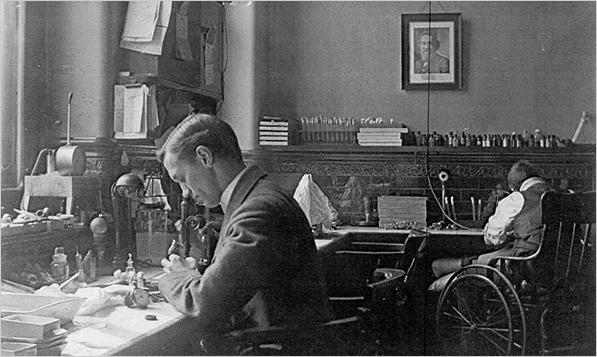
Photograph of Alexander Fleming around 1909. He discovered penicillin in 1928. (Fleming Laboratory Museum)

- Global Antimicrobial Resistance

Studies in antimicrobial resistance indicate a gradual increase in the number of microorganisms that are becoming resistant to currently available antimicrobial agents. Antimicrobial resistance has an adverse effect on mortality rates, treatment costs, spread of disease and leads to a longer duration of illness.

Consequences of antimicrobial resistance:

1. Increased morbidity & mortality
- “Best-guess” therapy may fail with the patient’s condition deteriorating before susceptibility results are available
- No antibiotics left to treat certain infections

2. Greater health care costs
- More investigations
- More expensive, toxic antimicrobials required
- Expensive barrier nursing, isolation, procedures, etc.

3. Therapy priced out of the reach of some third-world countries

A bleak 2014 report by economist Jim O’Neill, commissioned by the British government, estimated that in 2016 more than 700 000 deaths globally could be attributed to AMR and that the annual toll would climb to 10 million deaths in the next 35 years. The report projects US$ 100 trillion in losses by 2050 if nothing is done to reverse the trend.

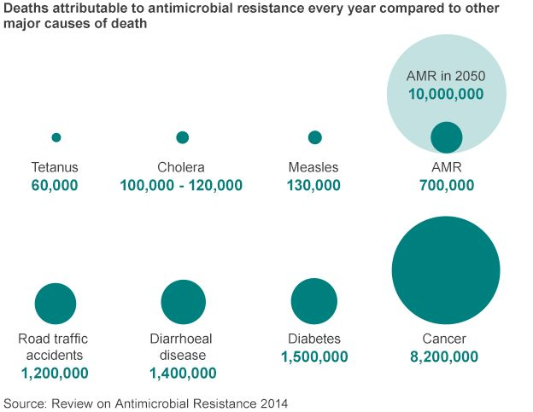

Most of the future burden of disease will be in Africa and Asia, and countries with weak and poorly-resourced health systems will have the greatest problems in managing drug resistance. In Africa alone, more than 4 million people could die by the year 2050 due to AMR.

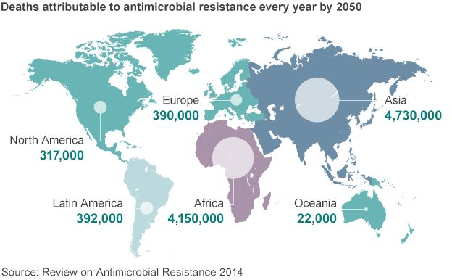

Video resource

Watch this video with a message from WHO Director-General Dr Tedros Adhanom Ghebreyesus on a Global Action Plan on Antimicrobial Resistance:

https://www.who.int/news-room/detail/18-07-2018-countries-step-up-to-tackle-antimicrobial-resistance

In this message the WHO Director General gives an update on the progress countries are making in tackling AMR. The report looks at surveillance, education, monitoring and regulating consumption and use of antimicrobials, as recommended in the Global Action Plan on Antimicrobial Resistance published in 2015. This is a good opportunity to familiarize yourself with the Global Action Plan on Antimicrobial Resistance.

- Antimicrobial Resistance

Antimicrobial resistance occurs when microorganisms such as bacteria, viruses, fungi and parasites change in ways that render the medications used to cure the infections they cause ineffective. When the microorganisms become resistant to most antimicrobials they are often referred to as “superbugs”. This is a major concern because a resistant infection may kill, can spread to others, and imposes huge costs to individuals and society.

Antimicrobial resistance is the broader term for resistance in different types of microorganisms and encompasses resistance to antibacterial, antiviral, antiparasitic and antifungal drugs.

Antimicrobial resistance occurs naturally but is facilitated by the inappropriate use of medicines, for example using antibiotics for viral infections such as cold or flu, or sharing antibiotics. Low-quality medicines, wrong prescriptions and poor infection prevention and control also encourage the development and spread of drug resistance. Lack of government commitment to address these issues, poor surveillance and a diminishing arsenal of tools to diagnose, treat and prevent also hinder the control of antimicrobial drug resistance.

Video Resource

In this video, you will find a clear explanation of resistance.

https://www.youtube.com/watch?v=VYAAM4HblCo

Below are two posters of the type displayed in health facilities – one on causes of antibiotic resistance and one on how it spreads.
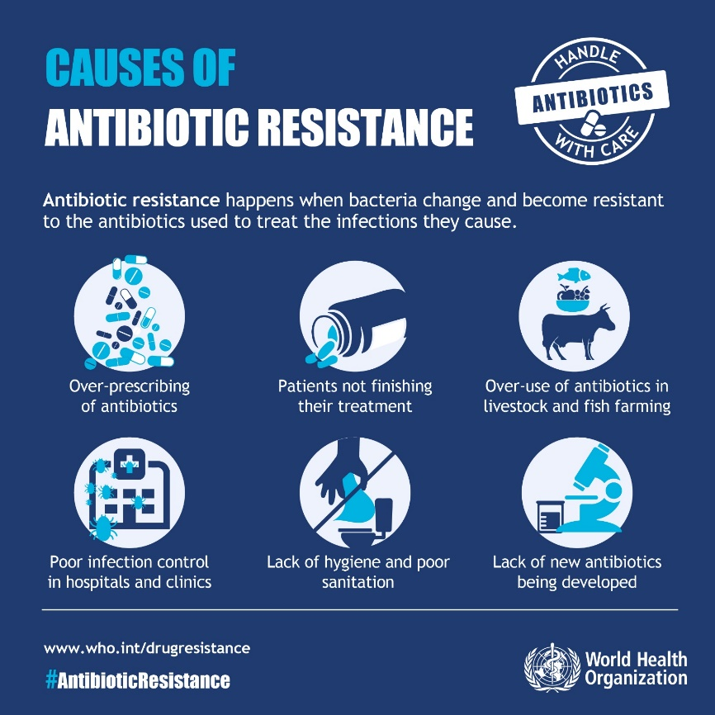

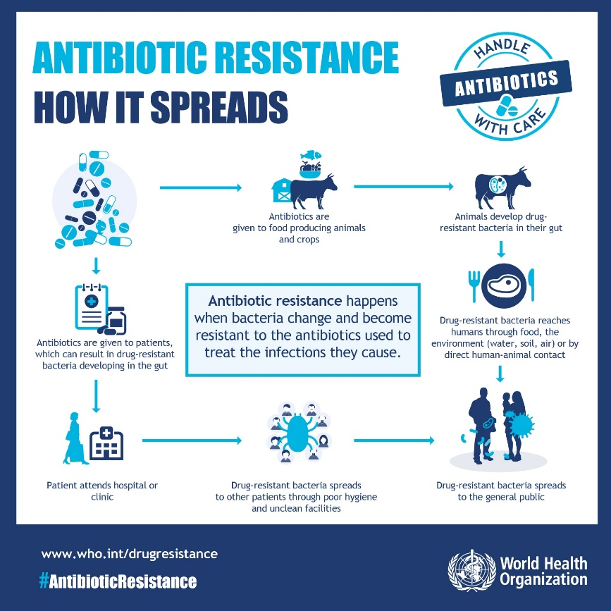

Activity 1

Briefly explain your understanding of antimicrobial resistance and how it can directly affect you. Are you aware of activities in your work environment to curb antimicrobial resistance? Explain.

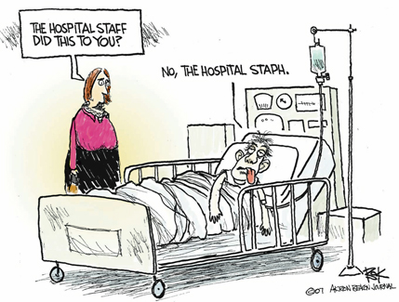

- Surveillance of Antimicrobial Use

The purpose of surveillance of antimicrobial use is to track how antimicrobials are used by patients and healthcare providers. Monitoring antimicrobial prescription and consumption behaviour provides insights and tools needed to inform therapy decisions, to assess the public health consequences of antimicrobial misuse, and to evaluate the impact resistance containment interventions.

Tracking consumption statistics quantifies the selection pressure on microbial populations and permits benchmarking comparisons at country or healthcare facility level and evaluation of the impact of educational or regulatory interventions. A common way to express consumption totals is through the use of “Defined-Daily Doses”, maintained by the WHO Collaborating Centre for Drug Statistics Methodology in Oslo.

For insights into how antimicrobials are used, indicator studies and focused surveys of patients, prescribers, and dispensers are used to explore the factors which drive antimicrobial use decisions. Examples and various tools to monitor consumption can be found here:

Reading

WHO Surveillance tools
https://www.who.int/antimicrobial-resistance/global-action-plan/optimise-use/surveillance/en/

The WHO methodology for a global programme on surveillance of antimicrobial consumption provides a common technical basis for setting up a surveillance system on antimicrobial consumption and allows for standardized data collection at the national level.

AMR Surveillance in the African Region
For the African Region, the patterns of antibiotic consumption were similar for Burkina Faso and Côte d’Ivoire, where penicillins (J01C) accounted for nearly 40% of all consumption, followed by sulfonamides and trimethoprim (J01E) (24% in Burkina Faso and 31% in Côte d’Ivoire). In the United Republic of Tanzania, penicillins (J01C) accounted for 27% of total consumption followed by tetracyclines (J01A) (18%) and quinolones (J01M) (14%).

The figure below shows the consumption of antibiotics (DDD per 1000 inhabitants per day) by pharmacological subgroup in four countries of the African Region (2015). This is taken from the WHO report on surveillance of antibiotic consumption: 2016-2018 early implementation.

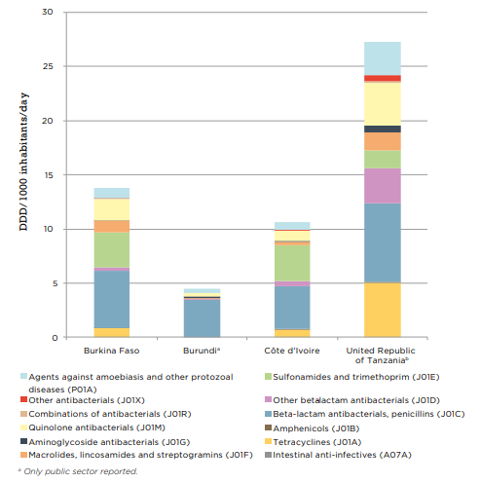

For a complete review of the WHO report on surveillance of antibiotic consumption see the following link.

Reading

WHO surveillance on consumption report
https://www.who.int/medicines/areas/rational_use/who-amr-amc-report-20181109.pdf

South Africa
In South Africa, import data for antimicrobials between 2014 and 2015 estimates procurement for animal health at 23-36% and for human use at 74-77%. Humans consume the majority of penicillins and streptomycins.

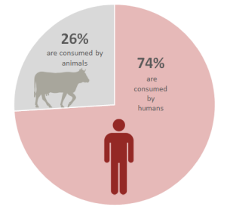

South Africa’s antimicrobial use is 21 149 standard units 17 per 1000/population, significantly higher than most other countries in the world, however similar to that of other BRICS countries where access to antibiotics has increased through improvements to primary health care facilities and health systems strengthening.

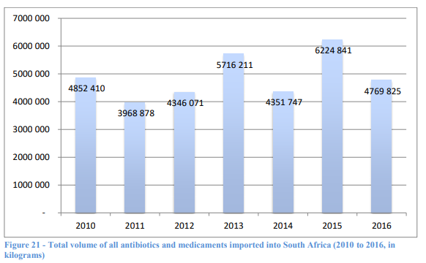
Estimated Antibiotic Consumption in South Africa – total volume of all antibiotics imported (2010 to 2016, in kg)

Reading

SA Surveillance report on consumption
http://www.health.gov.za/index.php/antimicrobial-resistance?download=3374:surveillance-for-antimicrobial-resistance-and-consumption-of-antibiotics-in-south-africa

Resistance to antibiotics would not be of concern if new ones were coming down the pipeline. However, only a handful of the new chemical entities registered by the regulatory bodies in recent years have been antibiotics, and these have all been what the industry calls ‘me-too’ drugs: existing compounds modified with small tweaks that might, for example, reduce side effects or improve their performance against resistant strains. In general these have been few and far between, but recent decades have seen none at all.

The figure below shows how resistance to commonly available treatment options is increasing.

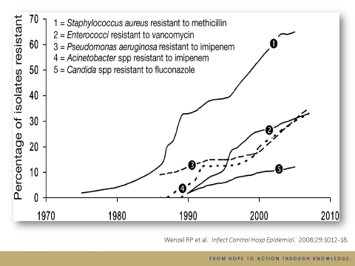

For some years, pharmaceutical companies have been withdrawing from the antibiotic market in search of the larger profits found in drugs for chronic diseases. The statement below shows the intentions of some major companies.
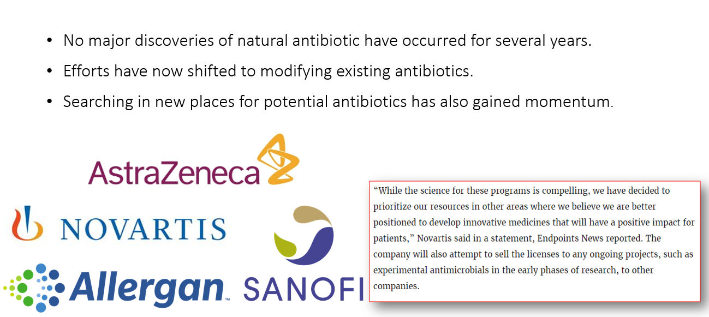

To read more about this situation of global concern, follow the link below.

Reading

https://www.chemistryworld.com/news/novartis-exit-from-antibiotics-a-setback-for-race-against-resistance/3009316.article

- Global Efforts to Contain Antimicrobial Resistance

Antimicrobial resistance can be attributed to socio-economic factors, and to a lesser extent, a lack of knowledge regarding the use of antimicrobials by patients, as well as irrational prescribing of antimicrobial agents by healthcare practitioners. In 2001 the World Health Organization (WHO) developed the WHO Global Strategy for Containment of Antimicrobial Resistance and in 2015 the WHO Global Action Plan on Antimicrobial Resistance was launched. Various proposals and initiatives have been suggested and implemented to combat antimicrobial resistance, yet the progress made has been very slow. A finding supporting the statement was the release of the first list of 12 families of bacteria that are antibiotic resistant and for which new antibiotics are urgently needed, in 2017.The prevalence of antimicrobial resistance led to awareness of the health threat but most of the attention was given to antibiotic resistance.

In September 2017, the WHO released a report stating that the world is running out of antibiotics. The WHO reported that out of the 51 new antibiotics and biologicals in clinical development to treat antibiotic-resistant pathogens, only 8 are innovative treatments that will add value to the current antibiotic treatment.

- Antimicrobial Policies in South Africa

Antibiotic resistance is very prevalent to South Africa, as South Africa is one of the countries with the highest burdens of tuberculosis. Mycobacterium tuberculosis, and Clostridium difficile, both with increasing antibiotic resistance patterns in South Africa, are priority pathogens for which new antibacterial agents are needed.

All levels of society have to be involved to reduce the impact and limit the spread of resistance. South African health professionals and policy makers are actively participating to prevent and control the spread of resistance. In 2014 a summit was held to discuss the action plan for curbing antimicrobial resistance in South Africa. Various governmental, civil societies and regulatory bodies signed to a collective approach for South Africa. The Journey towards South Africa’s AMS strategy can be seen below.

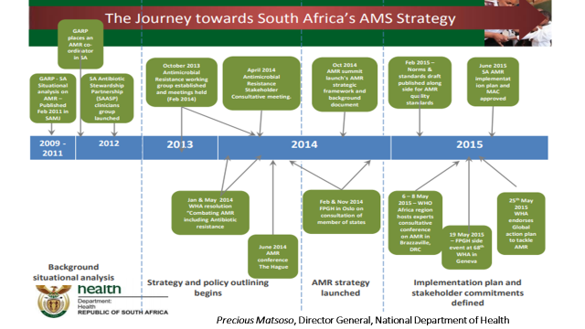

The South African Department of Health, under direction of the former Minister of Health, Dr Aaron Motsoaledi, developed the Antimicrobial Resistance National Strategy Framework 2014-2024. Read this document at the link below.

Reading

Antimicrobial Resistance National Strategy Framework 2014-2024
http://www.health.gov.za/index.php/2014-03-17-09-09-38/strategic-documents/category/223-st2014?download=925:a5-antimicrobial-resistance-national-strategy-framework-2014-2024

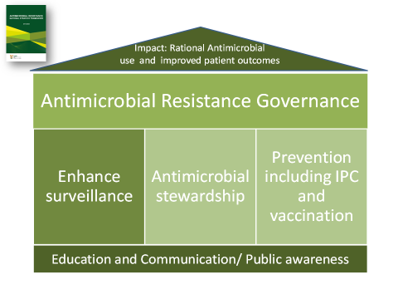
The Antimicrobial Resistance National Strategy Framework 2014-2024

Antimicrobial Resistance National Strategy Framework Commitments

Since the development of the Antimicrobial Resistance National Strategy Framework in 2014, South Africa finally developed the Guidelines on Implementation on 2017.
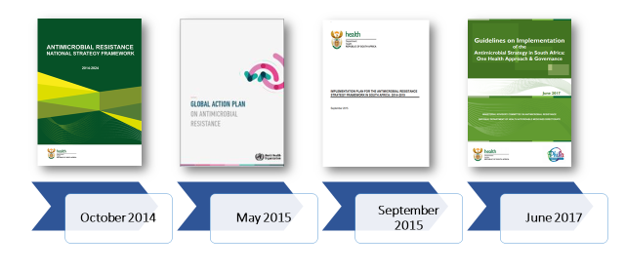
- Antimicrobial Stewardship

Health professionals are encouraged to participate in the Antibiotic Stewardship Programme and are recommended to follow institutional guidelines. Many health facilities make use of specific antibiotic prescription charts, especially tertiary health facilities. For an effective stewardship programme a One Health Approach is required.

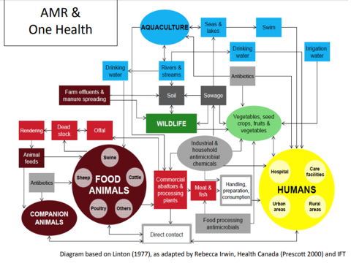
One Health Approach for Antimicrobial Stewardship

In order to work efficiently towards achieving the goals set out in the National Strategic Framework the former Minister of Health, Dr Motsoaledi, established the Ministerial Advisory Committee on Antimicrobial Resistance. This committee consists of various role players, e.g. academia, military and private hospitals.

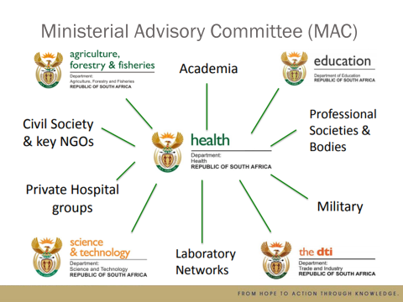
Ministerial Advisory Committee (MAC) on Antimicrobial Resistance

The role of the MAC is to:
- Enhance national surveillance and reporting in all sectors
- Guide selection of antimicrobials in the EML based on AMR
- Leadership & guidance to implement systems of stewardship
- Improve prevention strategies - IPC & vaccination programs
- Advise on core curricula for AMR, patient advocacy and awareness campaigns to reduce the inappropriate use

The South African Medical Research Council (SAMRC) in collaboration with other countries pledged to donate to the Global Antibiotic Research & Development Partnership (GARDP), to advance the development of new antibiotics. The South African agricultural sector is also actively involved in the fight against antimicrobial resistance. The South African Veterinary Council took the pledge to restrict the use of colistin in pigs, but expanded the program to all animals. Veterinarians use the Technical Guidelines for the Responsible and Prudent Use of Antimicrobials in Veterinary Medicine in South Africa when treating animals.

Research focus has been given to collaborative teams among nurses and pharmacist in South Africa but excludes patients. Limited or no data is available in South Africa regarding patients’ perspective on antibiotic use and knowledge on antibiotic resistance. As we are moving toward a post-antibiotic era, getting the patient’s perspective is important to preserve the effectiveness of antimicrobials and minimize the occurrence of antimicrobial resistance.

- What you can do?

Everyone can take some simple actions.
- Do not use antibiotics to treat viral infections, such as influenza, the common cold, a runny nose or a sore throat.
- Use antibiotics only when a doctor prescribes them.
- When you are prescribed antibiotics, take the full prescription even if you are feeling better. Ensure that members of your family do the same.
- Never share antibiotics with others or use leftover prescriptions.
- Antibiotic resistance can be prevented through immunization. It is important for both you and others that you follow the vaccination programmes.

Remember, each time you take an antibiotic when it is not necessary, the effectiveness of the antibiotic decreases and it might not work the next time you really need it.

Video Resource

Newborn baby Amala has a life-threatening infection called septicemia. Will her antibiotic treatment work? This video from the World Health Organization (WHO) explains what people can do to prevent the spread of antibiotic resistance.

http://origin.who.int/medicines/access_use/antimicrobial_resistance/en/

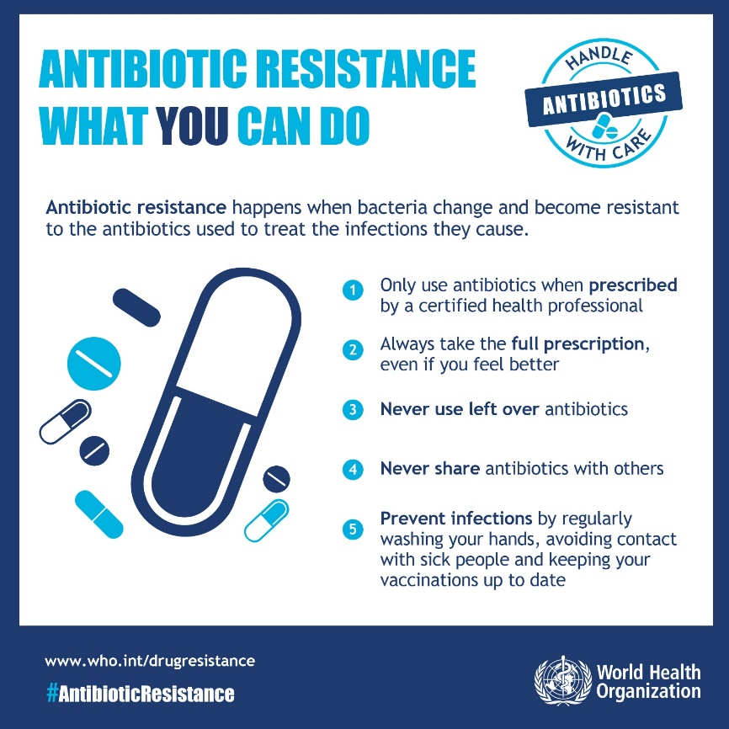
PART B - ANTIMICROBIAL STEWARDSHIP POLICY IMPLEMENTATION

Introduction

In this part of the session, you will focus on implementation of policy – firstly looking at factors that affect how policy is implemented, and then working more practically on an activity applying what you have learned.

It is important to read the materials suggested below in order to obtain a more detailed understanding of policy implementation.

The PowerPoint presentation and the readings by Michie, at al. (2011) and Kredo, et al. (2018) are important for performing Activity 2, which is an implementation of an aspect of an Antimicrobial Stewardship (AMS) Policy Framework

Part B Session Contents

1. An overview of aspects that affect the implementation of policies
2. Selecting interventions and influencing behaviour to promote policy implementation

Readings and resources

Buse, K., Mays, N., & Walt, G. 2005. Making Health Policy: Open University Press. Maidenhead. Chapter 2 pages 40 – 46; Chapter 4 pages 68 – 71 & Chapter 7. Available at: http://citeseerx.ist.psu.edu/viewdoc/download?doi=10.1.1.474.6452&rep=rep1&type=pdf

CREHS. 2009. The need for the active and strategic management of local-level policy implementation. Policy Brief. UK. Available at: http://www.chp.ac.za/PolicyBriefs/Documents/The%20need%20for%20the%20active%20and%20strategic%20management%20of%20local-level%20policy%20implementation.pdf

Erasmus E. 2009. Street-level Bureaucracy – Guidance Note 5. Guidance Notes in Health Policy Analysis in low- and middle-income countries. UCT: Cape Town. Available at: https://www.hpsa-africa.org/images/Street_level_bureaucracy_final_for_web.pdf

Michie et al. 2011. The behaviour change wheel: A new method for characterising and designing behaviour change interventions. Implementation Science. 6:42. Available at: https://implementationscience.biomedcentral.com/track/pdf/10.1186/1748-5908-6-42

Kredo et al. 2018. Using the behaviour change wheel to identify barriers to and potential solutions for primary care clinical guideline use in four provinces in South Africa. BMC Health Services Research. 18:965. Available at: https://bmchealthservres.biomedcentral.com/track/pdf/10.1186/s12913-018-3778-2

PowerPoint presentation
The Behaviour Change Wheel and COM-B model

Part B:
1. Overview of aspects that affect the implementation of policies

  - The policy process (Recap from Session 1)

The overarching process of making and implementing policy is called the policy process, indicating that the changes which make up and are part of the policy process occur during both development and implementation. At the heart of this process are the many and complex sets of decisions and actions entailed in developing policy and putting policy into effect. These decisions are sometimes understood as a set of steps that follow one another as in the ‘stages’ model in Figure 1. Part B of this session deals with the third stage – i.e. the implementation of a policy.

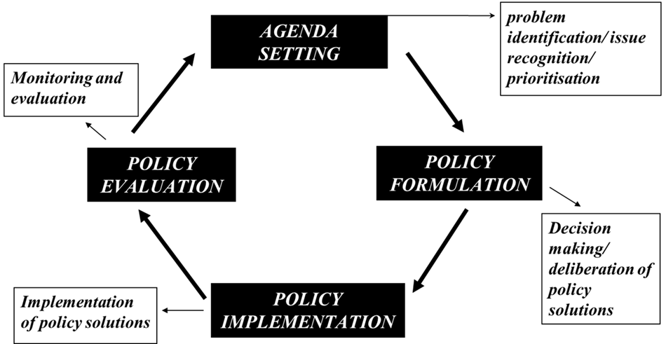

Figure 1: The Stages Model
Source: Sabatier P and Jenkins-Smith H (1993). Policy Change and Learning. Boulder, CO: Westview Press
Experience of policy making and planning shows that, in reality, the ways in which problems are identified for policy attention and in which policies are formulated, negotiated and implemented do not entail a simple process in which there is a clear and almost automatic decision to move from one stage to the next. Instead, the processes of policy making and implementation take place over many years, sometimes moving forward across the stages above, sometimes moving in stops and starts, and sometimes moving forwards, and backwards and sideways. In addition, policy making does not always begin in agenda setting; policies can be re-formulated after implementation failure or may not even get to the implementation stage.

  - What is policy implementation?
Read the two texts listed and then work through the content that follows.

Readings:
Buse, K., Mays, N., & Walt, G. 2005. Making Health Policy: Open University Press. Maidenhead. Chapter 7 pages 120 – 136.

CREHS. 2009. The need for the active and strategic management of local-level policy implementation. Policy Brief. UK.

Policy implementation is what happens between “policy expectations and (perceived) policy results”. This process involves implementation of the policy content through various strategies and by various structures and people, including the adaptation or non-implementation of the policy by these policy actors.
Successful policy reform or implementation is invariably shaped by the institutional arrangements and the balance of power in any given environment. Furthermore, behaviour changes to perform the desired actions are fundamental for effective implementation of a policy (Michie et al., 2011); and often, implementation strategies and interventions do not address the influences of impulsivity, habit, self-control and emotional processing of the implementation of the policy. For successful implementation, a policy needs to be well-designed and properly implemented. Thus, in considering implementation of a policy, we need to firstly understand the policy and actors involved (i.e. the policy type, context, concept and processes involved). Next, we need to decide what strategy or approach would best suit the implementation of such a policy; and thereafter select appropriate interventions to promote the target behaviour. When seeking interventions to implement the policy, we need to consider barriers and facilitators. Lastly, we need to measure & assess the intended as well as the unintended consequences.

  - Implementation Strategies / Approaches

Read the sections of the Buse et al. 2005 indicated below and then work through the summarised content.
Reading
Buse, K., Mays, N., & Walt, G. 2005. Making Health Policy: Open University Press. Maidenhead. Chapter 2 pages 40 – 46; & Chapter 7.

There are various approaches to implementing policy. The approach decided on will be based on factors such as the complexity of the policy, resources or funding available, stakeholders involved, etc.

- Incrementalism – ‘muddling through’
  - Involves small, conservative / cautious changes.
  - Used in situations when expecting strong opposition, when little resources are available or if there is uncertainty of the outcomes.
  - This approach is useful when you need to avoid damaging policy mistakes.
  - Effects of interventions can be assessed before taking the subsequent step.
  - Process may be slow and implementation prolonged.
- Rationalism
  - Decisions are taken in a rational manner and many options are considered before implementation.
  - This approach involves: identifying the problem / gaps for policy implementation; set objectives / targets; list all alternatives / options; perform comprehensive analysis of consequences of alternatives; and finally decide on an intervention strategy.
  - Used when you need to convince / persuade someone of an implementation strategy.
  - Time consuming to consider options, requires resources to do thorough analysis, and may not always be feasible.
- Bounded rationalism
  - Same as rationalism, but only 2 or 3 option are considered, instead of all alternatives.
  - More realistic approach than rationalism within the real-world constraints.
  - Used when you need to convince / persuade someone of an implementation strategy.
- Mixed scanning - middle way
  - Involves wide scoping of the general problem, and then focusing on specific issues.
  - Middle way – overcomes the unrealistic requirements of the rational approach and the conservative slant of incrementalism.
  - E.g. for an antimicrobial stewardship policy implementation in wards – do a general scoping of wards in a hospital – then address specific key issue e.g. focus on ICUs (high use of antibiotics); or target the inappropriate prescribing of specific antibiotics instead of all antibiotics.
- ‘Top-down’ approach
  - Useful for simple policies; for policies with a cause and effect slant (e.g. complete and submit a claim – you get reimbursed); and for compulsory actions e.g. legal requirements.
  - Used for simple processes, where consequences or penalties are clear, where public safety is affected, or where buy-in has already been established.
- ‘Bottom-up’ approach
  - Used in policies that are complex, significant behaviour change is required, discretionary actions are high, penalties are unclear, impact is wide, etc.
  - This approach may be time consuming in the beginning, but may have improved buy-in and facilitate implementation later.
  - Problems are identified early and improvements can be made.
  - Factors that influence policy implementation

Figure 2 illustrates the factors that impact on the implementation of a policy.

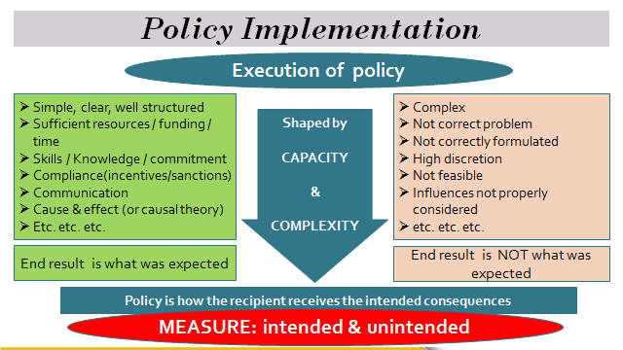

Figure 2: Policy implementation

The nature of policies
Policies are generally technical or social. Technical policies are usually simple and straightforward e.g. the procedure for submitting a claim for reimbursement of an expense. On the other hand, social polices (e.g. a patient rights charter; or appropriate use of antimicrobials) are generally more complex and involve high degree of discretion in terms of actions. They therefore have a greater risk of unintended consequences. With high discretion (e.g. a doctor may have many options in how to manage a patient and he decides what option to use), it becomes more challenging to measure correct behaviour. Also, outcomes are more difficult to measure e.g. for patient care - is it more important to treat a patient appropriately or see all patients? Social policies depend on the willingness of actors to comply. Success is often based on actor beliefs and tends to require a process of negotiation during implementation. The latter type of policy, thus, is more difficult to implement.

Policies that have a ‘cause and effect’ nature are usually easier to implement as the results are clear and tangible. Also, policies with incentives or sanctions attached usually motivate actors to implement them.

Sufficient resources, funding, time, commitment, skills and knowledge promote the expected end result / consequences of an implemented policy. Unrealistic expectations and policies that do not offer feasible solutions are often unsuccessful. When external or internal influences on policies are not considered adequately; and the impact on frontline workers and their reactions to the policy have not been taken into account, implementation will be hampered.

A policy may have different meanings for different actors, e.g. an AMS policy that restricts antibiotic use may mean greater savings for a finance manager, appropriate use of antibiotics for an infectious disease specialist and disempowerment for a doctor who cannot prescribe as he chooses. It is, therefore, important that the policy implementation actively communicates, manages and frames the meaning of a policy to provide greater account to the main goal of the policy i.e. appropriate treatment and reducing antimicrobial resistance. A practical step in this direction would be to define the performance measurement for implementation in terms of appropriate treatment and decrease in resistance rather than money saved or compliance with a guideline.

Understanding the organisational culture is imperative when presenting a policy for implementation. For an organisation that is more hierarchical and stable in nature it may be more suitable to introduce the policy in a series of smaller objectives. For a more rational or competitive culture, the emphasis could be more on achievements and meeting objectives.

Having an incorrect measure or target for assessing progress of policy implementation may result in unintentional or negative consequences, e.g. a user fee policy is, typically, intended to ensure that patient fees are structured to ensure that patients pay an affordable fee according to their income and thereby are not denied access to care. However, if the measurable outcome for the hospital is revenue generation, then such a policy encourages the behaviour that patients who can afford to pay more may be given preferential access to care and this may compromise access to care for poorer patients. This measure encourages an unintended, negative consequence for the policy.

It is important to measure both the intended as well as the unintended consequences of a policy in order to assess the actual impact of the policy. Furthermore, if you measure the wrong outcome, or measure the outcome in the wrong manner, the expected objectives may not be achieved, e.g. in an audit, staff often aim to achieve the expected audit result rather than identifying areas or gaps that need to be addressed. A practical step in the right direction would be to measure performance more regularly, at shorter intervals, have peer reviewed performance assessments, and make interventions as you go along. Quality improvement methodology involves regular measurements (run charts) rather than an ‘audit’ approach.

Kingdon and Shiffman (Buse et al. 2005) theorised that to create a policy window for successful policy implementation, the following need to be in place:
A clear, common problem; a feasible policy solution; political will; policy champions; strong indicators; and advocacy to address the problem.

  - Street Level Bureaucrat Theory

Reading

Erasmus, E. ( 2009). Street-level Bureaucracy – Guidance Note 5. Guidance Notes in Health Policy Analysis in low- and middle-income countries. UCT: Cape Town.

Frontline workers are usually the key actors that decide how a policy is implemented and how the client / patient / recipient of the policy experience the policy. It is important, therefore, not to underestimate their influence and to understand what drives their actions.

- Street Level Bureaucrats (SLBs) are FRONTLINE WORKERS in government that have regular, direct interaction with citizens or recipients of government services.
- SLBs are a specific group of frontline implementers. They are committed to providing a good service; however due to their stressful work environments, they develop patterns of practice, routines and simplifications that help them deal with their work load.
- SLBs have the power to exercise a degree of discretion over services, benefits & sanctions received by their clients / patients.
- SLBs bring policy to life, i.e. the SLB’s actions becomes or represents the policy (i.e. by applying benefits & sanctions to the recipients of the policy, the SLB in fact ‘makes’ the policy. The SLB often makes policy in unexpected and unwanted ways).
- As SLBs perform complex tasks and are regarded as professionals and thus, expected to use their own judgement, they are relatively free from oversight by the organisation (high degree of discretion).
- As a result of inadequate resources, vague organisational expectations, performance measurements that are not clear, and dealing with “captive” clients (i.e. clients that do not voluntarily choose the service as this may be their only option), the SLB will structure the context in which they interact with clients, develop routines & simplifications to make work easier.
- Performance measurements do not measure what the SLBs actually do as they change behaviour to suit the performance measurement.
- Strategies for managing SLBs during policy implementation:
  - Create a positive environment to reduce resistance from SLBs.
  - Develop messages, meanings & tones that are less threatening & more acceptable to SLBs.
  - Expose the SLBs to role modelling to which they could aspire to.
  - Introduce interventions / strategies for behaviour change.

Part B:
2. Selecting interventions and influencing behaviour to promote policy implementation

  - The Iceberg Model
How a policy is implemented (i.e. the everyday behaviour / actions observed as a result of the policy) is largely dependent on factors that are not visible to us. This phenomenon is depicted fittingly in the Iceberg Model illustrated below.
Behaviour is as a result of the interaction of two things:
- Characteristics we possess as a person, and
- Characteristics of the situation we are in (context)
The tip of the iceberg symbolises the observable behaviours in an organisation and the things that you can see, hear and touch e.g. actual behaviour / actions, skills, knowledge, tools, fiscal situation, technology, etc. The most dangerous part of an iceberg is the 90% that is below the sea that you cannot see – this symbolises the norms, values, beliefs, thoughts, social motives, etc. that drives the behaviours and actions that are visible to us (See Fig 2).

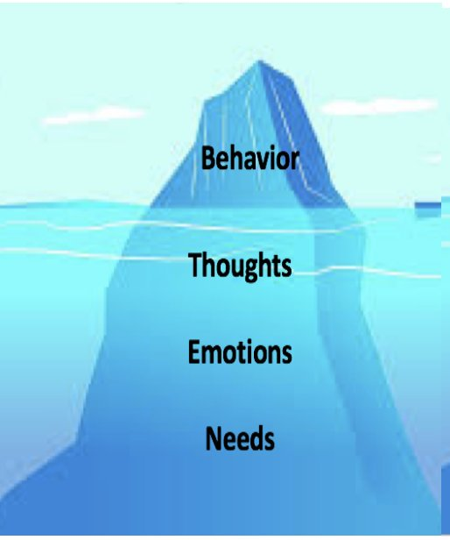
resources
experience
technology
physical facilities

values
self-image
beliefs

skills
knowledge
tools
organisation design

VISIBLE
INVISIBLE
motives
traits / patterns
social role

Thus, when implementing a policy, we need to consider the visible as well as the invisible factors that influence behaviour. In order to improve the implementation of policies, a systematic method is required that incorporates the selection of interventions that matches (i) the behavioural target (action to be implemented), (ii) the target population and (iii) the context in which the intervention is to be delivered. E.g. in order to reduce the overuse of antibiotics, providing an educational intervention alone may not necessarily achieve the desired outcome. Additional components of behaviour change are often required e.g. incentivising appropriate prescribing (motivates behaviour) or penalise inappropriate prescribing (coercion towards appropriate behaviour).
  - The Behaviour Change Wheel and the COM-B model

Once an implementation approach has been decided upon, interventions should be selected that will direct behaviour towards the desired actions that support the implementation of the policy.

The Behaviour Change Wheel and the COM-B model are techniques utilised to design behaviour change interventions for policy implementation endeavours.
Watch: PowerPoint presentation on the Behaviour Change Wheel and COM-B model.
Read:
Michie et al. 2011. The behaviour change wheel: A new method for characterising and designing behaviour change interventions. Implementation Science. 6:42.

Kredo et al. 2018. Using the behaviour change wheel to identify barriers to and potential solutions for primary care clinical guideline use in four provinces in South Africa. BMC Health Services Research. 18:965

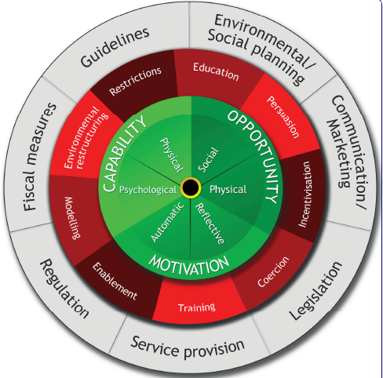
  - Implementation of a Policy Framework

We have discussed the types and nature of policies, the meanings assigned to policies, the context (situation, barriers, etc.) in which policies may be delivered, the approaches for policy implementation, the behaviour of stakeholders or implementers and the types of interventions that may promote successful implementation.

Further to this, it is imperative that responsibilities and roles in the implementation process are clearly and officially defined in a terms of reference or similar document. The terms of reference should also contain the communication strategy, especially with regards to reporting lines, frequency of reporting; as well as what and how the reporting will occur.

Measurement of performance should be feasible and should direct behaviour to the targeted outcomes. Measurements should be set for the implementation phase as well as the maintenance phase after implementation.

  - Key steps for implementing a policy:

- Understand the policy (nature of policy; meaning assigned to policy).
- Perform a situation analysis - Identify policy gaps / problems.
- Decide on a policy implementation approach.
- Identify and understand the scope (extent of policy – i.e. what it includes and excludes) & stakeholders involved (e.g. implementers’ reaction to the policy).
- Identify the action / behaviour to be changed by the stakeholder in order to implement the policy.
- Identify barriers & mitigation factors (working environment; organisational culture, resources, programmes already in place, etc.)
- Select interventions relevant to behaviour change (COM-B model), importance, ease of implementation, feasibility, and impact (effect size).
- Develop measurement instruments for intended and unintended consequences; as well as for assessing progress.
- Determine responsibility, timelines & communication strategy (e.g. feedback, comment, reporting).
- Implement processes for assessment of continued compliance to policy after implementation.
Activity 2 entails implementation of an antimicrobial stewardship policy and involves points 4 to 7 (highlighted) above.
Activity 2: Devise an implementation strategy for the implementation of components of an antimicrobial stewardship policy.
Note – this activity will be sent to you separately in an attachment.

References and further reading

National Department of Health. Republic of South Africa. (2015). Implementation plan for the antimicrobial resistance strategy framework in South Africa: 2014 – 2019. http://www.health.gov.za/index.php/antimicrobial-resistance?download=1175:implementation-plan-for-the-antimicrobial-resistance-strategy-framework-in-south-africa-2014-2019

National Department of Health. Republic of South Africa. (2018). South African Antimicrobial Resistance National Strategy Framework: A one health approach: 2018 – 2024. http://www.health.gov.za/index.php/antimicrobial-resistance?download=3308:amr-national-action-plan-2018-2024

National Department of Health. Republic of South Africa. (2014). Antimicrobial resistance national strategy framework 2014 – 2024. http://www.health.gov.za/index.php/antimicrobial-resistance?download=3308:amr-national-action-plan-2018-2024

National Department of Health. Republic of South Africa. (2017). Guidelines on Implementation of the Antimicrobial Strategy in South Africa: One Health Approach & Governance. http://www.health.gov.za/index.php/antimicrobial-resistance?download=2194:antimicrobial-stewardship-guidelines-governance-june2017

Essack S, Desta A, Abotsi R and Agoba E. (2016). Antimicrobial resistance in the WHO African region: current status and roadmap for action. Journal of Public Health, 39(1): 8 – 13. https://www.ncbi.nlm.nih.gov/pmc/articles/PMC5939661/pdf/fdw015.pdf

Leung E, Weil D, Raviglione M, Nakatani H and on behalf of the World Health Organization World Health Day Antimicrobial Resistance Technical Working Group. (2011). The WHO policy package to combat antimicrobial resistance. Bulletin of the World Health Organization, 89: 390 392. https://www.ncbi.nlm.nih.gov/pmc/articles/PMC3089396/pdf/BLT.11.088435.pdf

Erasmus E. ( 2011). Important policy analysis theories in-brief: Street Level Bureaucracy. Health Policy Analysis Research Guidance Note. Health Policy and Systems Programme, University of Cape Town. https://www.hpsa-africa.org/images/Street_level_bureaucracy_final_for_web.pdf

Hercot D, Meessen B, Ridde V and Gilson L. (2011). Removing user fees for health services in low-income countries: a multi-country review framework for assessing the process of policy change. Health Policy and Planning, 26: ii5 – ii15. https://doi.org/10.1093/heapol/czr063

O’Neill J. (2014) Antimicrobial resistance: tackling a crisis for the health and wealth of nations. Rev Antimicrob Resist. https://amr-review.org/sites/default/files/160525_Final%20paper_with%20cover.pdf

Kredo T, Cooper S, Abrams A, Muller J, Volmin J, Atkins S. (2018). Using the behavior change wheel to identify barriers to and potential solutions for primary care clinical guideline use in four provinces in South Africa. BMC Health Services Research, 18, Article number: 965
https://bmchealthservres.biomedcentral.com/track/pdf/10.1186/s12913-018-3778-2

Michie S, van Stralen MM, West R. (2011).The behaviour change wheel: a new method for characterising and designing behaviour change interventions. Implement Sci. 6:42.
https://www.ncbi.nlm.nih.gov/pmc/articles/PMC3096582/pdf/1748-5908-6-42.pdf

