Unit
2
Study designs

Welcome to Unit 2

In this unit of the Quantitative Research Methods module, we will focus on study designs, emphasising what is applicable for you to be able to produce a protocol for your research study. You have already been exposed to many of these concepts during the MHD module. Some of the basics are also covered in Unit 1 and some additional issues in Unit 3.

Study Sessions

There are four Study Sessions in Unit 2:

Study session | Topic | Page
1 | Observational Descriptive Study Designs | 2
2 | Analytic Studies | 9
3 | Experimental Study Design | 29
4 | Systematic Reviews | 53

Session 1 -
Unit
2
Observational Descriptive Study Designs

Session Content

  - Design of Epidemiological Studies
1.2 Observational Descriptive studies
1.3 Case Reports and series
1.4 Observational Descriptive Cross-sectional Study
1.5 Surveillance

Intended learning outcomes

By the end of this session, you should be able to:
- Define Epidemiology
- Understand the importance of design in epidemiological studies
- Be familiar with the features of different levels of epidemiological study designs
You will also practice the following academic skill:
- Reflecting on your learning

1.1 Design of Epidemiological Studies
Some research questions can be answered using an observational descriptive study design. Descriptive studies use the first 3 steps in the Seven Step approach to epidemiology only. These are:
- Define the Study Population
- Decide on measures of occurrence / frequency to measure the population
- If a census is not being done – then a study sample of the study population needs to be taken.

Epidemiology is a fairly new and emerging science. This can be seen by how the definition of epidemiology has changed with time. Most textbooks will use a definition which incorporates a descriptive and an analytic component, such as: The study of the distribution and determinants of health-related states or events in specified populations, and the application of this study to control of health problems.

Note the names of Rudyard Kipling's ‘Six honest men’ in his poem from The Just so Stories (1902):
I keep six honest men,
(they taught me all I know),
Their names are What & Why & When,
& How & Where & Who”

These questions cover the elements of epidemiology. In descriptive epidemiology, one is looking at the distribution of exposure or outcomes. The questions to be answered include:

What disease, condition, risk factor or exposure is present (often in excess) in this population?
Who is ill or has the risk factor of interest and where do they live?
When is the measurement of the population being done?
Another important question to be answered is: Why or how did the disease occur?
In analytic epidemiology, one is measuring the determinants of disease.

Once the research question is defined, the aims and objectives of the study need to be formulated. Whether you are using the IDRC format or the other template components, the next stage is to describe the methods to that will be used to answer the research question.

Deciding on the study design is an important part of the Methods section.

Design of Epidemiological Studies
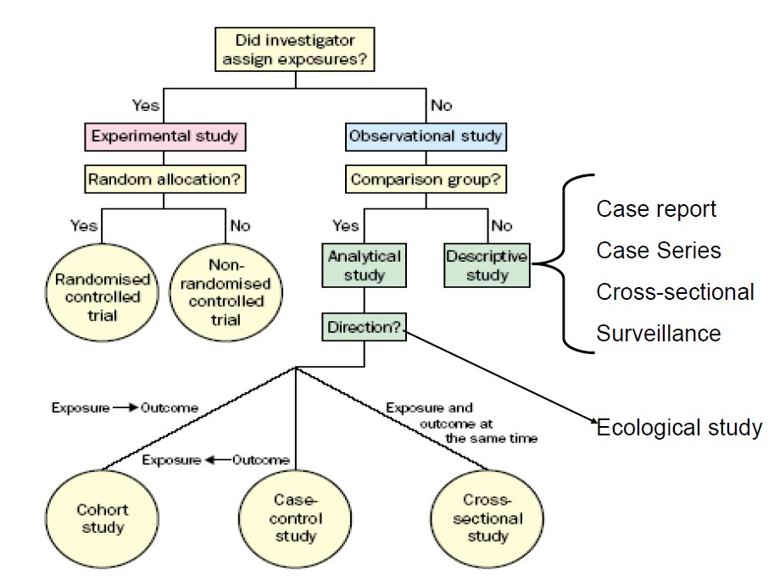

This is an algorithm for the classification of types of clinical and epidemiological research. The first question is: Did the investigator assign the exposure? In experimental studies the exposure is assigned by the researcher. In observational studies the researcher just observes what is already happening. There are two main types of experimental study design.

Those with random allocation of the study sample are called randomised controlled trials. Those where randomisation does not occur are called non-randomised experiments or quasi-experimental design studies. If it is not an experiment then it is an observational study.

If there is a control group it is categorised as an analytic study. If there is no control group then the study design would be classified as a descriptive study, which includes case reports, case series, cross-sectional descriptive or prevalence studies, surveillance and surveys including knowledge attitude and behaviour surveys.

Analytic studies are ranked from those that provide low levels of evidence to those that provide high levels of evidence. The lowest level of observational analytic study design is ecological studies. The next level is cross-sectional analytic studies where exposures and outcomes are observed and measured at the same time. Case-control studies are higher level studies but the exposure it is measured retrospectively. The highest level of observational analytic study design is cohort studies where the outcome is measured prospectively as an incidence.
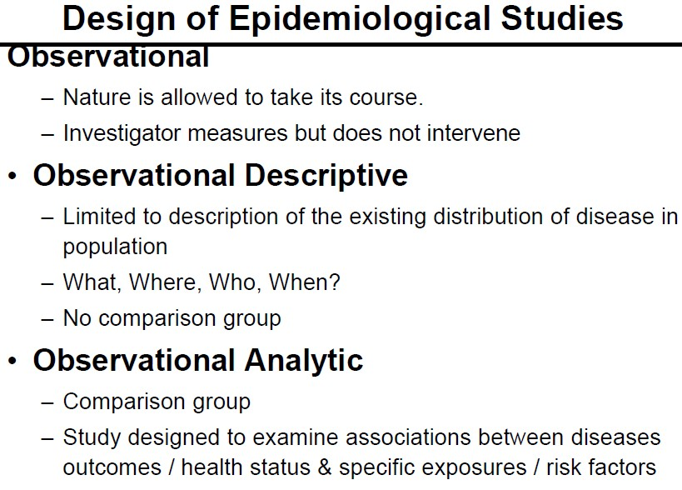

In observational studies nature is allowed to take its course. The investigator measures the exposures or outcomes but does not intervene by manipulating the exposures.
Observational descriptive studies are limited to describing existing distribution of disease or risk factors in population and answers the question is what where who and when. There is no comparison group.

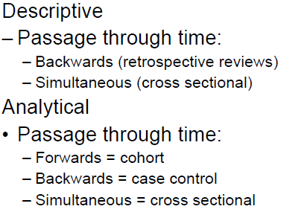
In observational analytic studies there is a comparison group and the study is designed to examine associations between specific exposures or risk factors (independent variables) and diseases, outcomes or health status (dependent variable). In descriptive studies the timing of data collection is either retrospective or simultaneous.

In analytic studies the passage through time varies in different study designs.

An experimental study design is a set of observations, conducted under controlled conditions, in which the scientist manipulates conditions to ascertain what effect such manipulation may have on observations. The exposure conditions are under the direct control of the investigator. Experimental designs can be randomised or non-randomised controlled trials.

1.2 Observational Descriptive studies

The purposes of Observational Descriptive studies are to answer questions about disease and risk factor frequency:
  - What?
  - Who?
  - When?
  - Where?
The purpose is to measure prevalence or coverage.

The different types of observational descriptive study designs include:
  - Case reports
  - Case series
  - Descriptive cohort studies
  - Cross sectional studies
  - Surveillance

1.3 Case Reports and Series

In a Case Report, clinicians describe an unusual case. They can serve to prompt further investigation but are the least publishable unit in the medical literature.

In a Case Series the writer aggregates descriptions of individual cases into one report. The series usually describes several similar cases which had occurred in a short period and could possibly herald an epidemic. This series could constitute a case group for a case-control study.

Some examples of case reports & case series that were instrumental in early identifications of health problems
  - Infants born with congenital cataracts, some with cardiac abnormalities - linked with epidemic of rubella (German Measles) 6-9 months earlier (Gregg, 1941)
  - Pulmonary embolism in 40 year old women 5 weeks after commencing oral contraceptive (Jordan, 1961)

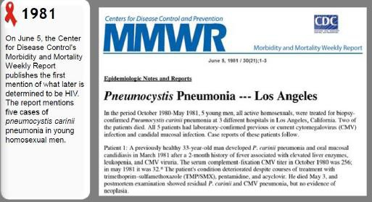

1.4 Observational, Descriptive Cross-sectional Studies (CS studies)

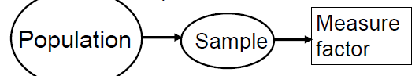
In an observational descriptive cross-sectional study design, a study sample is identified from a defined study population and a variable is measured. Data collection is retrospective or simultaneous.

Descriptive cross-sectional studies are used to:
  - Describe health or disease in a population;
  - Measure prevalence of health outcomes (disease) or determinants (exposures) of health in a population at a point in time or over a short period of time (Trend analysis) e.g. prematurity, low birth weight;
  - Health care planning e.g. hospices for AIDS patients, care for orphans
  - Hypothesis generation – clues about causes, e.g. oxygen in incubators leading to neonatal blindness.

Reflect on your learning and check your understanding

What are the differences between a descriptive and analytic cross-sectional study design?

The selection of the sample is vital. As most C/S studies are measuring a population parameter, it is essential that probability (representative) sampling is used.

Descriptive C/S studies dominate the medical literature as they are:
    - Cheap
    - Simple/ Easy to do
    - Few ethical problems
    - Data often already available
    - Generate hypotheses which then can be confirmed in analytical studies

Their Strengths are:
  - Primary method of estimating prevalence
  - Relatively inexpensive
  - Logistically efficient
  - Relatively fast (no follow-up required)
  - Can enroll large numbers of participants
  - Large surveys can be used for many exposures & diseases
  - Often generalizable
  - BUT smaller sub-populations can be over-sampled

Limitations of C/S studies include:
  - Large numbers needed for rare exposures / outcomes
  - No information on timing of outcome relative to exposure
  - Limits causal inference
  - Includes only those individuals alive at the time of the study
  - Prevalence-incidence bias (see Case-Control Studies)
  - Cases also often defined at the time of the study
  - They are only descriptive
  - Frequently researchers overstep the data & infer cause
  - Sometimes the lack of adequate case definition means conclusions from study are invalid

Cross-sectional Studies: What can we learn?
They are a snapshot of a defined population at one point in time.
Below are some useful references on these topics:

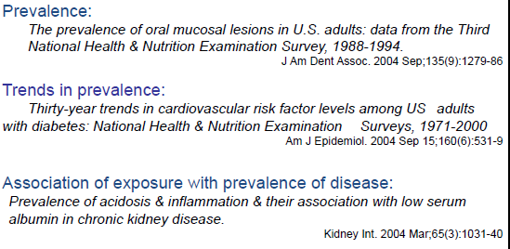

1.5 Surveillance
Although surveillance is not usually categorised as an observational descriptive cross- sectional study design, it actually is. The difference is that usually the data collection is continuous.

Surveillance means watchfulness over a community. It involves ongoing systematic collection, analysis, & interpretation of health data essential to the planning, implementation & evaluation of public health practice, closely integrated with timely dissemination of these data to those who need to know. Surveillance can be active or passive and critically requires feedback to be effective. Epidemiological surveillance has made valuable contributions to health worldwide.

Reflect on your learning and check your understanding

What is a research hypothesis? What is statistical hypothesis?
When should you have a hypothesis using an observational descriptive research study design to answer a research question?

Session 2
Unit
2
Analytical Studies

Session Content

2.1 Epidemiologic Reasoning
2.2 Ecological studies - Observational, Analytic
2.3 Cross-sectional Studies - Observational, Analytic
2.4 Case-control Study - Observational, analytic
2.5 Case-control Studies - What can we learn?
2.6 Cohort Study - Observational, Analytic

Intended learning outcomes

By the end of this session, you should be able to:
- Understand concepts of statistical association and causal relationships in epidemiology
- Calculate and measures of association and interpret correlations
- Critically review purposes, methods, advantages and limitations of five types of study designs.
You will also practice the following academic skills in this session:
- Analysing studies and data
- Critically appraising a study design
- Comparing study designs
- Reflecting on and summarizing your learning

2.1 Epidemiologic Reasoning

Observational analytic studies are designed specifically to test hypotheses that have usually been generated from descriptive studies. The purpose of these analytic studies is to determine whether a statistical association exists between a presumed risk factor and disease, and to derive inferences regarding a possible causal relationship from the patterns of the statistical associations that are shown.

Some studies use data collected using either populations or groups of individuals as units of observation:
- Descriptive studies (prevalence, trends)
- Ecological (Correlation) studies
Other studies use individuals as the units of observation:
- Cross-sectional
- Cohort
- Case-control
- Other (nested case-control, case-cohort)

Analytic study designs are used to answer the question:
Is there an association between exposure variables (risks); and outcomes (disease)?

Like all observational studies there should be no manipulation of the exposure variable, i.e. the researcher just observes what is happening already.

2.2 Ecological studies - Observational, Analytic
An ecological study would be categorised as having an analytical study design. Traditionally it involved an investigation of a measure of disease/mortality in relation to ecologic measure of exposure.

Usually an ecological study is based on a geographically defined population. The unit of observation used is a population or community rather than the individual. So, the units for comparison are population mean values for risk factors & outcome obtained from observation. The comparison is done by plotting a risk factor against an outcome values for all observation units, then assessing whether there is relationship or correlation between these variables.

The types of variables in ecological studies include:
- Aggregate measures - Mean value of a certain parameter is determined for the group e.g. Prevalence of a disease; average fat intake, proportion of smokers; median income.
- Environmental measures - Represents physical characteristic of geographic location for group e.g. air pollution; hours of sunlight
- Global measures - Not reducible to characteristics of individuals e.g. Laws; political or health care systems; presence & magnitude of health inequality.

As a results of the parallel trends observed between annual per capita consumption of cigarettes and annual deaths from lung cancer, in the 1940‘s, Doll and Hill designed studies to test this relationship starting with a Case-control Study and followed by the prospective Doctors Cohort Study (see Unit 1).
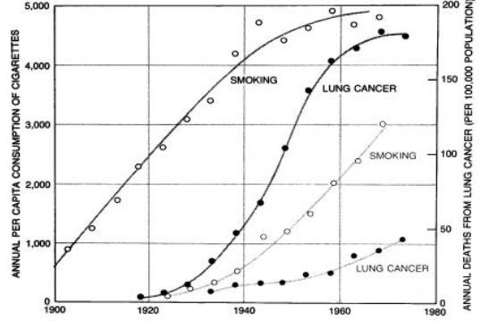

Another example was the ecological study assessing the correlation between dietary fat intake & breast cancer.
Figure 1: Parallel trends of cigarette smoking and lung cancer in men and women
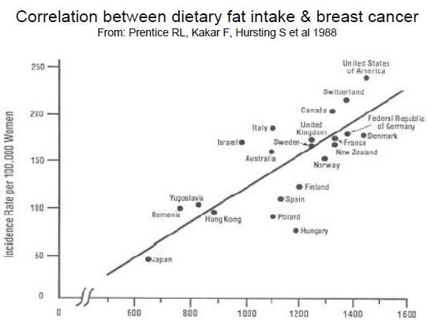
In the research process the first level of study would be an observational descriptive study and the lowest level of analytic study would be an ecological study design.

Task 1 – Analysing measures of association in studies

Consider these questions:
What is the measure of association used in these 2 studies?
How would you interpret the correlation?

Note: You will have an opportunity to discuss these questions (together with those in Task 2) in an online discussion forum. You will be sent an announcement about this.

In the study shown below, the authors looked at the correlation between male circumcision and HIV infection in 118 low income countries. The study showed that there was a correlation between HIV prevalence in both men and woman and the prevalence of male circumcision.

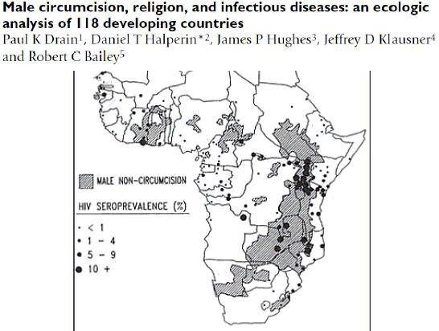

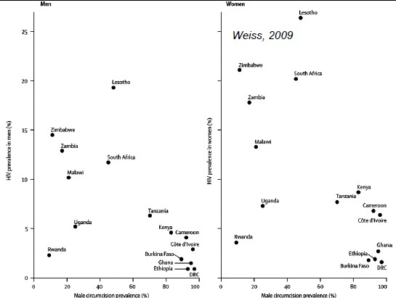

The advantage of ecological studies is that the setup costs are relatively low and they can be used as exploratory studies to generate hypotheses. They are frequently used to explore a negative health effect and a product or the environment.

The disadvantages are that few population parameter based variables are routinely available to answer the research question. Because this involves secondary data it is difficult to assess errors in data collection/quality of data. One is dependent on somebody else’s results.

The main problem however is the ecological fallacy, a situation that can occur when a researcher or analyst makes an inference about an individual based on aggregate data for a group.

So, in the example we looked at above, it is incorrect to infer that those who are circumcised have less HIV infection, when in reality those who are circumcised may well have had different sexual practices as well which led to them having less risk of HIV infection.

Other disadvantages of ecological studies include:
- Difficulty to control for confounding
- Biases if data collection (exposures & outcomes) in different populations not the same.

Task 2 – Critically appraise aspects of a study design

What is the significance of confounding and ecological fallacy in ecological study design?

Note: These questions will be discussed with Task 1 in an online discussion forum. You will be sent an announcement about this.

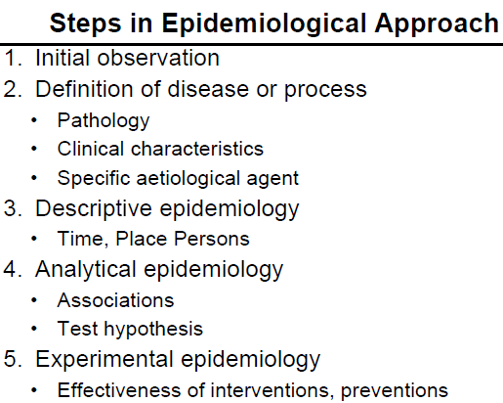

2.3 Observational, Analytic, Cross-sectional Studies

In observational analytic cross-sectional studies, the sample is selected from the study population. Data is collected on exposures, risk factors (independent variables) and outcomes, health status or disease (dependent variables) at a fixed point in time. The prevalence (not incidence) of the outcome and the prevalence of the exposure are measured concurrently. Comparison is done by analysing relative associations using a prevalence ratio.

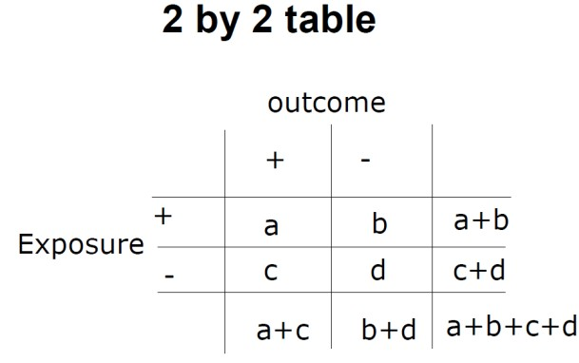
It is possible to compare disease outcomes in different exposure groups. Every analytic study requires the researcher to draw up contingency / 2 X 2 tables comparing the exposure and outcome variables.
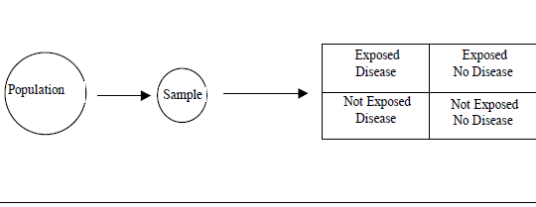
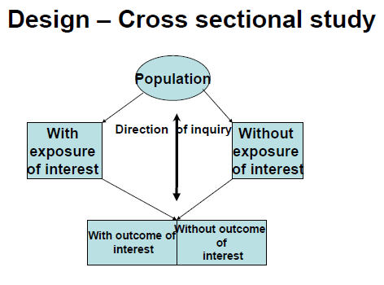

There are many advantages of using this study design including that one can evaluate multiple exposures and multiple outcomes at the same time.

Advantages
    - Primary method of estimating prevalence
    - Logistically efficient
- Relatively fast (no follow-up required) & cheap
- Can enroll large numbers of participants
    - Large surveys can be used for multiple exposures and outcomes/diseases
    - Often generalisable – can oversample smaller subpopulations
    - Useful for studying fixed exposures
Prevalence-incidence bias – One cannot determine the time relationship between the exposure and the outcome. There is a possibility of recall bias and only survivors are included in the sample.

Strength of association between disease and exposure
    - Prevalence (Risk) / ratio
    - If ratio >1, then exposure is a risk factor for the disease
    - If ratio <1 then exposure is protective for the disease
    - If ratio = 1 then exposure has no effect

Limitations
    - Large numbers needed for rare exposures / outcomes
    - No information on timing of outcome relative to exposure
      - Limits causal inference
      - Temporality
    - Includes only those individuals alive at the time of the study
      - Prevalence-incidence bias
      - Cases often defined at the time of the study
    - Cannot determine time relationship
    - Require large sample if exposure or outcome is rare
    - Recall of past events is often unreliable (recall bias)
    - Only evaluates survivors

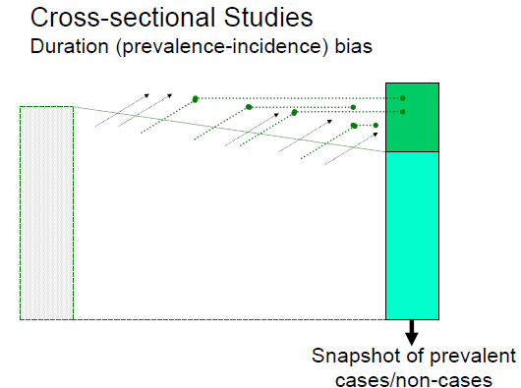

2.4 Observational, analytic, Case-control Study
In an observational analytic case-control study design, cases are identified in the study population with the disease. Controls who do not have the disease are selected from the same population as the cases. Either hospital or community controls are selected, but they must come from same study population as the cases. These can be frequency or individual matched.

The associations are calculated by measuring the frequency of exposure in cases and controls is compared and the odds ratio is calculated. The frequency of exposure in cases and controls is then calculated using the odds ratio.

Basic Features of a Case-control Study are:

- An analytical, observational study design
- Aims to identify determinants (risk factors) of disease
- Selection of subjects is based on disease status
- Compares exposure status between cases & controls
- CAN NOT calculate incidence or prevalence estimates
- Uses odds ratios for measuring the association between the exposure and outcome of interest
- Frequently used for rare diseases
- Used for diseases with long incubation period
- Can only study one outcome but many exposures

Task 3 – Critically compare and appraise two study designs

Below are 2 schematic diagrams illustrating Case Control Study designs.
Consider which one best describes this type of design. Why do you think so?

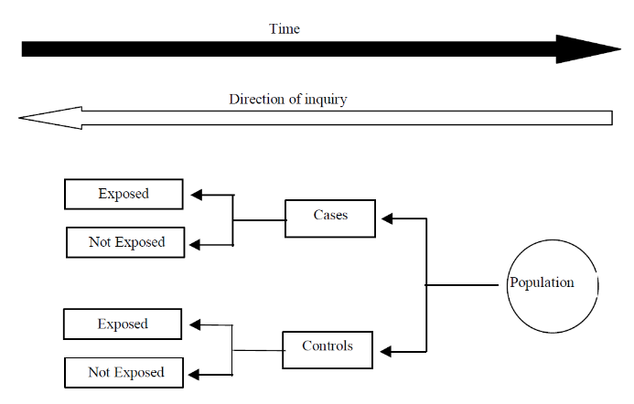
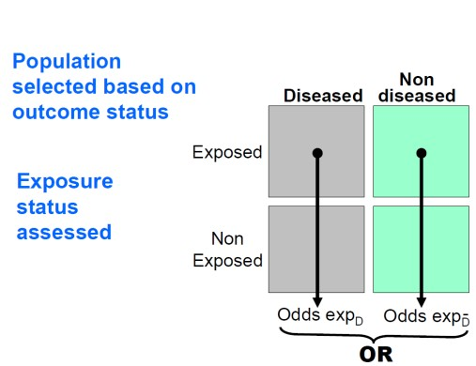

2.4.1 Subject selection
The study selection is based on outcome (disease) status. It is very important that there is a clear disease definition.

The selection of cases can be:
      - Prevalent vs. Incident cases
      - Hospital vs. Population cases

Selection of controls can be:
- Hospital vs. Population cases
- Case definition
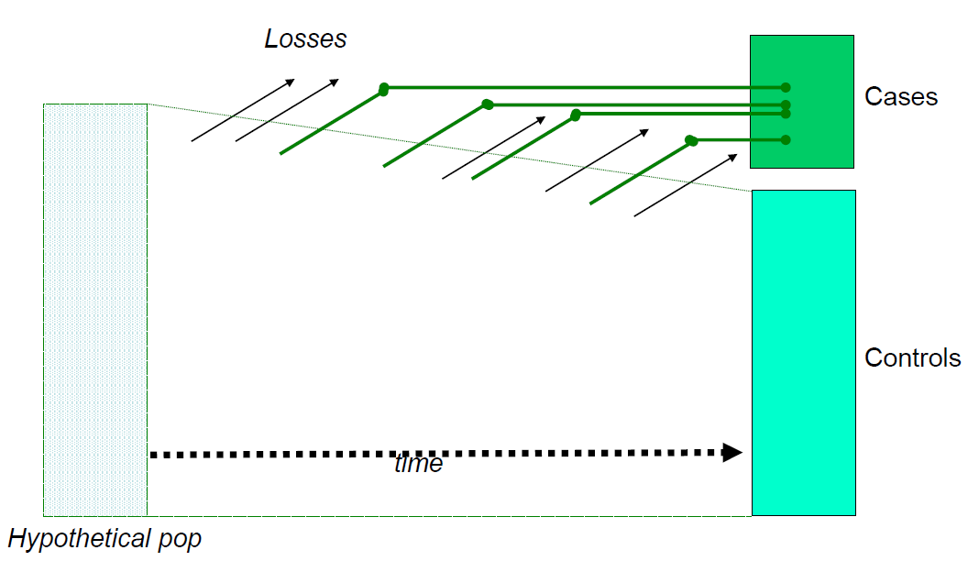
- Other
Figure 2: Hypothetical Case-control Study

Case Definition
The disease of interest needs to be very clearly defined. It needs to be a homogeneous group. It can be defined by:
        - Clinical diagnosis
        - Pathological diagnosis
        - Radiological diagnosis
        - Classification criteria
        - Other inclusion criteria including age, race, gender, language

How is sampling done in Case Control Studies?

Step 1: Subject Selection – Cases
Case selection can be based on Prevalent or Incident cases.

Prevalent cases would be existing cases of disease, which could include patients recruited from clinics, disease registers, GP register, surveys, etc.
The advantages are that it would be relatively easy to obtain and increase the sample size. The disadvantages are that there may be an over-representation of cases of long duration and problems with recall bias.

Incident cases would be newly diagnosed cases with disease, which could be patients recruited from clinics, disease register, GP consultations, surveys, etc.
The advantages are that they reflect determinants of disease onset, reducing recall bias. The disadvantages are that this method of obtaining cases is time consuming.
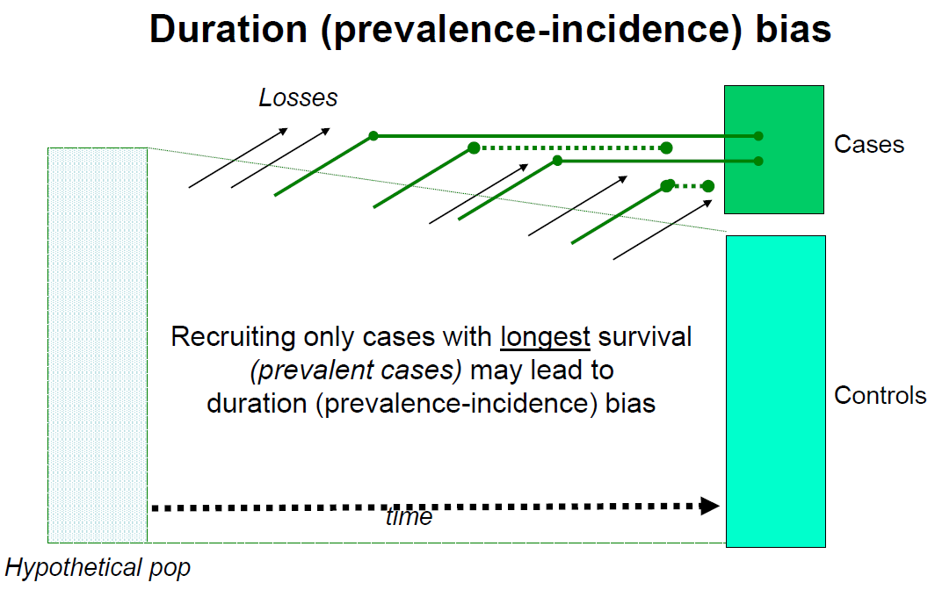

If only prevalent cases are selected then in this example above, only 2 cases would be included.
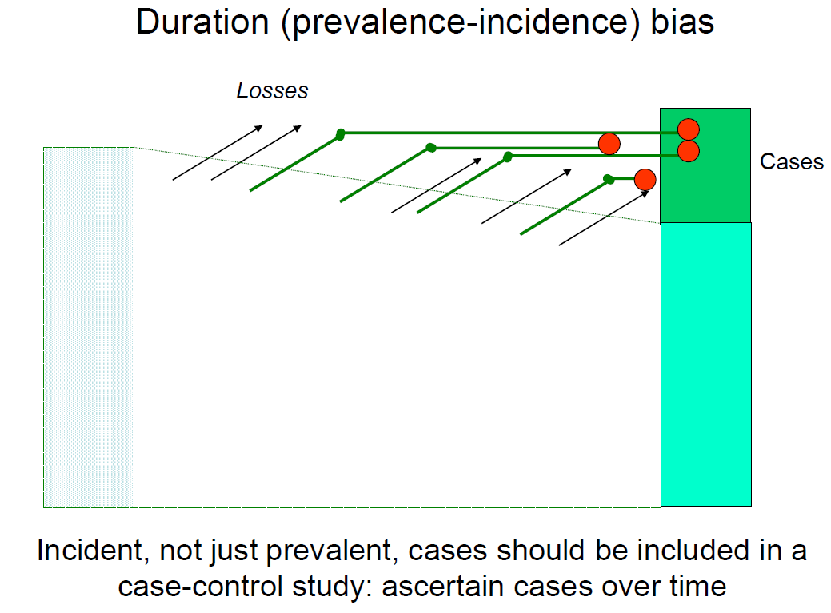

If incident cases were selected, then even those who did not survive would be included as well i.e. in this example 4 cases would be included.

Hospital or Population Based
Case selection can be based on Hospital or Population cases.

The advantages of hospital-based selection are:
        - Easy to implement
        - Inexpensive to identify The disadvantages are:
        - Represent severe cases - good for homogeneity, but not for generalizability
        - Possible issues of external validity

The advantages of Population-based selection are:
        - Better for selecting a representative control group
        - Improved external validity (generalisability) The disadvantages are:
        - Time-consuming
        - Expensive

Step 2: Selecting controls
Selection of controls is important. Controls should be from same population from which the cases were selected. They may be matched for certain characteristics not being tested.
Controls are used to determine the prevalence of exposure in the same population that cases come from. The source of the controls depends on where the cases came from and must have the same inclusion and exclusion criteria.

It is important to ensure there is no selection bias. A number of sources of controls could be considered. These could include: hospital controls; neighbourhood controls; controls nominated by cases e.g. relatives/friends.

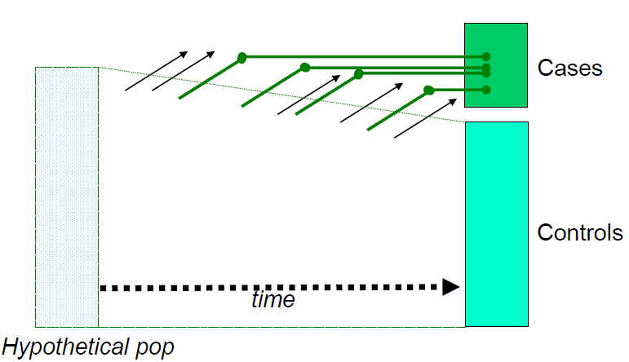
Case-control study NOT within a cohort

The control group should be selected so that they represent the hypothetical population from which the cases came. They should be individuals that would be included as a case had the disease developed in them.

Population–based controls can be obtained from many sources e.g. GP registers, random digit dialling (where most people have phones), electoral registers (where they are complete). The advantages of population-based records include:
        - Easily identified
        - Subjects are not ill as far as is known
The disadvantages of population-based records include:
- Differential cooperation
- Differential response rate

Hospital–based controls can be obtained from the same hospital, different wards or different clinics.

The advantages of hospital-based controls include:
        - Easily identified
        - (As) likely to cooperate
The disadvantages of hospital-based controls include:
- Illness
- Exposure distribution may be different to the population from which the cases arose (e.g. Lung cancer cases, controls from CVD ward)

How many controls are needed?
Using more than one control group is tempting but dangerous, for example if you get different results from each group, which one is correct?

The ideal ratio of cases: controls is 1:1. If the number of cases is limited, more than one control per case can be considered. This could increase statistical power of the study, but there is no benefit beyond 4 controls per case.

Matching
Matching ensures the distribution of potential confounding variables is equal between cases and controls. Usually matching is done on potential confounders. By doing this, it makes the cases and controls more alike. It may improve the efficiency of the CCS but it is dangerous - beware of overmatching. A matched analysis must be done and one cannot study factors for which you have matched.

Measurement of exposure
In a CCS, you need to collect information about retrospective exposure to factors of interest. It is possible that:
        - Both cases and controls may not remember exposure accurately
        - Cases and controls may remember exposure differently, resulting in recall (information) bias
        - Bias can also occur from data gatherers if they are aware of case/control status (observer bias).

How is collecting data on exposure done? Data can be obtained:
- By interview - personal, postal, telephone
        - From medical records – lab results, biological specimens
        - By using recall aids - Photographs, timelines

Data Analysis
A 2 X 2 table would be drawn, as in the illustration on the next page.
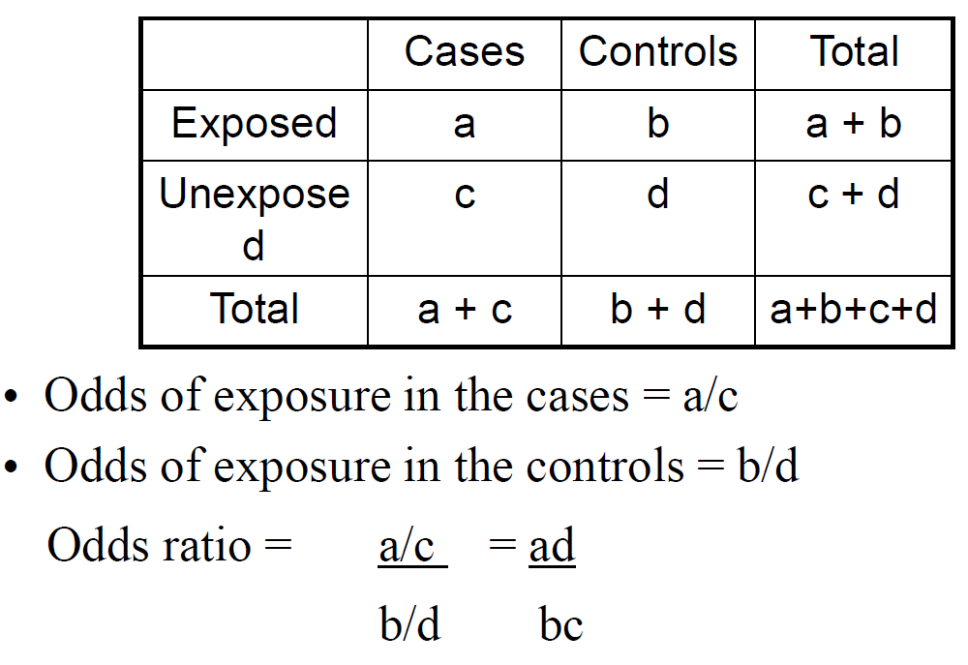

Interpretation of results
In one study the Odds Ratio = 1.5 in another Odds Ratio = 0.5. How can this be explained?
- Chance (statistical methods)
    - Selection and information bias
    - Confounding OR (Odds Ratio)
    - True association

NB: You cannot measure a Risk Ratio (Relative Risk) directly from a case-control study, but the OR is a good estimate of RR when the disease is rare.

2.4.2 Case-control Studies: Strengths & Limitations

Strengths:
CCS are usually very efficient in terms of:
- The number of participants
- The exposure measurements (cost)
- Short time required (retrospective design)
This study design can be used to look for risks in disease with rare outcomes and multiple exposures can be assessed.

Limitations:
The retrospective design limits causal inference.
There is a potential for numerous types of bias including:
- Duration
- Differential recall
- Reverse causation (outcome changes exposure)
- The Control group may be difficult to define and/or obtain

A CCS does not allow calculation of incidence. In addition, it is not suitable for rare exposures.

2.5 Case-control studies – What can we learn?

Read the information about two case-control studies on the following page and then do the task below.

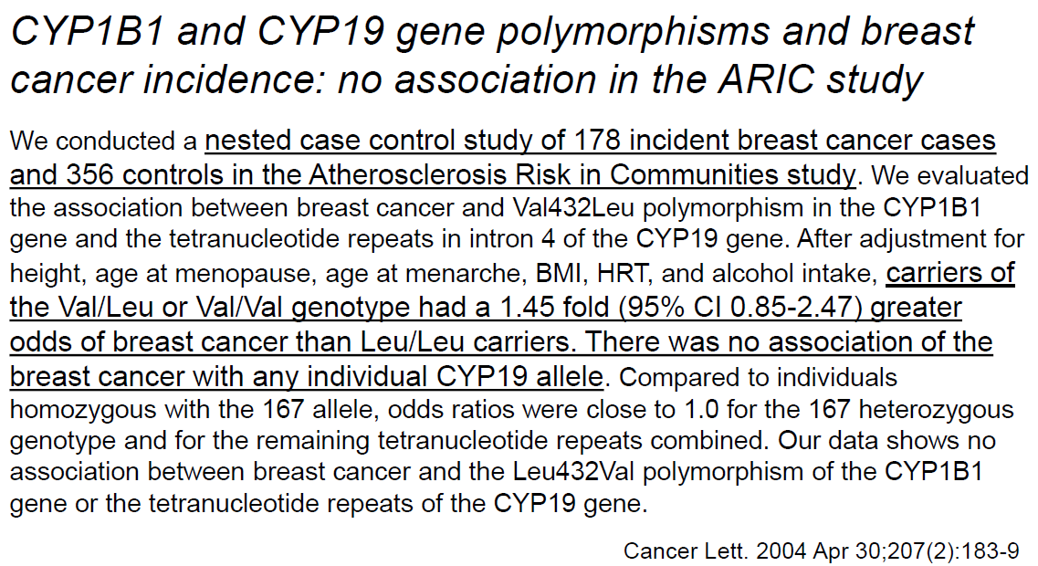
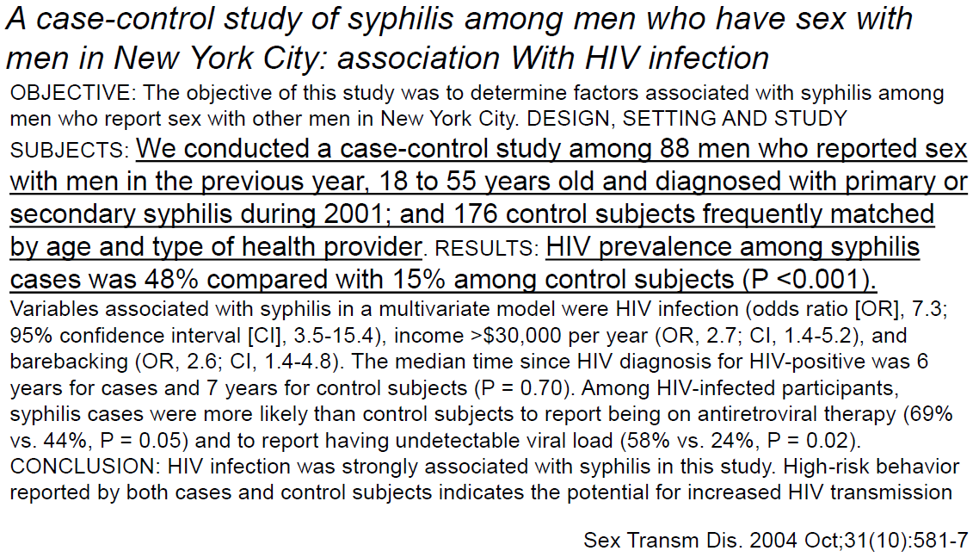

Task 4 – Analyse and compare two studies

How do you interpret the association between exposure and disease in these studies?

Note: You will be sent feedback on this task.

Reflect on your learning:
List some key points about Case-Control Studies.
Then check on the next page to see if your summary contains the same points

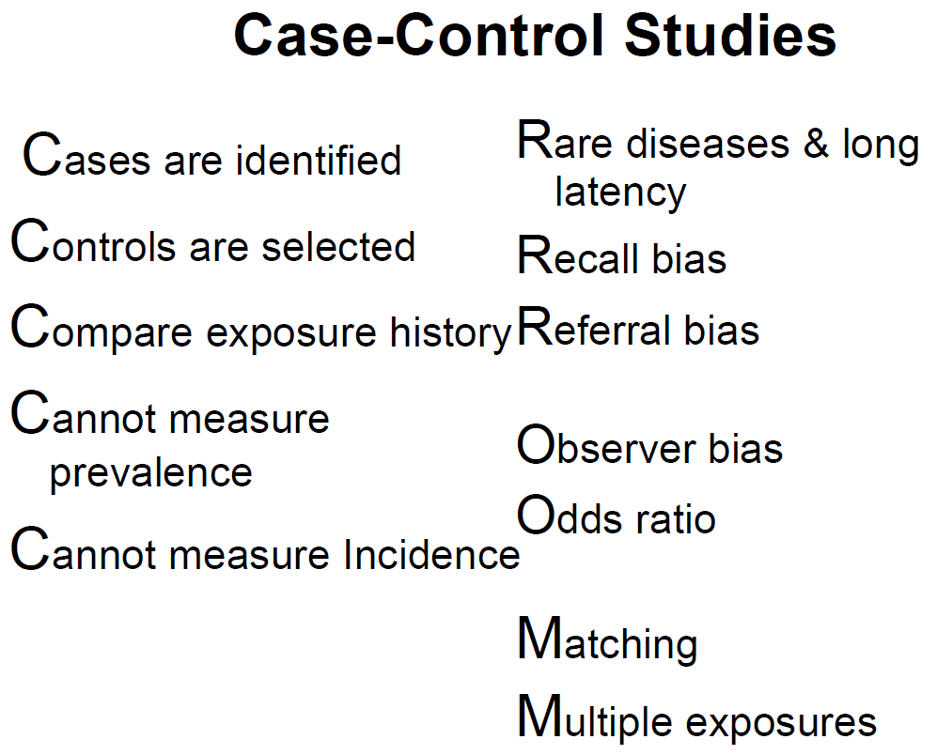
In the study below, the cases were men with TB who were HIV-infected and the controls were men who were not infected with HIV. One of the associations found was that lack of circumcision was significantly associated with HIV.
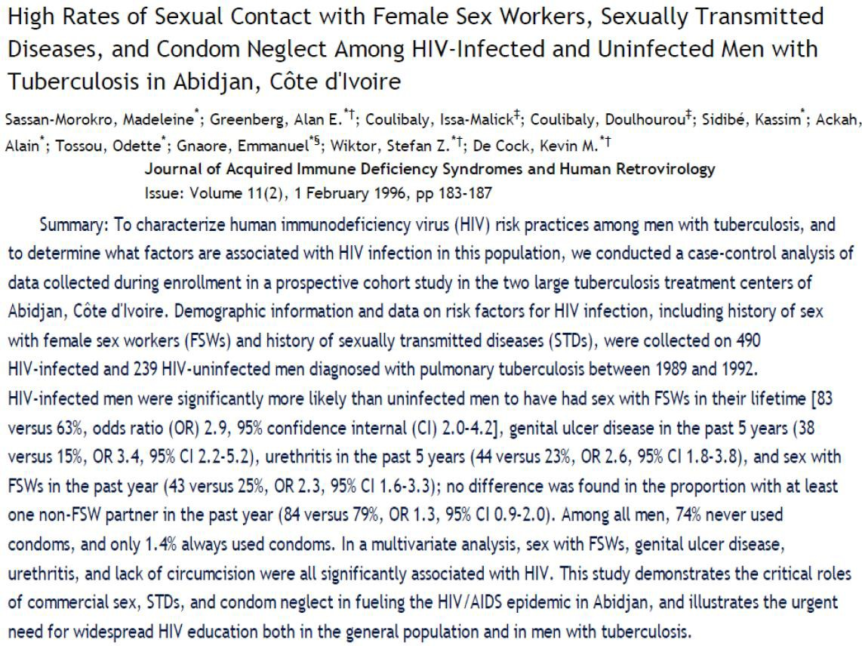
Task 5 – Analyse a study to identify differences and advantages

Discuss the special type of Case-control study presented in the paper above.
Why is it different from what has been presented already? What do you think are the advantages in this design?

2.6 Observational, Analytic, Cohort Study
In an observational analytic cohort study design or incidence study, a cohort of people without disease are identified. They are allocated to subgroups according to their exposure status. They are then followed up over a period of time and observed for the development of the outcome of interest or incidence. The incidence of disease in the exposed and unexposed is then compared using an appropriate measure of association. This could either be an incidence risk ratio (relative risk), incidence rate ratio, odds ratio, or hazard ratio.

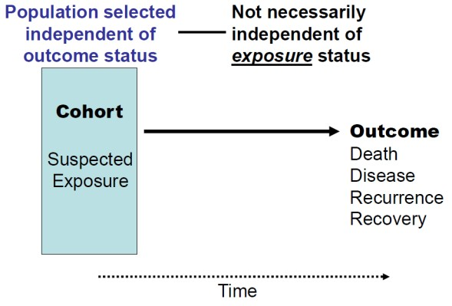
Figure 3: Schematic for Cohort Study Designs

Usually a cohort (defined population) on the basis of some factor (e.g., where they live) is selected before any of its members become exposed or before the exposures are identified. Then exposures are identified by histories or examination (e.g. blood tests) on the entire population to separate into exposed and non-exposed groups (Fig 4).

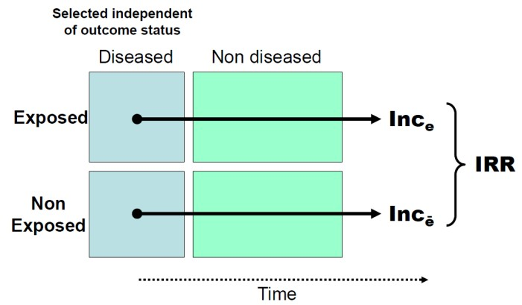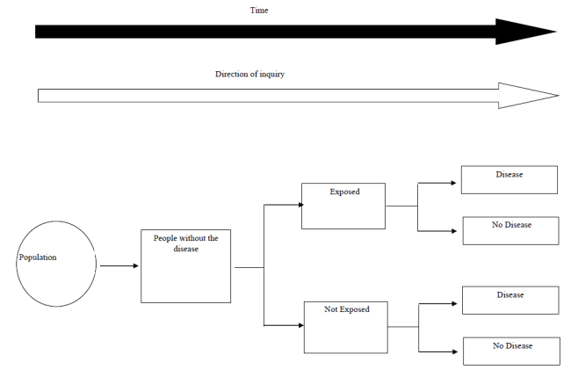

Fig. 4: ‘Normal’ cohort study design

This would be a Prospective Cohort (concurrent cohort) where the investigator ascertains
exposure and no exposure at the present time. The cohort will then be followed for a given time period, and incidence will be measured during this follow-up period. Groups move through time as they age.

Example: Framingham Heart Study, British Doctor‘s study.
The subjects were identified from British medical register in 1951. Each was sent a questionnaire about smoking habits. 34,349 men and 6,194 women were enrolled in the study. The study was renewed in 1957, 1966, 1972, 1978 and 1990 by which time 2/3 of the doctors were deceased. The incident event was cause of death obtained from the British vital registration of births and deaths register.

Sometimes the population is selected for higher exposure prevalence (higher risk of outcome). In this instance the population selection was not independent of exposure status e.g. rare exposure and outcome (Fig 5).

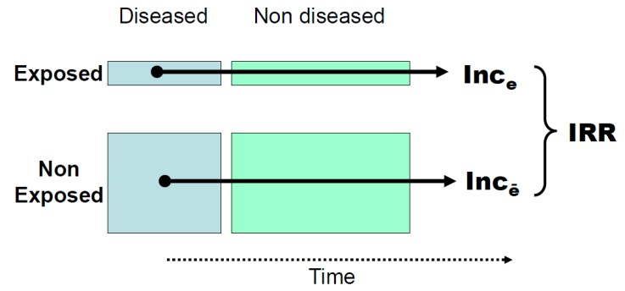

Figure 5: Population selected for higher exposure prevalence (higher risk of outcome)

Retrospective Cohort study design

A retrospective cohort study design makes use of historical data to determine exposure level at some baseline in the past and then determines subsequent disease status in the present. So the cohort is defined in the past, prior exposures are defined in the present and the outcomes are assessed at present.

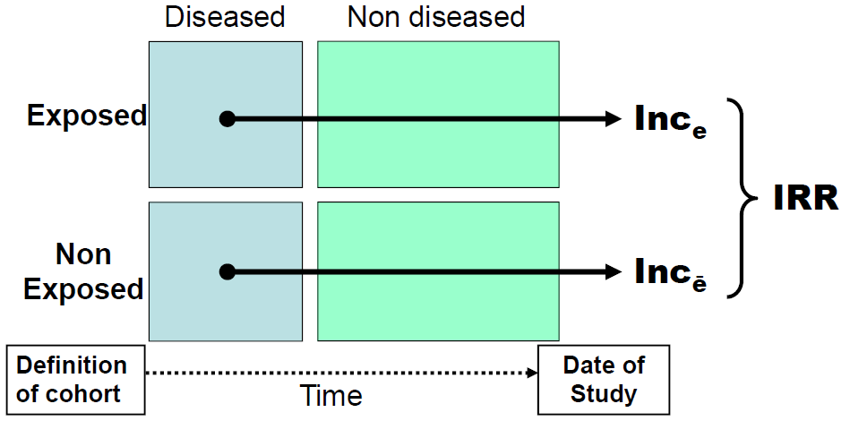
Least recall bias occurs if contemporaneous data on exposure are available (e.g. stored specimens).

Cohort Studies: Strengths & Limitations

Strengths
- Reduces potential for bias
- Allows calculation of incidence
- Allows calculation of all measures of association
- Multiple outcomes can be assessed
- Exposure data collected prospectively
- Useful for rare exposures
Potential for differential recall bias remains for some retrospective cohort studies.

Limitations
- Large number of participants needed for infrequent outcomes
- Expensive
- Time consuming - Lengthy follow-up is necessary for many outcomes
- Select a study population at higher risk
- Potential for losses to follow-up → reduces validity of study
- More difficult
- Less useful for long latent periods

Revise your learning – summarise this section

Think back to what you have learned about Cohort Studies and make a list of the main points you can remember.
Then compare your list with that in the box on the next page. Try not to look at the box until you have made your own list.

2.6.1 Nested Case-Control Studies
Nested case-control studies are a special type of case-control study where cases and controls are explicitly drawn from a defined larger cohort. It is a commonly used approach in occupational epidemiology.
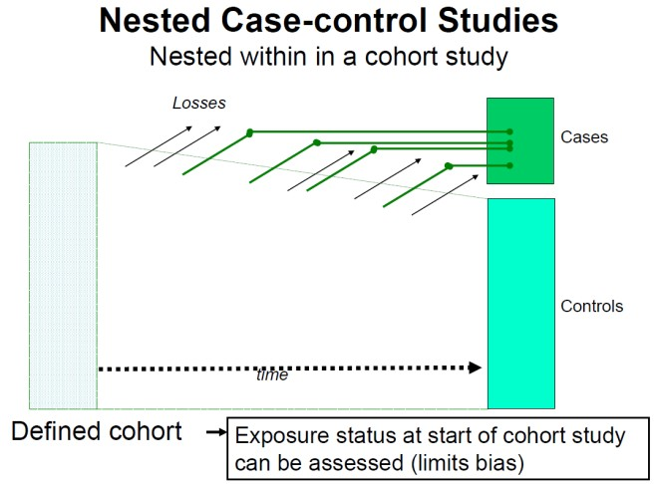
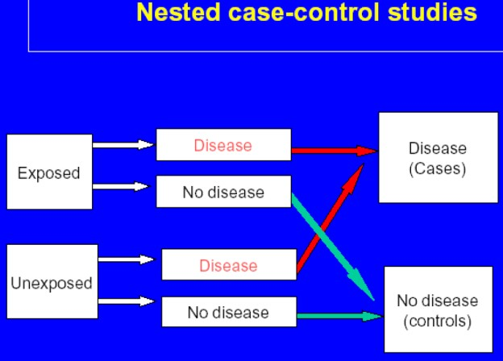
Cohort Studies - Summary
- Resources
- Relative Risk
- Methodological ideal for the examination of a causal association
- Measures disease incidence in exposed & non-exposed
- Measuring exposure precedes the disease (no recall bias)
- Multiple exposures and outcomes
- Not suitable for rare diseases
- Non-participation or lost-to-follow-up Selection bias

From a cohort study, the cases identified in the cohort become cases for the case-control study. A sample of unaffected cohort members is selected as the controls. The advantages are that it is an efficient way to do a study as one knows that cases and controls come from the same population.

Nested Case-Control Studies offer impressive reductions in costs and efforts of data collection and analysis compared with the full cohort approach. Compared to cohort studies, there is less potential bias from loss-to-follow-up, it is less time-consuming compared to classical case-control studies, it is less prone to recall bias, and temporality of causal effect is better established.

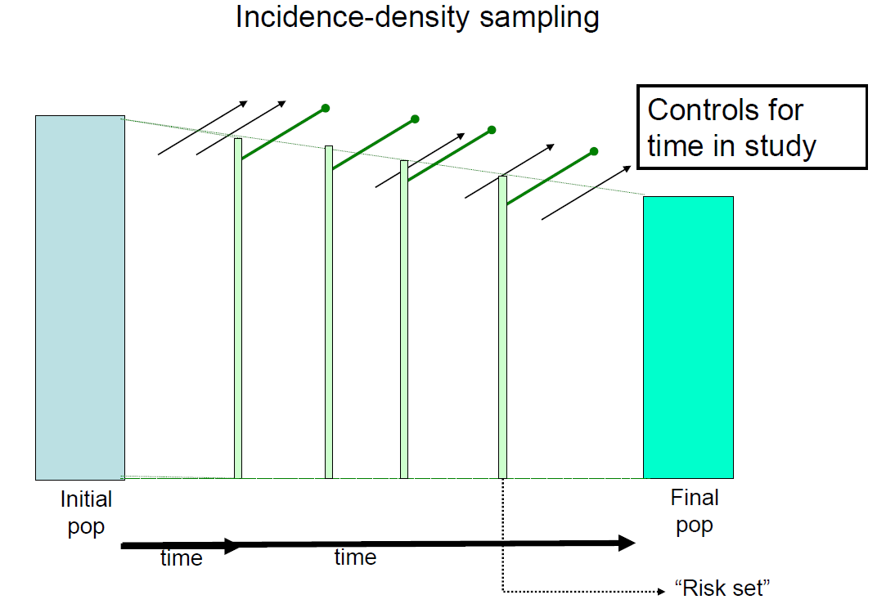

Case-cohort - Advantages over the Nested Case-control study:
- Sample of the whole cohort at baseline
      - Allows estimation of prevalence of risk factor(s), and thus of Population Attributable Risk
      - Can be used as single control group for many types of cases
      - Permits unbiased assessment of correlations among variables in the random cohort sample.

When are nested designs (case-cohort or nested case-control) the best choice?
These are best used in well-defined cohorts when additional (expensive or burdensome) information needs to be collected; and for laboratory determination in samples from specimen repository (e.g. serum bank).

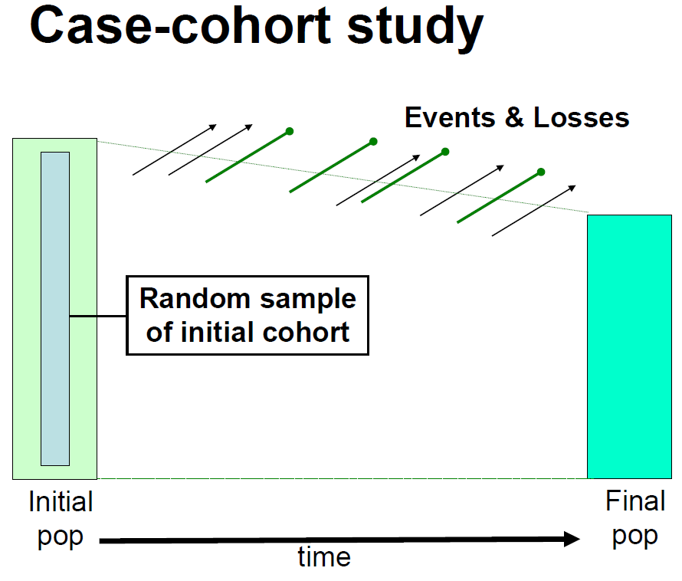

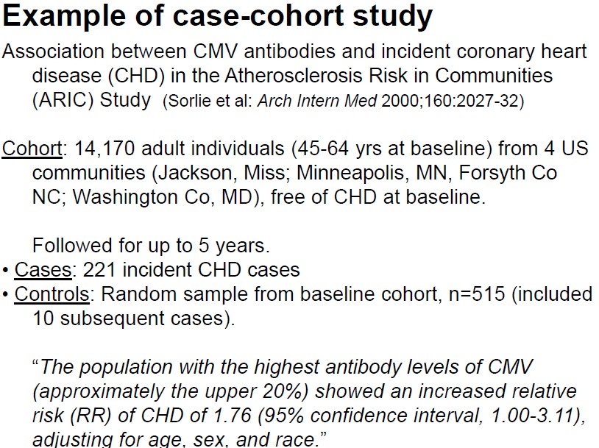

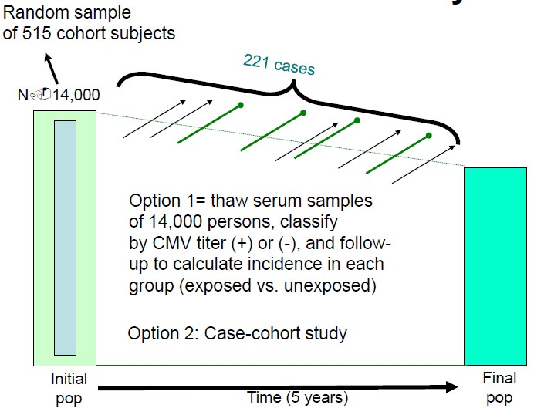

References for this session

Joubert, G. & Ehrlich, R. (2007) Epidemiology. A research manual for South Africa. 2nd edition Oxford University Press, Cape Town

Varkevisser, C.M., et al. (2003). Designing and conducting health systems research projects. 2nd revised edition. Amsterdam: KIT publishers; Ottawa: International Development Research Centre.

Gordis, L. (2004) Epidemiology 3rd edition, Elsevier Saunders

Webb, P. et al (2005) Essential epidemiology. Cambridge University Press.

Lecture material made available by:
  - Eliseo Guallar Intermediate Epidemiology in a Summer School at the Blumberg School of Public Health and from their Open Courseware material.
  - Alfredo Morabia, University Hospital, Geneva, Switzerland.

Study Session 3
Unit
2
Experimental Study Design

In this section, we will be looking at experimental study designs and specifically at randomised controlled trials.

Session Content
3.1 Introduction
3.2 Levels of Study Designs for assessing evidence
3.3 Randomized Controlled Trials (RCTs)
3.4 Masking or Blinding
3.5 Maintaining Comparability
3.6 Trials in development of new drugs
3.7 Intention-to-treat analysis
3.8 Consort statement

Intended learning outcomes

By the end of this session, you should be able to:
- Recognize the use of experimental studies as an epidemiologic study design,
- Distinguish between types of experimental studies,
- Describe key features of conducting experimental studies, and
- Recognize special considerations of experimental studies.
You will also practice the following academic skills in this session:
- Giving an opinion
- Identifying types of studies
- Using reasoning to respond to questions
- Checking your understanding
- Thinking of examples to illustrate a theory

3.1 Introduction

New products or therapies are regularly introduced, often with impressive claims. The question is how do you decide whether such claims are true or not?

One of the objectives of epidemiological study is to evaluate new preventive and therapeutic measures and modes of health care delivery. Experimental study designs are usually used for this purpose.

Other purposes for experiments or trials include:
- Investigate the aetiology of disease and modes of infection transmission
- Determine the extent of disease problems in the community
- Study the natural history of disease

Evaluate new preventive and therapeutic measures and modes of health care delivery
- Provide a foundation for developing public policy and regulatory decisions
There are different types of epidemiological studies:
In observational studies, the investigators use the data observed in the population to make inference on the relationship between exposures or independent variable and the outcome or dependent variable.

In experimental study design investigators intervene into the natural history by actively altering one of the exposure variables and then making inference of the relationship between the variables based on the outcomes measured

3.2 Levels of Study Designs for assessing evidence (from highest to lowest)

The strength of evidence from different study design varies. The lowest level of studies use observational descriptive study designs – case reports, case series, prevalence surveys and cross-sectional descriptive studies. Observational analytic studies provide stronger evidence, rising from ecological, to analytic cross-sectional, case-control and finally to cohort study design. Non-randomised experiments including controlled before and after studies and interrupted time series analysis can provide some evidence.

But a good quality randomised controlled trial can provide a higher level of evidence. Only a systematic review of randomised controlled trials and a meta-analysis of RCTs provide a higher level of evidence in health and medicine.

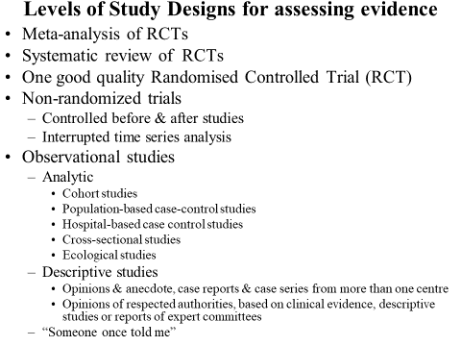

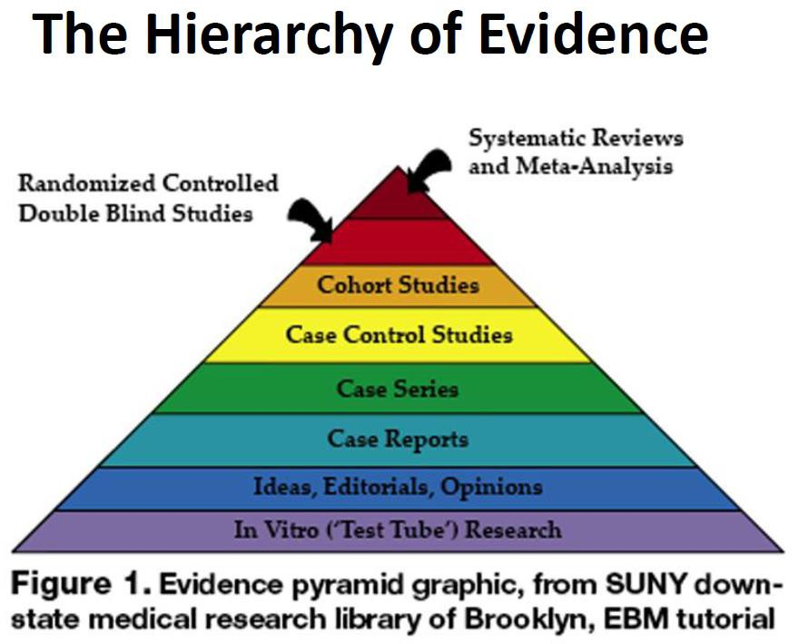

3.2.1 Historical example of an Experimental Study

James Lind in his Treatise on Scurvy gives an interesting example of an historical experimental study. He took 12 patients with scurvy. They were as similar as possible – he had very strict inclusion and exclusion criteria to exclude confounding effects (although long before confounding was recognised).Each pair was given a different intervention. Only those who received oranges and lemons recovered. The outcome was clear, it was measured as ‘fit for duty’.

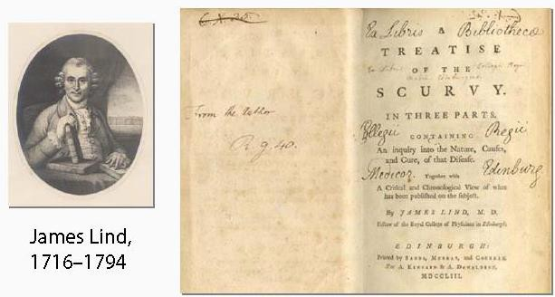
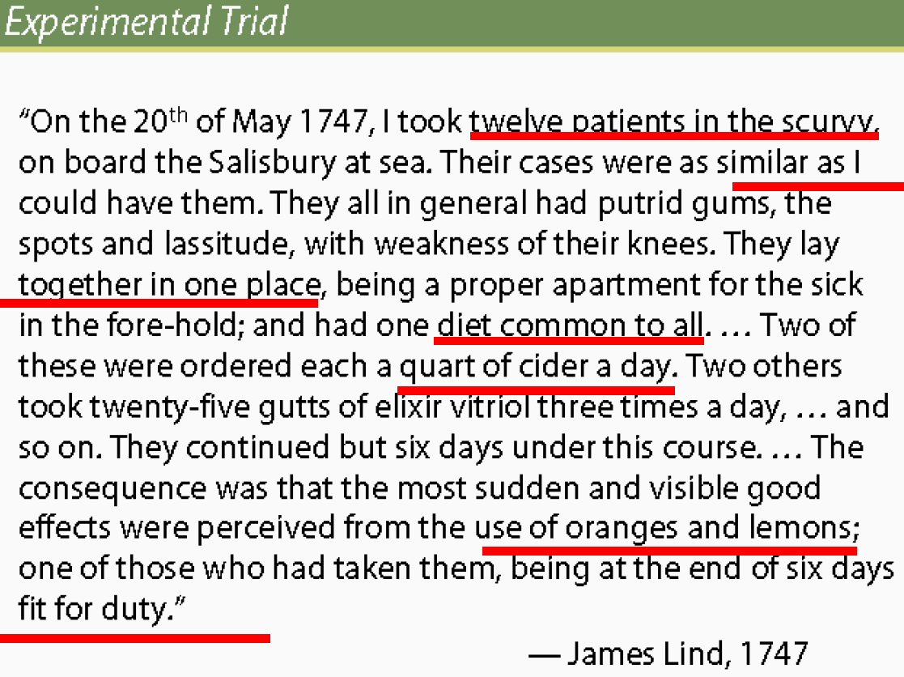
Giving your opinion:
Why would this study not be acceptable today?

Experimental studies can involve individuals or communities – this means that an exposure could be assigned on an individual basis, as in clinical trials where new drug treatments are being tested or the exposure could be assigned to an entire community, such as when health or educational campaigns are aimed at entire schools, neighbourhoods, or cities.

Assignment of exposure to individuals or communities can be random or non-random. Random assignment of exposure status involves a detailed series of steps that are taken to ensure that neither the investigator nor the participant has any influence on who gets assigned the exposure being studied.

The non-exposed group can be untreated, meaning that they are given no treatment at all, or are given a fake treatment (called a placebo), or the non-exposed group can be given a standard treatment. This might be done when a group of patients is participating in a drug study. The unexposed groups may be given the same medication they have always been given, while the exposed group may be given a newly developed medication, to see if the new medication is better in some way.

The most common type of experimental study is a randomized clinical trial. This type of trial is how most drugs or medical devices are tested for safety and efficacy.

Definitions:
- Trial: an experiment
- Clinical trial: controlled experiment having a clinical event as an outcome measure, done in a clinical setting, and involving persons having a specific disease or health condition
- Randomized clinical trial: clinical trial in which participants are randomly assigned to separate groups that compare different treatments

So a trial is an experiment which involves a manipulation of reality.
When a surgeon was asked to do a trial, he said: ‘Do you mean I do not operate on half the patients? This would doom half to death. Which half should be so unlucky?’
Before the advent of experimental epidemiology, many therapeutic interventions were reported in the same way as case studies and case series with no control group. Control groups in studies may be:
- Historical controls
- Non-randomised or
- Randomised
Non-randomised controlled studies are called Controlled Before and After (CBA) Interrupted Time Series (ITA) study design.

Allocation to Intervention Groups
- Without comparison - Case Study or Case Series; Results can be improved by omitting controls
- Studies with Comparison

Historical controls
  - Non-randomized
    - Controlled Before and After studies (CBA)
    - Interrupted Time-Series analysis (ITS)

Randomised

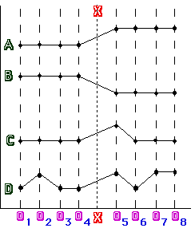
3.2.2 Non-randomised trials

Interrupted time-series analysis
- Change in trend attributable to intervention
  - Clearly defined time of intervention
  - At least 3 data points before and after

In an interrupted time series analysis each patient acts as its own control. The important thing is to ensure this is done in a standardised way. The intervention must be given at a clearly defined time. Measurements need to be done at least three times before and three times after the intervention.

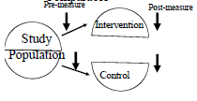
3.2.3 Controlled before & after studies

In a controlled before and after study the intervention and control groups are not randomized. There needs to be appropriate choice of the control sites. Data is collected on the intervention and control groups before and after the intervention (Contemporaneous data collection).

3.3 Randomized Controlled Trials (RCTs)
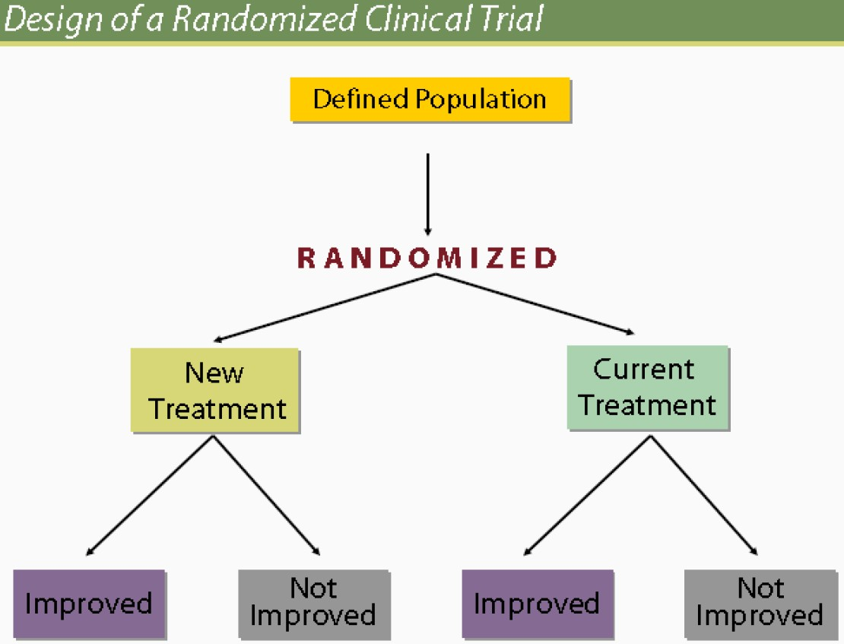
The schematic below is a design of a randomised trial. A defined population is randomised into an intervention and control arm. The outcome of interest is measured in each of these arms and compared. Look at this design in detail.

Why Randomised Controlled Trials?
Randomised controlled trials are performed in order to test the possible effect or efficacy of a therapeutic or preventive intervention, or to compare the efficacy of two interventions.
It is also used to estimate the frequency and nature of side-effects - adverse events and complications - to determine the factors associated with the effect or effect modifiers.

Types of interventions that can be randomized
- Experimental studies need not be limited to drug trials
- They could involve new medical and health care technologies
- New methods of primary prevention
- New programs for screening
- New ways of organising and delivering health services
- New community health programs
- New behavioural intervention programs

Task 6 – Identifying examples of a type of study

Look at the list above of possible types of randomized trials. Can you think of any examples of actual trials of one of these types conducted in your area or country?

Example: Results of a BCG Vaccination Trial
We can learn from past mistakes. The results of a trial of BCG vaccination reported in 1946 showed that 0.67% of those vaccinated died compared to 3.3% of controls.

Vaccination was given to children from good families who were likely to come back for repeat vaccination. When the trial was repeated and alternate children from no specific background were vaccinated, the effect or TB deaths was no different in the two groups.
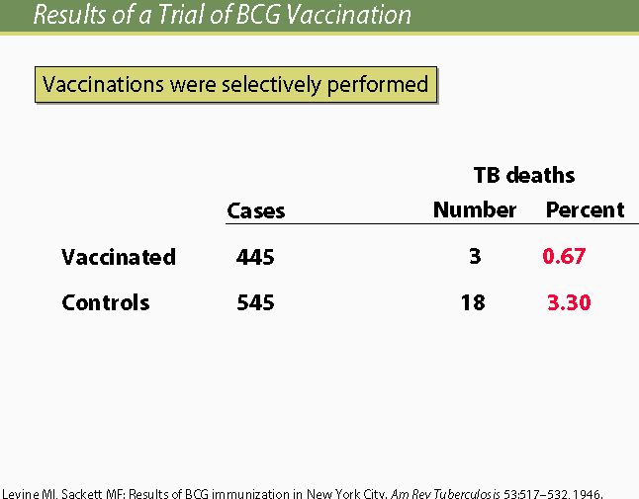

Randomisation

Randomisation in experimental studies has been around for a long time.
- Sir R.A.Fisher first developed the concept of experimental randomisation in 1925
- Anderson & MacMahon (1951) randomised patients by using a coin flip to see who received treatment for TB
- Sir Austin Bradford-Hill introduced the use of random numbers in allocation of patients in the study of streptomycin and tuberculosis

What is randomisation?
Randomisation is the process by which allocation of subjects to treatment groups is done by chance without the ability to predict who is in which group.
It guarantees equivalence of prognosis between exposure categories by creating comparability. However, randomisation brings chance into play – for example by chance there may still be more patients with bad prognosis in one of the randomised groups.

How to randomize?
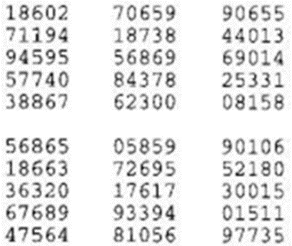
Tossing a coin is open to fraud, as is using envelopes numbered and well-sealed to be opened at the time the patient needs to be randomised. Random number tables such as this can be used.

Choose a starting point randomly, having decided whether you are going to go up, down, left or right from the starting number. Let‘s say you want five numbers between zero and 10 The numbers would be eight, 3, 3, 8, and 6.

This is an example using a one digit random number table:
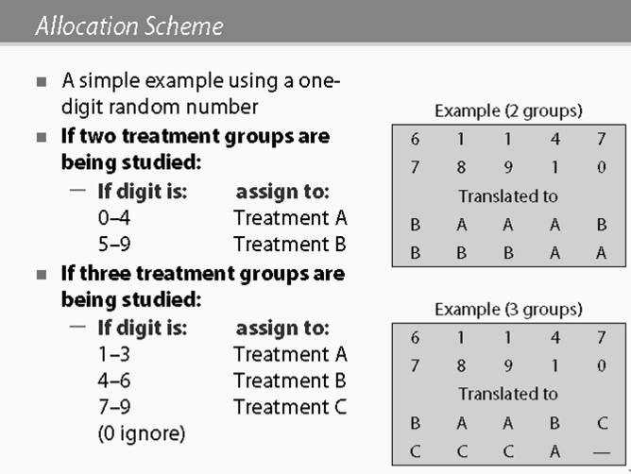

If there are 10 groups and two treatment groups are being studied and if the digit is 0 to 4, then they would get assigned to treatment A if digit is 5 to 9 then they would get assigned to Treatment B.
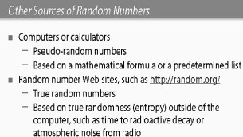

These days it‘s most likely that you would use computers and calculators to generate random numbers. There are websites with true random numbers as well.
How can one further increase the likelihood that both groups have equal prognosis?
One can increase the sample size – which is not very efficient
One can stratify randomisation according to prognostic indicators or scores

Patients with :
  - very good prognosis - randomise (A&B)
  - good prognosis - randomise (A&B)
  - medium prognosis - randomise (A&B)
  - poor prognosis - randomise (A&B)
  - very poor prognosis - randomise (A&B)

Purpose of randomisation
The primary purpose of randomisation is to prevent bias in allocating subjects to treatment groups and thus avoid predictability. The secondary purpose is to achieve comparability between the groups but there is no guarantee of this. Randomised trials are the gold standard of study designs because potential for bias is avoided.

Think about the cartoon below. Is what Charlie Brown says true?
How can educators avoid this phenomenon?

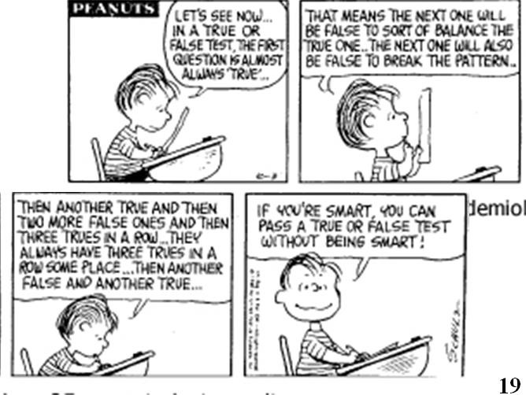

An example: Study of two groups of patients with myocardial infarction
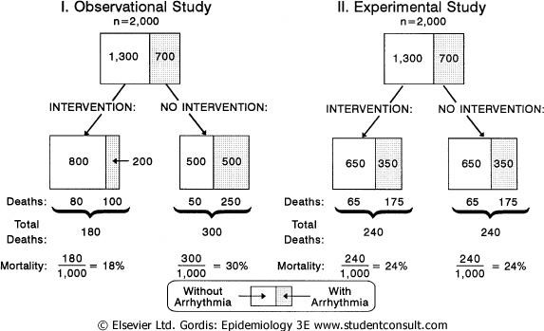
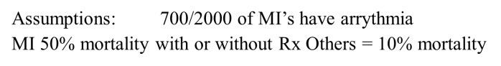

An observational comparative study of an intervention in two groups of patients with myocardial infarction shows that the mortality between the two groups differs.

There were 1000 patients in each group. In one group, the mortality was 18% and in the other group it was 30%. Assume an observational study in which by chance the proportion of patients with arrhythmia, the major cause of mortality in the two groups, differed – 200 in the intervention and 500 in the non-intervention group.

If randomisation had occurred using an experimental study design, the proportion of patients with arrhythmia in the two groups would be similar and there would be no difference in mortality in the two groups i.e. 350 with arrhythmia in the intervention in 350 in the non- intervention group = 24% mortality in each group.

This example emphasises the importance of randomisation.

Improving randomisation
Stratified randomisation is random assignment within groups defined by participant characteristics such as age or disease severity, intended to ensure a good balance of these factors across intervention groups.
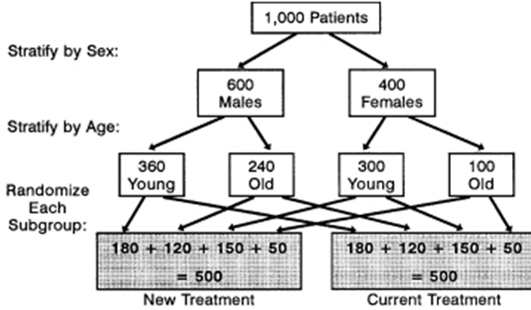
Stratified randomisation

Maintaining comparability during follow-up
Another criterion of a randomised controlled trial is maintaining comparability during the follow-up period. The time that each patient was followed up for should be the same in both groups. The two groups need to receive attention during follow-up in terms of the time they have contact with study clinicians and with the study conditions, type of treatments that they receive the quality of all these activities and the support that is given.

The way to ensure this is double blinding whenever possible.

3.4 Masking or Blinding

Masking or blinding increases the objectivity of the person dealing with a randomised study; it prevents prejudice or information bias.
Who can be blinded?
- Study participants
- Caregivers/‘treaters’
- Data collectors/assessors of the outcome
- Data analysts
- Investigators

There are different levels of masking. It can be an open or non-blinded RCT. A single, double or triple blinded RCT can also be designed.

Single blinding
- Subject does not know which therapy he/she gets.
- Trialist doesn‘t know which therapy the patient gets.

Double blinding
Ideally all randomised control trial should be at least double blinded in order to prevent transfer of the beliefs in efficacy from one group to the other and subjectivity of reporting. It would also prevent differences in quality or intensity of treatment according to such beliefs, to prevent differences in compliance or a subtle change in the patient-doctor relationship. Patient-trialist relationship differences could result in differences in compliance. Patient doctor relationship may affect (pharmacological) effects themselves.

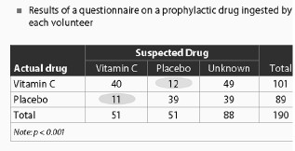
Placebo and blinding

In a study looking at the efficacy of Vitamin C in preventing the common cold, participants are asked whether they thought they were receiving vitamins C or placebo. Those who thought they were receiving placebo even though they were taking Vitamin C had increased colds.
Invariably, participants pick up beliefs or knowledge about the intervention that they are involved with in a trial – which can influence the outcome of either the control or intervention arm.

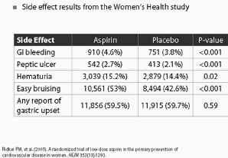
Placebo and side effects

In this study assessing the efficacy of aspirin, side effects were measured as well. Even those who were on placebo had substantial side-effects although in most instances these were significantly less than the active agent.

3.5 Maintaining Comparability

Compliance is the willingness of participant to carry out the procedure according to established protocols. ‘Drop outs’ are the participants who do not adhere to the experimental regimen during follow-up. ‘Drop ins’ are the participants who do not adhere to the control measurement during follow-up.
Drop outs can be for reasons un-related to the prognosis. These tend to affect only the power of the statistical analysis. If the dropouts are for reasons related to prognosis, for instance if the patients die, this may affect the comparability, especially if the deaths are all in one group. In which case, it may require statistical correction. Drop in’s usually reduce the observed differences between intervention and control groups.
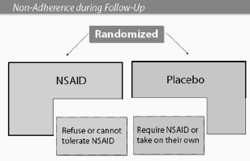
In this study looking at the efficacy of non-steroidal anti-inflammatory drugs the drop outs were those who refused or could not tolerate the NSAIDs. The drop in’s were those who weren‘t given NSAID but needed them for other reasons and decided to take them of their own accord.

Not everybody who has a condition that improves does so because of receiving a specified therapy. The improvement may be due to natural changes that have occurred without the therapy. It may be due to the pharmacological effect of the drug or it may be due to subjectivity of the patient during therapy, or as a result of the influence of the quality of care in the doctor-patient relationship. It may also be a non-pharmacological effect of the drug.

The first two can be eliminated by having a control group. The next two should be controlled by double blinding or masking and by receiving equal attention. Non-pharmacological effects are controlled by using a placebo.
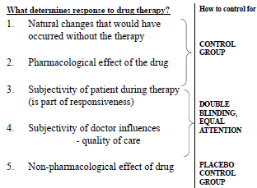

3.6 Trials in development of new drugs

There are four phases in the development of a new drug:
Phase 1: Involves an investigation into the pharmacokinetics and pharmacodynamics. It is done to determine the levels of drug toxicity, metabolism, pharmacological effect, and safe dosage range and to identify side-effects. (clinical pharmacological studies)
Phase 2: Efficacy studies - the drug treatment is given to large group of people. 100 to 300 are needed to assess efficacy and to further evaluate safety. (Preliminary safety and efficacy studies)
Phase 3: Effectiveness studies. The drug treatment is given to large groups of people to confirm its effectiveness and monitor side-effects. (Controlled trial for efficacy studies)
Phase 4: Post-marketing clinical trial. The drug treatment is monitored to gather more information on risks benefits and optimal use. (Post marketing surveillance studies).

3.7 Analysing Randomised Controlled Trials

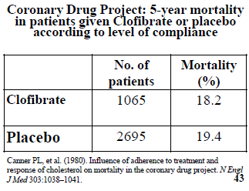
An example
In this study the reduction in mortality due to lowering of cholesterol using clofibrate was measured. Little difference was observed when aggregated groups were compared -18.2% vs. 19.4%.

When the outcome was disaggregated according to poor and good compliance to therapy, there was a marked difference in the intervention and control groups.

However, good compliance resulted in reduced mortality in both the intervention and the placebo group.
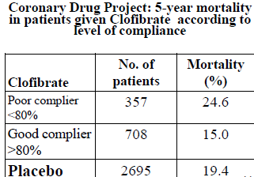

Task 7 – Use your own reasoning to give an opinion
Think about the statement above. Why do you think this was the case?
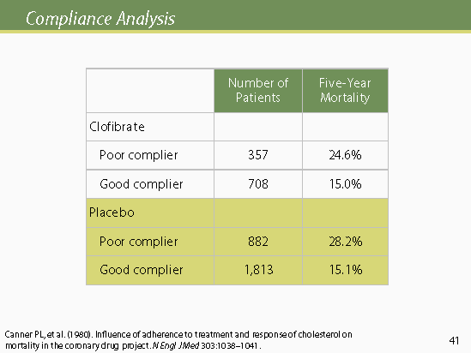

Note: Clofibrate is no longer used to lower cholesterol

3.7.1 Expressing results of RCTs

There are different ways to express the results of a randomised control. If it is a preventive intervention then the preventive vaccine efficacy is calculated. For this, one needs the incidence risk or incidence rate. The incidence risk ratio or relative risk and incidence rate ratio are other measures that can be used. Invariably the results of RCTs are graphically presented in survival curves.

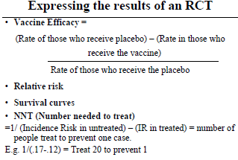
Example 1
In the Randomised controlled trial illustrated below, Abdool Karim et al from CAPRISA measured the efficacy and safety of Tenofovir Gel, an antiretroviral microbicide for the prevention of HIV infection in women. They showed that at 12 months there was a 50% reduction in HIV incidence in the Tenofovir group vs. the placebo group.

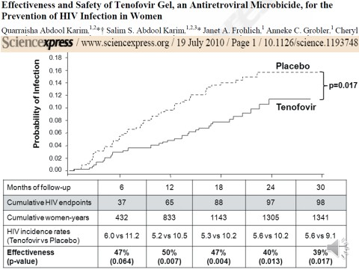
The HIV incidence rate for the intervention and placebo or control group was 5.2 versus 10.6 100 person years. The efficacy is calculated as 10.6-5.2 divided by 5.2 or 50%. This could also be presented as an incidence rate ratio. The survival curve is depicted in the graph.

3.7.2 Intention-to-treat analysis
An Intention-to-treat analysis (ITT) is a strategy for the analysis of RCTs that compares patients in the groups to which they were originally randomly assigned. This is generally interpreted as including all patients, regardless of whether they actually satisfied the entry criteria, the treatment actually received, and subsequent withdrawal or deviation from the protocol i.e. it is an analysis based on the initial treatment intent, not on the treatment eventually administered.

If people who have a more refractory or serious problem tend to drop out at a higher rate, even a completely ineffective treatment may appear to be providing benefits if one merely compares the condition before and after the treatment for only those who finish the treatment (ignoring those who were enrolled originally, but have since been excluded or dropped out). Clinical effectiveness may be overestimated if an intention to treat analysis is not done. Everyone who begins the treatment is considered part of the trial, whether he or she finishes it or not.

ITT versus PP
Per-protocol (PP) analysis is a strategy of analysis in which only patients who complete the entire trial are counted towards the results.

ITT versus AT/ES
Treated / Efficacy subset (AT/ES) analysis selects the subset of the patients who received the treatment of interest, regardless of initial randomization, and who have not dropped out for any reason. This can introduce biases to the statistical analysis and inflate the chance of a false positive; this effect is greater the larger the trial.

Why ITT? - ITT has two main purposes:
a. It maintains treatment groups that are similar apart from random variation. This is the reason for randomisation, and the feature may be lost if analysis is not performed on the groups produced by the randomisation process. For example, in a trial comparing medical and surgical treatment for stable angina pectoris, some patients allocated to surgical intervention died before being operated on. If these deaths are not attributed to surgical intervention using an intention to treat analysis, surgery seems to have a falsely low mortality.

b. ITT allows for noncompliance and deviations from policy by clinicians. There are, of course, exceptions. Some types of deviations from randomised allocation may occur only within the trial setting and would not be expected in routine practice. For example, in a trial comparing active and placebo vaccination there is the potential for placebo vaccine to be incorrectly administered in place of active, but this could not occur outside the trial and so need not be accounted for in estimates of potential efficacy. However, most types of deviations from protocol would continue to occur in routine practice and so should be included in the estimated benefit of a change in treatment policy.

Problems with ITT
- Measurement bias: knowledge of whether participants are receiving intervention or not influences outcome measurement
- Analysis bias: Researcher looks hard to find an effect somehow somewhere especially by assessing sub-groups or by varying cut-off points for categorical data
- Intervention partially given or not given due to participant choice: Participant decides not to continue with treatment or does not even take it
- Loss to follow-up: Cannot find participant to measure outcome
- Contamination: Non-intervention participant gets the intervention by mistake
- Co-intervention: Participants receive some other intervention besides the one being studied

End note on ITT
Intention to treat analysis is therefore most suitable for pragmatic trials of effectiveness rather than for explanatory investigations of efficacy i.e. Intention to treat analysis provides information about the potential effects of treatment policy rather than on the potential effects of specific treatment.

Check your understanding and give examples

What is the difference between efficacy and effectiveness?
Give an example of a pragmatic trial of effectiveness and a trial used for explanatory investigations of efficacy.

3.7.3 Number Needed to Treat
Number Needed to Treat (NNT) is an important new concept (said to be first described in 1988). It is an epidemiological measure used in assessing the effectiveness of a health-care intervention, typically a treatment with medication. The NNT is the number of people who need to be treated to prevent one additional bad outcome. In a RCT, it is the number of patients that need to be treated for one to benefit compared with a control.

Usefulness of NNT
NNT is important when making decisions about whether or not to implement an intervention that has been shown to be effective in an RCT on a wider-scale, especially in resource-limited settings. So it has important public health utility.

NNT Calculation
It is defined as the inverse of the absolute risk reduction.

1

(Rate of outcome in intervention group) – (Rate of outcome in the non-intervention group)

NNT is a number between 1 and ∞. The ideal NNT is 1, where everyone improves with treatment and no one improves with control, so effective interventions have a low NNT. The higher the NNT, the less effective is the treatment. A negative number would not be presented as a NNT; rather, as the intervention is harmful, it is expressed as a number needed to harm (NNH).
Some other related concepts are:
Number Needed to Treat (NNT) Number Needed to Prevent (NNP) Number Needed to Vaccinate (NNV) Number Needed to Harm (NNH)

The unit of NNT is expressed as number of events per subject; therefore the inverse NNH will be number of subjects (required) per event. NNT may be expressed as percentage, then calculated as 100/P(Control) – P (Intervention). Variants are sometimes used for more specialized purposes such as number needed to vaccinate (NNV) and number needed to prevent (NNP).

NNT values are time-specific. E.g. if a study ran for 5 years and it was found that the NNT was 100 during this 5 year period, in one year the NNT would have to be multiplied by 5 to correctly assume the right NNT for only the one year period (in the example the one year NNT would be 500).

3.7.4 Ethical Limitations of RCT
There may well be serious ethical issues associated with randomised controlled trials. Institutional Review Board needs to ascertain whether the control arm can use the treatment of placebo or the standard level of care available at the time. At least equivalence of efficacy is expected in both the intervention and control arm. The Board needs to be convinced that safety is no worse in the intervention arm.

Questions to consider:

- Is it ethical to randomise?
- Is it ethical not to randomise?
- Can truly informed consent be obtained?
- Under what conditions should a randomised clinical trial be stopped earlier than originally planned?
- If there are stopping rules in a formal trial this can be done by the independent monitoring group, if the trial is showing
- Extreme benefit or extreme harm
- Immediate and blindingly in the event of serious complications
- Extremely high significance to justify termination

Note: Your lecturer might invite you to discuss these questions online.

3.7.5 Generalisability of results
Another limitation of RCTs is the generalisability of the results. Because there is excessive control in experimental studies the results may not be readily applicable in general clinical or public-health settings. The selection of the patients is often NOT population-based - for instance only selective or severe cases may be included from a hospital.
Results that show efficacy in an experimental situation may not show effectiveness as a general intervention strategy. Pharmacological efficacy doesn‘t imply that a general policy will be effective.
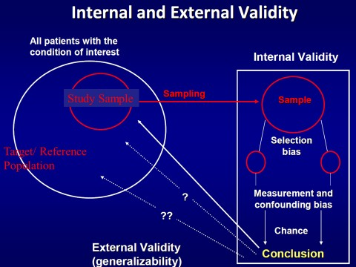

Generalisability or external validity, answers the question: ‘Can the results of the study be inferred in the reference or target population?’

Randomisation should ensure that the intervention and control arm of the study reflects the study population.

3.7.6 Example of results of a Randomized Trial
On the next page is an example of how to calculate the efficacy of the preventive intervention using data from physicians’ health study. The unadjusted efficacy was 42%.
It was concluded after adjustment that aspirin reduced the risk of myocardial infarction by 44% in men 50 years or older who did not have clinical evidence of coronary disease i.e. primary prevention.

Those with mild diastolic hypertensives who received step care showed a significant reduction in cumulative mortality over time.
The mortality reduction was significant in all categories of hypertension but the effect was less with more severe hypertension.
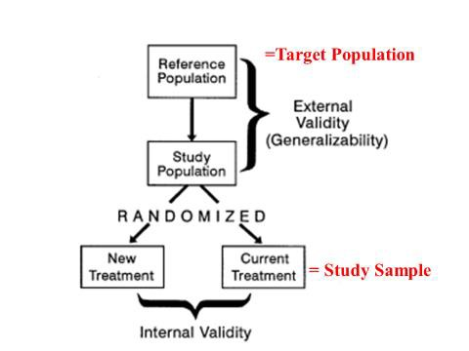

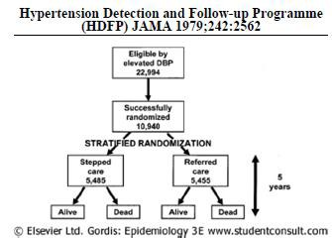

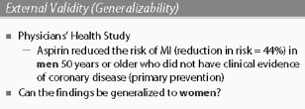
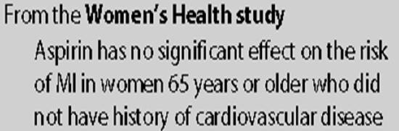

3.8 The Consort Statement

The consort statement is an important document intended to improve the reporting of a randomised controlled trial, enabling readers to understand a trials design, conduct analysis and interpretation and assess the validity of its results. It emphasises that this can only be achieved through complete transparency from authors.
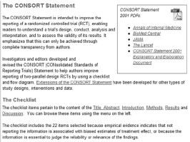
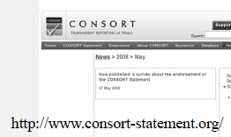

There is a checklist of items to include when reporting a randomised trial. The report must include:

- How participants were allocated to interventions in the title and abstract;
- A scientific explanation of the rationale for the chosen intervention;
- The eligibility criteria for participants as well as the settings and locations where the data were collected;
- Precise details of interventions intended for each group and when they were actually administered;
- A clear hypothesis and objectives;
- Clearly defined primary and secondary outcome measures including methods to enhance the quality of measurement;
- How the sample size was determined and, when applicable, explanation of any interim analyses and stopping rules;
- The method used to generate the random allocation sequence including details of any restrictions;
- Method used to implement the random allocation sequence;
- Who generated the allocation sequence, who enrolled participants and who assigned participants to their groups;
- Statistical methods used to compare groups for primary outcomes as well as methods for additional analyses – subgroup analyses and adjusted analyses;
- Flow of participants through each stage – a diagram is required Protocol deviations together with reasons;
- Dates defining the periods of recruitment and follow-up;
- Baseline demographic and clinical characteristics of each group;
- Number of participants (denominator) in each group included in each analysis and whether the analysis was by intention to treat.
- For each primary and secondary outcome a summary of results for each group and the estimated effect size and its precision or important adverse events or side-effects in each intervention group Interpretation of the results
- Generalisability external validity of trial findings
- General interpretation of the results in the context of current evidence

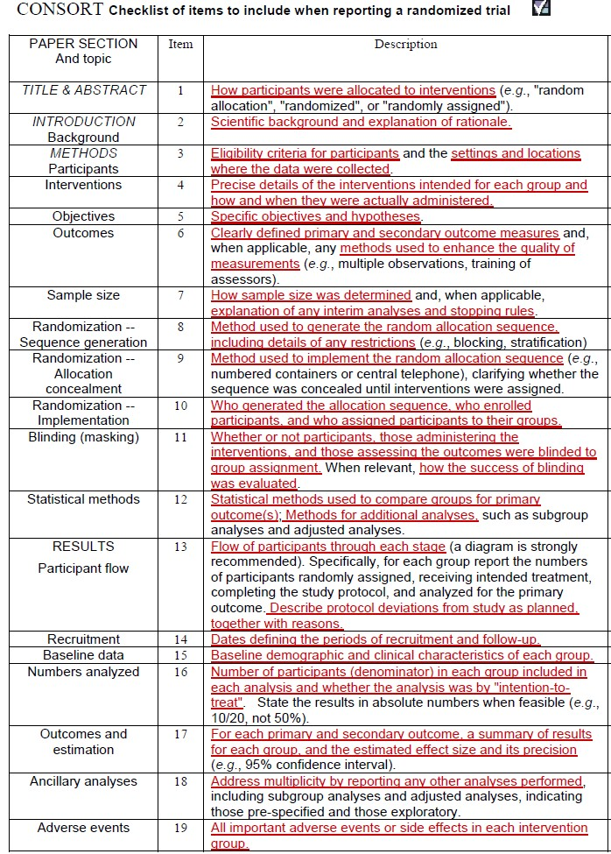

Session 4 –
Unit
2
Systematic Reviews

In this short session, we will be looking at the features of and steps in the systematic review as a study design.

Intended learning outcomes

By the end of this session, you should be able to:
- Describe systematic reviews and their uses
- Be familiar with the process involved in doing a systematic review
In addition, you will practice the following academic skill in this session:
- Sourcing information on the internet to supplement the course notes

What is a systematic review?

It is a review in which bias has been reduced by the systematic identification, appraisal and synthesis of all relevant studies according to a predetermined and explicit method. The benefits are transparency and reliability, and reduced bias (reviewer, reporting bias, etc.)

‘A review in which bias has been reduced by the:
- systematic identification
- appraisal,
- synthesis
- statistical aggregation (if relevant) of all relevant studies on a specific topic according
to a predetermined and explicit method.’
(Moher et al. Lancet; 354: 1896-900)

Meta-analysis
- Meta-analysis is the statistical analysis of the data/ results from studies included in a systematic review to produce an overall, pooled result.

Where to find SR’s
  - International organizations that aim to help people make well-informed decisions about healthcare by preparing, maintaining and promoting the accessibility of systematic reviews of the effects of health care interventions.
  - Advantages & disadvantages of different observational study designs
- Systematic Review and Meta-analysis
- A systematic review is a review of the methods and results of all individual studies designed to answer the same research question and that conform to set criteria.

Shortcomings of traditional reviews
  - Systematic error (bias) from: Incomplete literature searches (only English; one electronic database e.g. Medline); Selective inclusion of studies; insufficient attention to study quality
  - Random error from insufficient attention given to sample size

Examples of Systematic Reviews

Example 1: Corticosteroids for prevention of respiratory distress syndrome
- Expert review of the literature (Robertson, BMJ 1982)
The evidence suggests that antenatal steroids are of value only in white females, and even for them the benefit is mainly in those of 30-32 weeks gestation…

Example 2: Corticosteroids for prevention of respiratory distress syndrome
- Another non-systematic review (Crowley, 1989)
- The benefits of antenatal corticosteroids have been established. No further trials are necessary with the exception of certain specific situations (such as pre-eclampsia) or to establish other dosages or routes of administration.

Features of Systematic Review
- Rationale for Research Question: Why is research question important? What is already known? What is not known?
- Explicit Research Question
- Objective of Systematic Review
- Find / locate studies. (Where searched for studies that addressed the Objective).
- How searched (in detail so others can repeat and verify)
- Eligibility criteria: to identify which studies based on abstracts sufficiently addressed the Objective to warrant further assessment
- Eligibility criteria: PICOS
- Assess validity of studies included with regards to Bias and Confounding
- Final selection of Studies for Review: which studies were finally included and why; which studies were finally excluded and why
- Final selection of Studies for Review: based on Full Article; PICOS; Bias
- Report individual study results showing effect of chance and any/which confounders were adjusted for in each study and Bias
- Meta-analysis: pool all data from all studies and then analyse it for the outcome measure (allows one to decrease the effects of chance)
- List limitations of the systematic review
- Conclusion: Provide a definite conclusion on the Objective of the Systematic Review

Steps in a Systematic Review
- Find /locate studies
- Important to include both published (peer-reviewed) and unpublished literature
  - Studies with significant results and that are larger are more likely to be published than those without - publication bias
  - Include unpublished trials registered on trials networks and databases
  - Ensure comprehensive search strategy
- Generally health-related electronic databases (e.g. Pubmed/ Medline, Embase)
- For trials go to the Cochrane Controlled Trials Register
- Supplement with other databases e.g. Science Direct, Sabinet, Google Scholar, Epsco
- Also search grey literature (meetings or conference papers or abstracts, working papers etc.; access relevant websites
- Reference list of included articles
- Check to ensure all relevant publications and studies are included

- Assess the methodological quality of the studies
      - Typically used to describe the design, procedures and conduct of a study, data analysis, relevance to policy and practice and quality of reporting.
      - Why? - Poor quality studies distort results
      - How? - Multiple reviewers operating independently; Scoring the quality of studies on a scale (e.g. Jadad scale); Sensitivity analysis

Extract data
      - Use multiple independent reviewers
      - Data extraction from
        - Reference
        - Setting and sample of people
        - Intervention or treatment and measurement
        - Health outcome and measurement
        - Size of effect (OR or RR) with CIs

Presentation of data
- Give number of studies included and rejected
- Tabulate summary of results of the review
- Outline main results descriptively in a narrative

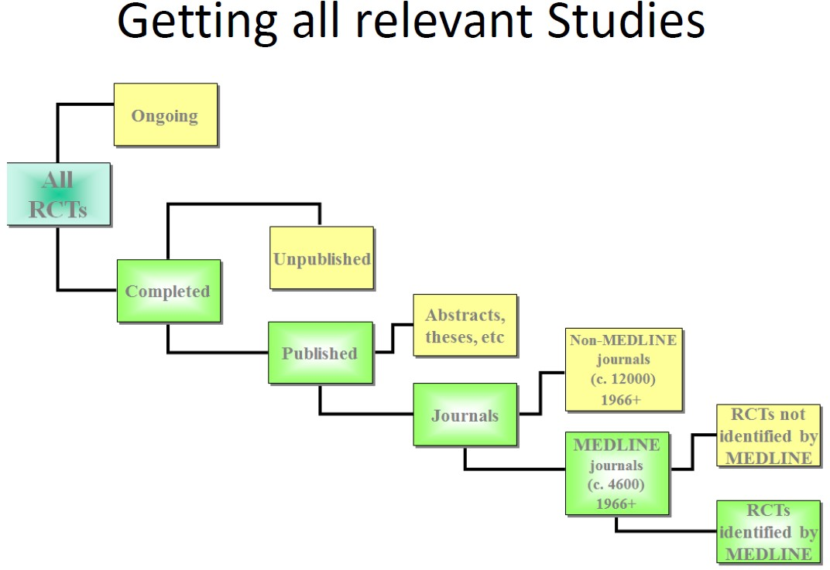

Additional readings

A useful website to refer to and browse about evidence-based medicine:

http://www.jamaevidence.com

