**Session 1 - Introducing Rational Medicines Use**

*“Access is determined by supply and use. Focusing on supply without addressing rational use will lead to shortages, adverse effects and poor clinical outcomes.” –* Prof. Richard Laing

Welcome to this first session of Rational Medicines Use (RMU) in which we define the concept and its origins. The session will also help you to understand the reasons underlying irrational use of medicines, and explore the consequences of irrational medicine use for individual patients but more importantly on our health systems. During the session, in addition to watching an introductory video, you will undertake some reading and activities on RMU to prepare for a facilitated online discussion. Refer to your *Study Schedule* for the timing of this event.

**Session Contents**

Session 1 will cover the following topics:

1. Introducing rational medicines use
2. Reasons for irrational medicines use
3. Consequences of irrational medicines use
4. Why does irrational use of medicines persist?
5. Session summary
6. References and further readings

|  |
| --- |
| **Learning Outcomes**  By the end of the session, you should be able to:  Define the rational use of medicines.  Explore the problem of irrational medicines use.  Identify sources of additional information about rational medicines use.  Describe reasons underlying irrational medicines use.  Discuss the consequences of irrational use of medicines on individuals and on health systems. |

**Readings**

Holloway, K. & Van Dijk, L. (2011). Rational Use of Medicines. *The World Medicines Situation 2011.* Geneva: WHO: 1-22 <http://www.who.int/medicines/areas/policy/world_medicines_situation/WMS_ch14_wRational.pdf>

Management Sciences for Health (2012) *MDS-3: Managing Access to Medicines and Health Technologies*. Sterling, Va: Kumarian Press. Chapter 27 Sections 27.1 to 27.4.

<https://www.msh.org/sites/msh.org/files/mds3-jan2014.pdf>

**1 INTRODUCING RATIONAL MEDICINES USE**

“*If present trends continue, antibiotic failure will claim 10 million lives per year by 2050, the report concludes. That's more carnage than what's currently caused by cancer and traffic accidents combined. The economic toll will also be mind-boggling. By 2050, the report estimates, antibiotic resistance will be incurring $8 trillion in annual expenses globally. That's equal to nearly half of the total output of the US economy in 2014 - an enormous haemorrhaging of global resources.” -* Philpott, T. (2015). ‘Antibiotic Failure Will Cost 10 Million Lives Annually’

**1.1 Defining Rational Medicines Use**

The concept of rational medicines use (RMU) dates back to 1984 when the World Health Assembly requested the Director-General of the World Health Organization to convene a meeting of stakeholders (governments, pharmaceutical industries, patients and consumers organizations) to deliberate on issues surrounding the rational use of medicines. The meeting, which was called Conference of Experts on the Rational Use of Drugs, was held in Kenya in 1985. Take a look at this newsflash written shortly after the conference: <http://apps.who.int/medicinedocs/documents/s21146en/s21146en.pdf>

At this conference in 1985, the following definition of RMU was decided on:

*"Patients receive medications appropriate to their clinical needs, in doses that meet their own individual requirements, for an adequate period of time, and at the lowest cost to them and their community" (WHO, 2002)*.

This definition built on concepts such as national medicines lists, including the essential medicines list (EML) and standard treatment guidelines (STGs), which were already in place before RMU came into being.

Consider the definition of rational medicines use by doing this activity. Critical reflection like this is an important part of your engaging with and understanding of the topic.

***Activity 1: Questioning the term “Rational”***

*How do you respond to the term “rational” in RMU? Do you think there might be a better way of communicating this idea?*

**Feedback**

Some people consider that the term ‘rational’ in RMU suggests rationing or restricting choice or use of medicines, which could have an unintended negative connotation. Other possibilities are the terms “Quality Use of Medicines” which is used in Australia, and “Appropriate Use of Medicines” which is commonly used in the US.

**Reading**

Refer to: Management Sciences for Health (2011) *MDS-3: Managing Access to Medicines and Health Technologies.* Chapter 27.1 and 27.2 for more information about the definition of RMU and some examples of irrational medicine use.

<https://www.msh.org/sites/msh.org/files/mds3-jan2014.pdf>

Before continuing with the session notes, watch the PowerPoint presentation by Prof. Richard Laing on *RMU and Consequences of Irrational Medicines Use*. The sections that follow below (1.2. 1 – 1.2.4) provide another look at some parts of the PowerPoint presentation. You can read through these sections after watching the presentation, to reinforce what you have seen and heard.

**1.2 Dimensions of Rational Medicines Use**

In the process of defining RMU, several dimensions were distinguished.

|  |
| --- |
| Rational medicines are medicines which comply to the following criteria:   * correct drug according to local Standard Treatment Guidelines * appropriate indication * well selected drug, considering efficacy, safety, suitability for the patient, and cost * appropriate dosage, administration, duration * correct dispensing, including appropriate information for patients * patient adherence to treatment |

**1.2.1 Adequacy of Diagnostic Process**

Before medicines can be used correctly patients must be diagnosed correctly. To do this, minimal diagnostic tools or facilities are required. The figure below shows that in studies undertaken between 1994 and 1998 in Africa and Asia only about a third of observed consultations were found to include adequate diagnostic process.

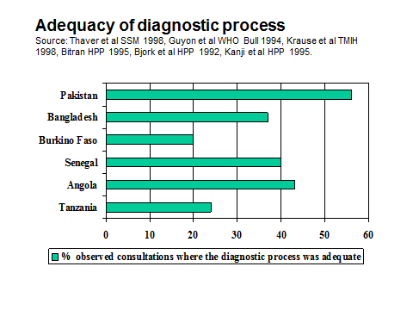

**1.2.2 How indicators of medicine use vary**

During the 1990s, the International Network for the Rational Use of Drugs developed a standard set on indicators to measure drug use which was published by WHO. (Ref to Indicator manual) You will be introduced to these methods in Session 3. Since the development of these indicators more than 850 studies have used them. Some of these results are summarized in the figure below.

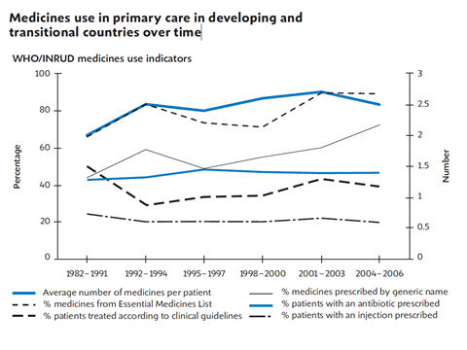

**1.2.3 Average number of medicines prescribed**

The most frequently used indicator is the average number of medicines per prescription. This number has increased over time possibly due to the number of patients with chronic non-communicable diseases increasing. Generic medicine use is increasing though it varies greatly between countries.

When these indicators are looked at by region there appears to be very little difference, as shown in the figure below.

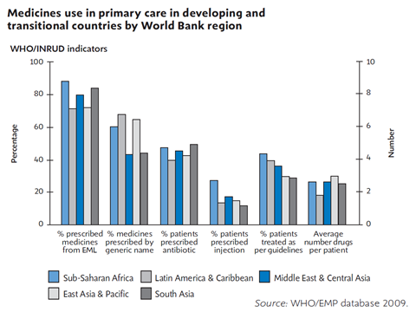

When comparing prescribing between public and private sectors most studies show that the public sector does better than the private sector, as illustrated below.

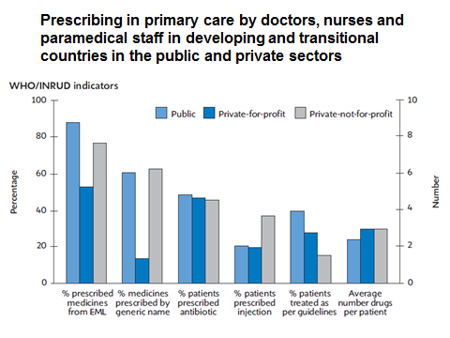

**1.2.4 Adherence to Standard Treatment Guidelines**

When looking at adherence to Standard Treatment Guidelines there has been very little improvement and most regions are only between 30% and 50%.

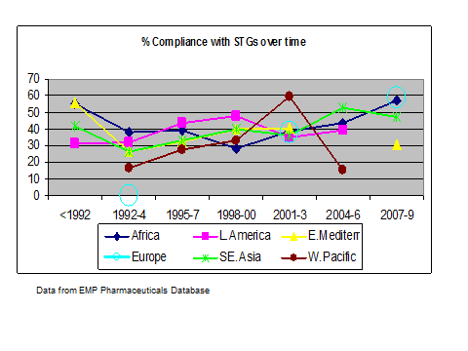

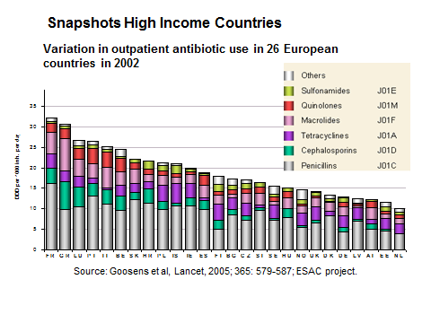

While this data comes from 26 European countries, similar results have been found in Latin American countries. What this chart shows is that antibiotic use varies widely between neighbouring countries both in the amount of use and the choice of antibiotic. As can be seen in the chart below there is a correlation between use as measured in DDs and prevalence of resistance.

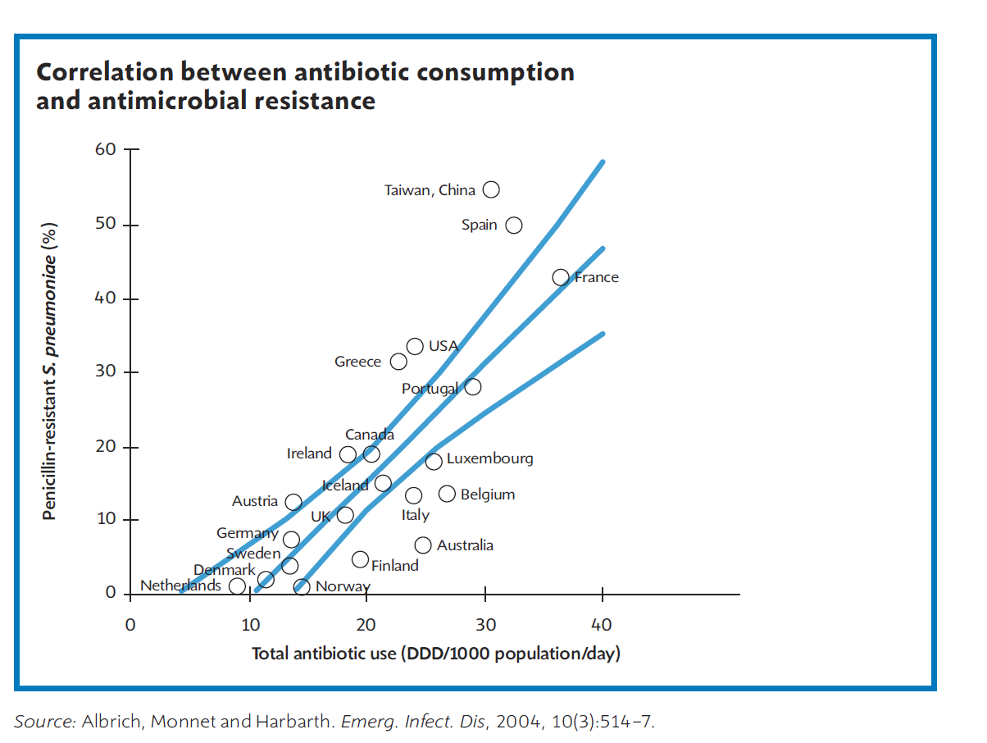

**1.2.5. Patient care indicators**

More recently efforts have been made to quantify the consulting and dispensing process.

Consultation Time

The consultation time in most country studies varies from 2.3 to 3.5 minutes. The events occurring during this time frequently do not include physical examinations.

Source of the next three graphics: *Promoting Rational Drug Use* course materials. <http://archives.who.int/PRDUC2004/RDUCD/TOC.htm>

**Average Consultation Time, 1990–1993**

Dispensing Time

Dispensing has been observed in a limited number of countries. The average times vary from 12 seconds to 86 seconds, which is a short time to convey what may be complex information about prescribed drugs to the patient.

**Average Dispensing time – 1990 - 1993**

Patients' Drug Dosing Knowledge

When patients are assessed as to their knowledge of how they should take drugs, between 27 percent and 83 percent know how and when to take their drugs. Potentially, this could result in major misuse of drugs.

**Percentage Patients with Drug Dosing Knowledge, 1990–1993**

**2 REASONS FOR IRRATIONAL MEDICINES USE**

Now that you have considered the definition of RMU and explored the range of indicators found in the world, let’s explore the reasons for irrational medicines use.

To get an overview of how and why medicines are prescribed irrationally in many countries in the world, look at the figure below. As you will see there are many different factors that could lead to irrational use. It is critical to understand which the key factors are before deciding on what sort of intervention to undertake. If the problem is a lack of knowledge then education would be an appropriate intervention. But if the problems exist within the workgroup then an alternative intervention such as an interactive group discussion or audit and feedback would be more suitable.

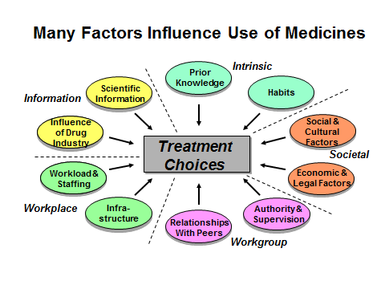

***Activity 2: Brainstorm reasons for irrational medicines use***

*Think about your own country and jot down 5 possible key reasons for the irrational use of medicines, from your own knowledge and experience. Discuss your ideas with a few colleagues. Save these notes because you will be asked to discuss this in the online Discussion Forum during this session.*

**Feedback**

There are many reasons for why people use medicines in what seems to be an irrational way but when you study the situation you often find that financial incentives or beliefs or external influences cause people to behave in this way.

***Activity: 3 Collect data and participate in online facilitated discussion on Rational Medicines Use in your setting***

*In order to consolidate what you have heard and read about in your own setting, you are asked to do some preliminary research and then to share it through the Discussion Forum. Your Study Schedule under Course Resources indicates the dates and requirements.*

*You are asked to investigate a number of questions related to RMU in your own setting. You can choose to work at national or district level, depending on your interest and the availability of data, but we would encourage you to consider antibiotic use as this is a national, regional and global priority. You are asked to bring your findings to the Discussion Forum, in which we aim to share our diverse experiences of irrational medicines use from different countries and settings, and to identify what information is available and where to get it. This will involve applying some of the concepts learnt so far.*

*Explore the following questions in relation to your own setting and enter your findings into the Data Collection Form provided. Post your completed data form onto the Discussion Forum for this session on the iKamva site so all participants can view it. The session convenor will then lead a Discussion Forum in which your findings and the main drivers if irrational prescribing in your setting will be discussed.*

*Questions:*

1. *Identify, from prior knowledge, the three most important medicine use problems at local or national level.*
2. *What specific factors cause irrational medicine use in your setting? (e.g. If it is a problem, what drives over use of antibiotic prescription behaviour in your setting?)*
3. *Find out the number of medicines per prescription in your setting or country and reasons for a high or low number.*
4. *What is the average consultation time and dispensing time in your setting or a nearby health facility?*
5. *What public health problems caused by irrational use of medicines can you identify in your setting?*

**3 CONSEQUENCES OF IRRATIONAL MEDICINES USE**

*What do you think are the consequences at patient level? And at the health system level?*

***Activity 4***

*To start this section, think about the question in the bubble.*

The main consequences of irrational medicine use can be summarized as:

* Impact on quality of medicine therapy and medical care
* Impact on antimicrobial resistance
* Impact on Cost
* Psychosocial impact

**Reading**

The adverse impact of irrational medicine use, as well as factors which underlie irrational medicines use are more fully described in chapter 27.3 and 27.4 of Management Sciences for Health (2011) *MDS-3: Managing Access to Medicines and Health Technologies.*

<https://www.msh.org/sites/msh.org/files/mds3-jan2014.pdf>

Irrational medicines use has consequences for the individual, but as you can read from this provocative excerpt by Tom Philpott, a left-leaning journalist published in *Mother Jones*, irrational medicines use could have a much more far-ranging impact (Philpott, 2015).

*“If your goal is to ruin the effectiveness of antibiotic drugs, I can think of two efficient ways. One would be to wildly overprescribe them... say, to people suffering from a cold virus, even though antibiotics work their magic on bacterial pathogens, not viral ones. The other would be to feed daily, low doses of them to animals confined by the thousands in vast indoor facilities. In both cases, you're creating ideal conditions for bacteria to evolve to survive the drugs we throw at them: A percentage of bacteria withstands the chemical onslaught, and passes genes on to ever-heartier next generations.*

*Unhappily, both of those practices – over prescription to people and routine use on animal farms - have been in play pretty much since the emergence of antibiotics after World War II. And so we have entered an age of widespread antibiotic resistance? On our way to what Thomas Frieden, of the Centers for Disease Control and Prevention, has called a ‘post-antibiotics era’. ..."*

**Reading**

Before going any further read the Rational Use of Medicines section in this WHO publication, pages 10 to 13:

Holloway, K. & Van Dijk, L. (2011). Rational Use of Medicines. *The World Medicines Situation 2011.* Geneva: WHO.

<http://www.who.int/medicines/areas/policy/world_medicines_situation/WMS_ch14_wRational.pdf>

As well as giving you a short overview of the key concepts to which you have been introduced already, this reading highlights some key trends in the use of medicines globally and outlines strategies for improving the use of medicines.

**4 WHY DOES IRRATIONAL MEDICINES USE PERSIST?**

In this session, you have examined the concept of RMU, indicators to measure medicine use and some of the reasons for irrational medicines. You will have an opportunity to explore these issues in your own setting, in your assignments.

*In the face of your understanding of irrational medicines use and the evidence you have read about, why do you think irrational medicines use continues?*

***Activity 5***

*Now think about the question in the speech bubble.*

Here are some points, suggesting that because very few low and middle income countries regularly monitor drug use, few effective nation-wide interventions are implemented. This may be because:

* They have insufficient funds or personnel
* They lack awareness about the funds wasted through irrational use
* There is insufficient knowledge concerning the cost-effectiveness of interventions
* They do not bear the cost of irrational use.

**Reading**

Look at pages 16-19 of the Holloway and van Dijk *World Medicines Situation 2011* report, referred on the previous page, for more information on this point.

**5 SESSION SUMMARY**

Medicine use is the end of the therapeutic consultation. Ensuring that the correct medicine is given to the correct patient is therefore a high priority for all health professionals.

Globally medicines are frequently used incorrectly. There are many reasons for this irrational use of medicines. Understanding the underlying reasons is important to guide the choice of the intervention to address this problem. These episodes of irrational use may have adverse clinical outcomes, cause antimicrobial resistance, waste resources and have a unwanted social effects. There is not a pill for every ill.

This session has introduced you to the RMU concept and its dimensions. It has discussed the extent of the problem of irrational use of medicines at country level through a number of set of standard indicators published by WHO and used to measure irrational use of medicines.

The key reasons and consequences of irrational medicines use have been explored and you have been asked to consider the situation of rational medicines use in your own setting. Finally, the ongoing global challenges of irrational medicines use are highlighted.

During the remainder of the module you will apply tools to identify medicines use problems, measure the extent of irrational medicines use using quantitative and qualitative methods and then apply strategies to improve rational medicines use in a way that can be evaluated.

**6 REFERENCES AND FURTHER READINGS**

World Health Organization. (2002). Promoting Rational Use of Medicines: Core Components. *WHO Policy Perspectives on Medicines,* 5: 1-6. [Online], Available: <http://apps.who.int/medicinedocs/pdf/h3011e/h3011e.pdf> [Downloaded 28 1 15].WHO. (nd).

Philpott, T. (2015). Antibiotic Failure Will Cost 10 Million Lives Annually – 2050. *Mother Jones.* [Online], Available: <http://m.motherjones.com/tom-philpott/2015/01/antibiotic-failure-will-cost-10-million-lives-annually-2050> [Accessed 31 1 15].

Did You Know. [Online], Available: <http://www.who.int/rhem/didyouknow/essential_medicines/rational_antibiotic_use/en/> [Accessed: 12.1.15].

**Source references for Powerpoint Slides**

Bitran, R. (Sep 1995). Efficiency and Quality in the Public and Private Sectors in Senegal. *Health Policy Plan* 1995 Sep; 10(3): 271-283.

Goossens, H., Ferech, M., Vander Stichel, R., Elseviers, M. (2005). Outpatient Antibiotic Use in Europe and Association with Resistance: A Cross-national Database Study. *The Lancet:* 365(9459): 579-587.

Guyon, A.B., Barman, A., Ahmed, J., Ahmed, A., Alam, M. A. (1994). Baseline Survey on Use of Drugs at the Primary Health Care Level in Bangladesh. *Bulletin of the World Health Organisation,* 72(2): 265-272.

Kanji, N., Kilima, P., Lorenz, N., & Garner, P. (June 1995). Quality of Primary Outpatient Services in Dar-es-Salaam: A Comparison of Government and Voluntary Providers. *Health Policy Plan* 10(2): 186-190.

Krause, G., Schleiermacher, D., Borchert, M., Benzler, J., Heinmüller, R., Ouattara, K., et al. (1998). Diagnostic Quality in Rural Health Centres in Burkina Faso. *Tropical Medicine and International Health*3(2): 100-107.

Shankar, P.R. (2009). Medicines Use in Primary Care in Developing and Transitional Countries: Fact Book Summarizing Results from Studies Reported Between 1990 and 2006. *Bulletin of the World Health Organization,* 87(10): 804. [Doi:10.2471/09-070417.Doc].

White, T.J., Arakelian, A., Rho, J.P. (1999). Counting the Costs of Drug-related Adverse Events. *Pharmacoeconomics,* 15(5): 445-458.

**Session 1: Activity 3**

**RMU DATA COLLECTION FORM**

Name: ………………………………………. Setting: ………………………………………………………

Level of information (National/regional/district/other): …………………………………………

Fill in the form below with information from your own setting.

|  |  |
| --- | --- |
| *3 most important medicine use problems at local or national level.* | 1.  2.  3. |
| *3 important factors causing irrational medicine use* | 1.  2.  3. |
| *Average number of medicines per prescription and main reasons for high or low number* |  |
| *Average consultation times and dispensing times* |  |
| *Public health problems caused by irrational use of medicines* |  |