Session 6 - Anti-microbial resistance and antimicrobial stewardship

Welcome to Session 6 which addresses key antimicrobial resistance (AMR) issues and the way forward with antimicrobial stewardship (AMS). You may be aware that deaths from acute respiratory infections, diarrhoeal diseases, measles, AIDS, malaria and tuberculosis account for more than 85% of the mortality from infection worldwide. This gives some sense of the critical role played by antimicrobials in maintaining global health even at its present levels.

Antimicrobial resistance impacts on heath delivery programmes at facility, provincial national and global levels as it is costly and undermines effective health care delivery. World leaders in health describe antimicrobial resistance as a global threat to stability and even national security.

Incentives for industry to develop new antimicrobials have not encouraged the development of new unique antimicrobial agents. You can imagine that there are many interconnected factors that influence antimicrobial resistance, and the challenge of stewardship needs to address all of these. This session talks to the relationship of rational prescribing and appropriate use of antimicrobials by health practitioners and patients. It also addresses the ongoing need for education interventions for both patients and health care providers.

There is an emphasis in this session on the promotion and use of an appropriate National Essential Medicine Guideline and facility directed formularies. You will see how important health policy and advocacy is, not only within National Departments of Health but also in the areas of Agriculture and Fisheries and Water, where antimicrobial use is implemented on a large scale. Specific issues around professional registration requirements for prescribers and dispensers as well as requirements for training and continuing education will be discussed. The important role of health laboratory involvement at ground level and at national level with ongoing surveillance of resistance, antimicrobial usage and disease burden is covered in the session. By the end of this session you should be equipped and motivated to champion antimicrobial stewardship (AMS).

In this session, as you work through the content, you will be asked to engage with a number of readings, and are encouraged to look at the Powerpoint slide presentations to which you will have access online. These offer additional information and detail on the topics covered in the session.

Session contents

Session 6 will cover the following broad topics:
1. Introduction to antimicrobials including the history, causes and impact of antimicrobial resistance (AMR)
2. What can we do as health workers to drive AMS?
3. Patient management at the bedside
4. Issues around administration of antibiotics
5. Governance issues around antimicrobial stewardship
6. The role of education in AMS
7. Tracking and reporting antimicrobial use and outcomes monitoring
8. Does stewardship work?
9. Session summary
10. References and further readings

Learning Outcomes
By the end of the session, you should be able to:
- Understand the global situation of antimicrobial resistance in the context of RMU
- Discuss multifaceted strategies to contain AMR, including rational medicines use
- Develop an awareness of infection control process and important areas of interventions
- Critically review and evaluate your AMS Programme in the facility you work in using aggregate data (e.g. ABC Analysis, DDD)
- Critically develop an AMS audit for your facility.

Readings

Centre for Disease Control (CDC). (2014). Core Elements of Hospital Antimicrobial Stewardship Programs. Atlanta, GA: US Department of Health and Human Services, CDC. [Online], Available: http://www.cdc.gov/getsmart/healthcare/implementation/core-elements.html [Accessed 20.5.15].

King D, Jabbar A, Charani E, et al. (2014). Redesigning the ‘choice architecture’ of hospital prescription charts: a mixed methods study incorporating in situ simulation testing. BMJ Open 2014; 4. Available: http://bmjopen.bmj.com/content/4/12/e005473.full [Accessed 20.5.15]

Wasserman, S., Boyles, T. & Mendelson, M. (2014). South African Antibiotic Stewardship Programme (SAASP): A Pocket Guide to Antibiotic Prescribing in South Africa 2014. Available: http://www.sahivsoc.org/upload/documents/Guide%20to%20Antibiotice%20prescribing%20for%20adults%20in%20SA_2014.pdf
[Accessed 20.5.15]

WHO. (2001). Global Strategy for Containment of Antimicrobial Resistance. Prioritization and Implementation Workshop, 12–14 September 2000. Geneva: WHO.
http://www.who.int/drugresistance/WHO_Global_Strategy.htm/en/
[Accessed 15.5.15]

WHO. (2015). Worldwide country situation analysis: response to antimicrobial resistance April 2015. WHO Library Cataloguing-in-Publication Data. ISBN 978 92 4 156494 6 (NLM classification: QV 250). Available:
http://www.who.int/drugresistance/documents/situationanalysis/en/
[Accessed 20.5.15]

1 INTRODUCTION TO ANTIMICROBIALS
The use of antimicrobial medicines has greatly contributed to the decline in morbidity and mortality resulting from infectious diseases over the past half-century. Infectious diseases, such as tuberculosis (TB), sexually transmitted infections, acute respiratory infections, malaria, dysentery, and HIV/AIDS, are becoming increasingly difficult and expensive to treat. The burden is greatest in developing countries where resources are limited and infection rates are high.

Antibiotics have been misused in many different ways in the health setting:

- Antibiotics are prescribed when they are not indicated;
- The inappropriate antibiotic for the clinical condition is prescribed;
- Antibiotic administration in critically ill patients is delayed;
- The dose of antibiotic is inappropriately low or high for the specific patient;
- The duration of antibiotic treatment is too short or too long;
- Antibiotic treatment is not streamlined according to microbiological culture data results.

The history of antimicrobials spans more than eight decades and is represented in the timeline below (Fig 1). We know that antimicrobial resistance is not a new phenomenon: it emerged within a short period after the introduction of new antimicrobials in the 1940s and 1950s and again after modification of these agents in the 1970s and 1980s. Drug company incentives to develop new antimicrobials are not significant and we have seen very few new unique antimicrobial agents developed since the 1980’s.
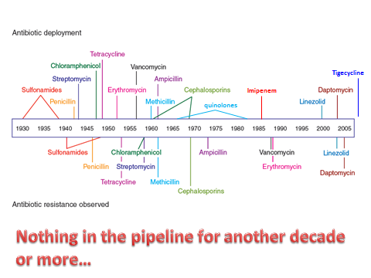
Figure 1: History of antimicrobials
Source: http://www.nature.com/nchembio/journal/v3/n9/images/nchembio.2007.24-F1.jpg

1.1 Antimicrobial Resistance (AMR) - the storyline……

The factors contributing to AMR are multifaceted, and are more evident in resource-constrained countries where problems with pharmaceutical access, quality, management and use are generally the norm. The increased inflow of HIV/AIDS, TB, and malaria medicines from global health initiatives has greatly increased the potential for drug resistance: this is especially so in countries with poor quality health systems, and weak pharmaceutical management capacity, which usually includes scarce health professionals with expertise on AMR and rational antimicrobial use. Often in these settings awareness of the dangers posed by AMR is generally non-existent, and relevant pharmaceutical management and AMR interventions are not being implemented.

1.2 Global Situation of Antimicrobial Resistance

Drug resistance has emerged across the spectrum of microbes: viruses, fungi, parasites, and bacteria.

Some of the major pathogens that have become resistant to antimicrobials include:
• Bacteria causing diverse infections such as Staphylococci, Enterococci, and E. coli
• Agents causing respiratory infections e.g. Streptococcus pneumoniae, TB, influenza
• Food-borne pathogens such as Salmonella and Campylobacter
• Sexually transmitted organisms such as Neisseria gonorrhea
• Candida and other fungal infections
• Parasites such as Plasmodium falciparum, the cause of malaria
• The human immunodeficiency virus (HIV), the cause of AIDS.

Activity 1: Reflect on this situation of growing AMR – Do you think it touches your life or your family?

Sometimes it is useful to reflect on a situation which seems to be largely scientific and statistical.

Review list of the spectrum of microbes (see 1.2 above) that are now resistant, and consider the health of you and your family over the past 10 years.

- Imagine if there was absolute resistance to these microbes
- Do you think your family would be affected negatively if this was the case?

There is no need to communicate this, but simply to consider how disastrous this trend could be.

Delegates at the World Health Assembly 25th May 2015 endorsed a global action plan to tackle antimicrobial resistance - including antibiotic resistance, the most urgent drug resistance trend. Antimicrobial resistance is occurring everywhere in the world, compromising our ability to treat infectious diseases, as well as undermining many other advances in health and medicine.
The plan sets out 5 objectives:
- improve awareness and understanding of antimicrobial resistance;
- strengthen surveillance and research;
- reduce the incidence of infection;
- optimize the use of antimicrobial medicines;
- ensure sustainable investment in countering antimicrobial resistance.

Reading
Read the WHO report below, which analyses the 5 objectives listed in the box above for 5 world regions. You can read about one region that interests you (we suggest looking at the African Region), or the Summary Report, which highlights the key findings and outlines the main actions to be taken in the Global Action Plan on AMR.

WHO. (2015). Worldwide country situation analysis: response to antimicrobial resistance April 2015

Figure 2 below demonstrates how a hospital setting is one of the largest contributors to the development of resistance but in the same vein can be the area where the greatest control of AMR can be enforced via good ICP (Infection Control Practices) and active AMS (Antimicrobial Stewardship).

Figure 2: Owens, R C. (2008). Antimicrobial Stewardship: Concepts and Strategies in the 21st Century. Diagnostic Microbiology and Infectious Disease, 61: 110–128.

1.3 Causes of Antimicrobial Resistance (AMR)

Multiple factors have contributed to the emergence and spread of AMR. These include inappropriate antimicrobial prescribing by health providers, inappropriate self-medication by patients and poor compliance. Intensive exposure of food animals to antibiotics in the food production cycle as well as extensive use in agriculture has worsened AMR risks.
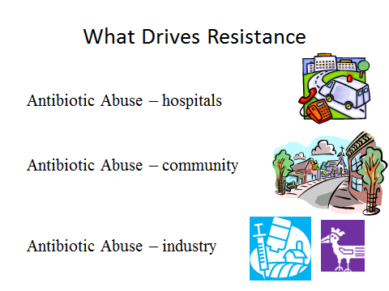

Unnecessary antimicrobial prescriptions is a major problem in driving AMR. It is now estimated that up to 50% of antimicrobials prescribed for human use may be unnecessary. In addition, about half of all antimicrobials are used in the agricultural sector. 40%-80% of antimicrobials for animal use are highly questionable. Have a look at the Power Point presentation: Antibiotics in Agriculture for more information on this.

Social factors can also play a significant role in AMR in the form of limited access to health care; poverty and economic hardships also lead to early termination of treatments or sharing of medicines within a family which contributes to the emergence and spread of AMR. Health facility-related factors attributable to poor resources and poor management may also play a part: inadequate infection control in health facilities, for example, contributes to the development and, more importantly, the spread of AMR. Other problems related to the regulatory climate in the health system include unregulated availability of medicines, poor quality, substandard, or counterfeit antimicrobials and poor storage conditions.

Several prescriber factors also contribute to the persistent problem of AMR:
- Insufficient level of training among health staff and pharmacists
- Diagnostic uncertainties, poor laboratory “Turn around Times” for cultures
- Formularies and standard treatment guidelines (STGs) not available or not used
- Fear of poor patient outcome and need for self reassurance
- Fear of litigation
- Microbiological information not readily available or not used
- Dispensing prescribers who are motivated by profit to sell more medicines
- Financial incentives for prescribers and dispensers from the health system or pharmaceutical industry, such as gaining more money through sales of medicines

Community cultural conceptions have also contributed to AMR through patient demand which is influenced by pharmaceutical manufacturers’ inappropriate and biased advertising.

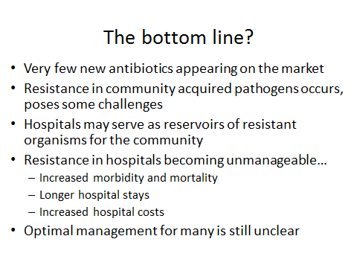
Activity 2 : Create a mind-map of AMR

Review the material covered so far and develop a mind map that describes the main areas of AMR.

Using your mind map, indicate whether these risk areas are evidence of irrational use of medicines for your health care facility or health system.

You are required to submit Activity 2 to the session convener via File Sharing, and will be given feedback.

1.4 Antimicrobial resistance mechanisms

We will now explore some of the complex mechanisms of AMR with the help of the power point presentation: Antibiotic Use and Resistance. Have a look at this presentation before proceeding through the session notes.

Some of the experiences from the past that you may be familiar with have contributed to the acceleration and surge of drug resistance and include:
- ineffectiveness of chloroquine as a primary antimalarial agent
- multidrug-resistant tuberculosis (MDR-TB)
- extensively drug resistant tuberculosis (XDR-TB)
- a diversity of antimicrobial-resistant diarrheal diseases
- acute respiratory infections, HIV/AIDS, and methicillin-resistant Staphylococcus aureus (MRSA).

Many complex mechanisms of resistance to antifungal medicines have been observed, such as:
- Fluconazole was introduced in the early 1990s as therapy for candidiasis and was rapidly followed by the emergence of fluconazole-resistant oral candidiasis, which is seen in one-third of patients with advanced AIDS
- The first-line pharmaceutical treatment (chloroquine) for malaria is no longer effective in 81 of the 92 countries where malaria is a major health problem.
- Penicillin has substantially lost its effectiveness against pneumonia, meningitis, and gonorrhea in many countries.
- Eighty percent of Staphylococcus aureus isolates in the United States are penicillin-resistant and 32 percent are methicillin-resistant.
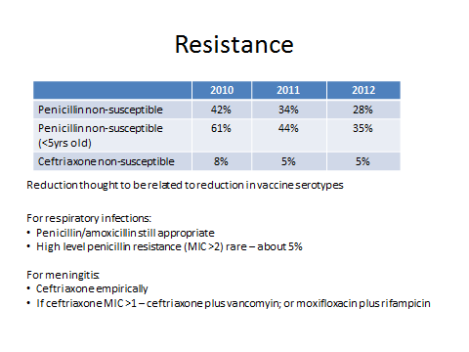
NB: Resistance in invasive Streptococcus pneumoniae in South Africa, from the GERMS-SA surveillance network"

Recently in both the Caribbean and South America, azithromycin resistance was found in 16–72% of isolates to Neisseria gonorrhoeae in different locations, resulting in the recommendation that this medicine in turn be replaced by ceftriaxone, spectinomycin, or the quinolones. The high cost of other options, however, such as third-generation cephalosporins makes their use prohibitive in many developing countries.

Antimicrobial resistance is becoming increasingly common in cholera infections in
developing countries. Up to 90% of Vibrio cholerae isolates are resistant to at least one antimicrobial. With antimicrobial options becoming limited, physicians in developing countries may have to use older antimicrobial medicines that have become increasingly ineffective, resulting in high rates of treatment failure.

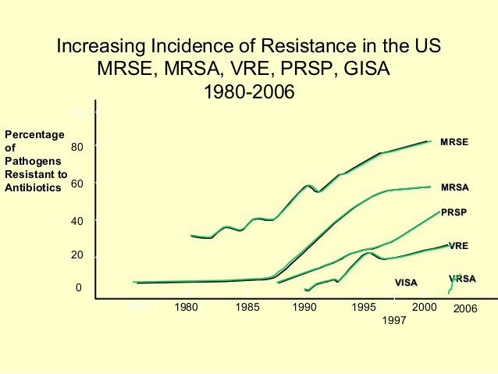
MRSE: Methicillin-resistant Staphylococcus epidermidis
MRSA: Methicillin-resistant Staphylococcus aureus
VRE: vancomycin-resistant enterococci
PRSP: Penicillin-resistant Streptococcus pneumoniae:
GISA: Glycopeptide-intermediate Staphlococcus aureus

One of the problems of introducing newer antimicrobials, including second-, third-, and fourth line choices is that they tend to be much more expensive than the original first-line medicines. They also do not have well established safety profiles.

In resource constrained settings, physicians often lack medicine susceptibility testing, or they do not have the option of changing therapies. With the increasing rates of AMR in developing countries, these limitations make their burden even greater.

Hospital settings are an important source of drug-resistant infections. Nosocomial infections occur in up to 10 percent of hospitalized infections. Important bacteria causing nosocomial infections include MRSA, Enterococcus faecium, E. faecalis, E. coli, K. pneumoniae, Enterobacter spp., Citrobacter spp., Pseudomonas aeruginosa, and Acinetobacter calcoaceticus. Nosocomial transmission of commonly encountered community acquired, multidrug-resistant organisms, such as pneumococcus, M. tuberculosis, Salmonella spp, Shigella spp, and V.cholerae, has been increasingly documented in developing countries. Horizontal transfer of resistant genes from one strain to another can also worsen the possibility of resistant nosocomial infections.

Have you heard about the “ESCAPE” Pathogens??
Enterococcus faecium
Staphylococcus aureus
Clostridium difficile
Acinetobacter baumannii
Pseudomonas aeruginosa
Enterobacteriaceae (includes Enterobacter sp, Klebsiella pneumoniae, Escherichia)

Now please review the PowerPoint presentation on Antibiotic Surveillance which introduces you to laboratory surveillance reports.



1.5 The broader impact of AMR

Cost to the health system and therefore to patients
Antimicrobials constitute a large portion (i.e. 20–40%) of a hospital’s medicines budget, and can lead to significant, unnecessary health care costs if not carefully managed. Hospital-acquired infections drain limited resources that would otherwise be available for other health programmes and quality of care.

Activity 3 : The cost of antibiotics

For this activity you are required to interrogate expenditure data for antibiotics in your institution.

In Session 2 you were introduced to ABC analysis and also DDD. These are useful tools to measure rational use of antibiotics which usually comprise a significant proportion of medicines expenditure. Using the ABC analysis for your institution (over 6 months, if possible) evaluate:

- What percentage of your medicine budget was used for antibiotics?
- Can you identify any items in the A category that should not be there? Explain.

Submit your responses (anonymized) to the session convener via File Sharing. You will be given feedback.

Note: If you are not able to access an ABC analysis for your institution then utilise other information available to you to answer questions 1 and 2. Explain what data you used.

As we discussed earlier there is extensive resistance to chloroquine in the management of malaria worldwide. Switching from chloroquine to artemisinin-based combination therapy (ACT) because of this resistance problem comes with an 18-fold increase in cost. This picture is worsened by the fact that there is now widespread resistance to artemesin based treatment regimens. The use of second-line antimicrobials to treat resistant infections is not only more expensive, but also can lead to a higher incidence of adverse drug reactions (ADRs).

Increased burden of disease
We know that AMR increases morbidity and mortality in patients if there is a prolonged period of infectiousness with increased risk of transmission of resistant organisms. These patients with resistant (and untreated) TB may, unfortunately, have spread this disease to others. The cost of AMR to the individual as well as society as a whole is enormous. MDR TB, for example, is about 300 times more expensive to treat than drug-sensitive TB. The cost of treating methicillin resistant Staphylococcus aureus (MRSA) is thought to be about three times that of methicillin-sensitivity staphylococcus infections.

1.6 Key approaches to containing AMR



You may at this stage be feeling quite overwhelmed as to the future of “health security” and be asking yourself how we stop AMR? There are many options, but we need to work together and work fast with immediate effect. There are two key strategies towards halting AMR, infection control and antimicrobial stewardship.

Activity 4 : Brainstorm strategies to halt AMR

Before reading any further, it might be helpful to brainstorm in the form of notes or a mind-map, and with a colleague if possible, strategies to halt AMR which are already in effect in your country.

Interventions that should be considered to manage and contain AMR include:
- AMR advocacy and communications;
- Research;
- Surveillance;
- Pharmaceutical regulations;
- Country-level interventions;
- Prevention of infectious diseases;
- Improved pharmaceutical quality;
- Improved medicine use;
- Training programmes;
- Improving pharmaceutical management capacity;
- Hospital and primary health clinic infection control programmes.

There are three key settings where AMR risks exist: hospitals or health facilities, community and industry. There are strategies that have been advocated by global policy makers where the biggest impact in controlling AMR occurs – but are most suited to hospital based strategies.

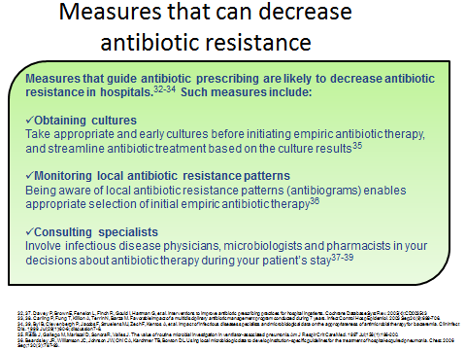

2 WHAT CAN WE DO AS HEALTH CARE WORKERS TO DRIVE
Antimicrobial stewardship (AMS)

2.1 The Bigger Picture

Here is a diagram representing the bigger picture of antimicrobial stewardship.

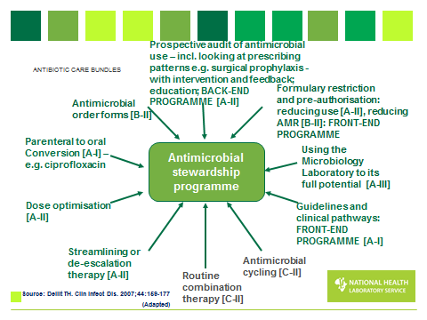
Fig 3: Diagram of an antimicrobial stewardship programme

2.2 Developing policy support to drive antimicrobial stewardship

There are a number of core elements for successful Health Care Facility Antimicrobial Stewardship Programmes; these include:

- Leadership Commitment: Dedicating necessary human, financial and information technology resources.
- Accountability: Appointing a single leader responsible for program outcomes; experience with successful programmes shows that a physician leader is effective.
- Drug Expertise: Appointing a single pharmacist leader responsible for working to improve antimicrobial use.
- Action: Implementing at least one recommended action, such as systemic evaluation of ongoing treatment-need after a set period of initial treatment (i.e. “antimicrobial time out” after 48 hours).
- Tracking: Monitoring antimicrobial prescribing and resistance patterns.
- Reporting: Regular reporting information on antimicrobial use and resistance to doctors, nurses and relevant staff.
- Education: Educating clinicians about resistance and optimal prescribing.

The only way that we will achieve success and prevent a worsening picture of antimicrobial resistance is to achieve high level governance support that promotes strong political will and commitment to change, at both global and national levels of health policy formulation. This can be seen in countries where there is an AMR and an AMS strategy formulated and written into the countries’ health policy framework strategies. In order to promote AMS locally, there needs to be governance driven interventions at Provincial and District levels, that impact within the health facilities and eventually at the patient household level.

Some of the main strategies include creating an active Pharmaceutical and Therapeutics Committee (PTC) or Antimicrobial Subcommittees. These forums can develop, implement and monitor relevant policies for antimicrobial procurement, use and quality. For example, only those antimicrobials that have been approved for the Formulary will be routinely procured for the hospital. Non-formulary antimicrobials can still be purchased or accessed, but only with permission from the PTC through a non-formulary process. Policies may also be developed for procurement of generic antimicrobials from suppliers, with a reliable track record according to National Essential Medicines Lists.

2.3 Infection prevention and control practices

Another strategy in preventing antimicrobial resistance development is to reduce the prevalence of infections requiring treatment.

Transmission of microbes occurs when the agent in the reservoir exits the reservoir through a portal of exit, travels via a mode of transmission and gains entry through a portal of entry to a susceptible host.

In order to prevent transmission of infectious agents in health care settings, it is important to identify and describe routine practices that must be carried out at all times. Containing AMR is a multi-level approach which needs to work all the way from global and national policy level through to facility policies and practices, as well as national research and surveillance activities. Advocacy and communications, as well as training remains important both with prescribers, but also with industry and the communities they all serve. Finally without antimicrobial stewardship interventions across countries, bringing with them monitoring and management practices, as well as a sense of urgency around infection prevention, the problem is likely to grow.

We know that routine practice for infection prevention and control is built on basic elements of:
- Risk assessment
- Hand hygiene
- Respiratory etiquette
- Personal protective equipment (PPE)
- Environmental control
- Sharps management
- Administrative controls
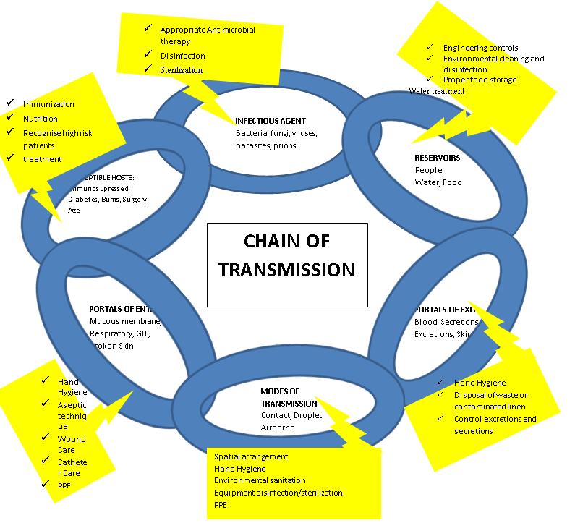
Fig 4: Chain of transmission of infection

2.4 Surveillance

Surveillence of antimicrobial resistance is a critical component of a proper stewarship programme – whether it be at a facility, regional, national or internatoinal level. Surveillance allows us to monitor resistance trends, and may be used to provide information about the success of stewardship programmes. Surveillance data is also a key component of informing clinicians about the most appropriate antibiotics to treat certain infections. For example, in the US, due to rising rates of cephalosporin resistance among S. pneumoniae, vancomycin is now included in the empiric treatent of acute bacterial meningitis. In South Africa there is a national surveillance programme which collects all invasive isolates from the state sector, and provides an annual report on susceptibility rates. Fortunately we know that our cephalosporin resistance rates are not high enough to warrant adding vancomycin to empiric treatment of meningitis – yet!

In the same vein, the SA Society of Clinical Microbiology collects and publishes susceptibility data from organisms isolated from blood cultures – see: http://www.fidssa.co.za/A_NASF_News.asp . There is also discussion going on about incorporating this onto a national “resistance map”, similar to the EARSS network – see: http://ecdc.europa.eu/en/activities/surveillance/EARS-Net/Pages/index.aspx

2.5 The role of stewardship

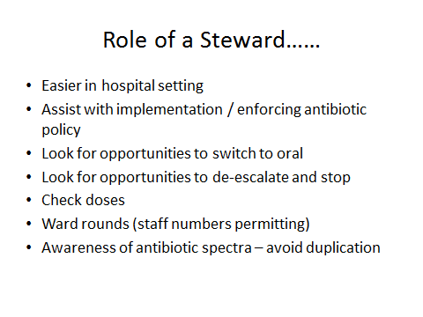

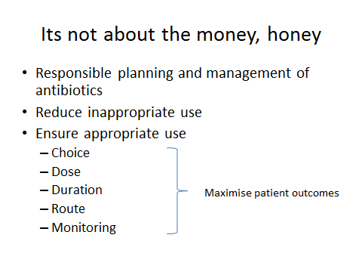
3 PATIENT MANAGEMENT AT THE BEDSIDE

3.1 Risk stratification of patients

Prescribing interventions are an important starting point for AMS. It is important that the Prescribing Practitioner is aware of some important aspects before starting antimicrobial therapy:

• Community-acquired pneumonia. Ensure diagnostic accuracy and tailoring of therapy to culture results and optimizing the duration of treatment to ensure guideline compliance.

• Urinary tract infections (UTIs). Patients who get antimicrobials for UTIs often have asymptomatic bacteriuria and not infections. Interventions for UTIs should focus on avoiding unnecessary urine cultures and treatment of patients who are asymptomatic and ensuring that patients receive appropriate therapy based on local susceptibilities and for the recommended duration

• Skin and soft tissue infections. Interventions for skin and soft tissue infections should focus on avoiding antimicrobials with overly broad spectra and ensuring the correct duration of treatment.

• Empiric coverage of methicillin-resistant Staphylococcus aureus (MRSA) infections. In many cases, therapy for MRSA can be stopped if the patient does not have an MRSA infection or changed to a beta-lactam if the cause is methicillin-sensitive Staphylococcus aureus.

• Clostridium difficile infections. Standard Treatment guidelines for CDI urge providers to stop unnecessary antimicrobials in all patients diagnosed with CDI, but in practice this often does not occur. Reviewing antimicrobials in patients with new diagnoses of CDI can identify opportunities to stop unnecessary antimicrobials, which improves the clinical response of CDI to treatment and reduces the risk of recurrence

• Treatment of culture proven invasive infections. Invasive infections (e.g. blood stream infections) present good opportunities for interventions to improve antimicrobial use because they are easily identified from microbiology results. The culture and susceptibility testing often provides information needed to tailor antimicrobials or discontinue them due to growth of contaminants

3.2 Empiric selection of antimicrobials

Antimicrobials are often started empirically in hospitalized patients while diagnostic information is being obtained. Review the following points and reflect on what exactly empiric therapy means. See the Western Cape Academic Hospitals Antimicrobial Recommendation in your Session 6 resources files in iKamva.

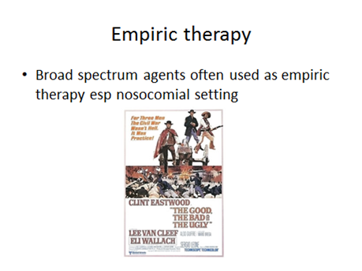

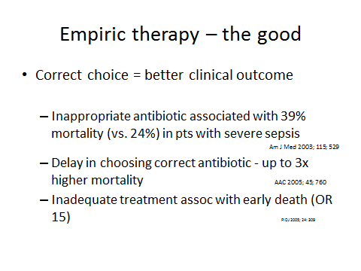

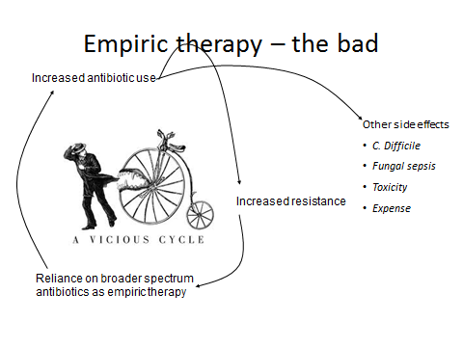

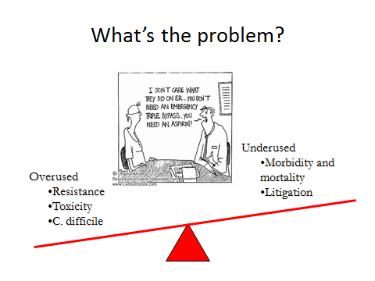

3.3 Antimicrobial “Time out”

Once the decision to start an antimicrobial has been taken it is important to revisit this empiric selection of the antimicrobial after more clinical and laboratory data (including culture results) become available. Antimicrobial “time out” messaging prompts reassessment of the continuing need and choice of antimicrobials when the clinical picture is clearer and more diagnostic information is available. NB All prescribing practitioners should perform a review of antimicrobials 48 hours after antimicrobials are initiated. Questions to consider include:
- Does this patient have an infection that will respond to antimicrobials?
- If so, is the patient on the right antimicrobial(s), dose, and route of administration?
- Are culture and susceptibility results available?
- If culture is available, can a more targeted antimicrobial be used to treat the infection (de-escalate)?
- How long should the patient receive the antimicrobial(s)?

3.4 Automatic Stop Order

One of the problems seen in high turnover wards such as the surgical wards is that patients often erroneously get antibiotics given to them over 10 -14 days as the prescription chart allows for dosing to be signed off without script renewal. The busy surgeon doesn’t always have time to check each patient and there is no clinical pharmacist monitoring the ward. The purpose of an automatic stop order is to appropriately limit the duration of antimicrobial usage. This strategy has been used successfully to limit duration of surgical prophylaxis in United Kingdom hospitals. Additionally, stop dates can be used for the use of empiric or therapeutic antimicrobials. These steps can be best implemented using antimicrobial order forms.

3.5 Cultures or Colonisation?

Please review the Powerpoint presentation entitled “The Antibiogram: How to make SIR (Susceptible, Intermediate, Resistant) work for you…” This will help you understand classification of resistance categories as well as spectrum and combination choices of therapy.

In order to prescribe antimicrobials appropriatey, it is critical to understand the spectrum of activity of any antimicrobial that you prescribe. The attached slide set outlines the spectrum of activity of some of the more commonly used antibiotics.

It is also important to be able to interpret a microbiology culture and susceptibility report, so that appropriate de-escalation can be practised. It is important to evaluate both real-time and retrospective inpatient culture data so as to determine correct time of antimicrobial intervention. Follow up culture reviews must also be done to ensure good outcomes long term.
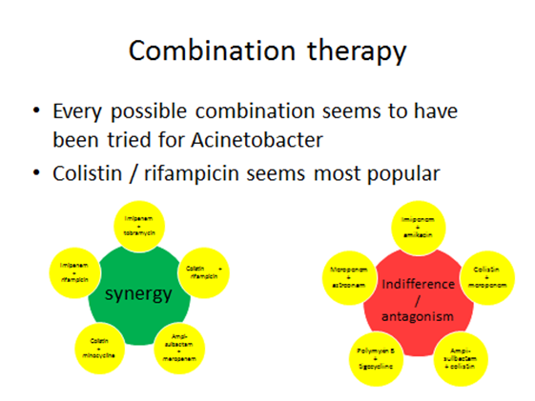

3.6 Dosing Of Antibiotics

3.6.1 Antimicrobial Order Forms (AOF)
Rather than the regular prescription form, the AOF is a special pre-printed form usually in a different colour. Prescribers can categorize antimicrobials as prophylaxis, empirical, or therapeutic. For surgical prophylaxis, automatic discontinuation of the antimicrobial takes place usually in the range of 24–48 hours as decided by the institution. For empiric treatment, the suspected cause of infection must be stated and it must be confirmed that a specimen has been collected and sent for culture before the antimicrobial is released or given. The form must show therapeutic treatment, isolated pathogens and relevant susceptibility. Within the AOF, an automatic stop order policy and list of restricted antimicrobials specific to the individual hospital can be shown. Go through the following Powerpoint slides to see how different forms are used: Antibiotic Stewardship – Lessons from the ICU and beyond.

Reading
Read the following article, about how changes in inpatient prescribing charts can improve prescribing practices:
King, D., Jabbar, A., Charani, E., et al. (2014). Redesigning the ‘choice architecture’ of hospital prescription charts: a mixed methods study incorporating in situ simulation testing.
http://bmjopen.bmj.com/content/4/12/e005473.full [Accessed 20.5.15]
3.6.2 When considering dosing:
- Know the specific antimicrobial’s characteristics
- Ensure loading doses are given to attain good blood levels and eliminate the microbe as quickly as possible
- Ensure that the correct weight-based dosing is calculated
- Dosage optimisation and adjustments for disease or co-morbidities may be needed (e.g. renal adjustment).
- Dose optimization including dose adjustments based on therapeutic drug monitoring, optimizing therapy for highly drug-resistant bacteria, achieving central nervous system penetration,
- Extended-infusion administration of beta lactams
- Check the dosing frequency and whether (PK/PD) Time or concentration dependent kinetics applies
- Monitor drug interactions and adverse effects and report accordingly
- Should extended infusions be considered for high risk patients
- Surgical prophylaxis? – pre and post op
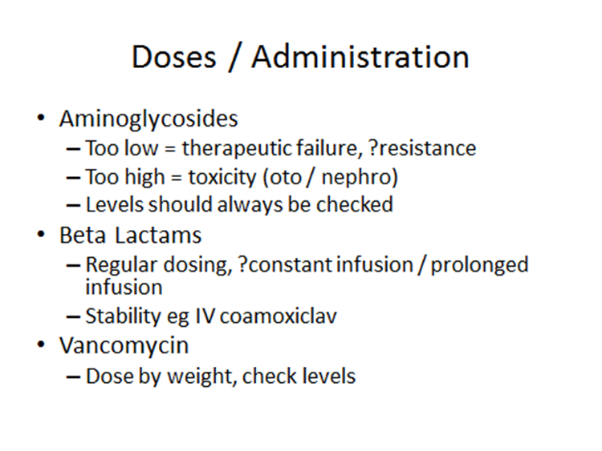
4 ISSUES AROUND ADMINISTRATION OF ANTIBIOTICS

4.1 Hang time - was antimicrobial administered within “magical” first hour?

Clinical guidelines recommend that antibiotic therapy be initialised with immediate effect. It is said that the patient’s survival rate decreases with every hour that the antibiotic is not administered. In order to establish this administration parameter “the Hang Time” is measured by noting the difference in time between the initial prescription generated and the actual time of administration of the antibiotic.
Ideally the hang time must be less than an hour.

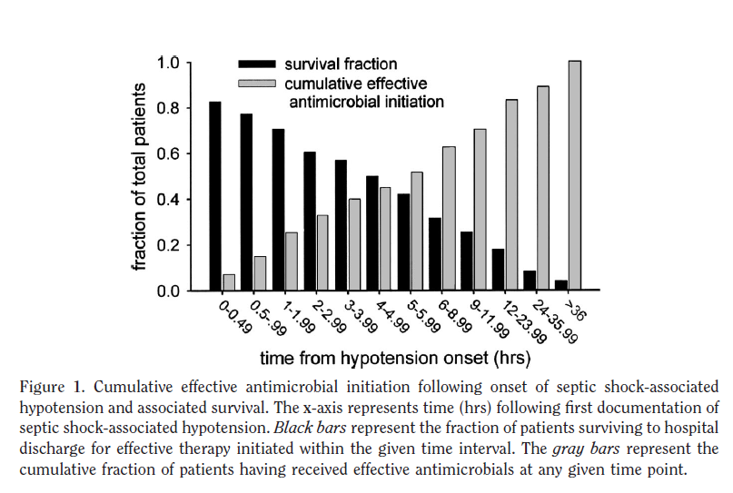
Source: Kumar et al. Crit Care Med 2006; 34: 1589

4.2 Optimizing Antibiotic Potency: The PK/PD Relationship

There are 3 main pharmacodynamics (PD) relationships that are important in AMS
- Peak to minimum inhibitory concentration (MIC)
- Time above MIC
- Total drug exposure (AUC/MIC)
Knowledge of the PD killing activities of the antibiotics guides us in appropriate dosing so we can:
- Increase the dose (Cmax/MIC – Aminoglycosides)
- Shorten the dosing interval (Fluoroquinolones – AUC/MIC)
- Increase the duration of the infusion (Time above MIC - β-Lactams)

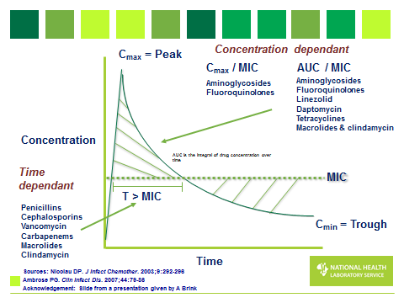

4.3 Extended or Continuous Infusion
By ensuring that the β Lactam type antibiotic is run over a longer period of time as a continuous infusion as opposed to an intermittent bolus dosing we are ensuring that we are maximising the time above the MIC which guarantees greater effect. This is particularly useful in ICU or extremely ill septic patients.

4.4 Duration of treatment with Antibiotics
It is important to switch from IVI to Oral therapy as soon as possible. 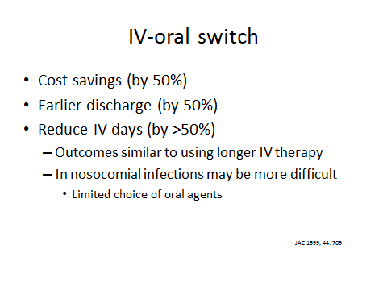
4.5 Streamlining or De-escalation as per culture report and Colonization

The strategies employed for ‘streamlining” or “de-escalation” include:
- Changing from broad spectrum to narrow spectrum agents as soon as a culture is established
- Change from IV to oral? – as long as there is equivalent bioavailability
- Get IVI lines out as soon as possible
- Adjust dosage by decreasing if there are susceptible organism
- Correct “stopping” of therapy as soon as the infectious process has been ruled out

5 GOVERNANCE ISSUES AROUND ANTIMICROBIAL STEWARDSHIP
(AMS)

A summary plan of action based interventions that promote AMS at governance and implementation levels is presented. This is in no way a complete list and you may have activities that still need to be included.

5.1 Comprehensive Infection Control
- Collecting managing data and information from audits
- Policy and procedural control
- Establishment of active PTCs and Antimicrobial Sub Committees (this will be covered in more detail in Session 11)
- Regulatory requirements compliance
- Employee health and wellness
- Prevention of transmission investigation of outbreaks
- Education & training - sustainable and possibly regulatory
- Good Finance and Human resource - ABC Analysis
- Effective and efficient laboratory services – Regular review of the Antibiobram

5.2 Prior Authorisation
Sometimes it is possible to institute control (See Section 5.1) of antimicrobial use in the facility by insisting that a ‘specialist” signature is obtained prior to release or issue of a certain antimicrobial. The problem then is that this seen as “policing” and may cause inter-professional friction.

5.3 Levels of Prescribing
Prescribing policies should establish three levels of antimicrobials i.e. first-choice, restricted-choice, and reserve.
- First-choice antimicrobials—to be prescribed by all doctors or registered prescribers
- Restricted-choice antimicrobials—for multiple-resistant pathogens, polymicrobial infections, or certain patient conditions that need special attention or more expensive antimicrobials to be prescribed after discussion with head of department
- Certain antimicrobials can be restricted to particular physician specialties or service areas (e.g., an intensive care unit [ICU]). Restriction may also be applied to certain antimicrobials with broad spectrum of activity.

5.4 Effective Antimicrobial Stewardship
The following actions are some of the ways to create effective AMS:
- Fully represented AMS teams are created and endorsed by the hospital management and put in place
- Ongoing prospective audits of antibiotic use to establish risk patterns and feedback with effective interventions
- Formulary restriction implemented and monitored
- Guidelines and Clinical pathways updated

5.5 AMS Team Created and Empowered

A fully representative AMS Team must be created as an official body within the facility and be given the necessary jurisdiction to ensure effective antimicrobial stewardship programme (ASP).

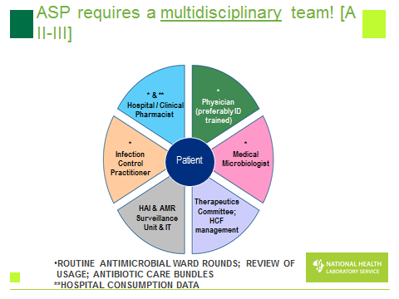

Some key functions of the AMS Team include:
  - Ongoing prospective audit and feedback with effective interventions
Multifaceted policies in combination with various approaches can be developed and
implemented via the AMS Committee or via PTC to improve compliance with antimicrobial guidelines and protocols. Providing local evidence, rationale, and benefits of antimicrobial policies is important when seeking consensus from hospital-wide stakeholders so that prescribers do not feel that they are being “policed” by the AMS Team or the PTC while implementing antimicrobial policies.

  - Developing antimicrobial policies to improve compliance with guidelines
You have learnt about the role of a “Formulary” in a hospital in Session 11 and how the PTC will use this to individualise patient care. The antimicrobial formulary must be reviewed regularly and include agents considered most useful in the context of hospital’s unique patient population. Efficacy, safety, quality, pharmacokinetic disposition, and cost must all be considered in the decision to add an antimicrobial to the formulary. Duplications within a therapeutic class of antimicrobials should be avoided (e.g. quinolones or third generation cephalosporins). Historically antimicrobials were restricted or rotated if there was evidence of increased resistance patterns towards the specific antimicrobial. This sometimes has short term benefits, but tends to result in resistance to the “new” antibiotic that has been cycled in. In the longer term, antibiotic cycling does not seem to be a very effective mechanism to control resistance.

c. Guidelines and clinical pathways updated

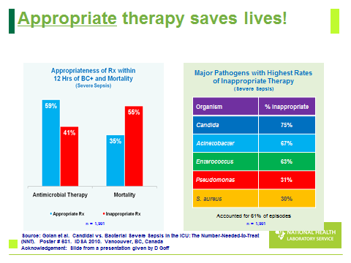

d. Role of the facility PTC in containing AMR and supporting the AMS Team
PTC’s (Discussed in Session 11) are important bodies needed to monitor and improve medicines use in institutional settings and help contain AMR. The World Health Organization (WHO) Global Strategy for Containment of Antimicrobial Resistance stated that PTC’s are a key means of intervention to contain AMR in institutional settings. It is important to note that in hospital settings, the PTC is a key body to help preserve effectiveness of existing antimicrobials.

The PTC impacts on AMS in various important areas including:
- Updating and managing an antimicrobial formulary
- Developing policies on antimicrobial procurement and quality
- Developing and updating antimicrobial guidelines and protocols
- Developing antimicrobial policies (e.g., reserve antimicrobials, levels of prescribing,
- automatic stop orders, and antimicrobial order forms) to improve compliance with antimicrobial guidelines and protocols
- Evaluating antimicrobial use based on pre-established criteria of appropriateness and applying remedial measures
- Providing pre-service and in-service education on rational use and AMR
- Contributing to collection and management of antimicrobial surveillance and resistance information for coordinated action with the Infection Control Committee
- Providing education to patients on the use and abuse of antimicrobials and encouraging adherence
- Supporting pharmacovigilance activities for antimicrobials
- Interventions to Contain Antimicrobial Resistance

There are 4 areas of involvement that are needed to support the work of the AMS team:
- Establishing an Antimicrobial Subcommittee within a PTC
- Developing a role for the PTC in supporting pharmacovigilance activities for antimicrobials
- Liaising with the Infection Control Committee with regard to the assessment
- Use of data obtained from monitoring AMR

- Establishing an Antimicrobial Subcommittee within a PTC
By establishing Antimicrobial Subcommittees within your PTC you can help create a task force that can do audits, design educational and intervention programs that will help contain the threat of AMR. The Antimicrobial Subcommittee can take leadership in developing policies concerning the use of antimicrobials for approval by the PTC and medical staff. The Antimicrobial Subcommittee can form part of the AMS team. Guidelines specific to antimicrobial dosage and duration may be developed by the subcommittee for formulary antimicrobials. They can be printed on dosing cards or in a concise, pocket-sized manual.
As an example you can review the pocket guide by Wasserman et al. (2014) South African Antibiotic Stewardship Programme (SAASP): A Pocket Guide to Antibiotic Prescribing in South Africa 2014.
http://www.sahivsoc.org/upload/documents/Guide%20to%20Antibiotice%20prescribing%20for%20adults%20in%20SA_2014.pdf [Accessed 20.5.15]

- The role of the PTC in Supporting Pharmacovigilance Activities for Antimicrobials
Antimicrobial safety and toxicity must be monitored in a coordinated, systematic method. Antimicrobial use in vulnerable groups such as paediatric and elderly patients may also be monitored. Interventions include dose adjustment in cases of hepatic or renal failure for certain antimicrobials (e.g., aminoglycosides, vancomycin), alertness for allergies (penicillins), and identification of relevant interactions with other medicines (macrolides, azoles). These pharmacovigilance activities will decrease the incidence of ADRs, decrease the unnecessary use of alternate antimicrobials, and improve the overall use of antimicrobials.

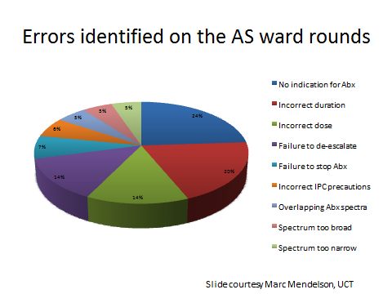

3. Evaluating Antimicrobial Use Based on Pre-established Criteria
By identifying (ABC Analysis) it is possible for you to identify the “cost- drivers” and possible “resistance drivers” and antimicrobials that have the greatest potential for abuse and then conduct a medicine use evaluation (MUE) in Session 5 of the module. The evaluation may be conducted by reviewing a random sample of prescriptions or case notes over a long period (e.g., 6 to 12 months) or a short study period (e.g. 1-3 months) where patients have received the specific antimicrobial. The data is processed, and compliance with various indicators is determined. If noncompliance is observed from the data, an intervention by the AMS Team may be taken to improve the use of the antimicrobial. After the intervention, a second evaluation is performed to determine the impact of the intervention on the use of the antimicrobial.

4. Liaising with the Infection Control Committee with Regard to the Assessment and Use of Data Obtained from Monitoring AMR
It is well known that surveillance of bacterial resistance to antimicrobials is an essential component of any program to contain the spread of resistance. Resistance data not only helps in choosing the correct antimicrobial in individual patient care; if collated, it also allows a PTC to be informed about sensitivity patterns when choosing antimicrobials for the formulary. Many hospital laboratories do not actually collate resistance data to inform the formulary process, but the PTC has a role to ensure that such information is collected and collated. Resistance is often reported in terms of the number of isolates. Such data, however, usually include multiple specimens from a few very sick patients and does not give an accurate picture of overall resistance in all patients. To inform the formulary process, resistance data should be representative of all likely patients, and therefore the data should be collated by case (or patient), not by isolate. If specimens for culture are taken from patients on arrival at a hospital, before they receive any antimicrobials, the resulting data may be used to gain an impression of resistance patterns in the community.

If surveillance is done, however, validity of the results and quality control within the laboratory is extremely important. Having inaccurate reports or bad data is worse than having none at all. Any good and reliable microbiology laboratory must be able to demonstrate to the PTC documented internal and external quality assurance.

• Internal quality assurance consists of regularly conducting and recording various internal checks to ensure that all laboratory equipment is functional and that all specimen collection and processing are done in a reliable manner.

• External quality assurance is accomplished when the laboratory participates in an external scheme run by a reference laboratory. In this situation, the reference laboratory sends out test clinical specimens, and asks the participating laboratory to identify the organism and its sensitivity pattern. In this way, the competence of the participating laboratory can be checked against that of the reference laboratory.

6 THE ROLE OF EDUCATION IN AMS

Antimicrobial stewardship teams need to provide regular updates on antimicrobial prescribing, antimicrobial resistance, and infectious disease management from a national and local perspective. One way that the AMS team can highlight poor prescribing practices is to compare facility-specific information on antimicrobial use. This can motivate improved prescribing, particularly if wide variations in the patterns of use exist among similar patient care locations.

There are a number of ways to provide education on antimicrobial use including:
- Training presentations (formal, informal, contact, online e-learning)
- proactive messaging through posters and flyers and newsletters or electronic communication to staff groups
- Formal Grand ward rounds reviewing complex cases with provider
- Discussions with de-identified cases where changes in antimicrobial therapy could have had better outcomes
- Web-based educational resources are available that can help facilities develop education content
- Use of IT to help decision making, issuing and monitoring of use
- Changes to Guidelines and clinical practice work- shopped
- Education campaigns (CPD for health professionals/posters etc for public)
- Formal feedback from PTC decisions via a Facility News Letter

Providing pre-service and in-service education on rational use and AMR
Training in the appropriate use of antimicrobials from the EML is essential for all health professionals within the hospital or primary health care facility. Regular in-service education programs can improve the use of antimicrobials and decrease the incidence of ADRs as well as decrease overall health care cost. Such education should also be provided at the undergraduate and post-graduate levels and local academic institutions should be encouraged to adopt rational antimicrobial use and AMR concepts in their curricula.

Below is an example of a poster designed to educate health professionals in hospitals on the appropriate use of antibiotics.

Providing education to patients on the use and abuse of antimicrobials and encouraging adherence
Dispensing pharmacists in the hospital outpatient ward must educate patients on the appropriate use of antimicrobials and encourage adherence. Besides one-to-one education to the patient, the Antimicrobial Subcommittee can create simple poster boards to be placed in the patient waiting area and near the dispensing window. Depending on the institutional context, patient education may also help reduce patients’ unnecessary demands to the provider for an antimicrobial.

7 TRACKING AND REPORTING ANTIMICROBIAL USE AND OUTCOMES
MONITORING

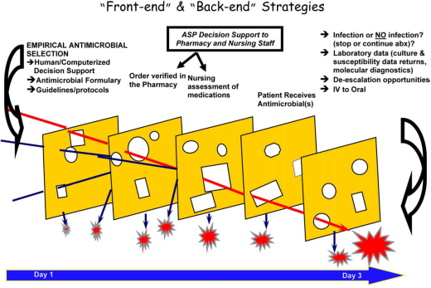
Source: Clin Infectious Disease 2007;44:159 – 177

7.1 Back end approach vs front end approach?

Back end approach: prospective audit with intervention and feedback
Prospective audit is an important function that can be customised per facility and even unit. It involves the design an intervention that systematically triggers ongoing reassessment, on specific days e.g. day 2 and 10, of specific broad-spectrum antibiotic use and to provide case-by-case monitoring say in a critical care setting. Targeted antimicrobials are chosen such as β-lactam antibiotics and/or β-lactamase inhibitor combinations (piperacillin–tazobactam), carbapenems (ertapenem and meropenem), fluoroquinolones (ciprofloxacin and levo-floxacin), third-generation cephalosporins (ceftriaxone and ceftazidime), and vancomycin. There must be agreement regarding optimal antimicrobial use with the entire team and definitions for appropriate and inappropriate use of each of the targeted antimicrobials. Buy in from the healthcare team is important for successful prospective audit and is often successful when there is ongoing feedback.

Advantages include:
- Customised to the facility
- Prescriber autonomy maintained
- Can be facilitated via computerised system
- Prevents delays in therapy initiation

Disadvantages include:
- Recommendations are optional
- May get inappropriate exposure

Front end approach: formulary restriction and pre-authorisation requirements

Restricting availability of antibiotics for use in specific conditions to certain categories of prescribers is one way of modifying antibiotic usage. The Western Cape Department of Health developed a list of restricted antibiotics for use at academic hospitals in 2011. This approach is often not popular with prescribers or dispensers and can have some negative implications for patients.

The advantages include:
- Initial orders funnelled through experts
- Immediate educational opportunity
- Acute control of antimicrobial use

Disadvantages may include:
- Delay in therapy in critically ill patients
- Labour intensive
- Loss of prescriber autonomy

After piloting this approach the Western Cape found that there wasn’t very much change in antibiotic prescribing and so they have now launched a new strategy, described in the Western Cape Antibiotic Guidelines 2013, which is more persuasive approach.

The new approach includes the following components:
- Dedicated prescription charts
- Dedicated AS ward rounds
- Education
- Reduce (simplify restriction)

8 DOES STEWARDSHIP WORK?
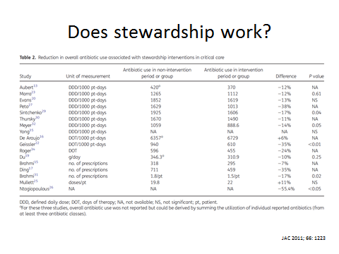

Emerging Developments in Antimicrobial Stewardship

Strategies for improving antimicrobial use and evidence for best practices in antimicrobial stewardship are evolving. The integration of IT into the clinical data presentation and decision-making for antimicrobial use will expand with increased uptake and capabilities of electronic health records.

The role of diagnostic laboratory testing is another area of evolution. Rapid diagnostic tests such as procalcitonin, fluorescence in situ hybridization using peptide nucleic acid probes (PNA FISH), and matrix-assisted laser desorption/ionization time of flight (MALDI-TOF) mass spectrometric analysis have been incorporated by some stewardship programs and may become important additions to stewardship efforts.

The use of these diagnostic tools on patient care is an area of great interest, and further research is needed to determine how they can best be applied to stewardship efforts. Another area of on-going work is better characterization of the impact of antimicrobial stewardship interventions on resistance. As more facilities engage in efforts to optimize antimicrobial use, future work is needed to evaluate which interventions or antimicrobial targets yield the greatest benefit in combating antimicrobial resistance.

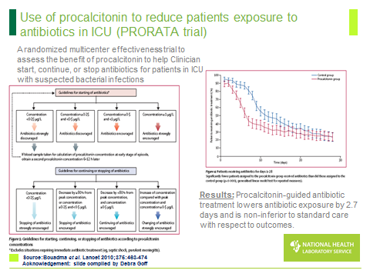

Activity 5: Complete a checklist

Evaluate the extent of AMS in your facility and how well you are doing, by following the link below to complete a checklist from CDC. This will help you to assess what systems are in place and what principles are being followed in your facility.

CDC (2014). Checklist for Core Elements of Hospital Antimicrobial Stewardship Programs. US Department of Health and Human Services. Atlanta, GA.
Available at:
http://www.cdc.gov/getsmart/healthcare/pdfs/checklist.pdf

9 SESSION SUMMARY

This session has highlighted the global public health problem of antimicrobial resistance which is increasing due to several factors, including irrational use of medicines, inadequate infection prevention and control, and weak laboratory capacity and surveillance of antimicrobials. Anti-microbial stewardship strategies to tackle this increasing problem are presented and the establishment of an AMS programme and involvement of the PTC are discussed. The final question for you to think about for this session is in the poster below……….



10 REFERENCES AND FURTHER READING

Owens, R C. (2008). Antimicrobial Stewardship: Concepts and Strategies in the 21st Century. Diagnostic Microbiology and Infectious Disease, 61: 110–128.

AHSP Advantage; www.LeadStewardship.org. Implementing Antimicrobial Stewardship Programs in Health Systems Continuing Education. Discussion Guide.

Provisional agenda item 8.1 Antimicrobial resistance: Draft global action plan on antimicrobial resistance. Report by the secretariat. WHO Executive Board EB136/20 136th session. 12 December 2014.

Antimicrobial Resistance National Strategy Framework 2014 – 2024. Department of Health, Republic of South Africa.

National Action Plan for Combating Antibiotic-Resistant Bacteria 2015. The White House, Washington.

Dept. of Health, HM Government (UK). UK 5 Year Antimicrobial Resistance (AMR) Strategy 2013–2018. Annual progress report and implementation plan.

