Session 7 – Strategies to Improve Medicine Use Practices

Introduction

There are many different ways to improve medicine use practices. The second part of this module (Sessions 7 – 11) will expose you to a number of different strategies that have been tried to improve medicine use, ranging from providing information to restrictive regulatory measures—and the evidence for or against their effectiveness. Not all strategies are relevant or feasible in your country, in your specific programme, or for every medicine use problem. However, this session will enable you to identify and choose among the possible intervention strategies that might be considered in a given situation.

The session will also make clear the need for carefully considering each approach's unintended as well as intended effects before widespread implementation.

In the module resources there is a Powerpoint presentation by Prof Richard Laing which you should view. It offers some additional information on the topics covered in the session.

At the end of the session you will be asked to read a case study in which you will identify and evaluate the approaches taken to improve medicine use practices. You will have to post your comments on the Ikamva site so that they and the case study can be discussed in the Discussion Forum. Check your Study Schedule for dates for the Discussion Forum.

Session Contents

- Factors that influence medicine use
- The process for changing a medicine use problem
- Intervention strategies
- Managerial strategies
- Economic strategies
- Regulatory strategies
- Examples of multiple intervention strategies
- Session summary
- References and further reading

Learning Outcomes

This session will develop your ability to:
- Identify specific medicine use problems and place them in the perspective of the factors underlying problems in medicine use.
- Identify eight to ten educational, managerial, and regulatory approaches to improve problems in medicine use that have been tried in developing and developed countries
- Understand some of the strengths and weaknesses of different interventions in terms of demonstrated effectiveness, cost, and suitability for specific country contexts and medicine therapy problems.

Readings

- Holloway, K. & Van Dijk, L. (2011). Rational Use of Medicines. The World Medicines Situation 2011. Geneva: WHO: pages 10-19. http://www.who.int/medicines/areas/policy/world_medicines_situation/WMS_ch14_wRational.pdf

- WHO (2004) Promoting Rational Drug Use (course materials). Public Education Session. http://archives.who.int/PRDUC2004/RDUCD/INRUD_2000_CDROM/PRDU_Course/Session_Guides/13_EFF_PUBLIC_EDUSG.doc

- de Vries, et al. (1995) Impact of a short course in pharmacotherapy for undergraduate medical students: an international randomized controlled study. Lancet 346: 1453–57

- MSH (2012) Managing Medicine Supply, 2nd ed. Chapter 27, pages 407-418 https://www.msh.org/sites/msh.org/files/mds3-ch26-kitsystem-mar2012.pdf

1 FACTORS THAT INFLUENCE MEDICINE USE

Before starting to go through the session notes below, we recommend that you look at the Powerpoint presentation ‘Framework for changing medicine use practices’. This will give you an overview of the topic of the session. The information in the slides is covered in: MSH (2012) Managing Medicine Supply, 2nd ed. Chapter 27, pages 407-418

A wide range of factors cause problems in medicine use. These factors differ in importance from problem to problem and from setting to setting. Before trying to correct any problem in medicine use, it is helpful to identify which factors are most important in causing the problem at hand. Unless the proposed intervention targets the appropriate causes of the problem, it is unlikely to be successful. The components of the medicine use system are complex and interrelated. They comprise the medicine supply process, provider and consumer behavior, and illness patterns.
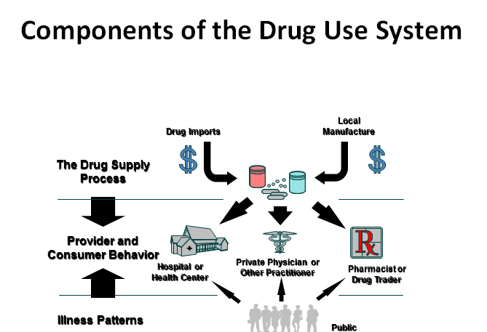

Source: http://archives.who.int/PRDUC2004/RDUCD/INRUD_2000_CDROM/PRDU_Course/Visual_Aids/9_Frameworkva.ppt

Categories of causal factors
We need to consider several categories of factors as possible causes of a problem in medicine use. Study the five categories below and the causes listed under each.

1.1 Characteristics of Providers of Care

Care providers may contribute to medicine use problems through causes including the following:
- Lack of knowledge about diagnosis, therapeutics, or the efficacy and risks of particular medicines
- Acquired habits in diagnosis and treatment that may not reflect what providers actually know, but are patterns of behavior they have come to adopt
- Beliefs about illness and medicines, such as the increased power of injections over oral medicines, which also do not always reflect their level of scientific knowledge
- Personal economic motivations for prescribing or dispensing particular medicines, such as medicine company incentives, dispensing fees, and referrals to private practice

1.2 Interactions between Patients and Providers

The interaction between patients and providers may lead to problems. These may include:
- Sociocultural attitudes and beliefs, including social distance and cultural barriers between patient and provider, beliefs about illness, or provider beliefs about patient expectations
- Quality of communication, which may be influenced by the setting, underlying beliefs and attitudes, language barriers, or a number of other factors
- Patient demand for specific medicines or forms of treatment (like injections)

1.3 Social Structure in which Providers Practice

The social structure in which providers practice also influences medicine use practices. Factors include the following:
- Authority and power relationships such as relationships with supervisors, criteria for performance evaluation, and practices of opinion leaders
- Peer interaction and consultation through which uncertainties about treatment can be discussed or new knowledge disseminated
- Peer practice norms, since most providers like to feel that their practices reflect the accepted norms of their peer group

1.4 Aspects of the Work Environment

The environment in which providers work also affects medicine use practices. Environmental factors include the following:
- Influence of medicine availability, due to purchase restrictions, irregular supply, overstocked products
- Availability of diagnostic services, such as diagnostic equipment or laboratory facilities
- Limitations of the physical environment, such as lack of privacy for consultation during examination or dispensing
- Workload, which may limit the ability of providers to spend an adequate amount of time with each patient
- Institutional economic motivations, such as the need to sell medicines to generate recurrent revenues or to capitalize revolving medicine funds

1.5 Medicine Information and Marketing

Finally, medicine information and marketing affect providers’ medicine use practices. These include:
- Availability of scientific information about medicines provided by neutral scientific or professional organizations
- Availability of potentially biased information about medicines provided by medicine companies
- Marketing pressure by industry, including media advertising, sales visits by industry representatives, and industry-sponsored "educational" meetings

In summary, many factors, stemming from different settings as shown in Figure 1, influence medicine use, including:
- Personal - Knowledge deficits, acquired habits
- Interpersonal - Cultural beliefs, patient demand
- Workgroup - Authority and supervision, relationship with peers
- Workplace - Infrastructure, workload and staffing
- Informational - Influence of industry, unbiased information

Informational

Personal

Workplace

Workgroup

Figure 1: Factors influencing medicine use

If the motivations and incentives in a certain situation are unclear, qualitative methods such as provider and patient interviews, observations of the process of care, or focus groups can help determine the relative importance of different factors in causing a particular problem in medicine use. Refer back to Session 4 for information on qualitative methods to investigate medicine use problems.

NOTE: Always make sure you understand the reasons for the problem behaviour before starting an intervention.

2 THE PROCESS FOR CHANGING A MEDICINE USE PROBLEM

Figure 2: Overview of process for changing medicine use
Source: http://archives.who.int/PRDUC2004/RDUCD/INRUD_2000_CDROM/PRDU_Course/Visual_Aids/9_Frameworkva.ppt

As you can see in Figure 2, there are four stages in the process of changing a medicine use problem. These are:

- Examine: Measure existing practices using descriptive quantitative studies.
- Diagnose: Identify specific problems and causes through in-depth quantitative and qualitative studies.
- Treat: Design and implement interventions to collect data to measure outcomes.
- Follow up: Measure changes in outcomes using both quantitative and qualitative methods of evaluation.

Once you have examined the situation and diagnosed the specific problem to be addressed you will have to choose a single or multiple interventions to implement and evaluate. The first two stages – ‘Examine’ and ‘Diagnose’ were covered in Sessions 1 – 5 of this course. In this session we will focus on the next stages – strategies to ‘Treat’ and ‘Follow up’ medicine use problems. You will be able to choose from a number of different options. The next section describes the many different interventions that could be tested. You should consider ALL options.

3 INTERVENTION STRATEGIES

A recent review by Holloway and van Dijk covered recent information about interventions to improve medicine use. This recent report covers aspects of medicine use both in high and low income countries and has an extensive reference list.
Have a look at this review now.

Reading
Holloway, K. & Van Dijk, L. (2011). Rational Use of Medicines. The World Medicines Situation 2011. Geneva: WHO: pages 10-19. http://www.who.int/medicines/areas/policy/world_medicines_situation/WMS_ch14_wRational.pdf

As shown in Table 1 (below) different strategies can improve medicine use. These strategies can be grouped into three broad categories:
- Educational: seeking to inform or persuade prescribers, dispensers, or patients to use medicines in a different way
- Managerial: structuring or guiding decisions through the use of specific processes, forms, packages, or monetary incentives
- Regulatory: restricting allowable decisions by placing absolute limits on availability of medicines.
- Economic: using financial incentives and disincentives to improve the use of medicines while ensuring access and quality of care

Brief descriptions and examples of specific intervention strategies follow. As you consider each strategy, think about the settings and types of problem for which it may be appropriate. Which of the possible underlying factors influencing medicine use does each intervention target? What would the potential strengths and weaknesses of such a strategy be in your country?

When thinking about interventions, remember that it is usually more effective to combine several different strategies to improve a single problem in medicine use. For example, in-service training programmes for prescribers about malaria treatment can be combined with supportive community education through the media. Or regulations that limit access to antidiarrhoeal medicines can be combined with the dissemination of standard diarrhoea treatment guidelines.

Table 1: Examples of Strategies to Improve Medicine Use

1. Educational: Inform or Persuade
Prescriber and Dispenser Training
• Formal Education (Pre-service Training)
• Informal Education (In-service Training)
Printed Educational Materials
• Formulary and Therapeutics Manuals
• Newsletters, Medicine Bulletins, Clinical Literature
• Illustrated Persuasive Materials (Flyers, Posters)
Face-to-Face Education/Persuasion
• In-service Lectures or Seminars
• One-on-One or Small Group Public Health "Detailing"
• Clinical Supervision or Consultation
• Patient Counseling during Prescribing or Dispensing
Media-oriented Approaches
• Public Health Spots in Newspapers, Radio, Television
• Audio or Video Tapes for Patients
2. Managerial: Structure or Guide Decisions
Selection and Procurement
• Essential Medicine Lists / Medicine Formularies
• Morbidity-Based Quantification to Guide Medicine Supply
• Medicine Procurement Review and Feedback to Managers
• Kit System Distribution
Prescribing and Dispensing
• Structured Medicine Prescribing Forms
• Diagnostic and Treatment Guidelines
• Utilization Audits plus "Feedback" to Prescribers
• Effective Clinical Supervision
• Improvements in Packaging or Labeling
3. Regulatory: Restrict Decisions
Market Controls
• Limits on Medicine Registration or Ban of Certain Medicines
• Changes in Product Registration Status
Prescribing and Dispensing Controls
• Limits on which Medicines Are Supplied in Public Sector
• Restrictions for Specific Medicines to Higher Levels of Care
• Requirements for Generic Prescribing
• Allowing Generic Substitution of Branded Medicines
• Limits on Number or Quantity of Medicines per Patient
4. Economic: Influence decisions using economic incentives
Financing
- Differential Medicine Pricing
- Patient Cost-Sharing / Revolving Medicine Funds

3.1 Educational Strategies

Table 1 presented several approaches that aim to inform or persuade prescribers to use medicines more rationally. Some of these approaches (e.g., those that rely on communication through the media) can also target patients. The session on Public Education in the PRDU course materials addresses this issue more directly. See http://archives.who.int/PRDUC2004/RDUCD/INRUD_2000_CDROM/PRDU_Course/Session_Guides/13_EFF_PUBLIC_EDUSG.doc)

We will now look at some of the educational strategies that can be used to improve medicine use.

Educational Strategies: Prescriber and Dispenser Training
Knowledge and habits that prescribers acquire during their formal training are the foundation for their subsequent prescribing. One important foundation for long-term improvement in medicine use is therefore improving the quality of pre-service training about therapeutics.

The World Health Organization Action Programme on Essential Medicines supported a controlled trial of a Guide to Good Prescribing, the cover of which is illustrated on the right. You can find the manual at: http://apps.who.int/medicinedocs/en/d/Jwhozip23e/


The guide provides an innovative strategy to improve the ability of medical students in their final year of formal training to prescribe effectively.

A trial of this strategy was carried out with medical students in seven universities in Asia, Africa, Australia, Europe, and North America. Results showed that a short, interactive, problem-oriented training course in therapeutics significantly improved the ability of students to prescribe effectively for both previously discussed and new patient problems. The performance of these students in subsequent clinical situations is as yet unknown.

Reading
Read about the trial in this article:
de Vries, et al. (1995) Impact of a short course in pharmacotherapy for undergraduate medical students: an international randomized controlled study. Lancet 346: 1453–57

Similar innovative methods for imparting the techniques of effective prescribing to interns, house officers, or paramedics during their period of clinical training have been developed after the publication of the Lancet article.

Do you know about any similar educational initiatives in your country or region? If so, were they successful or not, and why do you think so?

To think about:

Educational Strategies: Printed Educational Materials
Printed materials are the most common and least expensive educational interventions. They include scientific literature, pharmacy and therapeutics newsletters, and printed guidelines. Building on work on effective communication carried out in Western countries, some programs in developing countries have begun to use targeted graphic educational materials with headlines. For example, as one component of an intervention to improve diarrhoea treatment in pharmacies, the Kenya CDD Programme developed persuasive print materials targeting both medicine sellers and pharmacy customers (see below).

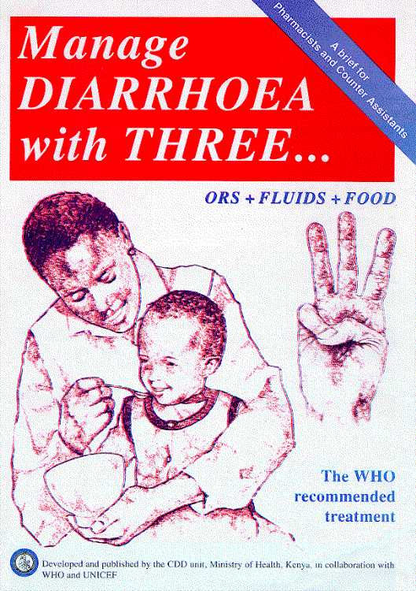
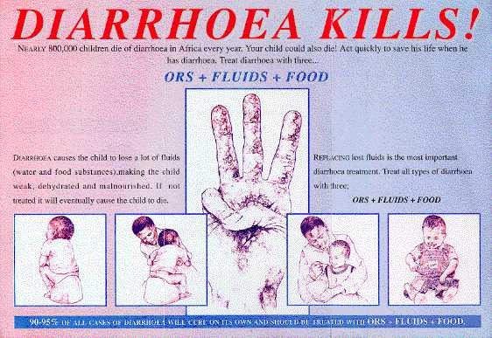

Printed materials can be—
- Mailed to prescribers or dispensers
- Posted on health center or hospital walls
- Handed in person to prescribers and patients

Using printed materials alone to improve prescribing assumes (1) the main reason for incorrect prescribing is lack of information and (2) if prescribers had the "correct" information, their prescribing would automatically improve. However, this is not always the case. The best studies in Western countries have shown that distributing printed educational materials alone results in brief, very small, or nonexistent improvements in prescribing. Many times prescribers do not even read these materials.

On the other hand, printed materials, particularly ones that are well constructed with easy-to-read messages, are an essential part of a total program that also includes more intensive and individualized education. A competition in Francophone West Africa by Réseau Médicaments & Developpment (ReMed) was an innovative way to produce locally appropriate printed materials (see below).

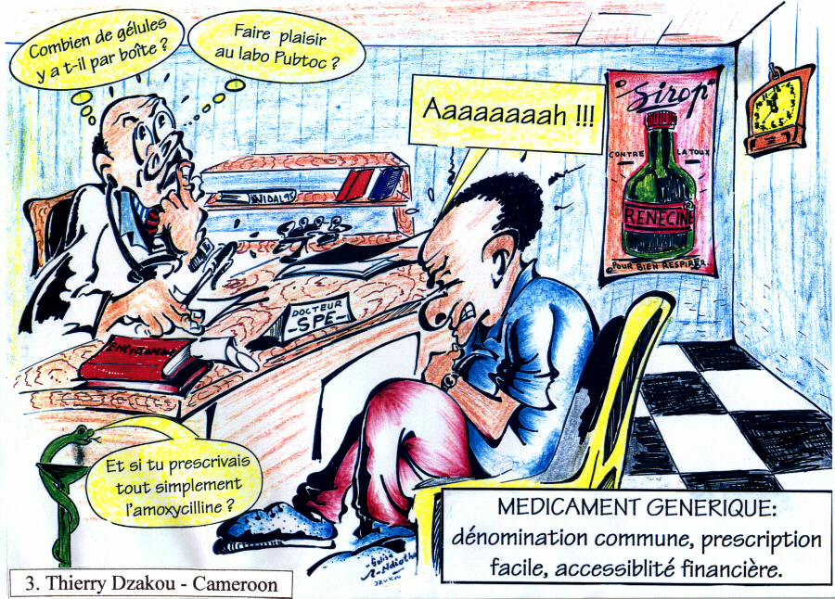

Above you have looked at three examples of printed material aimed at improving medicines use. Do you think they could be effective? Why or why not?

Educational Strategies: Face-to-Face Education - Persuasion
Talking directly to practicing prescribers about appropriate medicine use is a common intervention strategy. Research in Western countries where information is relatively plentiful has shown that face-to-face education is more effective than printed materials in actually changing behavior. This is also likely to be true in developing countries, but few studies have looked directly at this question. One study in Sri Lanka showed that mailing educational pamphlets about correct use of antibiotics to physicians in public health centers, even when combined with a large group in-service training seminar, did not result in a significant reduction in antibiotic use (Angunawela, et al., 1991).

However, a number of recent well-controlled studies have now shown that carefully targeted face-to-face education can be effective in changing prescribing behaviour.You can find out more about these in the following section.

One study from Indonesia demonstrated that face-to-face training of physicians and paramedics in both small groups at health centers and larger groups at district-level seminars was effective in improving prescribing for diarrhoea in children (Figures 3-6 below). The small group approach was less expensive and fit better with the existing supervisory system (Santoso, et al., 1996).

Figures 3 - 6: Indonesian Diarrhoea Trials

As seen in Figure 7 (below), a study from Kenya showed that small group training of counter attendants and one-on-one interactions with pharmacists could also improve diarrhoea treatment in private pharmacies, significantly increasing sales of ORS and reducing sales of antidiarrhoeals (Ross-Degnan et al., 1993).
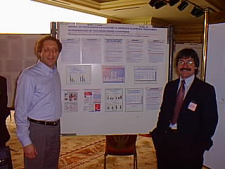

Figure 7

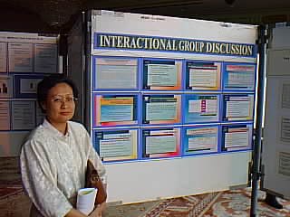Another study from Indonesia demonstrated, as seen in Figure 5, that moderated group discussions between community members and health workers, where both feelings about injections and scientific information about their risks were discussed, were effective in reducing the rate of injection use in public health facilities (Hadiyono et al., 1993).

Think about the question in the bubble in relation to Figure 8 below:
The decline in the intervention group was dramatic but there was also a decline in the control group. Why do you think this occurred?

Figure 8

This Indonesian study was particularly effective in that there was a sustained long term effect. It is unusual to study the long term effect of an intervention but what is striking in this case is that the difference as the result of the initial intervention persisted for 18 months after the intervention ended.

Figure 9

Think about these questions in relation to Figure 9:

Why do you think the effect persisted long after the intervention ended? Do you think the same outcome would have occurred if the intervention had been an educational training activity? What does this tell us about the effect of social pressures on changing or sustaining behaviour?

There are a number of reasons why face-to-face education is more effective than less personal approaches:
- Physicians and health workers remember and learn more when they participate in an active discussion rather than passively reading information.
- During face-to-face encounters, educators can assess specific motivations of prescribers for their practices and adapt messages to relate to these motivations.
- Verbal agreement with an educator or a peer group about correct behaviour can create psychological incentives for prescribers to conform to recommended practices.

Educational Strategy: Influencing Opinion Leaders
A study in the United States described an intervention that targeted authoritative senior department members on the issue of antibiotic prophylaxis of caesarian sections (see Figure 10). The intervention involved developing guidelines that were presented to leaders in the department of obstetrics and gynecology in a hospital. These department leaders ensured through various means that the desired antibiotic cefazolin was used rather than cefoxitin. While both antibiotics were available, a dramatic change in usage patterns occurred.

Figure 10

4 MANAGERIAL STRATEGIES

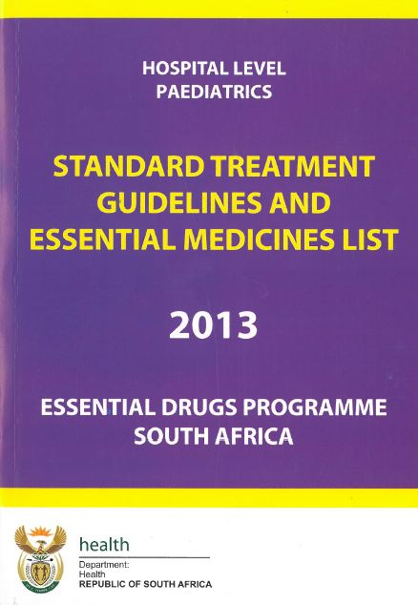
Managerial strategies attempt to improve medicine decision making by a variety of techniques. We have mentioned two of these already in Table 1 in section 3 above: Selection and Procurement, and Prescribing and Dispensing. These are described in more detail in this section. Other managerial strategies will be covered in more detail later in the course.

Managerial Strategy 1: Selection and Procurement
Essential medicine lists, such as that illustrated on the right, from South Africa, and national or institutional formularies provide prescribers with a list of the medicines felt to be most effective and economical in treating important health problems. They are usually found in the public rather than the private sector. The degree to which prescribers are allowed to deviate from listed medicines, and the procedures required to prescribe "off-formulary," vary in different settings. In general, larger medicine lists are considered appropriate in settings with better trained health workers (e.g., physicians), while community health workers may only be able to prescribe 20 medicines effectively.

There have been few objective studies of the impact of medicine lists and formularies in developing countries. They probably reduce use of unnecessary medicines by reducing their availability, but it is also likely that without prescriber or patient education, other listed medicines continue to be misused. Indeed, studies of prescribing in a number of countries where medicines are supplied to public facilities according to essential medicine lists have shown this to be the case. Although not a solution in themselves, limited medicine lists may be an important starting point in developing a more comprehensive program that also addresses appropriate use of the medicines supplied.

An extreme example of the essential medicines list concept is the medicine supply kit, where a limited number of medicines are supplied in fixed quantities at a regular interval to health facilities. Medicine kits are usually used in peripheral areas that are difficult to supply effectively.

One study of an essential medicines program in Yemen (Hogerzeil et al., 1989) compared two districts. In one, medicines were supplied in medicine kits and prescribers had been trained in their use; in the other, there was no essential medicines program. Results showed that the number of medicines prescribed in the intervention district was 1.5 per patient compared to 2.4 in the comparison area, and that both antibiotic use (44 percent vs. 66 percent) and injection use (24 percent vs. 58 percent) were lower. However kit systems are more suitable for emergency than regular supply situations. For more information on Kit Systems Management see Chapter 27, pages 407-418, in Managing Medicine Supply, 2nd ed. See: https://www.msh.org/sites/msh.org/files/mds3-ch26-kitsystem-mar2012.pdf

Similar results occurred in a study of a medicine kit supply program combined with a medicine use training seminar in Uganda (Christensen, 1991). This study also found that prescribing indicators were reduced, but much less dramatically (the number of medicines per patient: 1.7 vs. 1.9; antibiotics: 51 percent vs. 59 percent; injections: 44 percent vs. 50 percent).

Two other supply-oriented strategies, often used hand in hand, attempt to increase the availability of appropriate medicines.

Supply-oriented Managerial Strategies

Morbidity-based medicine quantification
This strategy involves:
- Assembling morbidity data on the frequency of important health problems presenting at a health facility or group of facilities (problems covering 90 percent of visits)
- Defining standard therapies for these health problems
- Calculating a medicine supply profile that would best match the observed morbidity profile if all cases were treated according to the standard therapies
- Altering the supply of medicines to health facilities accordingly, either all at once or incrementally

Procurement review
This strategy involves compiling data on medicines procured during a given period by a health facility or within an administrative area. Patterns of procurement of specific medicines, or the mix of medicines within therapeutic categories, can then be compared between facilities, or compared to an "ideal" pattern based on morbidity-based quantification, to demonstrate possibilities for increasing cost-effectiveness. Feeding back this information to persons responsible for medicine procurement is useful for correcting glaring problems in procurement, although its impact on medicine prescribing is uncertain.

Managerial Strategy 2: Prescribing and Dispensing

Prescribing forms
In hospitals, it may be possible to create simple medicine prescribing forms to correct common prescribing errors. For example, a Boston teaching hospital developed an intravenous antibiotic order form. An educational message, next to where a physician orders clindamycin and metronidazole on the order form, encourages three times rather than four times a day dosing of these medicines, due to their long half-lives. The boxes for the four times a day schedule are shaded to discourage physicians from making this choice. This simple intervention, which combines both managerial and educational elements to improve prescribing, can result in enormous savings by reducing unnecessary medicine expenditures.

Developing diagnostic and treatment guidelines
These can also encourage prescribers to follow a rational decision making process when deciding which medicines to use.

Standardized diagnostic and treatment protocols are decision rules that lead health workers to the most appropriate actions based on patient symptoms and clinical signs. They often work well for training less-skilled personnel to manage problems where differential diagnosis can be based on specific rules. One example is the WHO protocol for acute respiratory infections (ARI), which helps health workers differentiate pneumonia from mild respiratory infections (e.g., based on respiration rate and examination of the chest). Once a health worker has determined the severity of the problem, a specific treatment is recommended by the protocol.

Large studies in at least five countries have evaluated the impact on child mortality of implementing the WHO ARI diagnosis and treatment protocol in primary health care programs. These interventions combined training in use of the ARI protocol by community health workers and health facility staff with active health worker supervision, community case finding, and guaranteed supply of the recommended front-line antibiotic. Therapeutic guidelines are a common method for disseminating standards of practice in a form that is less proscriptive than a structured protocol. Many countries have produced collections of guidelines that detail the preferred treatment for major health problems. Important factors in determining how effective such guidelines will be in changing behavior in different settings include:
- How the guidelines are produced: by a unit in the Ministry of Health, by a consensus panel of acknowledged experts, or through a participatory process involving actual practitioners from the groups to whom the guidelines will apply
- How the guidelines are disseminated: mailed to providers and health facilities, coupled with a training program, integrated into clinical supervisory systems
- Whether the guidelines are "user-friendly": minimum amount of unnecessary text, able to fit in a pocket to be carried by practitioners; able to be referenced easily.

The Zimbabwe Essential Medicines Programme has established a set of national treatment guidelines for major health problems that apply to all levels of care in the country. Representative physicians, medical officers, nurses, and other health workers from all parts of the country participated in the drafting and revision of the guidelines, which are distributed in a convenient booklet to all health workers. Training in the essential medicines program is coordinated with these guidelines. In studies of medicine prescribing using standard indicators in 12 countries (Hogerzeil et al., 1993), the performance of Zimbabwe’s health workers comes closest to matching "ideal" parameters.

Prescribing and Dispensing Strategies: Utilization audits
These involve collecting and analyzing data on past or current prescribing by health facilities, clinical departments, or individual prescribers. Data on performance are usually fed back to prescribers as another type of prescribing improvement strategy. Audit and feedback interventions usually have the following characteristics as illustrated in Figure 11:
- Local experts establish basic criteria for specific medicine therapy problems (e.g., treatment guidelines).
- Prescribing data are collected (e.g., from prescription forms) on the number, types, and doses of medicines being prescribed for particular health problems.
- Data are reviewed to determine if prescribing (for a particular case or in the aggregate) meets the defined standards.
- Prescribers are then notified of results in the hope that incorrect practices are improved, and correct practices are reinforced and maintained.

Figure 11

The feedback of results can be structured in many ways:
- It can report the practices of individuals or of groups.
- It can be done just one time or repeated until the practices conform to the desired norm.
- It can be communicated by letter, in official patient records, or in person.
- It can be based on prior cases ("retrospective" cases), or cases reviewed close to the time of prescribing ("concurrent" cases). Concurrent feedback is more difficult to achieve since it requires immediate availability of data.
- Instead of assessing how prescribing compares with standards or guidelines, feedback can also compare individuals with their peers. For example, are a few prescribers giving twice as many antibiotics per patient as other prescribers?
This last approach (comparison with peers) may detect certain "outlier" or extreme "mis-prescribers," but it may also be hazardous if the outlier prescribers become defensive about the audit. Further, their prescribing patterns may be justified if they have an unusual patient population.

Because of the problems of data availability, there have been few examples of audit and feedback programs in developing countries. One of the most impressive programs exists at Soetomo Hospital in Surabaya, Indonesia, where continuous review of antibiotic practices for specific clinical problems (e.g., surgical prophylaxis) has resulted in dramatic improvements in the use of antibiotics.

Prescribing and dispensing strategies: Course-of-therapy packaging
This is a managerial strategy to prevent possible over- or under-use of medicines due to dispensing errors. For health problems that require the same amount of medicine, a package of therapy is given out that contains the exact number of doses of medication needed. For example, antibiotics that should always be dispensed in seven-day courses are packaged in this way to simplify dispensing.

A number of medicine labeling strategies have been tried to prevent errors in dispensing and mistakes by patients in frequency and dosages of medications taken. For example:
- Colour-coded labelling: specific colors on labels to identify the therapeutic uses of medicines (e.g., for malaria)
- Symbolic labelling: pictures of how and when patients should take the medicines

Few of these innovations in packaging and labeling have been critically evaluated to see if they improve actual therapy.

Supervision is a managerial tool that is often recommended but rarely evaluated. In a study undertaken in Zimbabwe that was published in 2001 facilities were randomly allocated to receive supervision in either rational medicine use or supply chain management. Both groups demonstrated statistically significant improvements when change was possible. The amount of supervision provided was very limited as due to the economic crises occurring at the time only two supervisory visits were possible in a year. (Trap, et al. 2001).

To think about:
Have any of the prescribing and dispensing strategies described above been used in your setting? Do you think any of the other strategies described above could be effective in your facility?

5 ECONOMIC STRATEGIES

Many public sector cost-recovery programs require patients to pay a portion of the cost of the medicines they consume. Economic studies have shown that higher fees result in lower utilization of services. While one goal of user fees is to discourage unnecessary use of services, it is hoped that the fees do not unintentionally prevent large numbers of patients from receiving essential medicines.

The key concept is to avoid perverse financial incentives in which prescribers benefit from their prescribing rather than the patient. To do this a system should ensure that prescribers’ salaries do not come from drug sales, or that insurance policies reimburse non-essential drugs or incorrect doses. In addition flat prescription fees encourage polypharmacy by charging the same amount irrespective of number of drug items or quantity of each item.

One way of encouraging more rational medicine use is to charge a lower price for essential, effective medicines and a higher price for nonessential ones. In the private sector, it is possible through the use of government subsidies (e.g., for ORS) and taxes (e.g., for antidiarrhoeals) to encourage similar shifts to preferred products.

Only a few studies have demonstrated how to price medicines effectively in a given economic environment in order to eliminate misuse, yet not cause patients to stop taking medicines they need. One of the best studies was undertaken by Holloway, Gautam and Reeves (2001) in Nepal where different fee bands were created that improved prescribing while reducing costs.

In communities where access to essential medicines is low, one strategy has been to purchase an inventory of medicines with an initial capital investment, and then charge patient fees sufficient to recover the cost of the medicines and to purchase new stock. Such revolving funds are often established with the assistance of external donors (e.g., UNICEF through the Bamako Initiative) during their initial period until utilization is sufficient to ensure sustainability. In a study from Nigeria, Uzochukwu and others (2002) demonstrated that while availability of essential medicines improved, the number of medicines per prescription increased from 2.1 to 5.3 with similar increases in use of injections and antibiotics (see Fig 12 below).

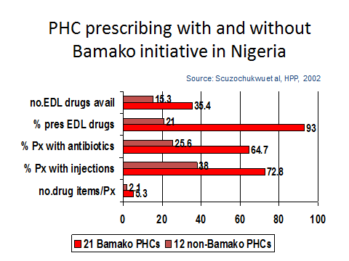
Figure 12

Although they are established to improve the use of essential medicines, incentives in revolving medicine funds can sometimes encourage inappropriate use of medicines. If the continuation of the program depends on increasing medicine sales, or if health worker remuneration is tied to sales, unnecessary overprescribing may result. There can also be a tendency to prescribe medicines with higher sales margins. Few studies of revolving medicine funds have examined in depth their impact on these aspects of rational use.

6 REGULATORY STRATEGIES

Regulatory strategies rely on rules or regulations to change behavior. They are intended to restrict decisions rather than to simply guide them, and are therefore usually designed to be inflexible. Because regulations are typically implemented on a system-wide basis, their impact is often difficult to measure in a valid way. There is a great need for studies from developing countries that critically evaluate the intended and unintended impacts of specific types of regulation.

Note: Many such regulatory approaches may have adverse unintended consequences.

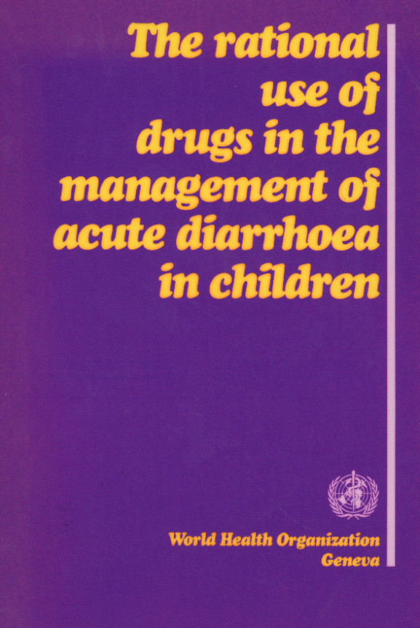
Some examples of regulatory strategies follow:

6.1 Market Controls

One common strategy for limiting the use of specific undesirable products is to not allow them to be registered within a country, or to remove them from the market (banning) if they have already been registered. Usually these regulatory controls are applied to medicines for which there are concerns about safety, efficacy, or their excessive cost.

As long as there is enforcement of registration decisions, never allowing a medicine to be registered is an effective strategy to control use. However, banning a product already in use carries the risk of encouraging unintended substitutions that are equally unsafe or ineffective. For example, some evidence from Bangladesh shows that the banning of all antidiarrhoeals resulted in increased use of metronidazole and mebendazole as "antidiarrhoeal" substitutes (Chowdhury et al. 1990).

Changing the prescription-only status of medicines is one way to encourage or discourage their use. Making a product over-the-counter (e.g., specific non-steroidal anti-inflammatories) encourages its use in relation to competitors, while making a medicine prescription-only (e.g., antibiotics or antidiarrhoeals previously available as OTCs) tends to reduce use. The recent tendency in many countries is to increase the number of products available over-the-counter in order to reduce cost and increase access.

Very little is known from developing countries about the impact of changes in product registration status, particularly in settings where enforcement of prescription-only regulations is weak.

6.2 Prescribing and Dispensing Controls

Sometimes an essential medicines list (EML) or formulary is used only as a guide for prescribers to help them in selecting preferred medicines. However, in some settings the choices of prescribers are limited only to the specific products listed. An EML or formulary can be used to limit the use of specific products to certain types of health facility (e.g., hospitals) or to certain types of prescribers (e.g., specialists). When there are major barriers to the prescribing of medicines not on an EML or formulary, these strategies take on a regulatory character.

As opposed to market controls on product availability that apply to all prescribers, restrictive EMLs or formularies can result in shifts in the use of certain medicines to the private sector or to facilities where the medicines in question are allowed. The fact that certain products are only available in the private sector can have the perverse effect of increasing their perceived status among patients. The impact of EMLs and formularies on total use of medicines in the community has not yet been studied.

A number of countries have adopted regulations to encourage the use of generic, non-branded medicines. It is generally believed that generic products offer therapeutic efficacy equal to their branded equivalents at a much lower cost.

Some of the ways generic medicines are encouraged include:
- Limiting EMLs and formularies to generic forms of a medicine, when available
- Requiring prescribers to prescribe by generic rather than brand name
- Limiting reimbursement to the cost of a generic equivalent, or charging patients higher fees for branded medicines
- Allowing pharmacists to dispense the generic equivalent for a branded medicine prescribed by a physician

As with other types of regulation that limit the availability of certain medicines, generic policies can cause shifts in utilization to the private sector. In addition, since prescribers and dispensers are often unaware of the exact ingredients of a medicine, regulations requiring generic prescribing or allowing generic substitution can cause unintended errors in therapy.

In settings where over-prescribing is common and pharmaceutical resources are scarce, sometimes limits are imposed on the number of medicines prescribed to a single patient (e.g., two or three medicines). In other settings, limits are placed on the number of days of supply of a medicine (e.g., oral antibiotics or antimalarials) that can be dispensed to a patient at one time; to receive the rest of a course of therapy, patients are expected to return for another clinic visit.

The risk with these types of arbitrary limits is that patients will not receive essential medicines they need. Previous studies in developed countries have shown that prescription limits can result in increased use of other, more expensive types of health care (e.g., hospital admissions).

Can you think of any adverse, unintended consequences that might arise in your context from regulatory approaches such as those described in section 6?

7 EXAMPLES OF MULTIPLE INTERVENTION STRATEGIES

The most effective interventions often combine different aspects of educational, managerial, and regulatory strategies to achieve maximum impact. These strategies can be implemented together to achieve maximum impact at a single point in time, or in sequence to reinforce effects.

A recent series of interventions by a group in Mexico City to improve the treatment of diarrhoea offer a good example of how interventions can combine different approaches (Gutierrez, et al. 1993; Muñoz, et al. 1993).

In the initial intervention, a prescribing survey for diarrhoea was carried out in two Social Security clinics in Mexico City. Physicians from the clinics then participated in a training workshop led by local experts where the results of the survey were presented and the physicians developed a normative treatment algorithm for diarrhoea. This was followed for the next six months by a peer review committee activity, in which physicians from the clinics rotated through the review committee assessing their own and their colleagues' diarrhoea case records. One remarkable feature of this study is the long follow-up (18 months) period, which showed how each strategy reinforced the changes in practice and how well the changes were retained (Figure 13).

Figure 13

In subsequent work, the intervention was simplified to allow for greater dissemination, as shown in Figure 14. In the second phase, the training workshops to review the normative treatment algorithms were conducted by opinion leaders in 18 Mexico City clinics, rather than by experts, with no post-training peer review committees. In this phase, the observed pre-post increase in use of the diarrhoea treatment algorithm was 25.6 percent (from 17.7% to 43.4%), compared to 46.7 percent (24.5% to 71.2%) in the initial study.

In the final phase of the work, rather than conducting the intensive participatory workshops to review the treatment algorithm, the algorithm was simply taught to health staff in 124 clinics around the state of Tlaxcala by coordinators from the project. Following this training, use of the algorithm improved by 6.5 percent (from 24.7% to 31.2%).

Table 2: Impact of training on the use of diarrhoea treatment
algorithm in three Mexico settings

Intervention given by | Prescribers | Baseline% | Post % | Change %
Experts in 2 clinics | 31 | 24.5 | 71.2 | +46.7
Leaders in 18 clinics | 65 | 11.7 | 43.4 | +25.6
Coordinators in 124 clinics | 157 | 24.7 | 31.2 | +6.5

This sequence of studies illustrates the magnitude of additional impacts that are possible by combining intervention strategies, but also demonstrates that even relatively limited intervention strategies can result in substantial improvements in practice.

7.1 Which are the most effective interventions?

A range of techniques exists to change medicine use practices. The different International Conferences on Improving Use of Medicines (ICIUM) have identified progress in improving the use of medicines in developing countries over the last decade.

The chart below shows that many different interventions can have an effect but what is clear is that printed educational material has a limited effect while combined interventions are more effective. The interventions at the bottom of the chart, namely provider group educational process, enhanced supervision with or without audit, economic incentives and national medicine policies combined with essential medicines programmes all are effective. Other educational interventions may be less successful.

While many practices have been identified as being effective, less than half of the 107 countries surveyed were using these approaches in 2007. Education of prescribers is more common but often has limited effects.

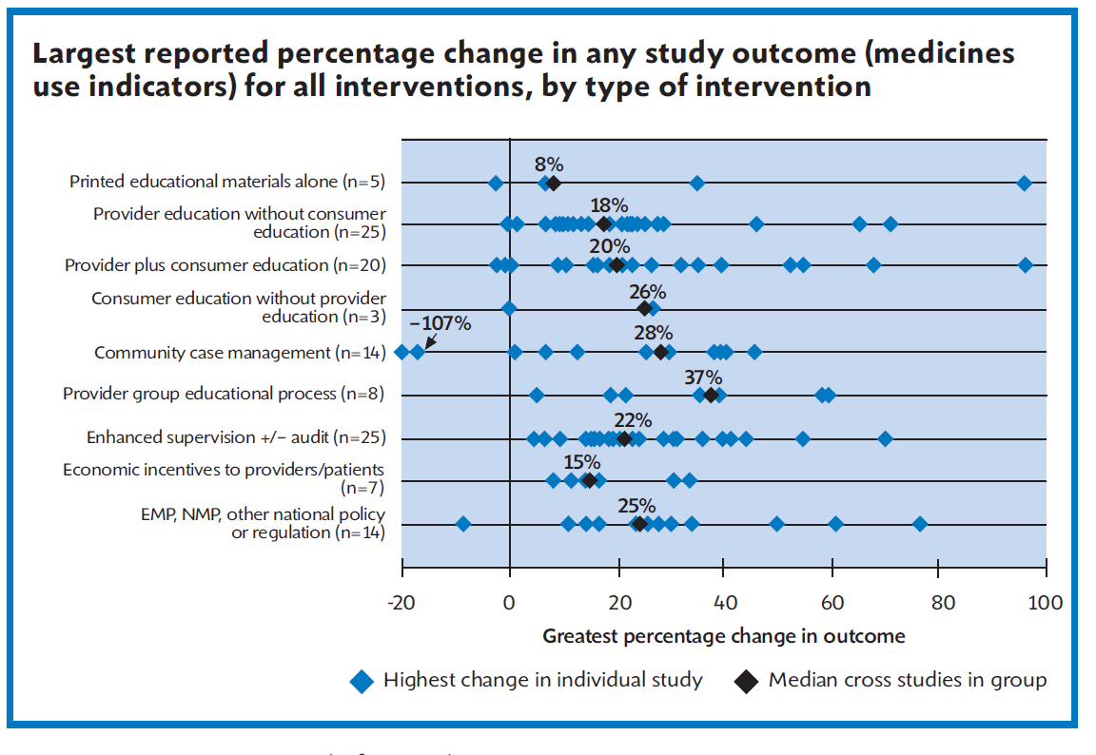Figure 14: Framework for changing drug use practices

You will now complete an activity in which you use a case study of medicine use change to analyse strategies covered in the session so far, their implementation, and application in your own setting.

Activity 1
Please read the Case Study, “Correcting Antibiotic Misuse in a South American City” in the Course Resources. You will then identify the approach taken to improve prescribing practices and evaluate its potential benefits and risks as a possible strategy in your own country, by writing brief answers to the following questions (not more than 400 words in total). Post your answers to the Session 7 convenor in File Sharing on the Ikamva site. Also be prepared to discuss them in the Discussion Forum, where you will get feedback. (Please note the dates in your Study Schedule):

1. What type of strategy was used to improve prescribing?
2. What were the possible motivations for physicians to prescribe in the way they did?
3. What were the motivations for physicians to comply with the recommendation of the Ministry of Health staff?
4. What were the overall strengths and weaknesses of this approach?
5. What are some of the risks of the type of communication used with the physicians?
6. What other strategies might have been used to feed back the results of the audit to prescribers?
7. Overall, do you think this would be a successful strategy in your country? Why or why not?
8. Would you have approached this problem differently in your country? If so, how?

CASE STUDY: Correcting Antibiotic Misuse in a South American City

Several officials in the Ministry of Health are interested in studying the extent of misuse of antibiotics prescribed in government-funded primary care centers within the country's capital city. Their first step was to collect prescription data from medicine prescription forms during a 15-day period from all health centers. These forms contained information on the problem being treated, medicines prescribed, dose, duration of therapy, and prescriber name.

The Chief Medical Officer is surprised by the initial tabulations of the data: tetracycline injections were the second most frequently prescribed antibiotic despite their high cost and the availability of alternative oral medications. Further analysis of the data revealed that the most common problems being treated were sore throat, sinusitis, and "general discomfort," all problems that could be treated with much safer and inexpensive medicines.

Concerned about the negative impacts of these practices on costs and quality of care, the Chief Medical Officer subsequently analyzes the data by prescriber and learns that only a few physicians are responsible for over two-thirds of the use of tetracycline injections. He immediately calls the responsible physicians and informs them that they are among the "worst" prescribers of antibiotics. He directs them to reduce this practice immediately or face the possibility of sanctions (e.g., banning their participation in government-funded clinics).

Three months later, the Chief Medical Officer repeats a 10-day survey of prescriptions, and finds that the use of tetracycline injections has declined by 70 percent. Satisfied that the problem has been solved, he plans no further follow-up or communication with these physicians.

One year later, a new 10-day survey of prescription forms is conducted. Unfortunately, it is found that tetracycline injections have risen again to nearly their former level. In addition, the prescription forms no longer contain readable names of the prescribers.

8 Session summary

What interventions exist to change medicine use? The best evidence exists in the primary health care (PHC) area in which focused, problem-oriented, repeated training has been shown to be effective. Also supervision or self-monitoring with simple indicators and peer group oriented guideline development have all consistently shown benefit.

Evidence however is lacking for interventions in the private sector, for adults, and especially for chronic non communicable diseases (NCD). Few interventions have been tested in hospitals in developing countries but great potential exists.

Consumers need to be involved! Experience is lacking, but interactive, context-specific programs with a mix of communication channels are likely to be effective. Medicine retailers’ sales practices can also be improved.

Studies on the impact of economic and pharmaceutical sector policy changes are sorely lacking. Finally we need more indicators for adequacy of diagnosis, guideline compliance, quality of care, cost, in-patient medicine use, success of Pharmaceutical and Therapeutic Committees (PTCs), and community programmes.

Consider these points and then share your ideas in the Discussion Forum:

Do you agree that ‘Consumers need to be involved’ in changing medicine use practice? How could this work in your country? Do you know what other interventions are effective in your country?

9 REFERENCES AND FURTHER READING

Angunawela, I., Diwant V., Tomson, G. (1991) Experimental evaluation of the effects of drug information on antibiotic prescribing: a study in outpatient care in an area of Sri Lanka. International Journal of Epidemiology. 20(2): 558-564.

Christensen, R. and W. Anokongo. (1991). Prescribing in out-patient departments and rural health facilities in Uganda: some clinical and educational implications. Dan. Med. Bull.

Everitt, D. E., Soumerai, S. B., Avorn, J., Klapholz, H., Wessels, M. (1990). Changing surgical antimicrobial prophylaxis practices through education targeted at senior department leaders. Infection Control, 11: 578-583. doi:10.1086/iche.1990.11.issue-11

Gutierrez, G., Guiscafre, M., Bronfman, H., Walsh, J., Martinez, H.& Munoz. O., (1994). Changing physician prescribing patterns: evaluation of an educational strategy for acute diarrhoea in Mexico City. Medical Care, 32 (5): 436–446

Hadiyono, J.P., Suryawat,i S., Danu, S.S., Sunartono, Santoso, B.(1996). Interactional group discussion: results of a controlled trial using a behavioral intervention to reduce the use of injections in public health facilities. Social Science and Medicine. 42:1185.

Hogerzeil, H.V., Walker, G.J.A., Sallami, A.O., Fernando, G. (1989) Impact of an essential drugs program on availability and rational use of drugs. Lancet 1989, 1(8630):141-142.

Hogerzeil, H.V., Bimo , Ross-Degnan, D., Laing, R.O., Ofori-Adjei, D., Santoso, B., et al. Field tests for rational drug use in twelve developing countries. Lancet .Dec.1993 342(8884):1408-1410.

Holloway, K.A., Gautam, B.R., Reeves, B.C.(2001) The effects of different kinds of user fee on prescribing costs in rural Nepal. Health Policy Plan 2001;16:421-7. doi:10.1093/heapol/16.4.421.

MSH (2012) Managing Medicine Supply, 2nd ed. 27: 407-418

Ross-Degnan, D. Soumerai, S., Goel, P.K. et al.(1996). The impact of face to face educational outreach on diarrhoea treatment in pharmacies. Health Policy and Planning. 11: 308–18

Santoso, B. (1996). Small group interventions vs formal seminar for improving appropriate drug use. Social Science & Medicine. April 1996.42(8 ): 1163–1168 doi:10.1016/0277-9536(95)00390-8

Trap, B., Todd, C.H., Moore, H., Laing, R. (2001). The impact of supervision on stock management and adherence to treatment guidelines: a randomized controlled trial. Health Policy and Planning. 16:273-280.

Uzochukwu, B.S.C., Onwujekwe, O.E. and Akpala, C.O. (2002) Effect of the Bamako-Initiative drug revolving fund on availability and rational use of essential drugs in primary health care facilities in south-east Nigeria. Health policy and planning 17.4: 378-383.

