Session 1 – Health Information Systems
Unit
2
Introduction
Introduction
In this session Health Information Systems is introduced as an overarching system that includes six components and their domains of measurement. The value of health information systems is described and emphasized with the purpose of linking effective and efficient health service delivery to health information systems.
Session Contents
- Defining Health Information Systems
- Six components of Health Information Systems
- Value of Health Information Systems
- The link between monitoring and evaluation and information systems

In this session the reading is the task.

Learning Outcomes of this Session

Public Health Outcomes
By the end of this session, you should be able to:
- Define health information systems
- Describe and understand the linkages between the six components of health information systems
- Determine the value of health information systems
- Describe the domains of measurement
- Identify the link between monitoring and evaluation and health information systems

Readings
- WHO. (2008). Framework and standards for Country Health Information Systems Health Metrics Network Part 2 Components and Standards of a Health Information System p16-35
https://www.who.int/healthinfo/country_monitoring_evaluation/who-hmn-framework-standards-chi.pdf

- Defining Health Information Systems

Let’s start by defining basic concepts:

Concept | Definition
System | A collection of components that work together to achieve a common objective
Information Management | The collection, collation and management of information from one or more sources (tick registers, patient records) and the distribution of that information to one or more audiences (facility managers, sub-district and district management). Basic components include data sources, data collection, data collation, data storage, data security.
Information System | A system that provides information support to the decision-making process at each level of an organization
Health Information System | A system that integrates data collection, processing, reporting, and use of the information necessary for improving health service effectiveness and efficiency through better management at all levels of health services
Health Management Information System | An information system specially designed to assist in the management and planning of health programmes, as opposed to delivery of care
(Adapted from Source: WHO, 2004)

Thus defining a health information system:
- Health information systems refer to any system that captures, stores, manages or transmits information related to the health of individuals or the activities of organisations that work within the health sector.
- incorporates district level routine information systems, disease surveillance systems, laboratory information systems, hospital patient administration systems (PAS) and human resource management information systems (HRMIS).

- Six components of Health Information Systems

There a six components of a Health Information System as illustrated in the diagramme below:

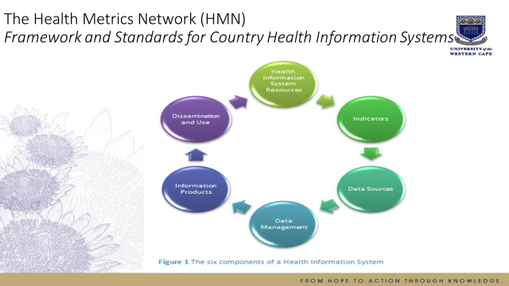

Defining core indicators (Extract from Framework for National Health Information Systems, 2008)

The core indicators of a health system should reflect changes over time. As with any indicator, health indicators should be valid, reliable, specific, sensitive and feasible/affordable to measure. They must also be relevant and useful for decision-making at data-collection levels, or where a clear need exists for data at higher levels. Carefully selected and regularly reviewed core indicators are vital to strengthening a health information system and can be viewed as the backbone of the system, providing the minimum information package needed to support macro and micro health system functions.

Domains of measurement for health information systems (WHO, 2008:16-17)

Determinants of health  • Socioeconomic and demographic factors  • Environmental and behavioural risk factors | Inputs  • Policy  • Financing  • Human resources  • Organization and  management
Health system | Outputs  • Information  • Service  availability  and quality
Health  status  • Mortality  • Morbidity/  disability  • Well-being | Outcomes  • Service  coverage  • Utilization

The domains of measurement and core indicators are further elaborated on in the sessions on information requirements and minimum datasets.

Task: Read WHO. (2008). Framework and standards for Country Health Information Systems Health Metrics Network Part 2 Components and Standards of a Health Information System p16-35
https://www.who.int/healthinfo/country_monitoring_evaluation/who-hmn-framework-standards-chi.pdf

- Value of Health Information Systems

WHO places information at the center of all management and monitoring activities.

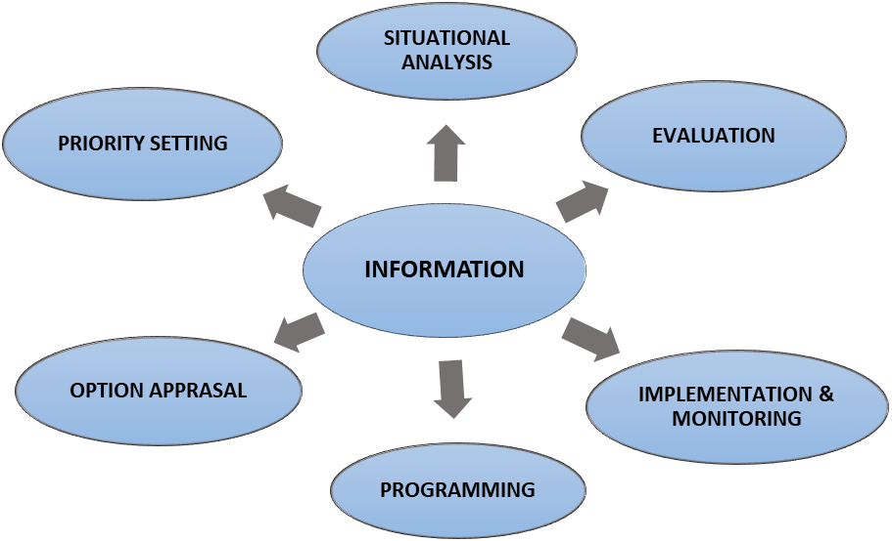

- Information can be used in health care provision specifically for:
- Objective identification of health needs of communities (i.e. a community diagnosis). Also, whether these health needs are unique or not.
- Prioritising health needs found in communities served.
- Continuous performance appraisal of health services provided.
- Pro-active monitoring and evaluation is possible and enhanced.
- Prioritising specific geographical areas for health service intervention and appropriate resource allocation.
- Informing the appropriate interventions required and it can describe the effectiveness and efficiency of the interventions.
- Promotion of continuous communication to enhance multi-sectoral approaches to health care.
- Equitable allocation of scarce resources can be determined, leading to greater fairness.
- To determine and improve the coverage of health services provided.
- To determine and improve the quality of health services provided.

- One of the most important uses of information is to improve the decisions that we make as managers. Just consider the consequences of your decisions if you did not monitor the amount of money you had in the bank. If you do not have information on the amount of money that you have available, or information on your budget, you may end up heavily indebted. Similarly, we need to have information to make managerial decisions for health care delivery. More specifically, we can use information to help improve our decisions during:
- Strategic planning for the future: Planning what direction the health services will take with clear goals, targets/objectives and indicators.
- Daily operational activities: Planning how the strategies will be implemented on a day-to-day basis, who will perform the activities, how and by when.
- Implementing controlling activities: Making sure that finances are spent sparingly, yet addressing the health needs of the communities served or ensuring that sufficient personnel are placed at the correct service points with the correct skills, workload and equipment.
- Appropriate policy development: Policies address in broad terms what, how, where and when we do things, or would like to do things. Information can give us answers to all these questions to ensure that policies are relevant and implementable.
- Problem areas and areas where health services should be improved can also be identified with information. It is important that we address the health needs of all our communities. Also, our health services must reach the entire community. If problems exist, either due to the coverage or quality of the services, we need to address them. Information can point the way in solving these problems.
- Information can also be used to directly increase the staff and communities’ understanding of how the organization functions and what its outputs are. Staff must be aware of the needs and norms of communities. If this is not known, the staff cannot be expected to provide an effective health service to the communities they serve. They also need to know who it is that they serve. Similarly, you will recall that the PHCA endorses the need for communities to participate in health care services provided to them. They have the right to know what it is that the DHS is providing to them, how well it is addressing their health needs, what they can do to assist in health care provision, and what improvements are being implemented or are planned to be implemented. In this way, information can create a better understanding and partnership between the health services and the communities they serve.
- A very important use of information that is often neglected by health authorities is its motivational role. Information can be used in positive ways to increase morale and levels of motivation. For instance, showing how well facilities are performing in relation to others, or the district target, can be very inspiring and provoke a greater interest in district performance by all staff. It is commonly understood that managers should praise often and reprimand only when necessary. Information can help us to see and show success and improvements, sing praises and motivate for sustained improvement of health care services.

Information can provide evidence and back-up for claims and requests advocating for improvements in the health service. Many district-level managers complain that their problems are not addressed by higher levels. “We don’t have enough money to … we don’t have enough staff…our needs are not considered …,” etc. These are all common phrases used by managers to justify poor performance of health services. However, managers at higher levels receive, and have to address, requests complaints from many different areas. Frequently, the requests for changes are not backed-up with solid information. Consider a situation where a district level HIV/AIDS manager has a low counseling coverage at facilities in the district; the manager believes this to be due to the fact that they have too few counselors. The request goes to the decision-makers that they need more counselors. The decision-makers would probably think that they have a similar problem in all the districts, and why should this district be advantaged above the others? They also have no idea as to the extent of the problem. However, if the manager indicated the actual coverage currently achieved, the potential workload in the health facilities, the exact number of counselors needed, and the district’s relative performance against others, he/she would probably receive more serious consideration.

- The link between monitoring and evaluation and information systems

We defined monitoring and evaluation in Unit 1 of this module. Monitoring and evaluation can be viewed in two ways: 1 To use monitoring and evaluation to measure the information system and 2 When information systems are a component of a monitoring and evaluation system. Keeping in mind that the goal of monitoring and evaluation is not to focus on what is wrong and condemn it; rather, it is to highlight the positive aspects of the system that make it work, as well as to identify what went wrong as a basis for improving the system.

When monitoring and evaluation is used to measure the information system

- Develop a plan for the systematic monitoring and evaluation of the system.
➤ What will be monitored and evaluated?
➤ How will it be done?
➤ Who will do it?
➤ How frequently will it be conducted?
➤ How will the results be systematically disseminated?
➤ How will action resulting from the evaluation results be generated?
- Identify the resources needed to implement the monitoring and evaluation plan.
- Prioritize the activities, based on availability of resources and need.
- Implement the monitoring and evaluation plan.
- Document and disseminate the results of monitoring and evaluation activities.
- Make recommendations based on the results of monitoring and evaluation activities

What are issues accompanying this process

Monitoring and evaluation have to be institutionalized to ensure that it becomes a regular activity and corresponding resources will be allocated. Also, technical expertise and other resources are required. The idea is not to destroy existing systems but to build on the strengths and learn from the weaknesses of what already exists. In order to this here are few steps to follow:
- Make an inventory of the forms, log books and other tools used to record and summarize data at different levels.
- Assess the quality of the data being collected using the existing forms at different levels. Among the aspects to be included in the assessment are:
➤ Accuracy
➤ Completeness
➤ Adequacy
➤ Timeliness
- Determine the problems encountered with the current system of data collection at different levels, including the timing and flow of information.
- Determine the current status of the other components of the HMIS like:
➤ Data processing
➤ Data analysis
➤ Data dissemination
➤ Supply and logistics
➤ Staff development
➤ Coordination, cooperation and communication within and between different units in the Ministry of Health, as well as with related agencies outside of the ministry
- Identify the aspects of the system that need to be:
➤ Retained
➤ Modified
➤ Abolished
- Summarize the results of the assessment in a formal report.
- Discuss results of the assessment with proper authorities
However, this process of assessing the current situation has its own issues:
- Who has the authority to make the assessment?
- Availability of technical expertise and resources to do the assessment.
- Cooperation among the different units in the assessment process; involvement of end-users at all levels.
- Formation of a body (ideally an inter-departmental committee) tasked with planning, monitoring and managing all phases of the development of the HMIS, from the baseline assessment to the evaluation phase.

When monitoring and evaluation is used to measure the information system

The diagramme depicts how an information system would fit into a monitoring framework.

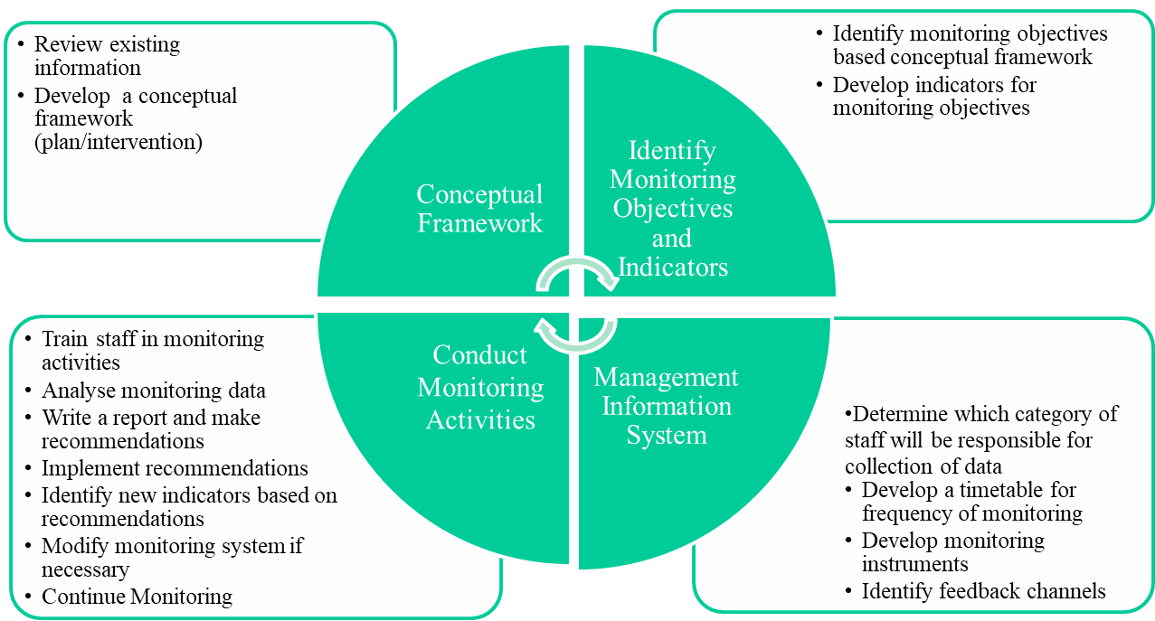

- Session Summary

The session provides an overview of heath information systems the value thereof and the linking it to monitoring and evaluation.

- References

- WHO. (2008). Framework and standards for Country Health Information Systems Health Metrics Network Part 2 Components and Standards of a Health Information System.
https://www.who.int/healthinfo/country_monitoring_evaluation/who-hmn-framework-standards-chi.pdf
- WHO. (2004). Developing Health Management Information Systems. A practical guide for developing countries.
http://www.wpro.who.int/health_services/documents/developing_health_management_information_systems.pdf

